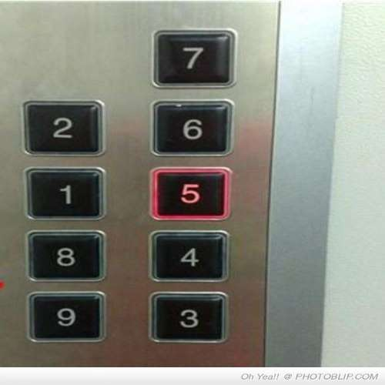

**Issues with current design**

-Too much confusing

-Numbers are out of order

**Possible Solution Sketch**

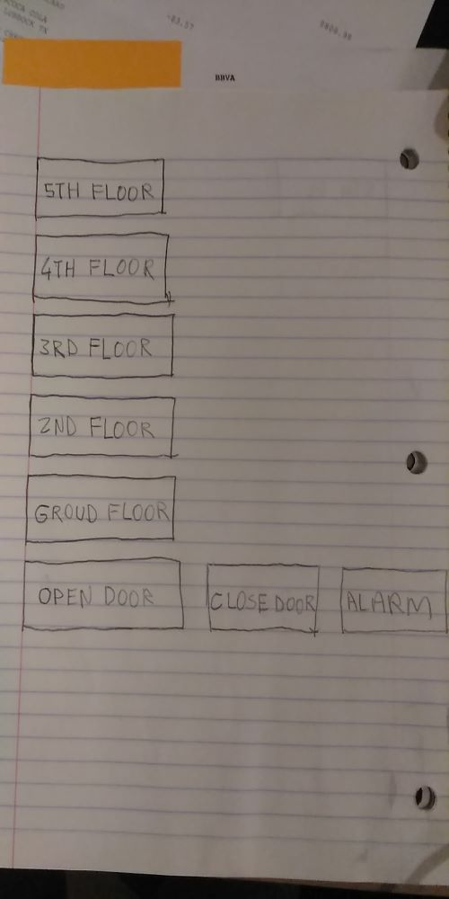

We use elevators to reach access other floors elevators control panel needs be simple and easy to use.

