**Lab Experience 4**

**Lab Exercises**

**Directions:**

Start Microsoft word and record the questions and answers to all of the exercises in the lab 5 word document   
Answer the following questions based on material presented in lecture and found in chapters 1-4 of our textbook.

**Lab Exercises**

1. The >> in a cin statement is called the **stream extraction operator** operator.
2. What is the result of the expression: **35 <= x <= 55** assuming x has a value of 30? (Hint: This is not a mathematical expression but a C++ expression so associatively rules apply and the result will either be a 1 or a zero.)

**The value would always be 1, as C++ is left to right and the 35<=x would always evaluate first, giving either a 0 or 1, which is less than 55.**

1. Assume **i = 2, j = 3, k = 4**, and **m = 1**. What does each of the following statements output? (**Note: It should be a numeric value.**)

|  |  |
| --- | --- |
| cout << (i != 1) << endl;  **Output: 1** | cout << (i < j < m) << endl;  **Output: 0**  **((2 < 3) < 1)->0** |
| cout << (j >= i || k == m) << endl;  **Output: 1**  **(j>=i)->1, short circuit eval.** | cout << (k + m < j || 3 - j >= k) << endl;  **Output: 0**  **(5<3 || 0 >= 4)->0 || 0** |
| cout << (j = 2) << endl;  **Output: 1**  **(Assignment evals to 1) (Double check later)** | cout << (j >= i && k == m) << endl;  **Output: 0**  **(3>=2 && 4==1)-> 1 && 0** |

1. What is the result of the compound expression (if it compiles): **x < 110 && < 200** if x contains 120? Why?

**Syntax error. You can’t put the less than directly after the and.**

1. Write an if-else statement that outputs the word **Passed** provided the value of the variable **exams** is greater than or equal to 60 and the value of the variable **programsDone** is greater than or equal to 10. Otherwise, the if-else statement should display the word **Failed**.

**if(exams >= 60 && programsDone >= 10)**

**cout << “Passed”;**

**else**

**cout << “Failed”;**

1. Write an if-else statement that outputs the word **Warning** provided that either the value of the variable **temperature** is greater than or equal to 100, or the value of the variable **pressure** is greater than or equal to 200. Otherwise the if-else statement outputs the word **OK**.

**if(temperature >= 100 || pressure >= 200)**

**cout << “Warning”;**

**else**

**cout << “OK.”;**

1. The customer is given the option of automated checkout at retail centers. Write a program that will accept the customer’s payment (in dollars only) and returns the correct change back to the customer.

For example, if the items purchased were $5.15 and the customer pays $10.00 the change returned would be four one dollar bills, three quarters, and one dime.

If the items purchased were $5.15 and the customer pays $20.00 the change returned would be a ten dollar bill, four one dollar bills, and three quarters, and one dime.

If the items purchased were $5.15 and the customer pays six dollars, then the change would be three quarters and one dime.

You may assume the following constraints:

1. The purchase price of all items will never exceed $50.00.
2. The customer will only pay in whole dollars only, never in cents.
3. The customer’s payment will always be greater than the cost of the items purchased.

**Your program should ask for the purchase amount and also the payment amount from the user.**

Copy and paste your program in your word document. Paste screen shots of the console window below your program. The number of console windows should be sufficient to show you tested your program adequately.

/*******************************************************************************

Programmer: Johnathan Lee

Class: CSCI 1106

Lab: 4

Submitted 2/7/17

Description:

*******************************************************************************/

#include <iostream>

#include <iomanip>

using namespace std;

int main() {

char temp;

int purchaseDollars,

purchaseCents,

dollarChangeLeft,

smallChangeLeft,

paymentAmount; // Int as whole dollar payment is assumed.

int pennies = 0, nickels = 0, dimes = 0, quarters = 0, oneBills = 0, fiveBills = 0, tenBills = 0, twentyBills = 0; // Change of each type.

cout << "Please enter the purchase amount ==> ";

cin >> purchaseDollars >> temp >> purchaseCents;

cout << "\n"

<< "Please enter the payment amount (Whole numbers only) ==> ";

cin >> paymentAmount;

if (purchaseCents > 0)

dollarChangeLeft = paymentAmount - purchaseDollars - 1;

else

dollarChangeLeft = paymentAmount - purchaseDollars;

if (dollarChangeLeft / 20 >= 1) {

twentyBills = dollarChangeLeft / 20;

dollarChangeLeft %= 20;

}

if (dollarChangeLeft / 10 >= 1) {

tenBills = dollarChangeLeft / 10;

dollarChangeLeft %= 10;

}

if (dollarChangeLeft / 5 >= 1) {

fiveBills = dollarChangeLeft / 5;

dollarChangeLeft %= 5;

}

if (dollarChangeLeft >= 1) {

oneBills = dollarChangeLeft;

}

if (purchaseCents > 0)

smallChangeLeft = 100 - purchaseCents;

else

smallChangeLeft = 0;

if (smallChangeLeft / 25 >= 1) {

quarters = smallChangeLeft / 25;

smallChangeLeft %= 25;

}

if (smallChangeLeft / 10 >= 1) {

dimes = smallChangeLeft / 10;

smallChangeLeft %= 10;

}

if (smallChangeLeft / 5 >= 1) {

nickels = smallChangeLeft / 5;

smallChangeLeft %= 5;

}

pennies = smallChangeLeft;

cout << "Your change: \n"

<< "Twenty Dollar Bills : " << twentyBills << endl

<< "Ten Dollar Bills : " << tenBills << endl

<< "Five Dollar Bills : " << fiveBills << endl

<< "Dollar Bills : " << oneBills << endl

<< "Quarters : " << quarters << endl

<< "Dimes : " << dimes << endl

<< "Nickels : " << nickels << endl

<< "Pennies : " << pennies << endl << endl;

return 0;

}

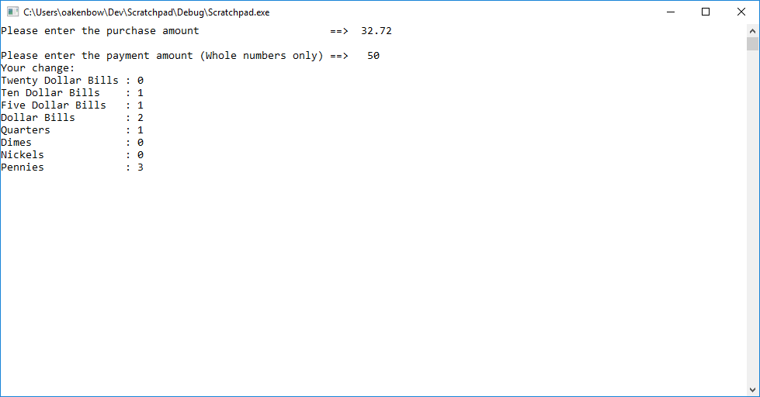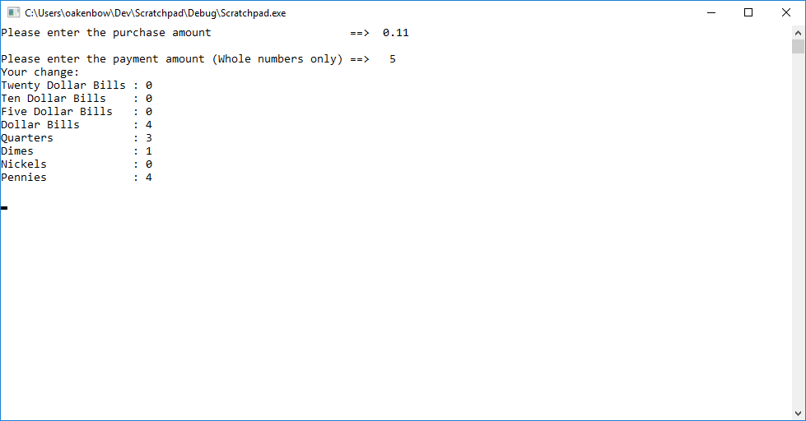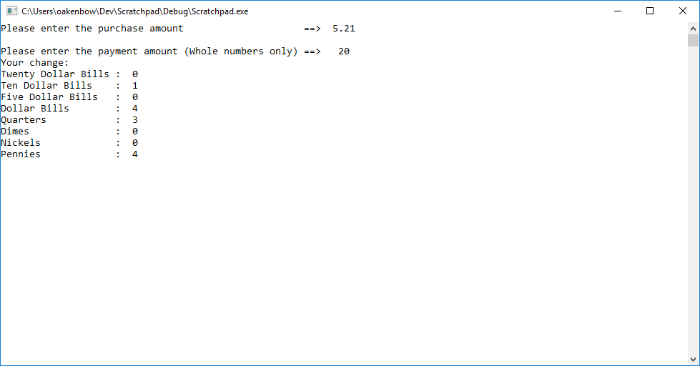

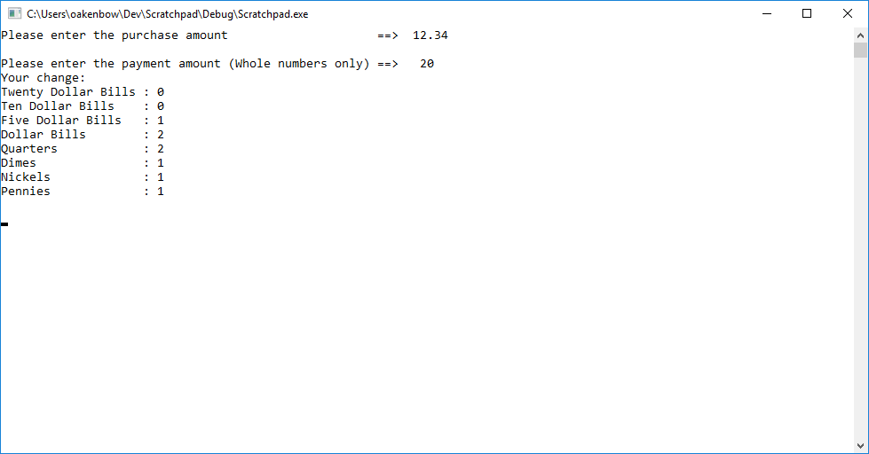

**Due Dates:** According to the due date posted for the assignment folder.

**What to hand in:**

1. Place the word processed document created to answer all of the questions using the filename **{yourname}Lab4.docx**  e.g. timwrennlab4.doc Note:**If your name is not part of the filename, I will not open the file.**
2. Hand in a print out of your word document.
3. Hand in a print out of your program.
4. Place the zipped file into the D2L assignment folder titled Lab Experience Four.