**Lab Experience 5**

**Lab Exercises**

**Directions:**

Start Microsoft word and record the questions and answers to all of the exercises in the lab 5 word document   
Answer the following questions based on material presented in lecture and found in chapters 1-4 of our textbook.

**Short Answer**

1. Convert each if/else if statement into a ternary expression.

a) if(pressureReading > 59)

reducePressure = true;

else

reducePressure = false;

**reducePressure = (pressureReading > 59 ? true : false);**

b) if(x == 2)

y = 1;

else

y = 0;

**y = (x == 2 ? 1 : 0);**

1. Convert the following if statements into an assignment statement.

a) if(pressureReading > 59)

reducePressure = true;

else

reducePressure = false;

**reducePressure = (pressureReading > 59);**

**or:**

**reducePressure = static_cast<bool>(pressureReading > 59);**

b) if(x == 2)

y = 1;

else

y = 0;

**y = (x == 2);**

1. Convert the following if/else if statement into a switch statement.

**if(grade == 'A' || grade == 'a')**

**aCount++;**

**else if(grade == 'B' || grade == 'b')**

**bCount++;**

**else if(grade == 'C' || grade == 'c')**

**cCount++;**

**else if(grade == 'D' || grade == 'd')**

**dCount++;**

**else**

**fCount++;**

switch(grade) {

case ‘A’:

case ‘a’:

aCount++;

break;

case ‘B’:

case ‘b’:

bCount++;

break;

case ‘C’:

case ‘c’:

cCount++;

break;

case ‘D’:

case ‘d’:

dCount++;

break;

default:

fCount++;

break;

}

1. Convert the following switch statement into an if/else if statement.

**switch(choice){**

**case 1: charges = months * 40;**

**break;**

**case 2:**

**case 3:**

**case 4: charges = months * 20;**

**break;**

**case 5:**

**case 6:**

**case 7:**

**case 8:**

**case 9: charges = months * 10;**

**break;**

**default:**

**charges = -1;**

**break;**

**}// end switch**

**if(choice >= 5 && choice <= 9)**

**charges = months * 10;**

**else if (choice >= 2 && choice <= 4)  
 charges = months * 20;**

**else if (choice == 1)**

**charges = months * 40;**

**else**

**charges = -1;**

1. What is the output of following code segment if ***choice*** contains the value 1 and ***months*** contains the value 5?

**switch(choice){**

**case 1: charges = months * 40;**

**case 2:**

**case 3:**

**case 4: charges = months * 20;**

**case 5:**

**case 6:**

**case 7:**

**case 8:**

**case 9: charges = months * 10;**

**}**

**cout << “Your total charges are $ “ << charges << endl;**

it outputs: **Your total charges are $ 200**

**Programming Exercise:**

Write a program that reports the contents of a compressed-gas cylinder based on the first letter of the cylinder's color. The program input is a character representing the observed color of the cylinder: 'Y' or 'y' for yellow, 'O' or 'o’ for orange, and so on. This process should continue until the user enters the letter ‘E’ or ‘e’ to exit the program. Cylinder colors and their associated contents are as follows:

orange ammonia brown carbon monoxide

yellow hydrogen green oxygen

If an invalid letter is entered, notify the user of incorrect input by stating Contents Unknown. The user will enter either upper or lower case letters. Your program should test for both upper and lower case letters.

**Implement the above by using a switch statement.**

Copy and paste your program into your word document. Capture the output window and paste it below your program. **You should have several console windows pasted into your word document showing that all cases in your switch statement execute.**

/*

Name: Johnathan Lee

Class: CSCI 1106

Lab: 5

Date started: 2/7/15

Description: Takes an input color code and reports the contents of the cylinder based on that code.

*/

#include <iostream>

#include <iomanip>

using namespace std;

int main() {

bool shouldQuit = false;

bool validChoice;

char choice;

string contents;

while (!shouldQuit) {

validChoice = true;

cout << "Please enter a color code: ";

cin >> choice;

switch (choice) {

case 'O':

case'o':

contents = "ammonia";

break;

case'Y':

case'y':

contents = "hydrogen";

break;

case 'B':

case 'b':

contents = "carbon monoxide";

break;

case 'G':

case 'g':

contents = "oxygen";

break;

case 'E':

case 'e':

shouldQuit = true;

break;

default:

validChoice = false;

break;

}

if (!shouldQuit) {

if (validChoice)

cout << "Your gas cylinder contained " << contents.c_str() << "!\n\n";

else

cout << "You entered an invalid choice! Please try again!\n";

}

else

cout << "Shutting down.\n\n"; // mainly here to provide proof in the screenshots

// that it was actually shutting down.

}

return 0;

}

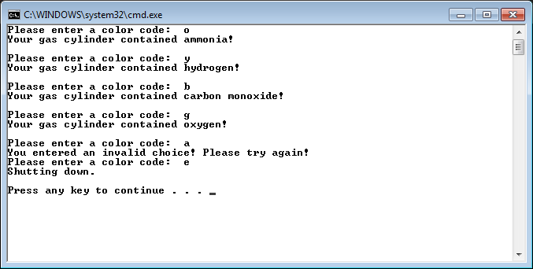

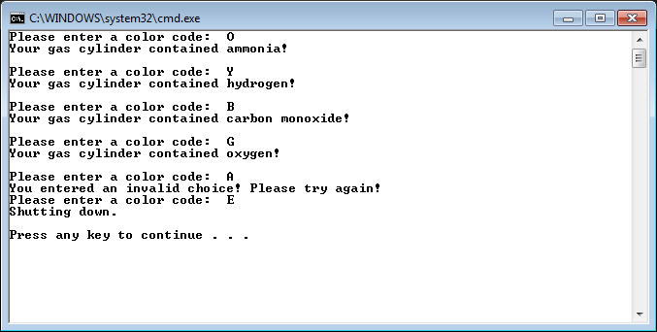

**Due Dates:** According to the Lab Experience Five assignment folder closing date/time.

**What to hand in:**

1. Compress the .cpp file from the programming exercise and the word document created into a single file called **{yourname}Lab5.zip** e.g. timwrennlab6.zip Note:**If your name is not part of the zip filename, I will not open the zipped file.** ***Note: Only compress the .cpp files for the programming exercise.***
2. Hand in a print out of your program and the word document.
3. Place the zipped file into the D2L assignment folder titled Lab Experience Five.