**Lab Experience Six**

**Lab Exercises**

**Directions:**

Start Microsoft word and record the questions and answers to all of the exercises in the lab 6 word document   
Answer the following questions based on material presented in lecture and found in chapters 1-5 of our textbook.

**Fill in the blank**

1. A block of code that repeats forever is called a(n) **infinite loop.**
2. To keep track of the number of times a particular loop is repeated, one can use a(n) **counter**.
3. A while loop is a(n) **pretest** loop that will never be executed if the test expression is initially false.
4. In the conditional if(++number < 9), number is incremented **before** it is compared to 9.
5. In the conditional if(number++ < 9), number is incremented **after** it is compared to 9.
6. Perform a hand trace by creating a table to show the contents of the variables as the loop is executing as in the example above. A snapshot of the program execution will receive no credit.

a)

**int i = 3;**

**cout << "12345678901234567890" << endl;**

**while (i >= 0){**

**cout << setw(3) << i ;**

**i--;**

**}**

|  |  |  |
| --- | --- | --- |
| **Value of i** | **Value of i>=0** | **Output** |
| **3** | **True or 1** | **“ 3”** |
| **2** | **True or 1** | **“ 2”** |
| **1** | **True or 1** | **“ 1”** |
| **0** | **True or 1** | **“ 0”** |
| **-1** | **False or 0** | **Nothing** |
|  |  |  |

b)

**int i = 5,**

**j = 4;**

**while (i >= 0 && j > 0){**

**j--;**

**if(i % 5 == 0){**

**i--;**

**cout << "Case 1: i = " << i << " , j = " << j << endl;**

**}**

**else{**

**i -= 2;**

**cout << "Case 2: i = " << i << " , j = " << j << endl;**

**}**

**}**

|  |  |  |  |
| --- | --- | --- | --- |
| Value of i | Value of j | Value of i>=0 && j>0 | Output |
| 5 | 4 | 1 | “Case 1: i = 4 , j = 3” |
| 4 | 3 | 1 | “Case 2: i = 2, j = 2” |
| 2 | 2 | 1 | “Case 2: i=0, j=1” |
| 0 | 1 | 0 | Nothing |

**Programming Exercises**

1. Modify the provided program to approximate the value of the transcendental number e, (which is also irrational) using the infinite series defined below

$$e=\sum_{k=0}^{n}{\frac{1}{k!}=1+1+\frac{1}{2}+\frac{1}{6}+…}$$

where $k!=k*\left(k-1\right)*\left(k-2\right)*…*3*2*1$

For example: $5!=5*4*3*2*1=120$ $6!=6* 5!=6*5*4*3*2*1=720$

0! = 1 (by definition.)

$e=\sum_{k=0}^{5}{\frac{1}{k!}=\frac{1}{0!}+\frac{1}{1!}+\frac{1}{2!}+\frac{1}{3!}+\frac{1}{4!}+\frac{1}{5!}}$ = 1 + 1 + ½ + 1/6 + 1/24 +1/120 = 2.716667

Approximate the value of e to 18 terms in the infinite series above. Use the factorial function provided to you since C++ does not have a built-in library factorial function. You will need to evaluate the series to 18 terms as shown below:

$e=\sum_{k=0}^{18}{\frac{1}{k!}=1+1+\frac{1}{2!}+\frac{1}{3!}+…+ \frac{1}{18!}}$ = 2.718282

After 18 terms the approximation should be: 2.718282

To learn more about the transcendental number e, see: <https://www.mathsisfun.com/numbers/e-eulers-number.html> or <https://en.wikipedia.org/wiki/E_(mathematical_constant)>

Copy and paste your program into your word document. Capture the console window and paste it below your program. You should have several output windows testing your program.

/*****************************************************************************

Description: Use this program skeleton to complete your lab assignment by

using the factorial function that is included.

*****************************************************************************/

#include <iostream>

#include <iomanip>

using namespace std;

unsigned factorial(unsigned n); // function prototype

int main() {

double eApprox = 0;

int k = 1;

for (k = 0; k <= 18; k++) {

eApprox += (1 / static_cast<double>(factorial(k)));

}

cout << eApprox << endl;

return 0;

}// end main

//****************************************************************************

// Function factorial

// Description: Returns the factorial of a natural number.

//

// Pre: The parameter must be a natural number which means it must be

// a positive integer including zero.

//

// Post: Returns the factorial of the parameter.

//

//****************************************************************************

unsigned factorial(unsigned n) {

unsigned product = 1;

for (unsigned i = 2; i <= n; i++)

product *= i;

return product;

}// end factorial

1. Write a program that calculates how much a person would earn over a period of time if his or her salary is one penny the first day and two pennies the second day, and continues to double each day. The program should ask the user for the number of days. **(Note: Do not use floating point values to represent the pennies, because floating point numbers represented in the computer are not numerically accurate. Miscalculations have and can occur when using floating point numbers for repeated calculations.)**

Display a table (with column headings) showing the salary earned for each day. At the end of the table show the total salary earned at the end of the job for the number of days specified. The output should be displayed in a currency format, not the number of pennies.

Input Validation: Do not accept a number less than 1 for the number of days worked and greater than 30 for the number of days worked.

Copy and paste your program into your word document. Capture the console window and paste it below your program. You should have several output windows testing your program.

/*

Author: Johnathan Lee

Class: CSCI 1106

Lab: 6

Program Description: Calculates an exponential income using powers of 2.

*/

#include <iostream>

#include <iomanip>

using namespace std;

int main() {

int numDays = 0, dailySalary = 1, totalPayed = 0, prevSalary = 1;

while (numDays < 1 || numDays > 30) {

cout << "Please enter a number of days: ";

cin >> numDays;

}

cout << " Day Earned Today" << endl

<< "-----------------------" << endl;

for (int i = 1; i <= numDays; i++) {

dailySalary *= 2;

totalPayed += dailySalary / 2;

cout << setw(7) << i << setw(8) << "$" << setw(12) << dailySalary / static_cast<double>(200) << endl;

}

cout << "\nTotal earned: $" << totalPayed / static_cast<double>(100);

cin.ignore();

cin.get();

return 0;

}

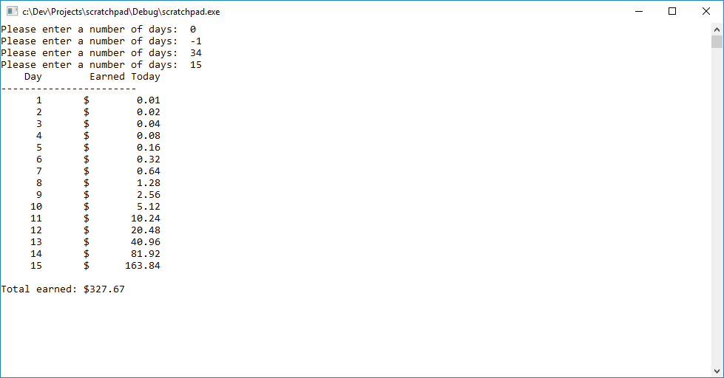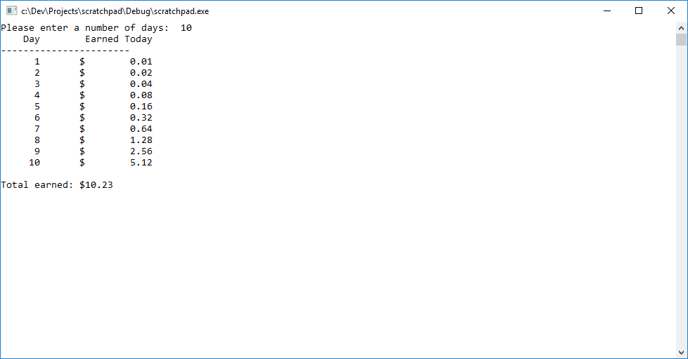

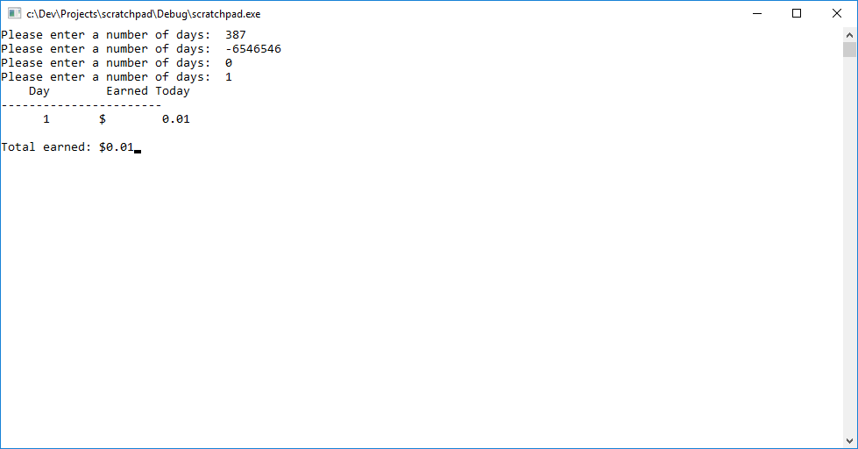

**Due Date:** According to the due date posted for the assignment folder for Lab Experience Six.

**What to hand in:**

1. Compress the word document and the .cpp file created in exercise two into a single file called yournamelab6.zip, i.e. timwrennlab6.zip. Place the compressed file into the Lab Experience Six assignment folder.
2. Hand in a print out of your word document.
3. Hand in a print outs of your programs. (i.e. printing your program from VS)