Readme Create Account and Login

A directory called Users must be created in the SERVER

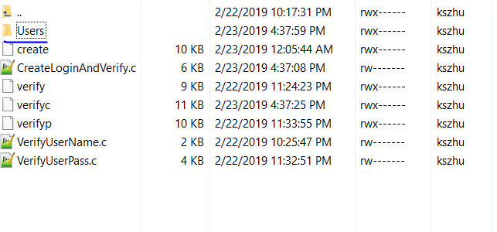

Everything else should work after that.

Important Notes;

This Code will Create:  
UserList.txt

A textfile containing all the usernames of the people

_________.txt  
 Each user will have their own textfile

Code Breakdown:

int VerifyUserName(char* username) :

Verifies Username   
Return 1 If the Username exists in the UserList.txt file   
(Located inside Users, the file does not need to be created after running the program the code will automatically create this)

int VerifyPassword(char* username, char* password):

Goes into user.txt file or creates a new text file if it doesn’t exist  
Returns 1 if correct password, or 0 incorrect password

(next page)

void AppendUser(char* username, char* password) :

Adds the username into UserList.txt

Creates a txt file for the user containing the password

Does not return anything (void)