Task Management System - Console Based
-----------------------------------------------------------------------
Introduction to Computing Project
Presented to the
Faculty of the College of Information Technology
Cagayan de Oro College
Cagayan de Oro City
-----------------------------------------------------------------------
In Partial Fulfillment
of the Requirements for the Degree
Bachelor of Science in Information Technology
-----------------------------------------------------------------------

NAME OF RESEARCHER

ANGCOY, JOHN DAVE
CRUZ, MARK KENRICK
CATIPAY, JERALD JAMES
PURISIMA, JOHN DARRYL O.
CAILO, DAVE IAN RUSSEL M.

OCTOBER 2026

Introduction
Task management is the process of recording, organizing, and monitoring tasks so that users can keep track of what needs to be done. For students, this is relevant because daily responsibilities often include assignments, projects, and deadlines. A 2025 study involving first-year college students examined future-oriented daily time-management behavior and its relationship with academic performance, supporting the importance of consistent time-management practices among student users (Zuo et al., 2025). Task-management software also commonly uses due dates and planned task information to help users organize work (Microsoft Support, 2026).
The project assumes a student setting in which students and other individuals manage tasks using memory, notes, or separate messages. Based on the approved Period 1 and Period 2 project materials, three practical problems are addressed: first, tasks can be forgotten or left out; second, deadlines and task progress can be difficult to track; and third, users may have difficulty seeing which tasks are completed and which tasks remain. These problems can make it harder to organize responsibilities and complete work on time.
The proponents developed the Task Management System - Console Based using Python as a simple console-based application for BSIT 1st Year students who need to organize academic responsibilities. The implemented system allows users to add tasks with a task name, deadline, and priority level (High, Medium, or Low); view all recorded tasks; search for tasks by name; mark tasks as completed; view a summary of total, completed, and pending tasks by priority; and view pending tasks under a selected priority. Task records are stored temporarily in a Python list while the program is running.

Statement of the Problem

General Problem
The main problem addressed by the project is the difficulty of keeping daily tasks organized and monitoring their completion. Students and individuals may forget responsibilities, lose track of what is already finished, or have difficulty knowing what still needs to be done. Without a simple task list, it can be harder to manage responsibilities consistently.

Specific Problems
- Tasks and assignments may be forgotten or not recorded in one place, making responsibilities harder to monitor.
- Deadlines and task progress can be difficult to track
- Users may have difficulty seeing which tasks are completed and which tasks remain.

Objectives of the Study

General Objective

To develop Task Management System - Console Based, a Python console-based system that enables BSIT 1st Year students to record, organize, search, and monitor academic tasks according to their deadlines, priority levels, and completion status.

Specific Objectives
- To provide a function for adding tasks by entering a task name, deadline, and priority level (High, Medium, or Low), with a default Pending status.
- To provide functions for displaying all recorded tasks, searching tasks by name, and updating a selected task's status from Pending to Completed.
- To provide a task summary showing total, completed, and pending tasks for each priority level to allow users to select High, Medium, or Low priority and view only the pending tasks under that priority.

Scope
The Task Management System – Console Based is a simple Python program designed specifically to help BSIT 1st Year students organize their daily academic tasks. It allows students to record tasks with deadlines and priority levels, search and view tasks, mark tasks as completed, and monitor progress through a summary grouped by priority.
- Users can add a task by entering its name and deadline, then selecting High, Medium, or Low priority. Each new task is stored with a Pending status.
- Users can view all currently stored tasks, including the task number, task name, deadline, priority, and status.
- Users can search for a task by entering all or part of its name. The program displays matching task details when a match is found.
- Users can select a task number and change its status from Pending to Completed. The program checks whether the selected number is valid and prevents a task that is already completed from being marked again.
- Users can view a summary of total, completed, and pending tasks for High, Medium, and Low priorities, and can filter the list to show pending tasks under a selected priority. The system uses Python lists, functions, loops, conditional statements, input, indexing, string operations, and basic arithmetic calculations.

Limitations
The final system is intentionally limited to a simple Python console-based application. Its restrictions are kept consistent with the approved project scope and the actual implemented program.
- Task records are stored only temporarily in memory while the program is running. The current program does not use a database or permanent file storage.
- The system is designed for use on a computer through the Python console and does not provide a web or mobile interface.
- The program does not automatically send notifications, reminders, or alerts about deadlines.
- The program is a simple menu-driven system and is not designed for simultaneous multi-user access.
- The current implemented version does not include task editing or deletion, permanent file/database storage, cloud storage, meetings, video calls, deadline notifications, or automatic completion of tasks.
- Task records are kept only in memory while the program is running. When the user exits the program, the recorded tasks are not saved for the next session.

System Requirements

Hardware Requirements

- Processor: Intel Core i3 or equivalent processor for running Python and the Task Management System.

- RAM: Minimum 4 GB RAM for basic programming, testing, and running the system.

- Storage: At least 100 MB of available storage for Python, VS Code, and project files.

- Monitor: 14-inch or larger monitor with 1024×768 resolution or higher.

- Input Devices: Keyboard and mouse for entering task information and selecting console menu options.

Software Requirements

- Operating System: Windows 10 .
- Programming Language: Python 3.x.
- Development Environment: Visual Studio Code.

Functional Requirements

- The user can enter a task name and deadline, select a High, Medium, or Low priority, and have the program store the task with a Pending status after validating the required inputs.
- The user can view all recorded tasks, including their name, deadline, priority, and status, and can search for a task by name.
- The user can select a task number to mark it as Completed and view a summary of total, completed, and pending tasks grouped by priority.
- The user can select a priority level to view only pending tasks in that category. The program validates menu choices and task numbers and displays an error message for invalid numeric input.

Code Snippet of Task Management System - Console Based

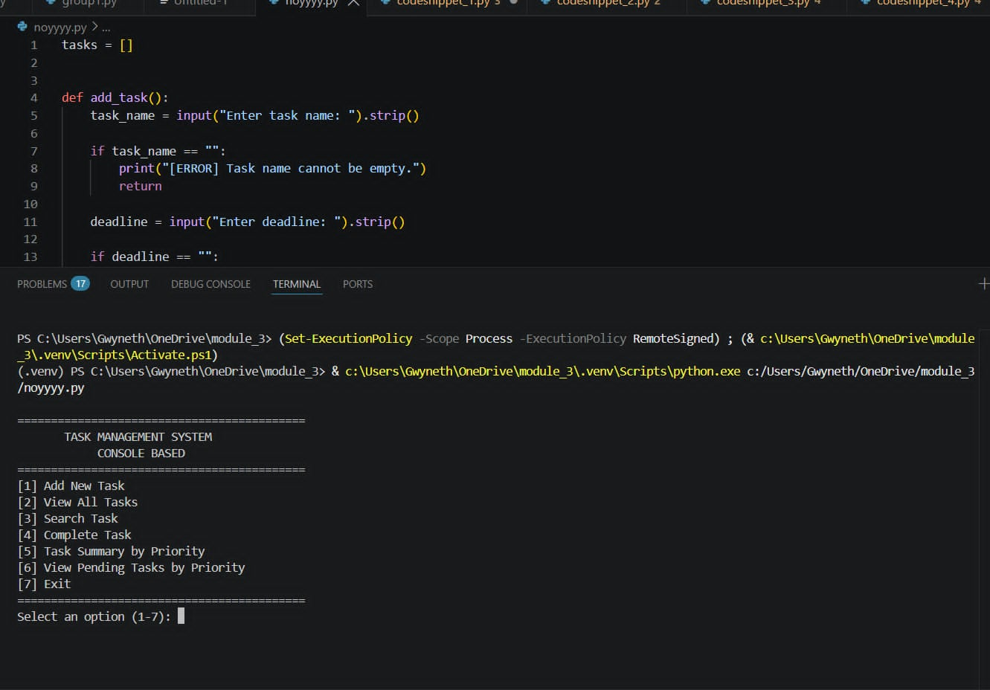

Snippet 1: Adding a New Task
Related objective: Add a task name, deadline, priority, and default Pending status.
def add_task():
task_name = input("Enter task name: ").strip()
if task_name == "":
print("[ERROR] Task name cannot be empty.")
return
deadline = input("Enter deadline: ").strip()
if deadline == "":
print("[ERROR] Deadline cannot be empty.")
return
priorities = {"1": "High", "2": "Medium", "3": "Low"}
print("[1] High [2] Medium [3] Low")
choice = input("Select priority (1-3): ").strip()
if choice not in priorities:
print("[ERROR] Invalid priority.")
return
task = [task_name, deadline, priorities[choice], "Pending"]
tasks.append(task)
print("[SUCCESS] Task added successfully.")
Explanation: This function checks that the task name and deadline are not empty, asks the user to choose a priority, and stores the task as [task name, deadline, priority, status]. New tasks start with Pending status.

Snippet 2: Viewing All Tasks
Related objective: Display each task's name, deadline, priority, and status.
def view_tasks():
if len(tasks) == 0:
print("[INFO] No tasks available.")
return
for index, task in enumerate(tasks, start=1):
print(index, task[0], task[1], task[2], task[3])
Explanation: This function checks whether the list is empty. If tasks are available, it loops through the list and displays each task with its number, name, deadline, priority, and status.

Snippet 3: Searching for a Task
Related objective: Let users search for recorded tasks by name.
def search_task():
keyword = input("Enter task name to search: ").strip().lower()
found = False
for index, task in enumerate(tasks, start=1):
if keyword in task[0].lower():
print(index, task[0], task[1], task[2], task[3])
found = True
if not found:
print("[INFO] No matching task found.")
Explanation: The function compares the entered keyword with task names without considering uppercase or lowercase letters. It displays matching tasks or a message if no match is found.

The Input, Output, and Link to the Objective

SNIPPET 1: ADDING A NEW TASK

Related Objective: Allow BSIT 1st-year students to record tasks with a name, deadline, priority, and default Pending status.

Input: The user enters a task name, deadline, and priority (High, Medium, or Low).

Processing: The function checks that the task name and deadline are not empty. It also validates the selected priority before creating a task record and storing it in the tasks list with a default Pending status.

Output: The system displays an error message if the input is invalid or a success message when the task is added.

Link to the Objective: This supports the objective of allowing students to record and organize their tasks according to their deadlines and priorities.

SNIPPET 2: VIEWING ALL TASKS

Related Objective: Allow users to view all recorded tasks, including their deadlines, priorities, and statuses.

Input: The user selects View All Tasks from the main menu.

Processing: The function checks whether the tasks list is empty. If tasks are available, it uses a loop and enumerate() to display each task's number, name, deadline, priority, and status in a formatted table.

Output: The system displays the recorded tasks in a table or shows a message stating that no tasks are available.

Link to the Objective: This supports the objective of helping students monitor their recorded tasks, deadlines, priorities, and completion statuses.

SNIPPET 3: SEARCHING FOR A TASK

Related Objective: Allow users to find specific recorded tasks by name.

Input: The user enters a task name or keyword to search for.

Processing: The function checks whether tasks are available and whether the search keyword is empty. It then compares the keyword with each task name without considering uppercase or lowercase letters.

Output: The system displays the details of matching tasks, including their deadlines, priorities, and statuses. If no match is found, it displays an informational message.

Link to the Objective: This supports the objective of helping students quickly locate recorded tasks and check their current details.

References

- Microsoft Support. (2026). Add due dates and reminders in Microsoft To Do. https://support.microsoft.com/en-us/todo/add-due-dates-and-reminders-in-microsoft-to-do

- Zuo, M., Wang, K., Tang, P., Xiao, M., Zhou, X., & Luo, H. (2025). Predicting academic performance from future-oriented daily time management behavior: A LASSO-based study of first-year college students. Behavioral Sciences, 15(9), 1242. https://doi.org/10.3390/bs15091242

