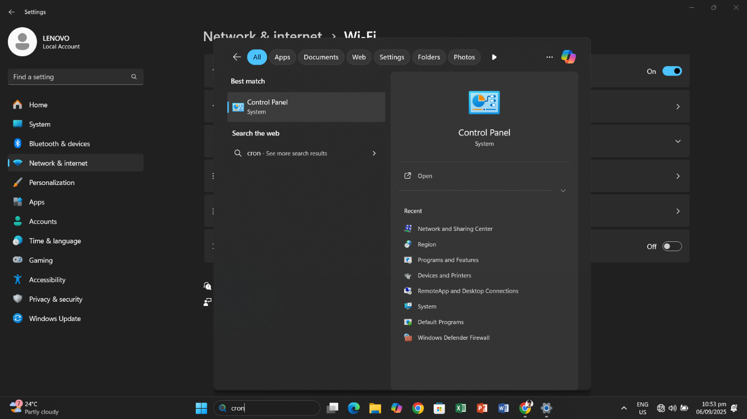

Search Control Panel
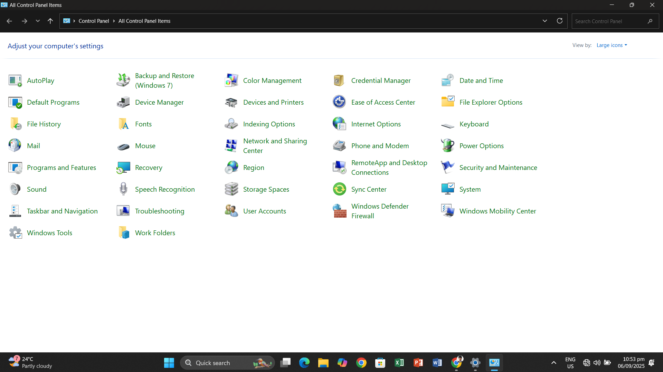
s

Open The Network and Sharing Center

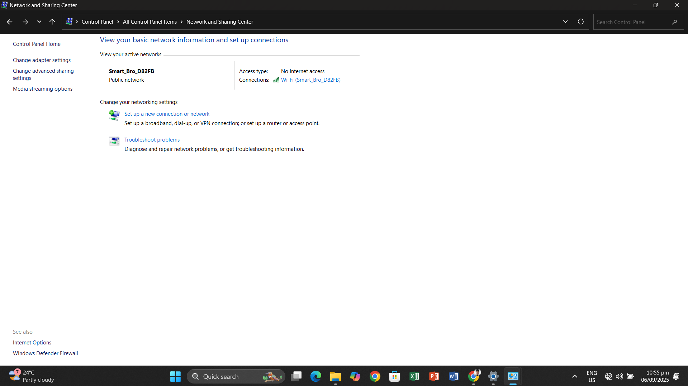

Open Windows Defender Firewall
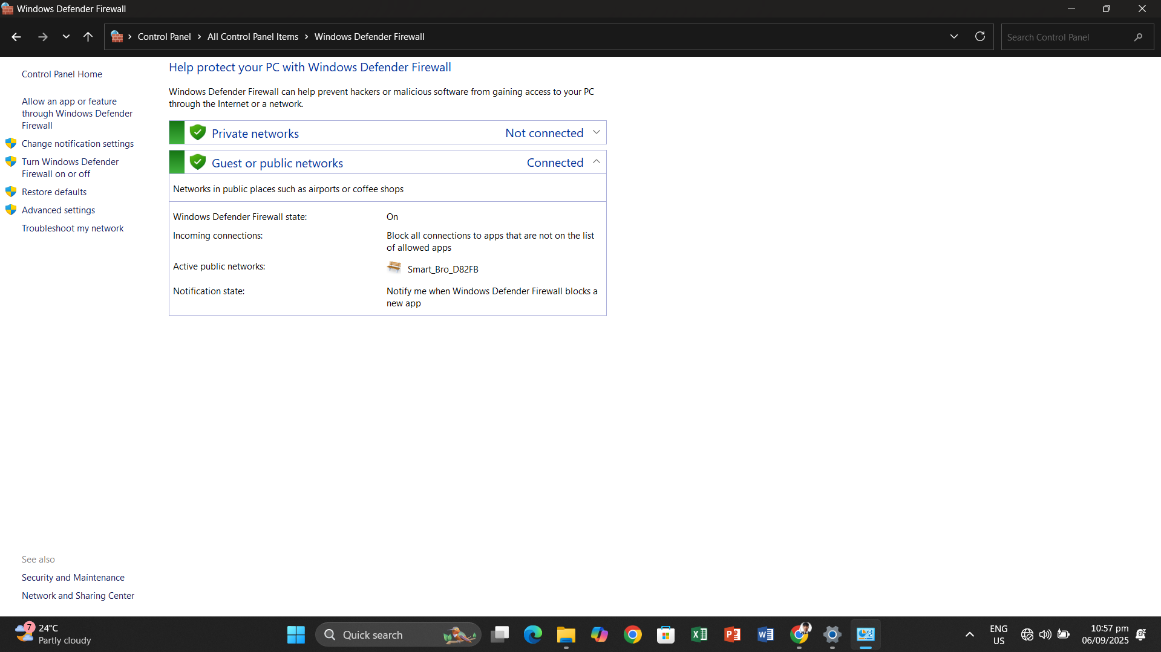
Click Turn Windows Defender Firewall on or off

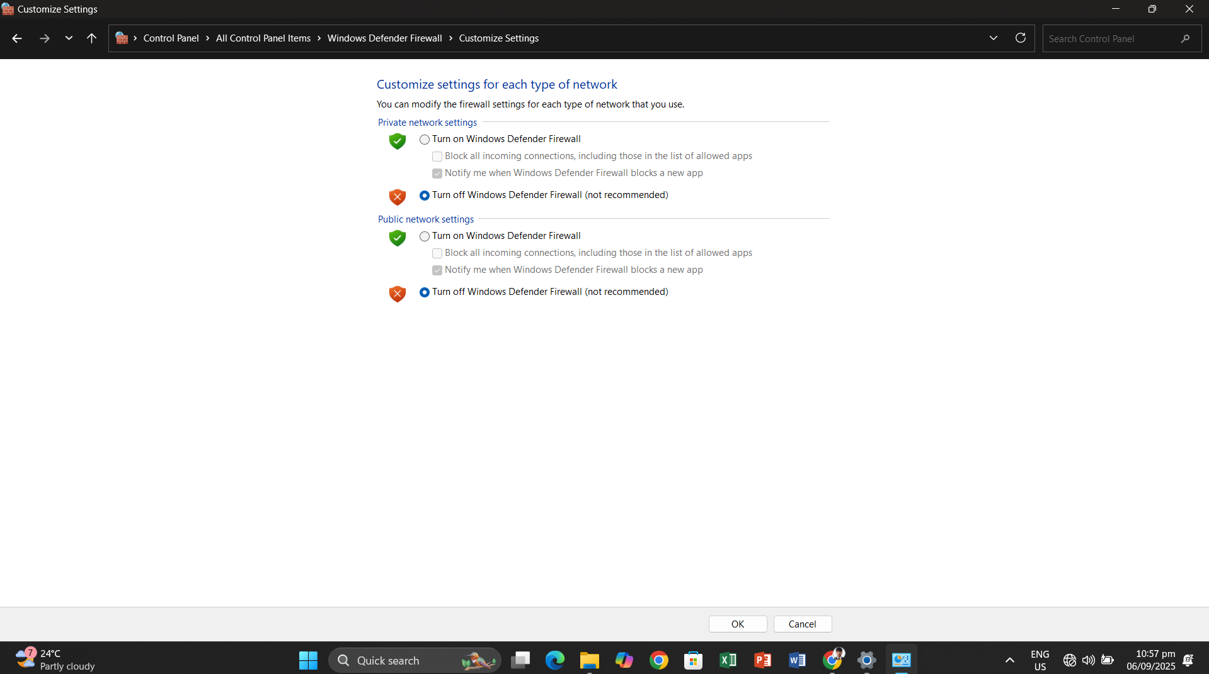

Turn OFF Windows Firewall during network setup to avoid problem on networking

Open Change Advance Sharing Settings

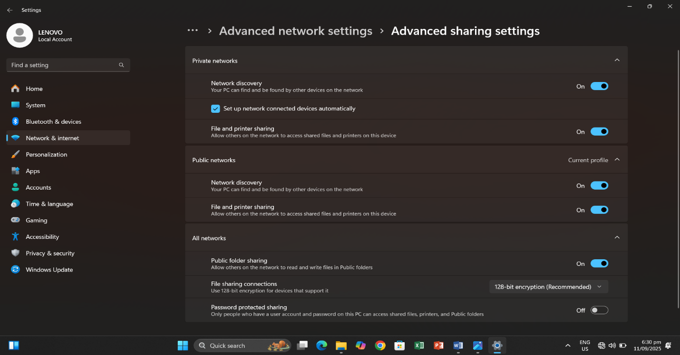

Turn on network discovery
Turn on file and printing sharing
Turn on sharing so anyone with network access can read and write files folder


Open Change Adapter Settings
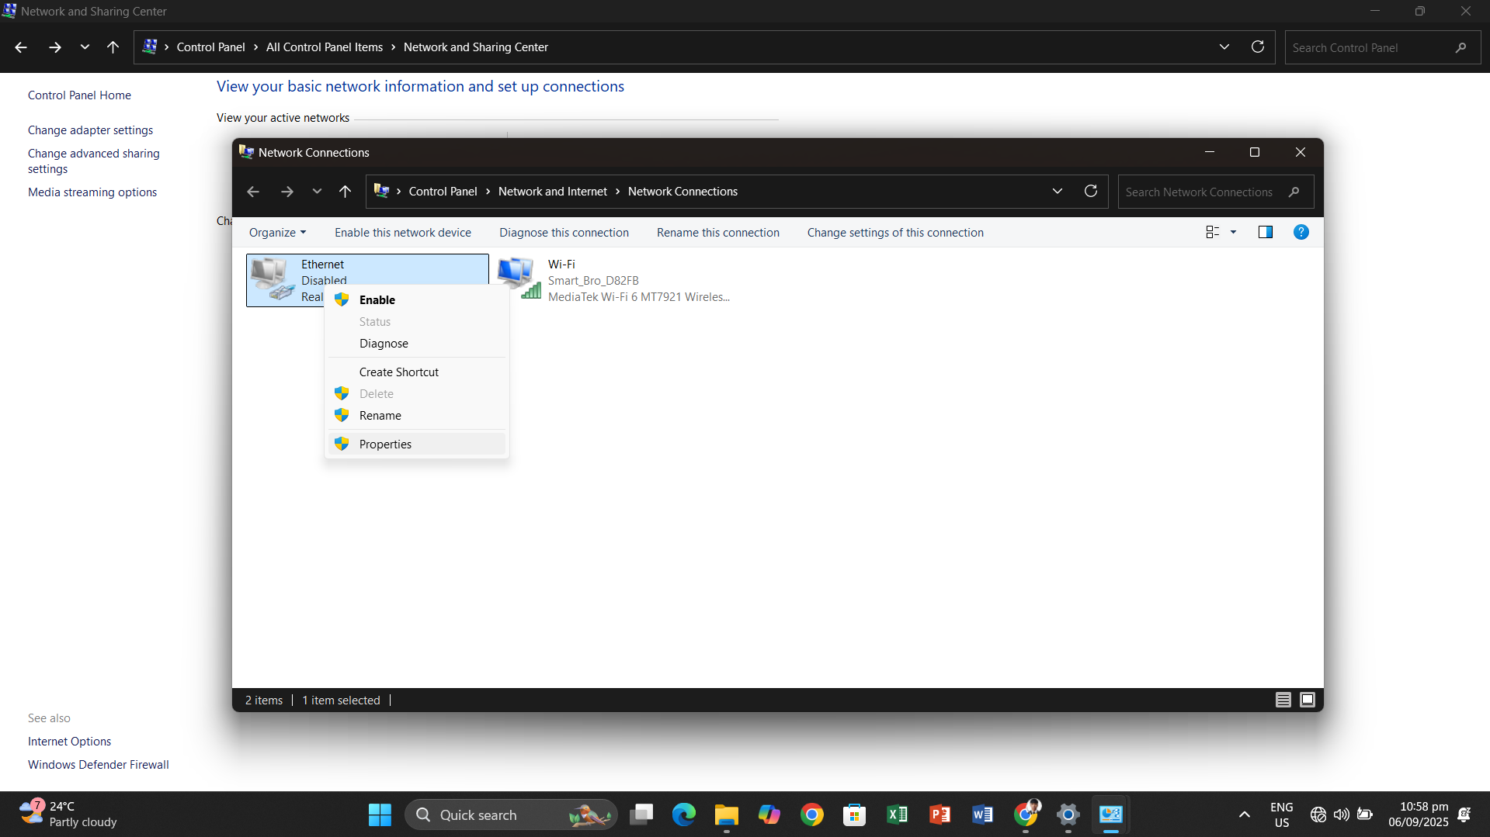

Right Click Ethernet then properties
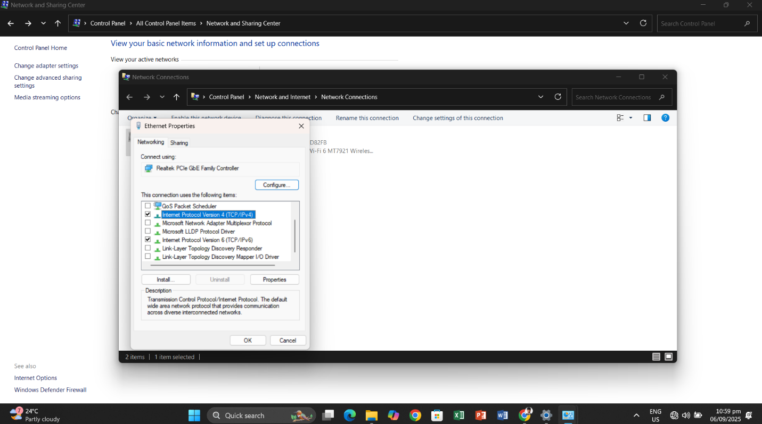

Click Internet Protocol version 4 (TCP/IPv4) then properties

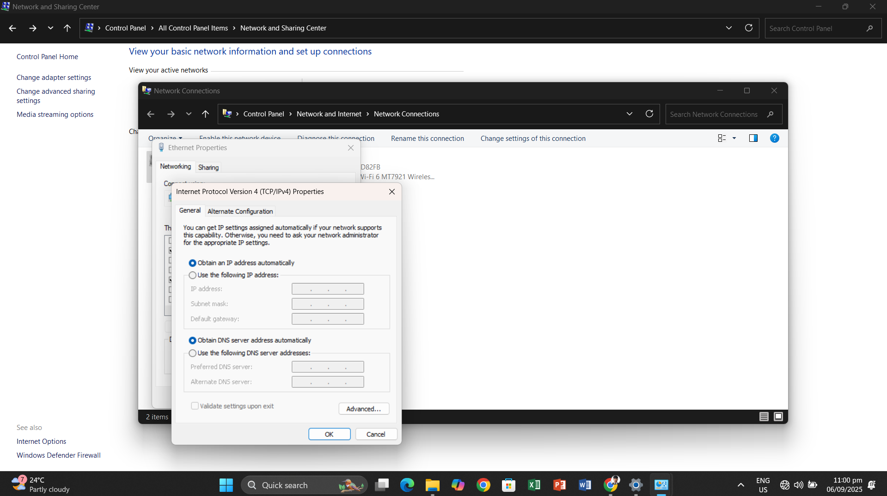

IP Address must be Obtain

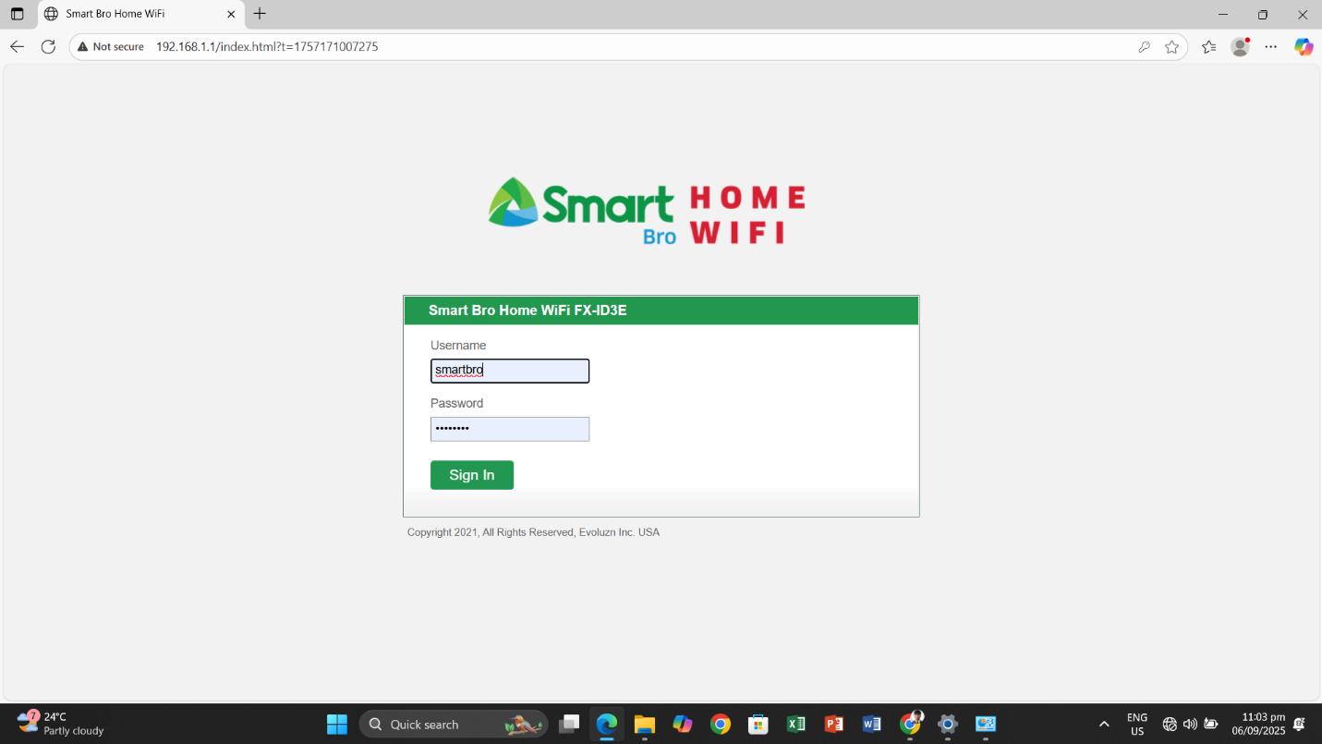

Open browser default IP add 192.168.1.1
User name : smartbro
Password : smartbro

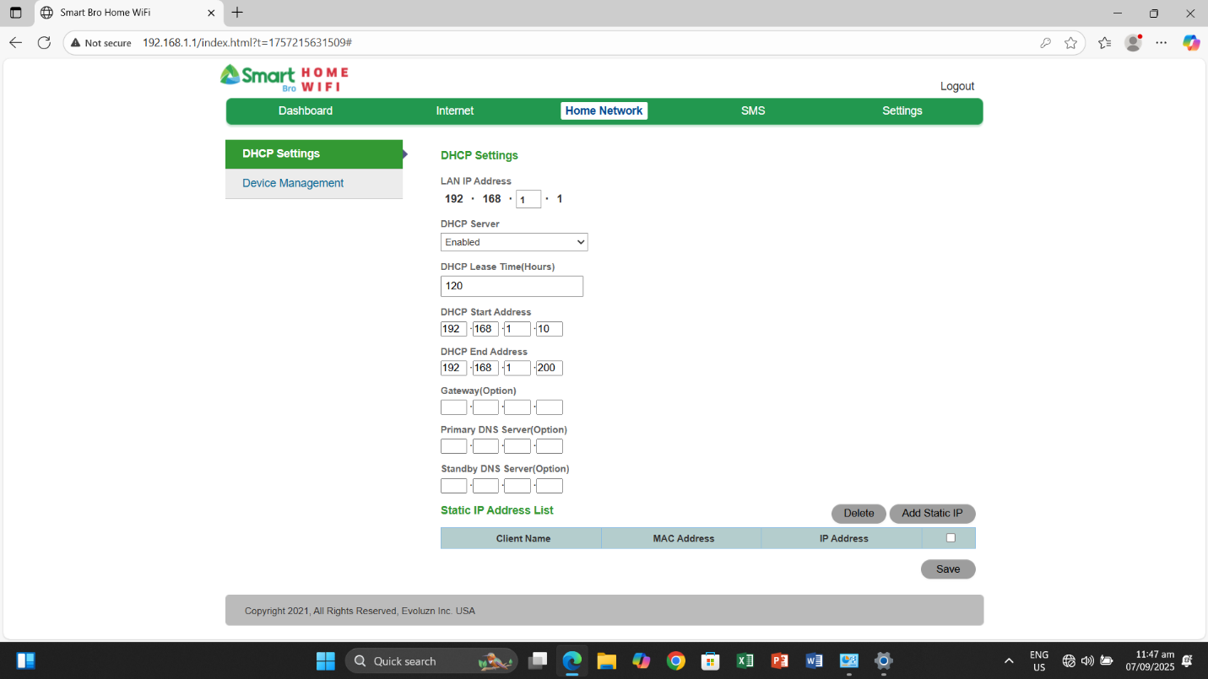

Can change IP Address depends on your server #
192.168.1.10
Subnet mask : 255.255.255.0 and enable
Then save

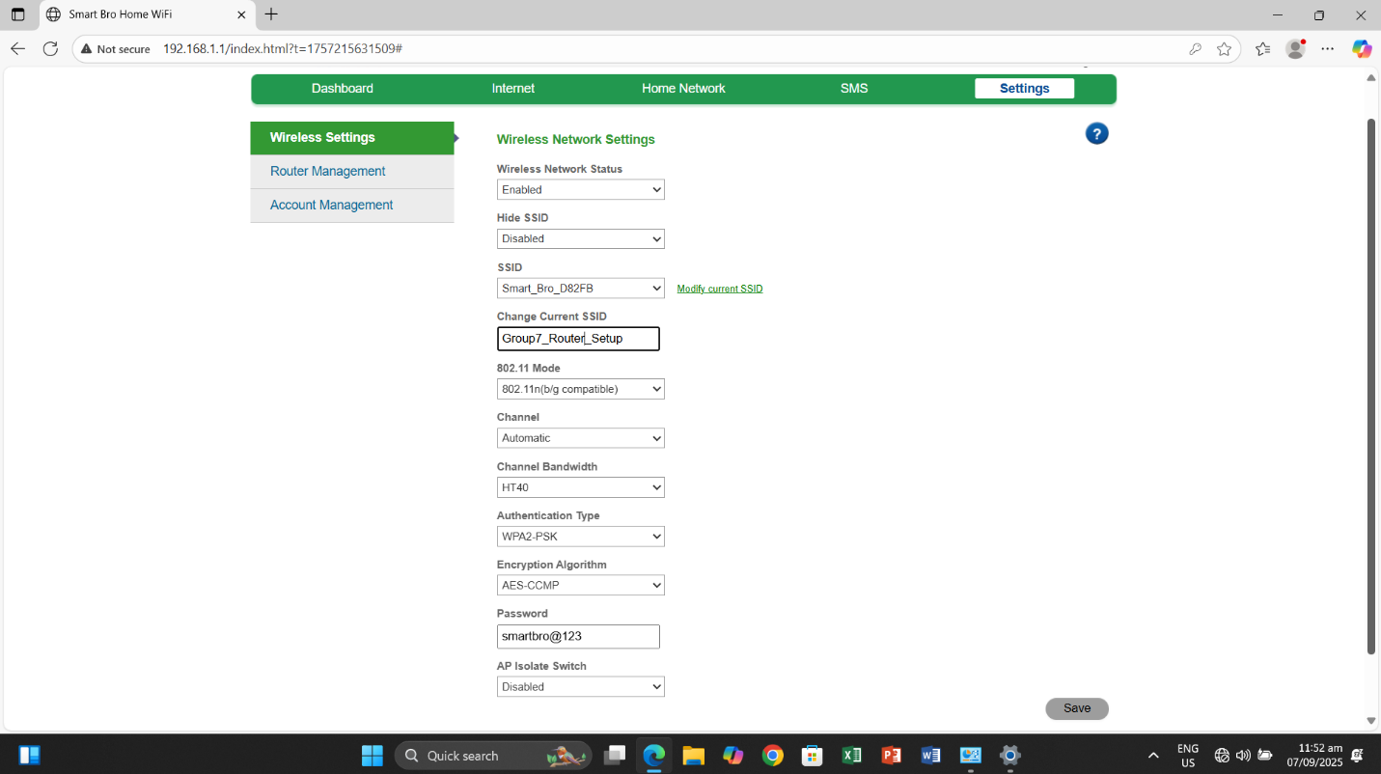
Set your own SSID / wireless network name
Set Password WPA2-PSK
Set your own password
Then save

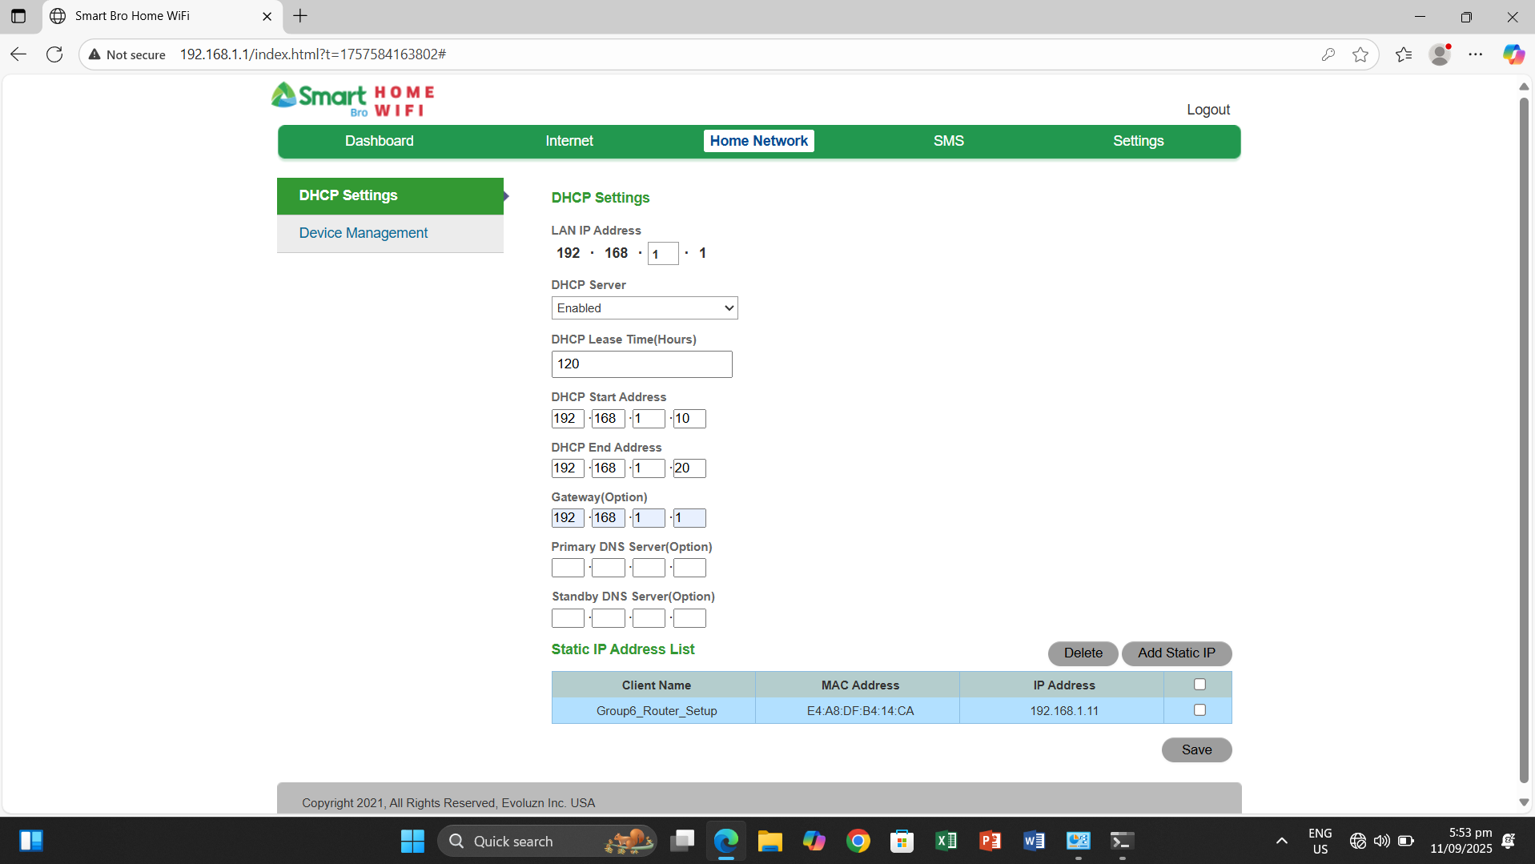
DHCP Setting depends on range
Start IP Address : 192.168.1.10
End IP Address : 192.168.1.20
Default Gateway : 192.168.1.1
Then save

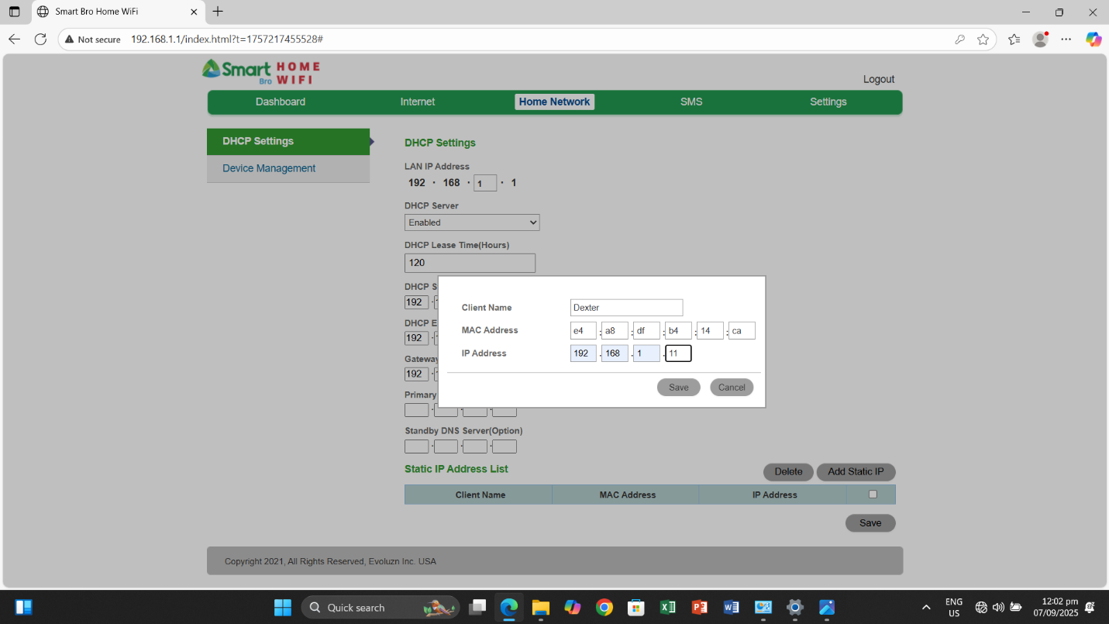
DHCP Address Reservationa for IP Addressing
Add MAC Address



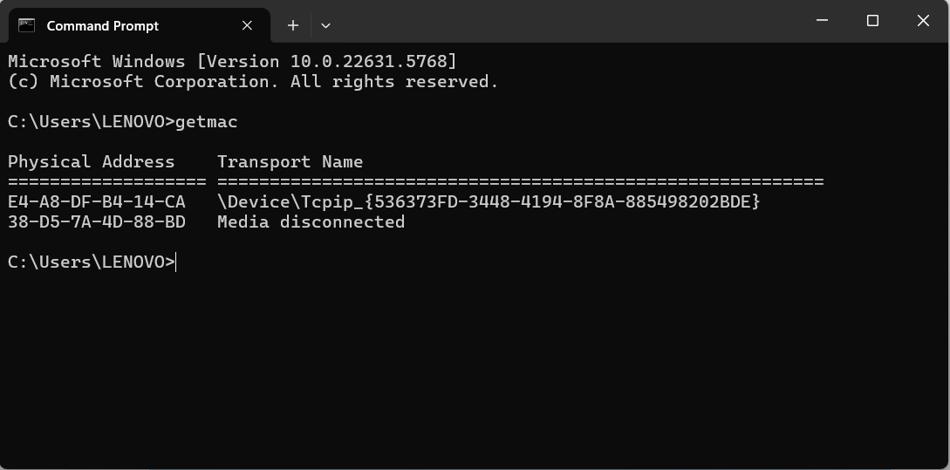

To Get MAC Address
CMD : getmac and copy MAC add
MAC Address : E4-A8-DF-B4-14-CA
Reserve IP Address : 192.168.1.11
Then enable and save

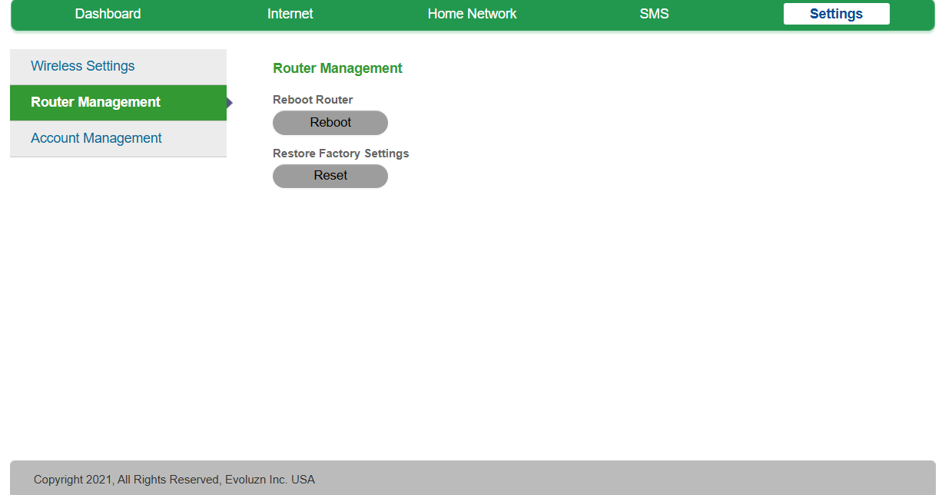
Add all MAC address of Server PC, AP,Laptop and Client and deside IP add reservations
Then Reboot to take effect on changes

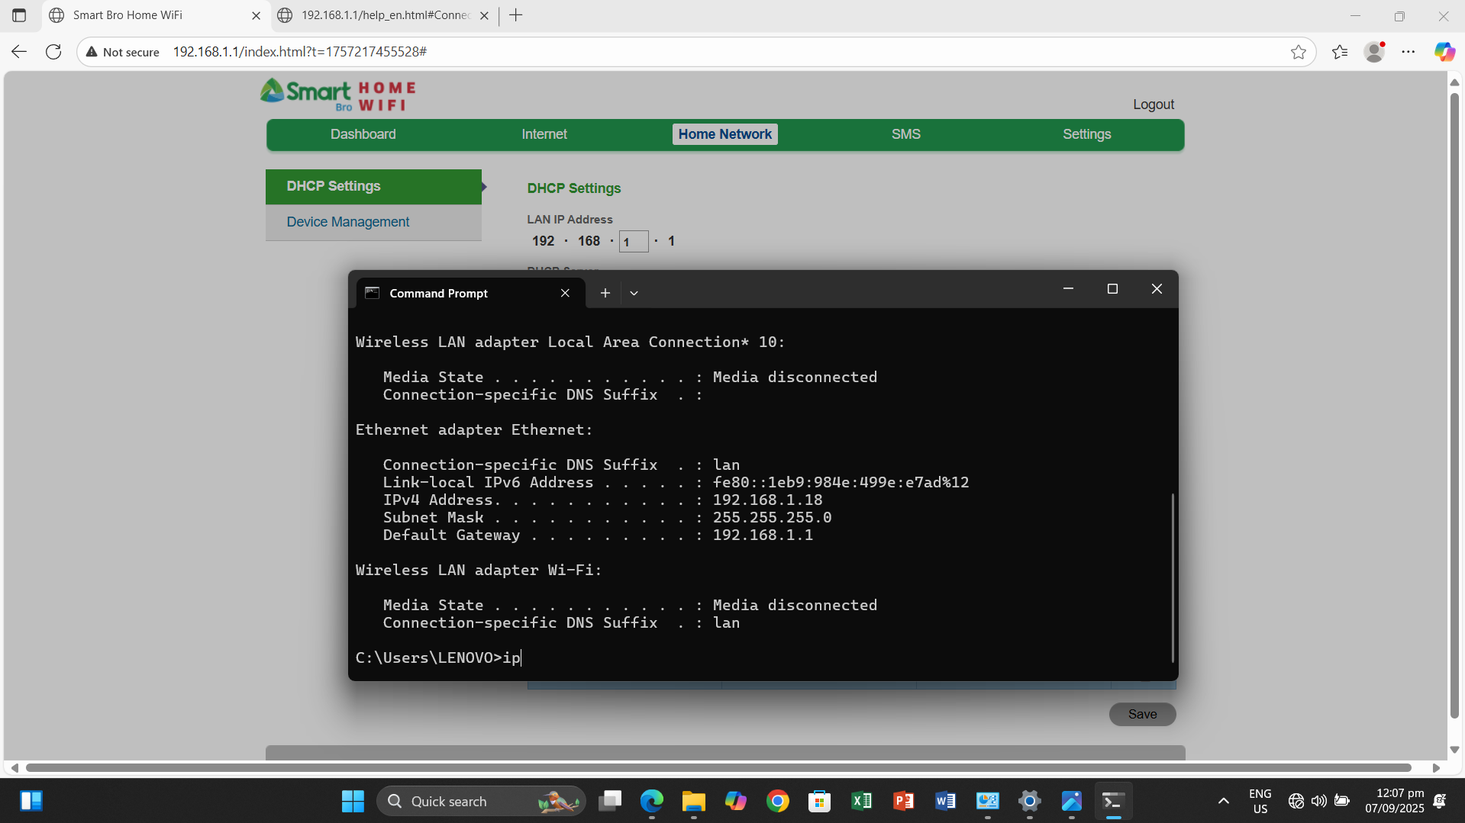

CMD : Type ipconfig then enter to see physical IP Address
Default Gateway : 192.168.1.1
Type : ipconfig/release
Then ipconfig/renew to configure your IP address
- IPv4………………………. : 192.168.1.18
- Subnet Mask ………. : 255.255.255.0
- Default Gateway…….. : 192.168.1.1

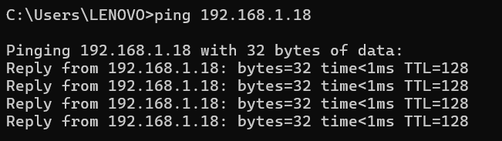

IP Address Reservation List
Server PC – 192.168.1.11
Client PC – 192.168.1.12
Laptop – 192.168.1.13
AP – 192.168.1.14
Router – 192.168.1.1

NOTE: Acesas Point (AP) same configuration on router and AP must be STATIC setup then connect to Laptop via Wifi
Then Ping all IP Add if connected to loop network topology

