" J4PWDs: An AI-Powered Web-Based Employment Platform for Persons with Disabilities in Pampanga"

IT50

by
De Jesus, Mar Vincent Y.
Evasco, John Timothy S.
Figueroa, Jio Eshua R.
Ingal, Charl Rai Ley R.
Maksuod Tolba Ahmed, Mahmood S.
Malit, Mark Joshua A.
Ocampo, Dexter S.

JOHN MARK S. POLICARPIO
ADVISER

CHAPTER I
INTRODUCTION
Technology offers impact across multiple fields that transformed the conventional practices, such as labor. Yet, even with these developments, already disadvantaged groups like Persons with Disabilities (PWDs) in the Philippines remain to be seriously constrained when it comes to accessing employment opportunities. These are especially intensified in areas like Pampanga, which is affected by socio-economic inequalities and poor infrastructure that aggravate the exclusion from the job market.
The Philippine government has legislated various laws to advance the welfare and rights of PWDs, such as Republic Act No. 7277, or the Magna Carta for Disabled Persons, which seeks to mainstream PWDs into society through rehabilitation and self-development programs. In addition, Republic Act No. 10524 requires that at least 1% of all government agency and private corporation positions employing over 100 people are reserved for PWDs to ensure equal employment opportunities. Even with these legislative initiatives, effective implementation is still lacking, and most PWDs continue to experience discrimination and limited access to appropriate employment.
To resolve these challenges, utilizing Information and Communication Technology (ICT) is an effective solution. Web-based job platforms have the potential to close the gap between employers and disadvantaged job applicants by offering easy-to-use, accessible interfaces that address the special needs of PWDs. Furthermore, integrating sophisticated recommendation systems, including context-aware collaborative filtering, can improve the personalization of job recommendations so that users are provided with appropriate opportunities that are compatible with their skills, interests, and contextual factors.
Collaborative filtering (CF) is a method applied by recommender systems to predict a user's preferences based on gathering the tastes of numerous users. It applies to the idea that where two users share common tastes, they will probably concur with other things Context-aware collaborative filtering applies the above idea with the addition of more contextual knowledge, including time, place, and factors specific to the user, to serve better and more tailored recommendations. It is especially useful in job platforms, where the relevance of job recommendations heavily depends on knowing the context of the user. Recent research has been shown to prove the effectiveness of hybrid recommendation systems that fuse collaborative filtering and content-based filtering. For example, the Smart Work Recommendation System (SWR) uses both methods to produce highly personalized job recommendations.
Collaborative filtering (CF) has become a cornerstone in the development of recommended systems, widely used in platforms such as Netflix, Amazon, and Spotify. Traditional CF algorithms base their recommendations on user-item interactions, if user preferences remain consistent across different situations. However, this assumption often overlooks the impact of context, which can significantly influence user behavior. As a result, Context-Aware Collaborative Filtering (CACF) has emerged as a refined approach that incorporates additional contextual information such as time, location, social environment, and device type into the recommendation process (Adomavicius & Tuzhilin, 2023).
Also, it influences the use of Natural Language Processing (NLP) to evaluate user proficiency and match it with job postings, as well as examining application histories and user activity to improve recommendation accuracy. Such systems can solve typical issues such as the cold start problem and data sparsity, which are traditional problems in classical recommendation models. In the Philippines, efforts to enhance web accessibility among PWDs were initiated as early as the early 2000s. The National Council on Disability Affairs (NCDA) played a pivotal role in shaping policy and coordinating actions pertaining to issues of disability. Initiatives like the "Disabled Friendly Website Awards" persuade website designers to incorporate universal access strategies, advocating accessibility on digital sites.
Nonetheless, there is still a huge digital divide, particularly in rural regions such as Pampanga, where infrastructural constraints and absence of ICT competencies among PWDs impede their online resource access. Local organizations such as the Kapampangan Development Foundation (KDF) have developed initiatives to improve the lives of PWDs in Pampanga. Among its activities, these organizations conduct prosthetic services, eye surgery, and wheel distributions, highlighting their commitment to ensuring the mobility and independence of PWDs. Upon this effort, employing employment-oriented digital solutions can even further empower the community by helping gain access to jobs. With the above challenges and opportunities in mind, this study suggests the creation of a web-based job platform specifically designed for PWDs in Pampanga. The platform will integrate context-aware collaborative filtering to make personalized job recommendations based on users' skills, interests, and contextual information. By catering to the unique needs of these underprivileged groups and utilizing cutting-edge recommendation technologies, the platform seeks to improve employment accessibility and inclusivity in the province.
PURPOSE AND DESCRIPTION
The project aims to design and develop J4PWDs: An AI-powered web-based employment platform for people with disabilities in Pampanga using Context-Aware Collaborative Filtering tailored specifically for the Province of Pampanga. The project seeks to address the long-standing issue of unemployment among these marginalized communities by creating a digital environment that supports inclusive, accessible, and intelligent job matching. By leveraging the power of web technology and personalized recommendation systems, the platform aims to bridge the gap between job seekers with unique needs and potential employers who value diversity and inclusion.
Moreover, the project anchored on the development of a user-friendly, accessible online platform where PWDs can create personal profiles, upload resumes, and receive job recommendations that are suited to their skills, preferences, location, and accessibility requirements. A key innovation of the system is the integration of a Context-Aware Collaborative Filtering (CACF) algorithm, which enhances the accuracy and relevance of job recommendations by analyzing contextual factors such as geographic location, user behavior, device accessibility settings, and job market trends.
Furthermore, the proposed system is intended to administer different needs of the following entities:
- Job Seeker
- Employer and other Stakeholders
The platform provides potential game changer to elevate the employment capacity of the PWDs in the province of Pampanga.
OBJECTIVES OF THE STUDY
In general, the capstone project aims to develop a context-aware web-based employment platform that effectively connects PWDs in Pampanga with suitable job opportunities, using personalized recommendation technologies to improve employment outcomes and digital inclusion. Specifically, the capstone project aims to achieved the following:
- To design a web system that showcases job posting which tailored fit to the specific needs of PWDs.
- To develop a system that provides platform allowing collaboration among local stakeholders in job postings and promote inclusive hiring practices within Pampanga’s labor market.
- To integrate a Context-Aware Collaborative Filtering algorithm into the platform to provide personalized job recommendations based on user profiles, contextual data, and behavior patterns.
- To evaluate the usability of the platform using ISO 9241-11 with the following criteria:
- Effectiveness,
- Efficiency, and
- Satisfaction.
SIGNIFICANCE OF THE STUDY
The proposed system is significant for several sectors of society, especially in promoting inclusive economic participation and technological implementation. The system addresses long-standing barriers faced by marginalized groups in accessing equitable employment opportunities and represents a step toward social innovation in labor market systems. The proposed system will cater the needs of the following entities.
Persons with Disabilities (PWDs). This study holds the promise of improving their visibility in the labor force through a system that respects accessibility needs, offers user-friendly interfaces, and delivers job recommendations tailored to their skills and contextual challenges. The integration of assistive technologies and inclusive design principles ensures that the platform is usable by individuals with visual, auditory, cognitive, and mobility impairments.
Employers and local stakeholders. The platform encourages inclusive hiring practices, improves talent discovery among marginalized sectors, and strengthens collaboration between employers and local support networks. By facilitating direct interaction between job providers and seekers, it supports economic development while fostering corporate social responsibility.
Government. The system offers data-driven insights into the employment patterns and needs of underrepresented groups. These insights can inform local labor policies, training programs, and inclusive workforce strategies tailored to the needs of PWDs and IPs. The study also aligns national and international goals for inclusive development.
Future researchers. The study contributes to the growing body of knowledge on inclusive digital systems, context-aware recommendation algorithms, and socially driven technological innovation. It demonstrates how collaborative filtering, and adaptive systems can be applied to real-world social issues, serving as a model for future ICT-based inclusion projects.
SCOPE AND LIMITATIONS
This project focuses on the design, development, and initial deployment of a web-based employment platform specifically tailored for Persons with Disabilities (PWDs) residing in the Province of Pampanga. The primary goal of the platform is to address the employment gap experienced by these marginalized groups by providing a digital space where job seekers can create profiles, access job opportunities, and receive intelligent, personalized recommendations through the integration of a Context-Aware Collaborative Filtering (CACF) system.
The platform will include key features such as user registration, resume upload, job application tracking, and a job recommendation engine that factors in user context such as skills, location, device type, and accessibility needs. Additionally, it will be designed with inclusive features like screen reader compatibility, simplified navigation, and support for local dialects to ensure usability among diverse users.
The scope of the study includes the development and evaluation of the platform with a selected group of PWDs in Pampanga, as well as collaboration with local employers, non-government organizations, and government units. Technologies to be used include web development, a relational database for storing job and user data, and machine learning techniques to implement the collaborative filtering algorithm. The project also involves conducting usability tests to assess platform effectiveness.
However, the project has several limitations. Geographically, the platform is limited to users within Pampanga during its initial phase, and expansion to other regions would require further resources and development. In addition, some intended users, in remote areas, may lack internet access or the digital literacy required to navigate the platform effectively. The success of the job-matching feature also depends heavily on employer participation, and limited job postings in the early stages may affect the performance of the recommendation engine. However, with the efforts made to include accessible design elements and language support, the platform may not fully accommodate all disability types or indigenous languages at the outset. Also, the system will be able to register for an account, build professional profiles, upload resumes, and apply to job postings tailored to their skills and specific disability profiles as individual job seekers. Employers, on the other hand, can create company profiles, post vacancies, search and filter applicants, and manage incoming job applications. A core feature of the system includes a built-in matching function that aligns job offers with the qualifications and accessibility needs of registered PWD applicants.
Furthermore, it does not guarantee job placement and solely functions as a medium to connect applicants and employers. The system is based on widely used assistive technologies but may not address all disability types or rare software. Lastly, the platform does not manage employment negotiations, contracts, or legal documentation.
CONCEPTUAL FRAMEWORK
The conceptual framework of the study is anchored on the Input-Process-Output (IPO) Model, which illustrates the systematic approach in developing the J4PWDs: An AI-Powered Web-Based Employment Platform for Persons with Disabilities using Context-Aware Collaborative Filtering for the Province of Pampanga.
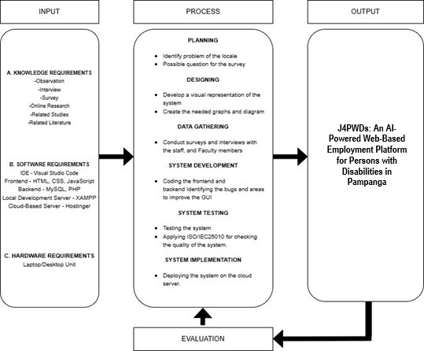
Figure 1: Paradigm of the Study
Figure 1 illustrates the three main phases of the IPO. First, the Input Phase encompasses all the necessary requirements to initiate the development process. It includes Knowledge Requirements gathered through observations, interviews, surveys, online research, related studies, and literature that provide the foundational understanding of the problem domain and user needs. The Software Requirements consist of development tools such as Visual Studio Code for coding; frontend technologies like HTML, CSS, and JavaScript; backend tools including MySQL and PHP; as well as server environments like XAMPP for local development and Hottinger for cloud deployment. The Hardware Requirements include the use of laptop or desktop computers for development, testing, and deployment purposes.
Second, the Process Phase outlines the series of methodological steps taken to transform the input into the final product. It begins with Planning, which involves identifying the specific problems and formulating survey questions tailored to the local context. In the Designing stage, the system’s structure and user interface are visualized through diagrams and wireframes. Data Gathering follows, where surveys and interviews are conducted with key stakeholders such as staff and faculty to validate user requirements. The System Development step involves coding both the frontend and backend components, with continuous bug tracking and user interface improvement. Once developed, the system undergoes ISO 9241-11, a framework for understanding and applying usability principles which includes ensuring effectiveness, efficiency, and satisfaction. Finally, in the System Implementation stage, the platform is deployed on a cloud-based server to make it accessible to its intended users.
Third, the Output Phase concludes the entire process by implementing the web-based employment platform specifically designed for PWDs in Pampanga. The platform features personalized job-matching capabilities powered by Context-Aware Collaborative Filtering, ensuring that recommendations are tailored to the users’ skills, preferences, and environmental context. It is developed to be accessible, inclusive, and aligned with local employment needs.
Lastly, the conceptual framework also includes a feedback loop through an Evaluation component, where system performance, usability, and user satisfaction are assessed. This allows continuous improvement of the platform based on real user feedback and system performance metrics.
DEFINITION OF TERMS
Collaborative Filtering. A recommendation technique that predicts user preferences based on similarities between users or items. This is used in the system to analyze user behavior and make job recommendations based on similar users' actions and interests.
Context-Aware Collaborative Filtering (CACF). A machine learning-based recommendation approach that combines traditional collaborative filtering with additional contextual information (e.g., user location, skills, job preferences, and accessibility needs) to generate personalized job suggestions. It is the core technology used to recommend suitable job openings to users of the platform.
Digital Divide. The gap between individuals who have access to digital technologies and those who do not. This study seeks to narrow the digital divide experienced by PWDs in Pampanga by improving access to online employment tools.
Employment Platform. An online portal designed to host job listings, candidate profiles, and application processes. This platform is customized to support inclusive job matching for PWDs in Pampanga.
Job Matching. The process of connecting job seekers with appropriate job listings based on their qualifications, preferences, and contextual information. The platform automates this process using CACF.
Job Seeker. A registered user of the platform who is actively looking for employment. In the context of this project, job seekers are limited to PWDs within Pampanga.
Local Government Units (LGUs). Government entities within Pampanga may support platform implementation and outreach. In this project, LGUs are considered stakeholders for community mobilization and policy integration.
Persons with Disabilities (PWDs). Individuals who have long-term physical, mental, intellectual, or sensory impairments which, in interaction with various barriers, may hinder their full and effective participation in society. In this project, PWDs are the primary beneficiaries and users of the system.
Stakeholders. Individuals or groups who have an interest or role in the development, implementation, or success of the platform. This includes PWDs, employers, LGUs, NGOs, and community leaders.
User Interface (UI). The graphical layout and interactive components of the platform that users engage with. For this project, the UI is designed to be accessible, simple, and user-friendly for individuals with various abilities and backgrounds.
User Profile. A digital record within the platform containing information about a user's demographics, skills, disability status, preferences, and job search behavior. This data is crucial for personalized job recommendations.
Web-Based Platform. A digital system accessible through a web browser that allows users to interact with employment-related features such as job searching, profile creation, and application tracking. In this study, the platform serves as the main medium connecting job-seeking PWDs with employers.

CHAPTER II
REVIEW OF RELATED LITERATURE
The studies and literature that served as the foundation for the suggested system were presented in this section. The researchers presented the review by identifying different areas related to the proposed system.
RELATED LITERATURE
The development of employment platforms designed specifically for Persons with Disabilities (PWDs) has become an important area of focus in recent literature, particularly considering increasing awareness around equity, diversity, and inclusion. In the study of Sharma et. al (2023) explored how ableism continues to negatively impact employment opportunities for PWDs across different job sectors and disability types. The study emphasized the need for inclusive design approaches in employment platforms to mitigate these barriers and promote more equitable access to work. Supporting this, a study conducted by Jurado-Caraballo and Quintana-García (2024) examined the broader implications of hiring PWDs, revealing that companies benefit from improved performance and enhanced public reputation when they implement inclusive employment practices. These findings suggest that beyond ethical obligations, inclusive employment platforms also present practical advantages for both users and employers.
Furthermore, a study of Alajmi et. al (2025) supported the employment for people with developmental disabilities emphasized the importance of user-centered design and long-term support systems in digital employment services. This research reinforces the necessity of including PWDs in every stage of platform development to ensure that their needs are genuinely addressed. Taken together, these studies suggest that employment platforms should be designed with a multidimensional approach and direct engagement with the communities being served. By doing so, such platforms can bridge long-standing employment gaps and support a more inclusive and equitable labor market.
In the Philippines, the integration of Persons with Disabilities (PWDs) into the labor market has been a focal point of various studies and initiatives. However, many PWDs continue to face significant employment challenges. A policy brief highlighted that many PWDs remain unemployed due to misconceptions about their capabilities and the lack of inclusive hiring practices (Pedron, 2024).
In addition, the rise of digital platforms has offered new avenues for employment. Remote work has been beneficial for PWDs, providing flexibility and reducing physical barriers associated with traditional workplaces. However, challenges such as access to reliable internet and appropriate technology persist, especially in rural areas (Pagsolingan, 2024).
Despite these efforts, social protection coverage for vulnerable groups has declined. The 2025/2026 Philippines Labor Market Profile noted a decrease in the population covered by social protection benefits, highlighting the need for more inclusive policies.
RELATED STUDIES
Recent advancements in digital technology have significantly influenced the development of inclusive employment platforms, particularly for marginalized groups such as Persons with Disabilities (PWDs). A notable initiative is the "Workability" platform, designed to support individuals with intellectual disabilities in India. This digital platform emphasizes user-friendly interfaces and tailored job recommendations, facilitating better employment opportunities for its users (Madan et. al, 2024).
In the realm of recommendation systems, context-aware collaborative filtering has emerged as a pivotal technique. Azri and colleagues developed a context-aware job recommender system that integrates collaborative filtering, content-based methods, and matrix factorization to enhance job matching accuracy. Similarly, a study by Hameed and Hassan introduced a context-aware recommendation system employing effective contextual pre-filtering, which significantly improved the relevance of job suggestions by considering various user contexts (Hameed & Hassen, 2025). However, addressing the employment challenges faced by Indigenous communities, the article published by Minderoo Foundation (2022), the Australian Indigenous Employment Index provided insights into the employment experiences of First Nations Peoples. The report highlighted systemic barriers and proposed strategies to enhance employment outcomes for Indigenous populations. Complementing this, the World Bank's initiatives have focused on promoting Indigenous Peoples' development by ensuring that projects respect their cultural identities and provide meaningful employment opportunities.
The integration of artificial intelligence (AI) in employment platforms has also shown promise. A study presented a Context-Aware Multi-Criteria Group Recommender System (CA-MCGRS) that addresses challenges in group settings by integrating contextual factors and multiple criteria, thereby enhancing recommendation accuracy. Additionally, the Udyog Saarthi App aims to empower adults with disabilities by offering a tailored web platform for job coaching, skill development, and employment support, showcasing the potential of AI-driven platforms in facilitating employment for PWDs (Luyen & Abel, 2023).
The digital divide remains a significant concern, especially for marginalized groups. The Global Disability Inclusion Report emphasized that while the digital economy offers new job opportunities, there is a risk of exacerbating existing inequalities if accessibility is not prioritized in digital platforms. Furthermore, studies have shown that people with disabilities have benefited from expanded work-at-home opportunities, highlighting the importance of flexible work arrangements in promoting inclusive employment (Murphy and Thomas, 2024).
Also, several studies have demonstrated the superiority of CACF over traditional CF. For example, Baltrunas et al. (2011) highlighted the effectiveness of contextual modeling in tourism recommendation systems, where user preferences are highly sensitive to temporal and situational factors. Similarly, Zheng et al. (2010) employed context in mobile location-based services to recommend relevant activities based on current user surroundings and weather conditions, showing improved recommendation precision.
Researchers have proposed various techniques to integrate context into CF models. One approach is pre-filtering, where context is used to select relevant data before applying traditional CF algorithms. Another is post-filtering, which adjusts the recommendations after standard CF processes. More sophisticated methods, such as contextual modeling, embedding context directly into the model using tensor factorization, matrix factorization with contextual bias terms, or neural network-based architectures (Karatzoglou et al., 2010; He & Chua, 2017).
The emergence of deep learning has further propelled CACF research. Models like DeepFM and neural collaborative filtering (NCF) have been adapted to incorporate contextual embeddings, allowing systems to learn non-linear interactions among users, items, and contextual dimensions. For instance, Hidasi et al. (2015) demonstrated that recurrent neural networks (RNNs) can effectively capture sequential context in session-based recommendations.
Despite its promise, CACF faces challenges related to data sparsity, high dimensionality, and the cost of acquiring accurate contextual data. Nonetheless, with the growing ubiquity of sensors, smartphones, and user tracking technologies, the availability of rich contextual data continues to improve, making CACF a critical area for innovation in personalized recommender systems.
In summary, the reviewed studies underscore the importance of developing inclusive, context-aware employment platforms that leverage advanced technologies like AI and collaborative filtering. Such platforms should be designed with a deep understanding of the unique challenges faced by PWDs, ensuring accessibility, cultural sensitivity, and relevance to local contexts. These insights are instrumental in guiding the development of the proposed web-based employment platform for PWDs in the Province of Pampanga.
SYSTEM TECHNICAL BACKGROUND
The development of the proposed system was rooted in the needs to have a web-based platform in the Region. Leveraging the advancements in web technology, J4PWD aims to provide a user-friendly platform that enables PWDs to develop and implement the Employment Platform.
The development of J4PWD involves utilizing modern programming languages and frameworks. The application integrates with web services to accurately manage effective record retrieval. The researchers used different development tools such as:
MySQL. The proposed system uses databases to save recent transaction and user’s information and data from the user and Department of Agriculture office. The tool allows the application to store data through online databases using MySQL to manage transaction and effectively retrieved data, share information, upload crop status, and communicate effectively.
PHP. The proposed system management module was developed using the Web-Based platform. To create the module, the researchers used PHP as the based language for the integration of back-end data processing and transactions.
Context-Aware Collaborative Filtering. The proposed system will incorporate a Context-Aware Collaborative Filtering (CACF) recommendation engine with Traditional collaborative filtering techniques that recommend items (in this case, jobs) to users based on the preferences and behaviors of similar users. In this project, the CACF system will operate in the background to analyze data collected from user profiles, job applications, and interactions on the platform.

CHAPTER III
METHODOLOGY OF THE STUDY
In this section the researcher identifies the different methodology that will be use in the capstone project.
RESEARCH METHODOLOGY
In this section, the researchers presented the methodology that will be used in development of the proposed system. The researchers presented research design, the research instrument, the data gathering procedure, the methodology in developing the proposed system, and the evaluation criteria in evaluation of the proposed system.
RESEARCH DESIGN
The researchers will employ a descriptive research design to describe the current state of employment accessibility and inclusivity for Persons with Disabilities (PWDs) in the Province of Pampanga. The descriptive method enables the researchers to gather quantifiable information, observe patterns, and measure changes before and after the implementation of the proposed system. The researchers will evaluate the existing and proposed system using a survey questionnaire among the respondents. Finally, they analyzed and presented the collected data to determine the extent to which the project’s objectives were achieved.
SOFTWARE DEVELOPMENT METHODOLOGY
A system development methodology guides the development of a system. it contains a collection of procedures, techniques, tools, and documentation aids. According to itinfo.am (n.d), a software development methodology is a software development framework used for planning. Build and control the process of building information systems.
AGILE DEVELOPMENT METHODOLOGY
Agile Software Development is a conceptual framework for building information systems. These methodologies such as Scrum, Crystal methods and Dynamic systems development model has the ability to manage changing priorities particularly in improving project visibility, and increasing productivity (VersionOne.com, 2012). Scrum was the most consistent framework which belongs to agile type of methodologies.
Furthermore, Pelclova (2014) pointed out that agile methodologies are introduced to offer a better setting for software development, in which frequent feedback, incremental work, and adaptation to change are embraced. According to guru99.com, agile methodology promotes synchronized development and testing throughout the software development lifecycle. In addition, Malek et al. (2017) specified that agile software design and development methodologies are receiving immense responsiveness in the software development research community since their early introduction in the mid-nineties in addition of becoming highly adopted by the system development industry adopted by the software development industry.
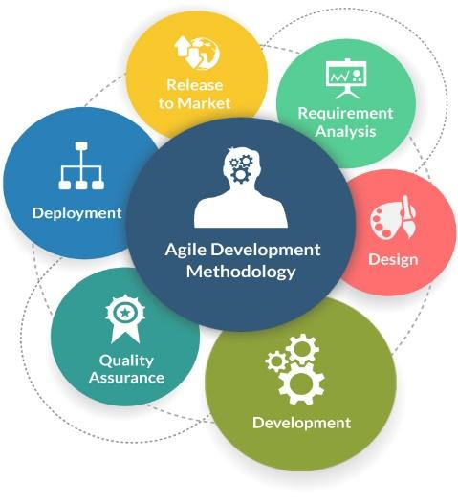
Figure 3. Agile Development Methodology
Figure 3 shows the Agile Development Methodology composed of requirement analysis, Design, Development, Quality Assurance, Deployment and Release to Market.
REQUIREMENT ANALYSIS
Requirements of the system developed are considered and documented in a requirement specification document. The researchers started to gather information about the system. Then, the researcher conducted an interview together with a survey and lastly the researchers started brainstorming.
DESIGN
In the first stage the requirement specifications were examined, and the system design was prepared. System Design helps the researchers to identify hardware and software system requirements and helps in outlining overall system architecture. In this stage, the researchers start making the design for the modules of the system and the creation of Entity Relationship Model, Context Diagram and Data Flow Diagram.
DEVELOPMENT
The result from system design is implemented and used to develop small units of programs or sub-systems, which are implemented in the next stage. Each unit was developed and examined for its functionality which is known as Unit Testing. The researchers choose a specific programming language and other tools to develop the application.
QUALITY ASSURANCE
Programs created in the development stage are combined into a system and tested to ensure the quality for any possible faults and failures. The researchers need to plan and follow a systematic implementation of activities within the quality system that can be established to provide assurance that the system will function according to its intended purpose.
DEPLOYMENT
Once the evaluation is done, such as functional and non-functional examination, the system will be released into the market. In this stage, the system will be deployed to the locale that can be used by the Job seekers.
RELEASE TO MARKET
In this phase, the application will be released to the market so they can test and enjoy the functions of the system specifically the Mobile Application. The system will also be tested to assess the functionality and reliability of the system. The following are different testing procedures to be conducted by the researchers through the help of some experts to check, detect errors and evaluate the system. It includes integration testing, unit testing, acceptability testing and system testing.
REQUIREMENTS ANALYSIS AND DOCUMENTATIONS
To fully develop the system according to its intended purpose, the researchers need to identify the different analysis and specifications needs for the development of the application.
CONTEXT DIAGRAM
Context diagrams depict the interactions between an internal software system and external entities. Its main purpose is to assist users in comprehending the extent of a system. It can determine the most effective way to build a new system and its specifications or how to enhance an existing system. Furthermore, the graphics are high-level and do not explore the specifics of the system. Rather, it represents a system in an understandable, straightforward manner (Miro, n.d).
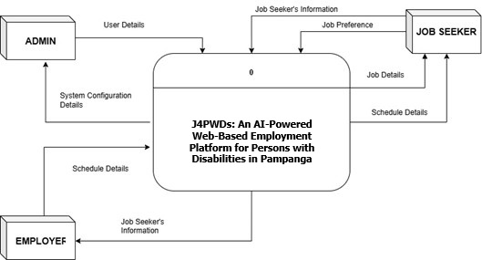
The researchers used Context diagram to initially identify the boundaries of the proposed system. It creates understanding from the entities involved and the initial data produced by each entity.
DATA FLOW DIAGRAM
According to Lucidchart (n.d), offer insights into the flow of information within a process or system. They utilize specific symbols like circles, arrows, rectangles, tables, outputs, and storage points to depict data inputs, outputs, and routes. DFDs contribute to a better understanding and increased knowledge of how data is managed.
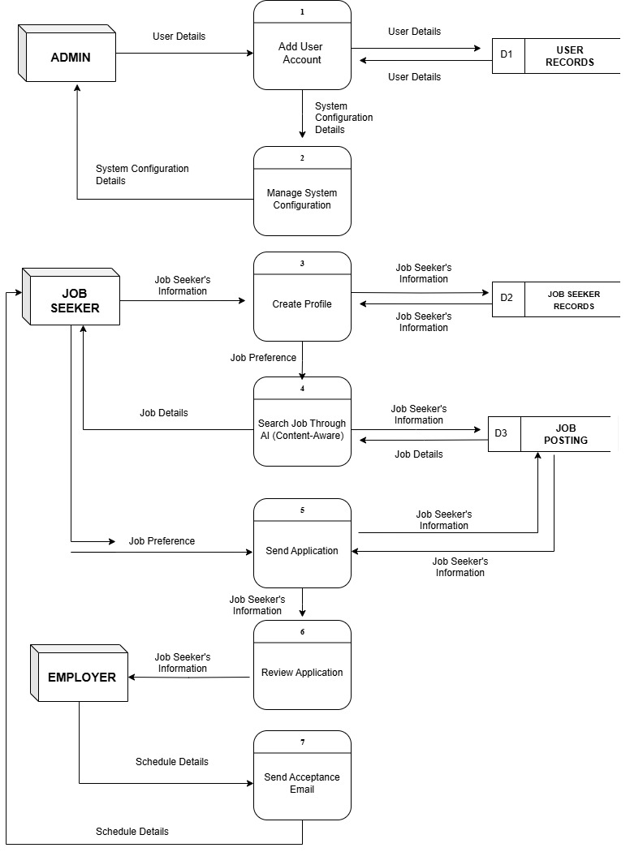
The DFDs were employed to provide a comprehensive overview of the functionality and processes involving the entities. They served as guidelines for identifying the necessary data required in each process during the system's deployment. By utilizing DFDs, the researcher gained a deeper understanding of how data was handled within the project, facilitating better comprehension and knowledge of the system's operations.
USE CASE DIAGRAM
According to Visual Paradigm (n.d), Use Case Diagram (UCD) is simple and offers a high-level view of the system and delivers the requirements in laypeople's terms for the stakeholders. Use case diagrams are implemented to understand the development procedure and purpose of the system: The following are the reasons in presenting the UCD 1) Capture the requirements of a system, 2) Specify the context of a system, 3) Validate a systems architecture, 4) Developed by analysts together with domain experts and 5) Drive implementation and generate test cases.
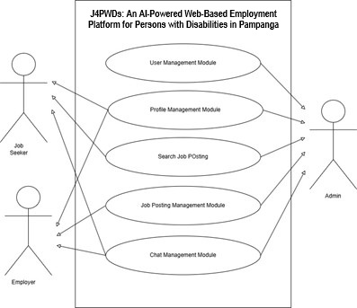
The researcher uses the concept of use-case modelling to help communicate with user’s point-of-view by specifying all externally visible system behavior.
ENTITY RELATIONSHIP DIAGRAM
According to Tech Target (n.d), the entity relationship model, known as entity relationship (ER) diagram, is a graphical illustration of data and their relationships to one another, typically used to present the data needed when the capstone project is already deployed.
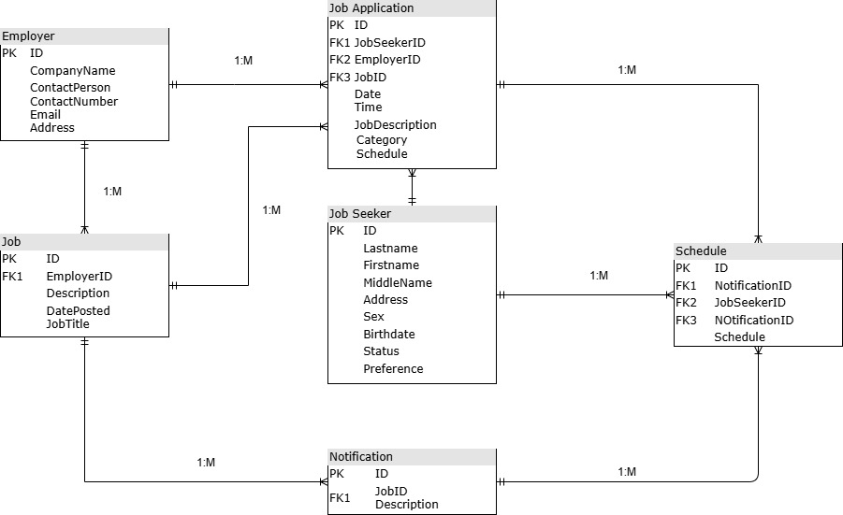
RESEARCH TOOL AND INSTRUMENTS
The researchers will use quantitative questionnaires for research instruments as a basis on the development and evaluation of the proposed system. The development of the system is made possible through observations, online research and real-life experiences of the researchers towards the development of the application.
QUESTIONNAIRE
According to Petrat (2022), a questionnaire is a research tool that consists of a series of questions designed to elicit useful data from respondents. Questionnaires are widely used in research because they provide a quick, efficient, and low-cost way of gathering large amounts of information from large volumes of people. The researchers will use the questionnaires as a basis for development and evaluating the proposed system based on usability using ISO 9241-11 standards. The researchers will formulate the questionnaires in lieu of the ISO 9241-11 key aspects effectiveness, efficiency, and satisfaction which are evaluated by an expert. The questionnaire will be distributed to twenty-five (25) PWDs, and five (5) employer and three (3) IT experts which evaluate the system.
EVALUATION INSTRUMENT OR CRITERIA
The researchers will use questionnaires as the study's evaluation tool under the descriptive research approach. The evaluation tool met all of the requirements of the ISO 9241-11 standard, which includes effectiveness, efficiency, and satisfaction. Each criterion is rated on a five-point Likert scale, and ratings are given for each one.
Table 1: Likert Scale
VALUE | RATING
5 | Strongly Agree
4 | Agree
3 | Moderately Agree
2 | Disagree
1 | Strongly Disagree

Table 2: Evaluation Rating Scale and Interpretation
MEAN RANGE | VERBAL INTERPRETATION
4.21 – 5.00 | Outstanding
3.41 – 4.20 | Very Satisfactory
2.61 – 3.40 | Satisfactory
1.81 – 2.60 | Unsatisfactory
1.00 – 1.80 | Poor

The evaluation uses a scale where different ranges of scores correspond to different levels of performance: scores in the range of 1.00 to 1.80 are considered Poor, scores in the range of 1.81 - 2.60 are considered Unsatisfactory, scores in the range of 2.61 - 3.40 are considered Satisfactory, and scores in the range of 3.41 - 4.20 are considered Very Satisfactory, and scores in the range of 4.21 – 5.00 are considered Outstanding.
Table 3: Overall Evaluation Rating Scale and Interpretation
GRAND MEAN RANGE | VERBAL INTERPRETATION
4.21 – 5.00 | Highly Acceptable
3.41 – 4.20 | Acceptable
2.61 – 3.40 | Moderately Acceptable
1.81 – 2.60 | Unacceptable
1.00 – 1.80 | Highly Unacceptable

The verbal interpretation falls into the following categories: highly unacceptable for a grand mean range of 1.00 to 1.80; unacceptable for a mean range of 1.81 to 2.60; moderately acceptable for a mean range of 2.61 to 3.40; acceptable for a mean range of 3.41 to 4.20; and acceptable for a mean range of 4.21 to 5.00.
IMPLEMENTATION PLAN
A specific and workable plan needs to be created to make the capstone a project a reality. As a result, the researchers have offered a narrative and descriptive process for completing the suggested capstone. The website was initially hosted for free at a location. It was, nevertheless, hosted in a premium web hosting account with enough bandwidth for further adoption. The application requires relatively little bandwidth because it doesn't have any multimedia features. Second, the web application for the users can be accessible using an internet. Finally, the technical abilities needed by both the users and the employer are minimal since the features were anchored to their day-to-day operation. Finally, the system can be accessed via a desktop, laptop, tablet or any mobile devices through browser by the prospective user.
System Usability Scale
In the evaluation of the proposed system, the researchers formulated a questionnaire based on ISO 9241-11. It is employed to gather quantitative feedback from end-users who have interacted with the proposed system. The scale consists of 12 items, alternating between positively and negatively worded statements, which users rate on a five-point Likert scale ranging from Strongly Disagree (1) to Strongly Agree (5). This approach helps mitigate response bias and ensures a balanced perspective on user experience. The results will be analyzed and interpreted to inform further refinement of the system, ensuring it aligns with user expectations and usability standards.

REFERENCES
Alajmi M, Persch A, Taylor A, Dean B, Rosenberg CR, Graham JE. Supported Employment for People with Developmental Disabilities During COVID: A Scoping Review. Journal of Vocational Rehabilitation. 2025;0(0). doi:10.1177/10522263251326408

Careers and academic support for employability: What are the research gaps to support higher education learners? (n.d.). https://www.bera.ac.uk/blog/careers-and-academic-support-for-employability-what-are-the-research-gaps-to-support-higher-education-learners

Cat-Wells, K. (2024, November 1). Disabled workers deserve more than subminimum wage. TIME. https://time.com/7171382/disabled-americans-section-14c-subminimum-wage/

Charan, S. N., Suhas, G. K., Yathisha, L., & Devananda, S. N. (2025). Job Recommendation System: Content-Based and Collaborative Filtering for Predictive Job Recommendation Systems. Journal of Information Systems Engineering and Management, 10(2).JISEM+1Preprints+1

Clem, A. (2025, April 16). Disability Index - Disability:IN. Disability:IN. https://disabilityin.org/what-we-do/disability-index/

Giving Compass. (2023, September 5). Using AI to Match Neurodivergent Jobseekers with Jobs that Suit Their Talents. https://givingcompass.org/article/using-ai-to-match-neurodivergent-jobseekers-with-jobs-that-suit-their-talents

Hameed, Duaa & Hassan, Rehab. (2025). A Context-Aware Recommendation System with Effective Contextual Pre-Filtering Model. Informatica. 49. 10.31449/inf.v49i15.5065.

Hope, S. (2025, April 1). The enduring pay gap for disabled people. Financial Times. https://www.ft.com/content/d9d61ff1-733e-4b28-8204-0ae2246a71b0

Ians. (2024, January 24). Swarajability, an AI-based job platform for persons with disabilities. Techgenyz. https://techgenyz.com/swarajability-for-persons-with-disabilities/

Inclusive Employment Position Paper - Inclusion International. (2023, January 23). Inclusion International. https://inclusion-international.org/what-we-do/inclusive-employment/

Jurado-Caraballo, M. Ángeles & Quintana-García, Cristina (2024). Disability inclusion in workplaces, firm performance, and reputation, European Management Journal. https://doi.org/10.1016/j.emj.2024.08.001.

Luyen, LE Ngoc and Abel, Marie-Hélène (2022). From Individual to Group: Developing a Context-Aware Multi-Criteria Group Recommender System. https://arxiv.org/pdf/2503.22752

Madan, Shalini, Kumar, Tarun, and Bhagat, Ajit (2024). Inclusive Hiring through Technology: A Recruitment Platform for Individuals with Intellectual Disabilities. Volume 128. https://doi.org/10.1016/j.procir.2024.05.091

Manila Standard (2023). Human rights body hails bill on employment for indigenous peoples. https://manilastandard.net/?p=314374964

Minderoo Foundation (2022). Woort Koorliny - Australian Indigenous Employment Index 2022: national report. https://apo.org.au/node/317965

Mosquera-Guerrero, A., Rodríguez Martínez, J., Ordoñez Abril, D. Y., & Calderón Sotero, J. H. (2022). Project design and development in indigenous communities: a literature review. Gestão & Produção, 30, e6022. https://doi.org/10.1590/1806-9649-2022v29e6022

Murphy, C., & Thomas, F. P. (2024). Employment and people with disabilities: Reframing the dialogue in the post-pandemic era. The Journal of Spinal Cord Medicine, 47(2), 187–189. https://doi.org/10.1080/10790268.2024.2315927

National Council on Disability Affairs | Empowering Inclusion of Persons with Disabilities. (n.d.). https://ncda.gov.ph/

Pacheco, E. (2023, April 26). Digital technologies in the context of university transition and disability: Theoretical and empirical advances. arXiv.org. https://arxiv.org/abs/2304.13262

Pagsolingan, John Carlo (2024). Everything a PWD Needs to Have a Thriving Remote Career in The PH. Remote Staff. https://www.remotestaff.ph/blog/everything-pwd-needs-remote-work-in-ph

Pedron, Billy Jay N. (2024). Breaking The Barrier: Persons With Disabilities (PWDs) As A Workforce in The Philippines. https://www.ejournals.ph/article.php?id=25319

Sharma, R. H., Asselin, R., Stainton, T., & Hole, R. (2025). Ableism and Employment: A Scoping Review of the Literature. Social Sciences, 14(2), 67. https://doi.org/10.3390/socsci14020067

Stoevska, V. (2024, May 3). International Day of Persons with Disabilities: how disability affects labour market outcomes - ILOSTAT. ILOSTAT. https://ilostat.ilo.org/blog/international-day-of-persons-with-disabilities-how-disability-affects-labour-market-outcomes/

Team, S. (2024, September 24). 8 Ways to use AI for customized employment. SETWorks. https://set-works.com/ai-for-customized-employment/

