DocuTrack: A SCHOOL DOCUMENT MANAGEMENT SYSTEM FOR PAMPANGA STATE UNIVERSITY - MEXICO CAMPUS

A Capstone Project
Presented to the Faculty of College of Computing Studies
Pampanga State University
Mexico Campus

In Partial Fulfillment
of the Requirements for the Degree of
Bachelor of Science in Information Technology

Prepared by:

Firstaname MI. Lastname
Firstaname MI. Lastname
Firstaname MI. Lastname
Firstaname MI. Lastname
Firstaname MI. Lastname

May 2025

Chapter I
INTRODUCTION
In the evolving landscape of higher education, the efficient and secure management of institutional records has become increasingly critical. Many educational institutions strive to enhance their administrative processes and service delivery, the reliance on traditional, paper-based document systems poses significant operational challenges. The growing volume of academic, administrative, and student-related records imposes the development of a systematic, secure, and efficient method for document handling. In addition, the use of physical filing systems, manual documentation, and fragmented record-keeping not only hampers workflow efficiency but also exposes a lot of risks related to data loss, limited accessibility, and information security breaches (Luis, 2024).
A School Document Management System (SDMS) is a software-based solution that facilitates the creation, storage, retrieval, sharing, and archiving of documents within an educational institution. The system offers a centralized platform where documents can be digitally processed, indexed, and managed, significantly improving operational efficiency and data integrity (Ikuomola et. al, 2022). By digitizing essential records such as enrollment forms, grade reports, faculty evaluations, and administrative memos, schools can reduce the time and labor associated with manual recordkeeping. Moreover, a robust SDMS supports transparency, compliance with data protection policies, and seamless data integration across departments (Falolo, 2022).
In the Philippine context, the push towards digitalization in education has been gaining momentum. The Department of Information and Communications Technology (DICT) has been instrumental in promoting digital transformation initiatives across various sectors, including education. The National ICT Ecosystem Framework (NICTEF) emphasizes the importance of participatory e-governance and the development of a sustainable ICT environment, which aligns with the objectives of implementing a DMS in academic institutions (DICT, 2024).
The current document management practice at Pampanga State University - Mexico Campus (PMC), like in many other state universities in the Philippines, which involves extensive manual processing. Physical filing cabinets, paper-based forms, and hand-written entries dominate the administrative workflow. Such practices not only increase the risk of document loss, damage, or unauthorized access, but they also hinder timely decision-making and data sharing among academic and administrative units. According to a study by Riño and Daing (2022), nearly 60% of school administrative staff in public institutions in the Philippines reported delays and inefficiencies due to outdated documentation processes. As a result, students and faculty often face unnecessary delays in accessing critical academic records, which can affect enrollment, graduation, and institutional reporting.
The implementation of a SDMS at PMC is not merely a technological upgrade but a strategic initiative aimed at enhancing administrative efficiency, ensuring data security, and promoting environmental sustainability. By digitizing document management processes, PMC stands to benefit in multiple dimensions. Firstly, digital document storage significantly reduces the physical space required for file archives, freeing up resources for other academic and student service purposes. Secondly, digital documents are easier to search and retrieve using metadata, indexing, or keyword queries, thus reducing retrieval time and improving response efficiency. Thirdly, data security can be enhanced by implementing access controls, encryption, and audit trails, which are not feasible with traditional systems (Ivins, 2024). Furthermore, automated backups and disaster recovery solutions ensure the long-term preservation and protection of sensitive information.
The adoption of an SDMS aligns with the broader national and global trends in e-governance and digital transformation in education. The Philippine government, through various initiatives such as the e-Government Master Plan 2012-2016 and the Enhanced Basic Education Information System (EBEIS), has promoted the use of information and communication technology (ICT) in improving public service delivery, including in the education sector (Department of Information and Communications Technology [DICT], 2016). In this context, PMC’s move toward an SDMS is not only a practical administrative upgrade but also a strategic step in compliance with government policy and international best practices.
Project Context
In the face of rapid technological advancements and increasing administrative demands in the education sector, higher education institutions are compelled to modernize their processes to remain efficient and responsive. One of the most critical areas requiring innovation is the management of student and institutional records. At PMC, the current approach to record keeping remains predominantly manual, paper-based, and fragmented. This reliance on traditional systems poses considerable challenges in terms of data retrieval speed, storage capacity, accuracy, security, and overall operational efficiency.
The School Document Management System (SDMS) will serve as a transformative solution to many issues face by the Campus. An SDMC is a comprehensive digital platform that aims to consolidate and simplify the management of academic records, enrollment files, grading sheets, student profiles, and faculty documents. The development of such a system at the PMC seeks to digitize important administrative operations, minimize reliance on physical papers, and improve data accessibility and integrity. This digital change is consistent with the university's overall aims of institutional development, digital transformation, and quality assurance. Moreover, the implementation of an SDMS contributes to environmental sustainability by significantly reducing the university’s paper consumption, thus aligning with global sustainable development goals and institutional green.
Statement of Objectives
The main goal of the capstone project is to design and develop the DocuTrack: A School Document Management System for Pampanga State University – Mexico Campus. Specifically, the capstone project aims to achieved the following:
- To determine the comprehensive functional requirements necessary for DocuTrack to effectively manage academic and administrative records at PMC.
- To design web-based system that ensure optimal information structure and organization within the system that guarantee rapid retrieval, seamless cross-referencing, and centralized control of all digitized records.
- To evaluate the develop system using the Usability and Effectiveness Evaluation (ISO 9241-11) using the following criteria:
  - Effectiveness
  - Efficiency
  - User Satisfaction
Scope and Limitations
The Capstone Project is precisely developed to facilitate the digital transformation of crucial record-keeping processes exclusively within the PMC administrative and academic units. The system’s primary objective is to streamline the management and archival of student academic and related administrative records to drastically improve efficiency, data integrity, and accreditation compliance. To achieve this, the developed system incorporates several core functional modules. First, it will digitize and centralize a vast array of records, encompassing student enrollment data, official grade sheets, required school forms, and key administrative records. Second, a secure, role-based user portal will be implemented to provide authorized users, specifically faculty and administrative staff, with the appropriate levels of access needed to manage, upload, update, and retrieve relevant records efficiently. Furthermore, DocuTrack is designed to generate analytical reports and summaries on document requests and archival metrics, providing essential data for informed institutional planning and policy implementation. Importantly, the system will implement rigorous security protocols, including user authentication, secure storage mechanisms, and comprehensive audit trails, ensuring uncompromising data privacy and integrity in adherence to the Data Privacy Act of 2012. Finally, the system will support document archiving and backup functionality, enabling secure long-term storage and a reliable recovery mechanism to prevent data loss.
Despite the extensive functional scope, this initial implementation of the DocuTrack system is bound by specific limitations. The project is strictly limited to academic and administrative record management; consequently, it does not include modules for financial transactions, the campus payroll system, or specialized library services. Furthermore, system access is strictly restricted to authorized administrative users and campus staff based on their defined roles and access levels; the general student body or the public will not be granted direct access to any part of the record database. Lastly, integration with other existing enterprise systems currently used by the university such as a Learning Management System (LMS) or a Human Resource Information System (HRIS) is considered limited or non-existent during this initial development and implementation phase. These constraints are deliberately recognized in the project's planning and execution stages to maintain a focused, achievable objective, ensure realistic expectations from stakeholders, mitigate development risks, and establish a clear foundation for defining future system enhancements.
Definition of Terms
Academic Records. Digital files maintained in the SDMS containing students’ grades, subjects, schedules, enrollment history, and school records specific to PMC.
Audit Trail. The tracking feature in the SDMS that logs user actions such as login time, data access, and record updates for accountability purposes at PMC.
Backup and Recovery. The routine process in the SDMS of PMC that ensures school records are regularly backed up and can be restored in the event of system failure.
Data Security. The protocols and features (e.g., user authentication, encryption, role-based access) integrated into the SDMS to ensure that student and institutional data at PMC are kept confidential and secure.
School Decument Management System (SDMS). The digital platform to be developed and implemented at PMC to store, retrieve, update, and manage student-related academic records such as grades, enrollment data, forms, and administrative records.

Chapter II
REVIEW OF RELATED LITERATURE
The studies and literatures served as the foundation for the suggested system were presented in this section. The researchers presented the review by identifying different areas related to the proposed system.
School Document Management System
The implementation of SDMS has transformed the way educational institutions manage, store, and access student information. As schools increasingly embrace digital solutions, SDMS has emerged as a critical tool for improving administrative efficiency, data accuracy, and overall institutional performance.
According to Adeyemi and Uko-Aviomoh (2020), SDMS contributes significantly to the efficiency of administrative processes in schools by minimizing manual paperwork and reducing the risk of data loss. These systems streamline the management of academic records, including attendance, grades, and enrollment details, thus allowing school personnel to focus more on student development and less on clerical tasks.
In the study of, Nair and Krishnan (2019) emphasize the role of SDMS in enhancing data accuracy and accessibility. The authors argue that digital record systems help eliminate redundancy and human errors that are prevalent in traditional filing systems. With centralized digital databases, schools can ensure that records are consistently updated and easily retrieved, leading to better decision-making and more responsive student services.
Moreover, Osei and Mensah (2021) found that SDMS positively impacts communication between stakeholders, including teachers, students, and parents. Through integrated platforms, parents can monitor their children’s academic performance and attendance in real time, fostering a more transparent and collaborative school environment.
The security of student data is another important aspect addressed by SDMS. A study by Ahmed et al. (2022) highlights that modern SDMS platforms incorporate encryption and access controls, ensuring that sensitive information is protected from unauthorized access. This is particularly crucial in the context of growing concerns over data privacy and cybersecurity in educational institutions.
Finally, the World Bank (2018) noted that countries that have adopted school information management systems at scale have observed improved policy implementation, better resource allocation, and more efficient monitoring of school performance. This macro-level benefit underscores the potential of SDMS not just as a local administrative tool, but as a driver of systemic educational improvements.
Implementation of document tracking system
The implementation of Document Tracking Systems (DTS) has increasingly gained traction across various sectors due to its ability to streamline workflows, improve access to information, and strengthen document security. TrustLayer (2023) reported that organizations adopting document tracking technologies experienced a notable 30% reduction in operational costs and a 20% increase in productivity. These systems reduce the reliance on manual processes, minimize errors, and facilitate efficient retrieval and sharing of documents. By ensuring documents are accessible and organized in real-time, DTS helps institutions maintain operational fluidity and accountability.
Moreover, Kefron (2025) emphasized that document management systems with built-in tracking features enhance collaboration across departments through real-time access, version control, and metadata tagging. These tools support effective communication and faster decision-making, especially in settings where time-sensitive documents need to be reviewed and approved by multiple stakeholders. Enhanced accessibility also allows for remote and hybrid work environments, which are becoming more common in the post-pandemic era.
In addition to improving workflow efficiency, DTS plays a vital role in maintaining data security and regulatory compliance. Docsvault (2025) highlights that newer systems are now equipped with artificial intelligence features that automate classification, routing, and auditing of documents while maintaining high standards of security and user access control. These improvements are essential for protecting sensitive data and ensuring that organizations remain compliant with increasingly stringent data privacy laws.
Local case studies further affirm the practical benefits of DTS. Pama (2020) conducted a study on the Department of Education in Misamis Oriental, Philippines, which showed that implementing a DTS significantly improved document retrieval times, reduced delays in processing, and enhanced transparency in administrative functions. This study illustrates how even in government settings, which often rely on traditional processes, digitizing document flow can produce measurable benefits.
Similarly, in academic institutions, Salleh et al. (2020) developed an Accreditation Document Tracking System (ADTS) using the Scrum methodology to support quality assurance efforts in higher education. Their study found that the ADTS improved document tracking and submission across departments during accreditation, thereby reducing inefficiencies and potential data loss.
Collectively, these studies demonstrate that the implementation of document tracking systems on School Record Management System increases administrative efficiency and data security. Also, it facilitates better collaboration and accountability in both public and private institutions.
Synthesis
The literature consistently demonstrates that the implementation of Document Tracking Systems (DTS) significantly enhances organizational performance by improving efficiency, accuracy, accessibility, and data security. Across both private and public sectors, these systems streamline the management of documents, reducing operational costs and minimizing human error.
The implementation of Document Tracking Systems (DTS) within SDMS plays a pivotal role in enhancing the efficiency, accuracy, and security of managing student and administrative records. It also emphasizes that by incorporating DTS, schools can automate record retrieval, minimize errors, and ensure that important documents are tracked accurately, thus improving overall administrative workflows within an SDMS.
The researchers recognized the potential of benefits of the proposed system. It offers a comprehensive solution that improves administrative efficiency, enhances collaboration, ensures data security, and supports compliance. The adoption of these technologies is a significant step toward optimizing school management processes and making educational institutions more responsive, transparent, and data-driven.

Conceptual Framework
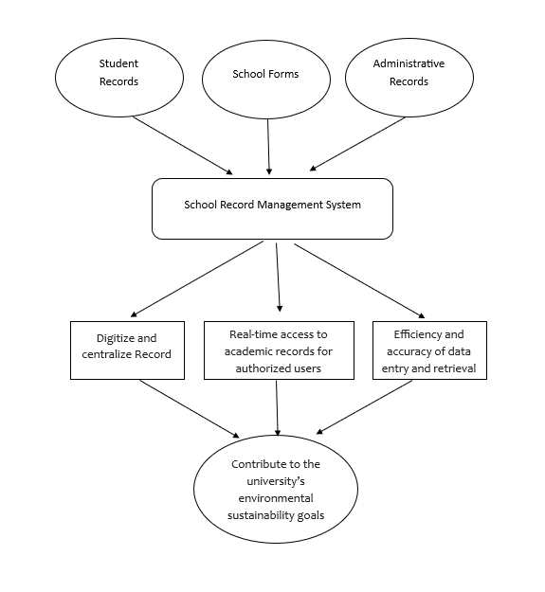
Figure 1. Conceptual Framework
The Figure 1 represents a flow of information and decision-making that drives the DocuTrack: A School Document Management System (SDMS) which designed to enhance the management and accessibility of academic and administrative information within a university. At its core, the system consolidates data from three primary sources: student records, school forms, and administrative records. These inputs feed into the centralized SRMS, which functions as a digital hub for storing, organizing, and retrieving essential documents and data.
The implementation of the SDMS yields several functional outcomes. First, it enables the digitization and centralization of records, ensuring that all relevant information is electronically stored and maintained in a single, secure location. This not only reduces the reliance on physical documents but also promotes easier access and improved data integrity. Second, the system provides real-time access to academic records for authorized users, such as faculty members and administrative staff. This facilitates prompt decision-making and supports efficient academic and administrative operations. Third, the SRMS improves the efficiency and accuracy of data entry and retrieval, minimizing errors commonly associated with manual record-keeping processes.
Ultimately, these improvements contribute significantly to the university’s broader environmental sustainability goals. By reducing the use of paper and minimizing the carbon footprint associated with traditional record-keeping, the School Record Management System supports a more sustainable and environmentally responsible approach to information management in higher education.
Technical Background
The development of the proposed system was rooted in the needs to have a SDMS in PMC. Leveraging the advancements in web technology, DocuTrack aims to provide a user-friendly platform that enables teachers and administrative staff to digitalized and centralized the record keeping and management in the Campus.
The development of DocuTrack involves utilizing modern programming languages and frameworks. The application integrates with web services to accurately manage effective record retrieval. The researchers used different development tools such as:
MySQL. The proposed system uses database to save recent transaction and user’s information and data from the farmers and Department of Agriculture office. The tool allows the application to store data though online database using MySQL to manage transaction and effectively retrieved data, share information, upload crop status, and communicate effectively.
PHP. The proposed system management module was develop using the Web-Based platform. In order to create the module, the researchers used PHP as the based language for the integration of back-end data processing and transactions.
React JS. As a leading JavaScript library, React JS is utilized to create a highly responsive, component-based Single Page Application (SPA), optimizing interaction and minimizing page load times for the users.
Tailwind CSS. This utility-first framework allows for rapid styling and responsive design, delivering a modern and intuitive experience for all authorized campus personnel.

Chapter III
METHODOLOGY
In this section, the researchers presented the methodology that used in development of the proposed system. The researchers presented the research design, the research instrument, the data gathering procedure, the methodology in developing the proposed system, and the evaluation criteria in evaluation of the proposed system.
Research Design
The researchers employed a descriptive mixed-method research design to identify the essential features for developing the proposed system. In the qualitative approach, they examined the needs of teachers and administrative staff and incorporated these requirements into the system. Meanwhile, in the quantitative approach, the researchers evaluated the system using a survey questionnaire to assess its usability and effectiveness among the respondents using the ISO 9241-11. Finally, the researchers analyzed and presented the collected data to determine the extent to which the project’s objectives were achieved.
Research Instruments
The researchers used different research instruments as a basis on the development and evaluation of the proposed system. The following are the research instrument used in the study. The development of the system is made possible through interviews, observations, online research and real-life experiences of the researchers towards the development of the application.

Interview
According to research-methodology.net (n,d.), interviews can be seen as a qualitative research method that involves conducting lengthy one-on-one interviews with a small group of respondents to learn about their perspectives on a particular issue or concept. The target respondents’ difficulties will identify through an interview with the respondents. The researchers able to build the proposed system in accordance with the primary needs of the Campus.
Observation
According to Creswell and Creswell (2018) Observation is a fundamental research method used to systematically collect data by watching and recording behaviors, events, or phenomena as they occur in their natural settings. It is a key on qualitative method that allows researchers to study behaviors and phenomena in natural settings while minimizing participant bias.
The researchers used observation to identify underlaying problem that the respondents encounter in retrieval and management of records. This allows the researchers to analyze effectively and access the respondent’s perspective.
Questionnaire
According to Petrat (2022), a questionnaire is a research tool that consists of a series of questions designed to elicit useful data from respondents. Questionnaires are widely used in research because they provide a quick, efficient, and low-cost way of gathering large amounts of information from large volumes of people. The researchers used the questionnaires in evaluating the proposed system based on ISO 9421-11 or the Usability and Effectiveness Evaluation. The researchers formulated the questionnaires in lieu with the ISO 9421-11 criteria and evaluated by an expert. The questionnaire was distributed to twenty-five (25) faculty members, five (5) Administrative Staff and three (3) IT expert which evaluated the system.
Respondents of the Study
The researchers identify the respondents through Purposive Sampling. The researchers utilized specific criteria to identify the qualified respondent in evaluation of the proposed system. The researchers used twenty-five (25) faculty members and must be working in PMC, have an administrative task or assigned unit/office, and handle or prepare school records. Also, the researchers used four (5) administrative staff and three (3) technical experts for the alpha test of the proposed system.
Ethical Consideration
The researchers considered ethical process in acquiring data to different entities such as teachers and staff of PMC. The researchers seek an approval thru letter in conducting interview and observation of day-to-day operation of the campus. Then the researchers asked an approval each teacher and staffs who performed evaluation thru a consent form and presented the tool. The researchers also consider sensitive data collected as valuable, that is why the researchers ensure the safety and proper usage of data.
Evaluation Instrument or Criteria
The researchers used questionnaires as the study's evaluation tool under the descriptive research approach. The evaluation tool met all of the requirements of the ISO 9421-11 standard, which includes Effectiveness, Efficiency, and User Satisfaction. Each criterion is rated on a five-point Likert scale, and ratings are given for each one.
Table 1: Likert Scale
VALUE | RATING
5 | Strongly Agree
4 | Agree
3 | Moderately Agree
2 | Disagree
1 | Strongly Disagree

Table 2: Evaluation Rating Scale and Interpretation
MEAN RANGE | VERBAL INTERPRETATION
4.21 – 5.00 | Outstanding
3.41 – 4.20 | Very Satisfactory
2.61 – 3.40 | Satisfactory
1.81 – 2.60 | Unsatisfactory
1.00 – 1.80 | Poor

The evaluation uses a scale where different ranges of scores correspond to different levels of performance: scores in the range of 1.00 to 1.80 are considered Poor, scores in the range of 1.81 - 2.60 are considered Unsatisfactory, scores in the range of 2.61 - 3.40 are considered Satisfactory, and scores in the range of 3.41 - 4.20 are considered Very Satisfactory, and scores in the range of 4.21 – 5.00 are considered Outstanding.

Table 3: Overall Evaluation Rating Scale and Interpretation
GRAND MEAN RANGE | VERBAL INTERPRETATION
4.21 – 5.00 | Highly Acceptable
3.41 – 4.20 | Acceptable
2.61 – 3.40 | Moderately Acceptable
1.81 – 2.60 | Unacceptable
1.00 – 1.80 | Highly Unacceptable

The verbal interpretation falls into the following categories: highly unacceptable for a grand mean range of 1.00 to 1.80; unacceptable for a mean range of 1.81 to 2.60; moderately acceptable for a mean range of 2.61 to 3.40; acceptable for a mean range of 3.41 to 4.20; and acceptable for a mean range of 4.21 to 5.00.
System Development Procedure
A system development methodology guides the development of a system. it contains a collection of procedures, techniques, tools, and documentation aids. According to itinfo.am (n.d), a software development methodology is a software development framework used for planning. Build and control the process of building information systems.
Agile Development Methodology
Agile Software Development is a development methodology for building information systems. These methodologies such as Scrum, Crystal methods and Dynamic systems development model have the ability to manage changing priorities particularly in improving project visibility, and increasing productivity (VersionOne.com, 2012).
Furthermore, Pelclova (2014) pointed out that agile methodologies are introduced to offer a better setting for software development, in which frequent feedback, incremental work, and adaptation to change are embraced. According to guru99.com (n.d), agile methodology promotes synchronized development and testing throughout the software development lifecycle. In addition, Malek et al. (2017) specified that agile software design and development methodologies are receiving immense responsiveness in the software development research community since their early introduction in the mid-nineties in addition of becoming highly adopted by the system development industry adopted by the software development industry.
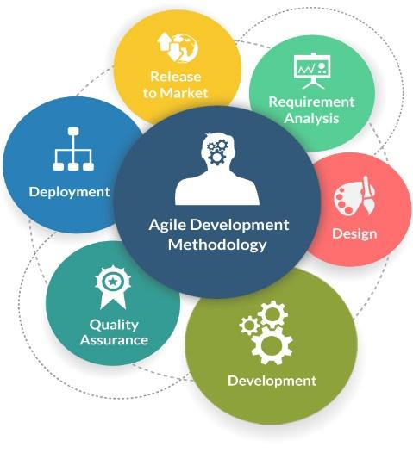
Figure 3: Agile Development Methodology
Requirement Gathering
At this stage, the researchers started gathering data or information about the system. Then, the researchers conducted an interview to communicates with the teachers and staff and collects all the requirements for the proposed system.
Design
In the first stage, the requirement specifications are examined and the system design is prepared. In the System Design stage, the researchers structured and design the proposed system. It also identifies the hardware and software system requirements and also help in outlining overall system architecture. Furthermore, the researchers started making the design for the modules of the system and the creation of Entity Relationship Model, Context Diagram and Data Flow Diagram.
Building Prototype
In this stage the researchers implemented the result from system design and use it to developed small unit of programs or sub-system. Then, the researchers chooses a specific programming language and tools to develop the system.
User Evaluation
In this stage the researchers test the developed prototype and identify errors and areas for improvement. These processes clarify the proper operation of the proposed system that fitted on the user’s perspective.
Prototype Refinement
In this stage the researchers use feedbacks obtained from user evaluation and improved the prototype and meet the requirements of the user. Also, in this stage series of testing are conducted such as beta testing, and alpha testing to ensure the quality for any possible faults and failures.
Deployment
In the deployment stage the system will be release to the market once the evaluation and testing were done, including functional and non-functional tests. The system has now been deployed to the locale and is ready for use by the intended users.
Organizational Assessment

The section presents the researchers’ evaluation of the local organizations’ assessment in terms of technical viability, operational viability, financial viability, and participant involvement in the study.
Technical Feasibility
The capstone project was a complete web application. Initially the system was accessed through the free hosting environment, but for future adaptation of the system it will be transferred in a paid hosting with an enough bandwidth. Bandwidth needed in this system was very minimal, since it did not contain massive amount of multimedia component.
Operational Feasibility
The locale’s existing internet connection will be utilized by the faculty members. The requirements for the operation of the proposed system depends on the user’s resources. The operation and procedure implemented on the proposed system is patterned from the respondents needs. Users can easily understand the design and module implemented in the proposed system since it is based from different popular social media platform.
Financial Feasibility
The financial capacity of the locale is stable, and the expenses associated with web hosting, application development, maintenance, and equipment for the capstone project are relatively low compared to the expected benefits. The capstone project's utilization of new technology had the potential to attract a larger clients base in the future. The adoption of this innovative technology in the project is expected to generate increased interest and engagement from farmers, providing long-term advantages.
Requirements Analysis and Specification
In order to fully develop the system according to its intended purpose, the researchers need to identify the different analysis and specifications needs for the development of the application. This includes Requirements modelling, System Design Specification, Development Specification, Test or Evaluation Plan, and Implementation Plan.
Requirements Modelling
A requirements model provided an emphasis about the different diagrams that serves as a guide of the researchers in order to develop the system. The researchers used the Context Diagram, Data Flow Diagram (DFD), and Use Case Diagram (UCD) to identify the different processes needed to accomplish in the system.
Context Diagram
Context diagrams depict the interactions between an internal software system and external entities. Its main purpose is to assist users in comprehending the extent of a system. It can determine the most effective way to build a new system and its specifications or how to enhance an existing system. Furthermore, the graphics are high-level and do not explore into the specifics of the system. Rather, it represents a system as a whole in an understandable, straightforward manner (Miro, n.d).
The researchers used Context diagram to initially identify the boundaries of the proposed system. It creates understanding from the entities involved and the initial data produced each entity. (See Appendix A)
Data Flow Diagram
According to Lucidchart (n.d), offer insights into the flow of information within a process or system. The researchers utilize specific symbols like circles, arrows, rectangles, tables, outputs, and storage points to depict data inputs, outputs, and routes. DFDs contribute to a better understanding and increased knowledge of how data is managed.
The DFDs were employed to provide a comprehensive overview of the functionality and processes involving the entities. It served as guidelines for identifying the necessary data required in each process during the system's deployment. Lastly, the researchers gained a deeper understanding of how data was handled within the project, facilitating better comprehension and knowledge of the system's operations. (See Appendix B)
Use Case Diagram
According to Visual Paradigm (n.d), Use Case Diagram (UCD) is simple and offers the high-level view of the system and deliver the requirements in laypeople's terms for the stakeholders. Use case diagrams are implemented to understand the development procedure and purpose of the system: The following are the reasons in presenting the UCD 1) Capture the requirements of a system, 2) Specify the context of a system, 3) Validate a systems architecture, 4) Developed by analysts together with domain experts and 5) Drive implementation and generate test cases. The researcher uses the concept of use-case modelling to help communicate with user’s point-of-view by specifying all externally visible system behavior. (See Appendix C)
System Design Specification
The System Design Specification contained essential information required for the system development. The researchers gathered data from online research, including relevant literature and studies, to assess the feasibility of the system's development. Furthermore, an interview of faculty and staff of PMC provided a valuable insight regarding the various concepts that needed to be considered in the system.
Output and User Interface Design
The researchers considered different modelling structures that helps them to understand and developed the system. This ensured the researchers to have clearer view of the final output.
Entity Relationship Diagram
According to Tech Target (n.d), the entity relationship model, known as entity relationship (ER) diagram, is a graphical illustration of data and their relationships to one another, typically used to present the data needed when the capstone project is already deployed. (See Appendix D)
Data Dictionary
According to Uc Merced Library (n.d), Data dictionaries are used to provide description about the contents of a dataset or database, such as the names of the variables, text descriptions, and their data types or formats. Data dictionary offers a concise guide to understand the use of data. (See Appendix F)
Story Board
According to VanZandt (2023) the story board was included to the initial phase of the study. It is a strategic visual roadmap that is essential in creative fields such as graphic novels, animation, video games, advertising, and film. It carefully lays forth the story progression or project dynamics through a series of graphics or visuals. The storyboard ensured the researcher to have clearer view of the final output. (See Appendix G)
Development Specification
This section includes the process of specifying the hardware, software and other requirements needed in the development and implementation of the system.
Table 4: Software Specification
Windows 10 Pro
HTML, CSS Java Script, PHP, Tailwind, ReactJS
Xampp
PhpMyAdmin database
Android Studio

Table 4 shows the software specification that deals with identification of the all software needed for the development of the application.
Table 5: Hardware Specification
Components | Specification
Processor | Intel® Core™ i5‑6400 Processor
RAM | 8GB
Storages | 512 GB of internal Solid-State Drive (SSD) or 1 TB internal HDD
Graphic Card | Intel HD Graphics

Table 5 reflects he hardware specifications that involves the identification of hardware requirements to help in the development of application.
Test Evaluation Plan
The proposed system is evaluated by the researchers using an ISO 9421-11 Usability and Effectiveness Evaluation-based questionnaire. An expert reviewed the questionnaire to ensure that it evaluated the suggested system fairly. The system was assessed using beta and alpha tests. The researchers identify twenty-five (25) Faculty member, five (5) administrative staff, and three (3) IT experts who evaluated the system's acceptability.
Implementation Plan
A specific and workable plan needs to be created in order to make this suggested capstone a reality. As a result, the researchers have offered a narrative and descriptive process for completing the suggested capstone. The website was initially hosted for free at a location. It was, nevertheless, hosted in a premium web hosting account with enough bandwidth for further adoption. The application requires relatively little bandwidth because it doesn't have any multimedia features. Second, the web application for the teachers can be accessible using an internet. Finally, the technical abilities needed by both the teachers and the staff are minimal since the features was anchored to their day-to-day operation. Finally, the system can be accessed via an desktop, laptop, tablet or any mobile devices through browser by the prospective user.

References

Ikuomola, Aderonke & Oyekan, Ezekiel & Orogbemi, Olutomisin. (2022). A Secured Cloud-Based Electronic Document Management System. International Journal of Innovative Research and Development. 10.24940/ijird/2022/v11/i12/DEC22010.

Falolo, Vilma & Capillas, Kenneth & Vergarra, Nerissa & Cerbito, Adonis. (2022). Student Registration and Records Management Services towards Digitization. International Journal of Educational Management and Development Studies. 3. 10.53378/352867.

Department of Information and Communications Technology (DICT). (2024). National ICT Ecosystem Framework (NICTEF). Republic of the Philippines.

Riño, J. & Daing, C. (2022). Challenges in Handling Student Records and Characteristics of Student Information Management System in Public Secondary School in Marilao South District IV Bulacan. Psychology and Education: A Multidisciplinary Journal, 4(1), 105-120. https://doi.org/10.5281/zenodo.7033238

Ivins, Nicks (2024). Document Digitisation: Boost Efficiency with DocuWare Integration. DocuWare. https://start.docuware.com/en-gb/blog/document-digitisation-boost-efficiency

Adeyemi, A. M., & Uko-Aviomoh, E. E. (2020). The Role of Information Management Systems in Secondary Schools in Nigeria. Nigerian Journal of Educational Technology, 22(1), 45-56.

Nair, R., & Krishnan, S. (2019). Improving Educational Outcomes Through Effective Student Record Systems. Journal of Education and Information Technologies, 24(3), 1559–1571.

Osei, G., & Mensah, E. (2021). Digital Transformation in Basic Education: The Case of School Management Systems in Ghana. African Journal of Educational Studies, 13(2), 100–115.

Ahmed, M., Khan, T., & Sultana, N. (2022). Data Privacy in Education: Evaluating Security Measures in School Management Systems. International Journal of Educational Technology and Security, 7(1), 35–49.

World Bank. (2018). Using Information Technology to Improve Education Systems in Developing Countries. [Online] Available at: https://www.worldbank.org/education/technology

APPENDICES

Appendix A
Context Diagram
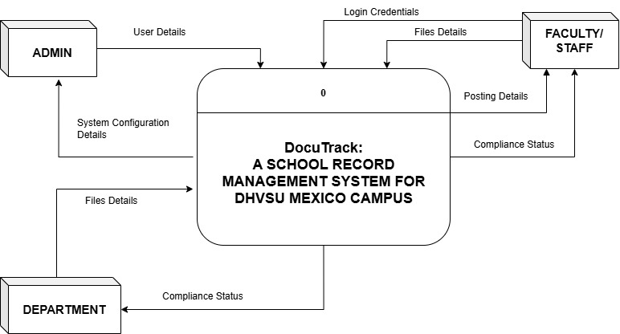

Appendix B
Data Flow Diagram (Level 1)
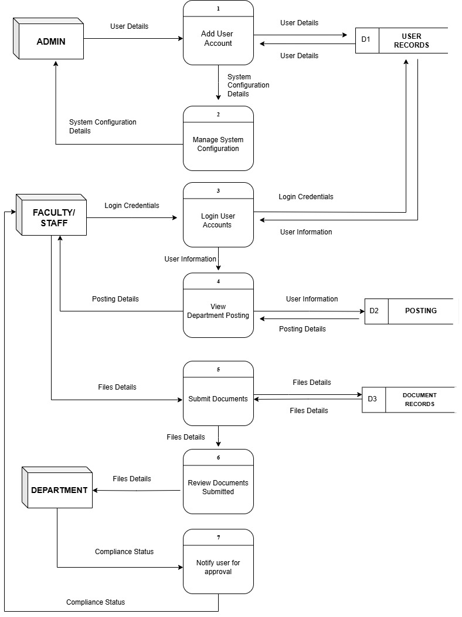

Appendix C
User Case Diagram
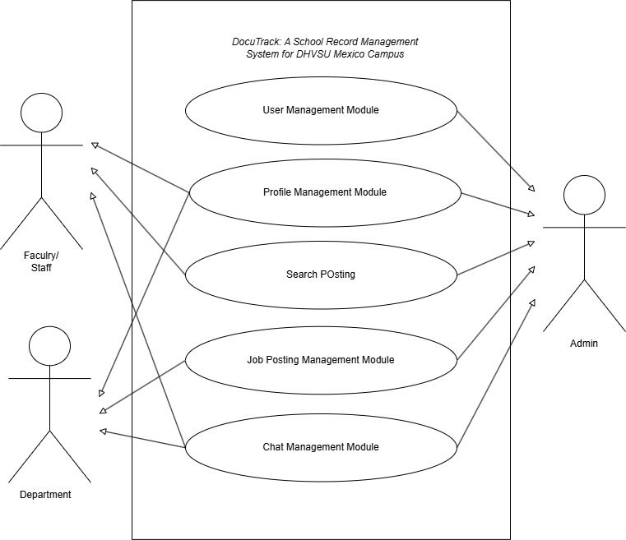

Appendix D
Entity Relation Diagram
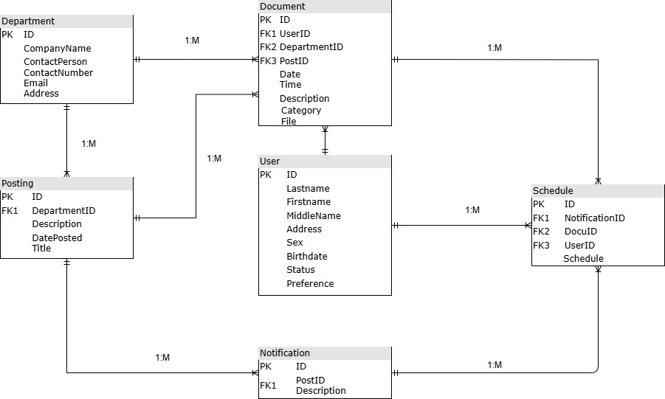

Appendix E
Data Dictionary
Table Name: Department
Field Name | DataType | Details | Description
ID | Int(10) | PK
CompanyName | Varchar(100)
Contact Person | Varchar(100)
ContactNumber | Varchar(100)
Email | Varchar(100)
Address | Varchar(100)

Table Name: Document
Field Name | DataType | Details | Description
ID | Int(10) | PK
UserID | Int(10) | FK1
DepartmentID | Int(10) | FK2
PostID | Int(10) | FK3
Date | Varchar(100)
Time | Varchar(100)
Description | Varchar(100)
Category | Varchar(100)
File | Text

Table Name: Posting
Field Name | DataType | Details | Description
ID | Int(10) | PK
DepartmentID | Varchar(100) | FK1
Description | Varchar(100)
DatePosted | Varchar(100)
Title | Varchar(100)

Table Name: User
Field Name | DataType | Details | Description
ID | Int(10) | PK
LastName | Varchar(100)
FirstName | Varchar(100)
MiddleName | Varchar(100)
Address | Varchar(100)
Sex | Varchar(100)
Birthdate | Varchar(100)
Status | Varchar(100)
Preference | Varchar(100)

Table Name: Notification
Field Name | DataType | Details | Description
ID | Int(10) | PK
PostID | Int(10) | FK1
Description | Varchar(100)

Table Name: Schedule
Field Name | DataType | Details | Description
ID | Int(10) | PK
NotificationID | Int(10) | FK1
DocuID | Int(10) | FK2
UserID | Int(10) | FK3
Schedule | Varchar(100)

