Rule of thumb: empty airframe (wings, fuselage, tail) weight will be about 40-50% of the All-Up Weight (AUW).

This checks out with commercial quadcopters like the DJI AGRAS T40 which has an empty weight of around 38kg and can carry 50kg of (equipment and payload). This also checks out with the XAG P100 quadcopter which has an empty weight of about 33kg and can carry 88kg of (equipment and payload).

Batteries rule of thumb: Batteries for these two platforms above are around 7kg. Which is 20% of their empty weight. But these are quadcopters. I need to search for fixed wing platforms to have a better idea.

A great example/design is this one:
https://www.buildyourowndrone.co.uk/finwing-sabre-arf

And this one:
https://en.wikipedia.org/wiki/AeroVironment_Switchblade

with an all up weight of 5kg. Hand launchable. Unoptimized for sure. I definitely think it could become smaller, faster and compact.

Software:
XFLR5 for wing design
Autodesk Fusion (personal use)

Center of gravity is super important. As we already know from simulation..

Step | Goal | Key Software | Key Metric / Outcome
1 | Weight & Requirements | Spreadsheet (Google Sheets, Excel) | Target All-Up Weight (AUW)
2 | Aerodynamic Design | XFLR5 | Wing Area (S), Stable Static Margin (5-15%)
3 | Mechanical Design | Autodesk Fusion 360 | A buildable 3D model, Correct Center of Gravity (CG)
4 | Propulsion System | eCalc | Motor/Prop/Battery combo, Thrust-to-Weight (>0.7), Flight Time
5 | Build & Test | 3D Printer, Hand tools | A physical, working UAV

And repeat

I need to find the payload weight first.

Bionic Morphing wings? Too far fetched? Might work.

Davis recoiless gun. This one is great. Should consider.

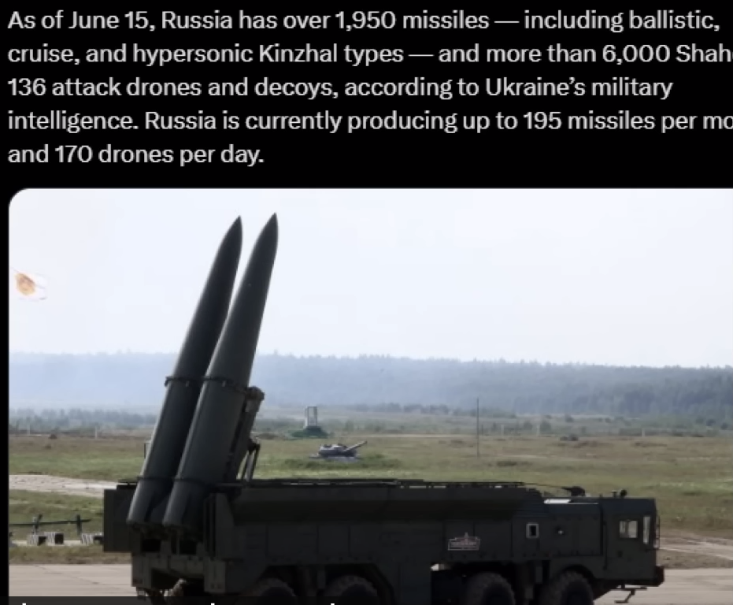

Great video:
https://www.youtube.com/watch?v=x4bHc4X5Ilw

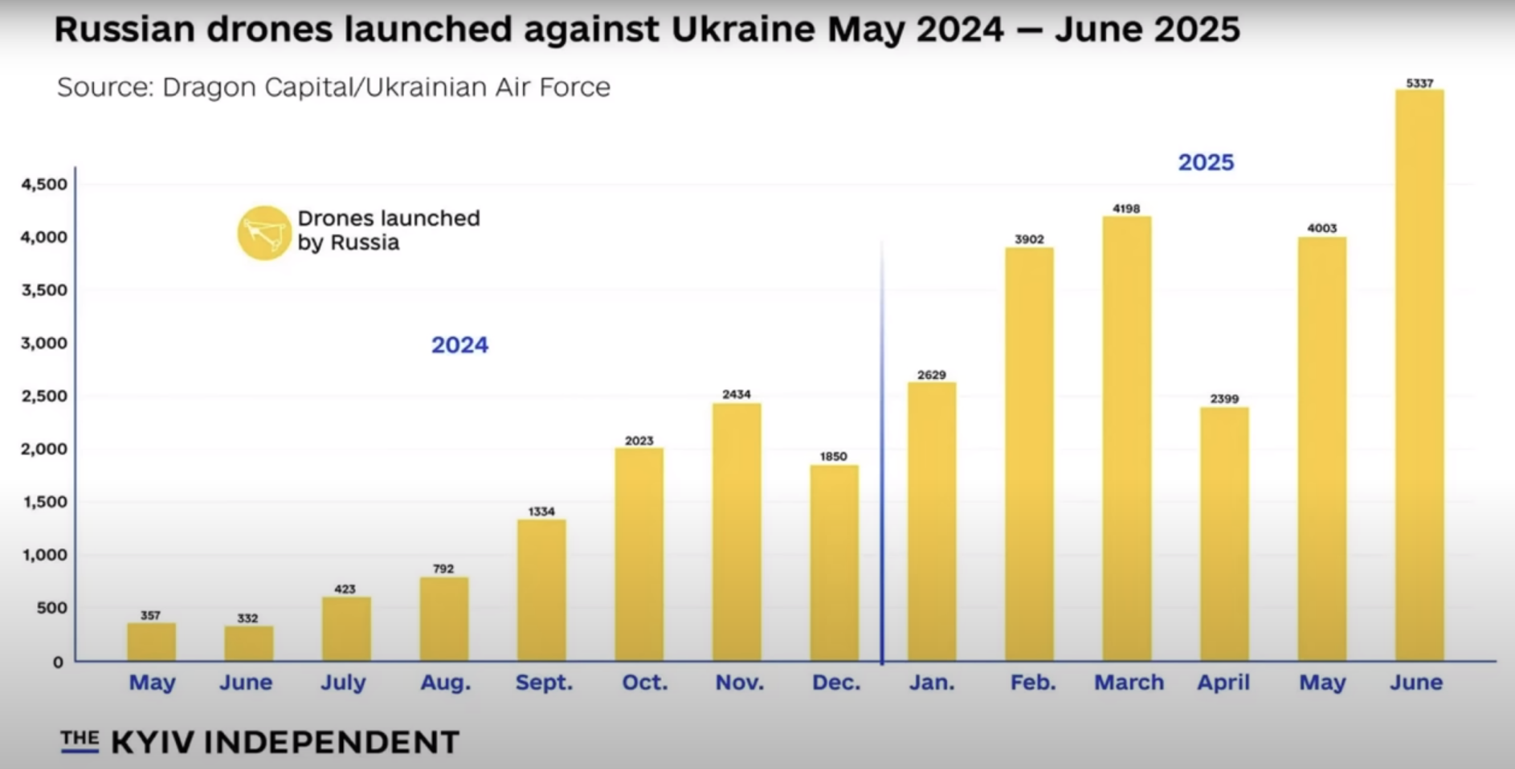

ZOHD company is very interesting: https://www.zohd.net/planes

Let us copy something like this for starters:
https://www.zohd.net/zohd-dart-xl-extreme

RC companies use slightly forward swept wings to balance nose weight. I think the initial design should be like this. Because it also looks cool and stable. And we will see for later. Our camera will be in the front as well. The computer probably also.

Related publication by ELKAK:

https://www.elkak.gr/information-requests

