- 安装环境
# cat /etc/redhat-release
CentOS Linux release 7.2.1511 (Core)
2.防火墙及SELINUX关闭
systemctl stop firewalld.service
systemctl disable firewalld.service
sed -i 's/SELINUX=enforcing/SELINUX=disabled/' /etc/selinux/config
grep SELINUX=disabled /etc/selinux/config
setenforce 0
- yum源配置
将已经配置好的所有repo注释掉，即加上后缀bak比如：
# mv /etc/yum.repos.d/CentOS-Base.repo /etc/yum.repos.d/CentOS-Base.repo.bak
改使用163.repo
# cd /etc/yum.repos.d/
wget http://mirrors.163.com/.help/CentOS7-Base-163.repo
- 导入epel和zabbix源
# rpm -ivh http://dl.fedoraproject.org/pub/epel/7/x86_64/e/epel-release-7-9.noarch.rpm
#rpm -ivh http://repo.zabbix.com/zabbix/3.0/rhel/7/x86_64/zabbix-release-3.2-1.el7.noarch.rpm
- Zabbix安装
# yum install -y zabbix-server-mysql zabbix-web-mysql zabbix-agent zabbix-server zabbix-get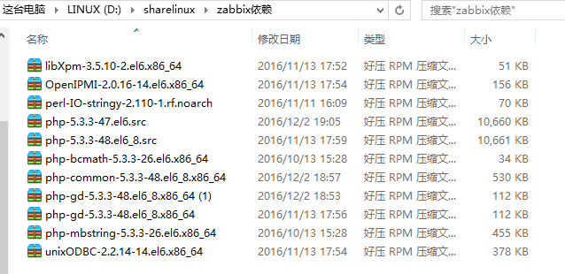
安装过程或许会报错，一般原因是lamp环境没有建好。我的报错是提示缺少依赖包：php-common，php-mbstring，php-bcmath。原因是搭建lamp是php出现问题，没安装好。可以自行下载一些依赖包，如下：

# cd /mnt/hdfs/sharelinux/zabbix依赖
# rpm -ivh *
一般按照报错提示，缺什么下载安装。
安装成功。
6.初始化数据库,创建zabbix数据库
CentOS 7 版本将MySQL数据库软件从默认的程序列表中移除，用mariadb代替了。用mariadb也行。我还是选择了mysql
# Mysql -u root -p
Password:xmr123
mysql> create database zabbix character set utf8 collate utf8_bin;
Query OK, 1 row affected (0.00 sec)

mysql> grant all privileges on zabbix.* to zabbix@localhost identified by 'zabbix'
-> ;
Query OK, 0 rows affected (0.00 sec)

mysql> quit
Bye
测试zabbix数据库连接是否正常：
# mysql -u zabbix -p zabbix
Password：zabbix
[root@Xururu ~]# mysql -u zabbix -p zabbix
Enter password: zabbix
Reading table information for completion of table and column names
You can turn off this feature to get a quicker startup with -A

Welcome to the MySQL monitor. Commands end with ; or \g.
Your MySQL connection id is 121
Server version: 5.6.37 MySQL Community Server (GPL)

Copyright (c) 2000, 2017, Oracle and/or its affiliates. All rights reserved.

Oracle is a registered trademark of Oracle Corporation and/or its
affiliates. Other names may be trademarks of their respective
owners.

Type 'help;' or '\h' for help. Type '\c' to clear the current input statement.

mysql> show databases;
+--------------------+
| Database |
+--------------------+
| information_schema |
| zabbix |
+--------------------+
2 rows in set (0.00 sec)

mysql> quit;
Bye
[root@Xururu ~]#
连接成功。

7.初始数据导入
# cd /usr/share/doc/zabbix-server-mysql-3.0.1/
# pwd
/usr/share/doc/zabbix-server-mysql-3.0.1
# ls
AUTHORS ChangeLog COPYING create.sql.gz NEWS README
# zcat create.sql.gz | mysql -uroot -p zabbix
红色命令注意：易错！！！
8.进行zabbix配置
1、编辑zabbix_server.conf
# grep -n ^[a-Z] /etc/zabbix/zabbix_server.conf
# vim /etc/zabbix/zabbix_server.conf
38:LogFile=/var/log/zabbix/zabbix_server.log
49:LogFileSize=0
72:PidFile=/var/run/zabbix/zabbix_server.pid
81:DBHost=localhost ###此行需要修改，去掉注释即可。
91:DBName=zabbix
107:DBUser=zabbix
115:DBPassword=zabbix ###此行需要修改，去掉注释加上密码。
287:SNMPTrapperFile=/var/log/snmptrap/snmptrap.log
413:Timeout=4
455:AlertScriptsPath=/usr/lib/zabbix/alertscripts
465:ExternalScripts=/usr/lib/zabbix/externalscripts
501:LogSlowQueries=3000

2、启动zabbix server并设置开机启动
# systemctl enable zabbix-server
# systemctl start zabbix-server

3、编辑Zabbix前端PHP配置,更改时区
# vim /etc/httpd/conf.d/zabbix.conf
php_value max_execution_time 300
php_value memory_limit 128M
php_value post_max_size 16M
php_value upload_max_filesize 2M
php_value max_input_time 300
php_value always_populate_raw_post_data -1
php_value date.timezone Asia/Shanghai ###此行需要修改，去掉注释，改成Asia/Shanghai

- 修改配置文件：
#vim /usr/share/zabbix/conf/zabbix.conf.php.example
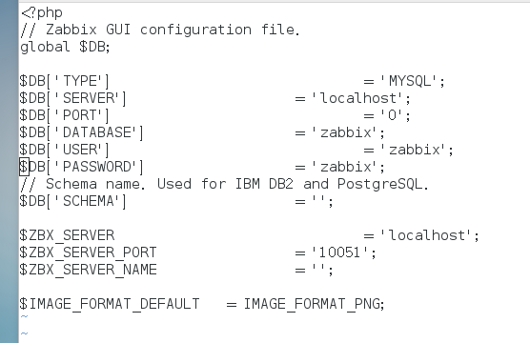
<?php
// Zabbix GUI configuration file.
global $DB;

$DB['TYPE'] = 'MYSQL';
$DB['SERVER'] = 'localhost';
$DB['PORT'] = '0';
$DB['DATABASE'] = 'zabbix';
$DB['USER'] = 'zabbix';
$DB['PASSWORD'] = 'zabbix'; ####密码写入
// Schema name. Used for IBM DB2 and PostgreSQL.
$DB['SCHEMA'] = '';

$ZBX_SERVER = 'localhost';
$ZBX_SERVER_PORT = '10051';
$ZBX_SERVER_NAME = '';

$IMAGE_FORMAT_DEFAULT = IMAGE_FORMAT_PNG;

5、重新启动httpd并设置开机启动
# systemctl restart httpd
# systemctl enable httpd
9.安装Zabbix Web
1、浏览器访问,并进行安装
http://192.168.18.132/zabbix/
显示的界面
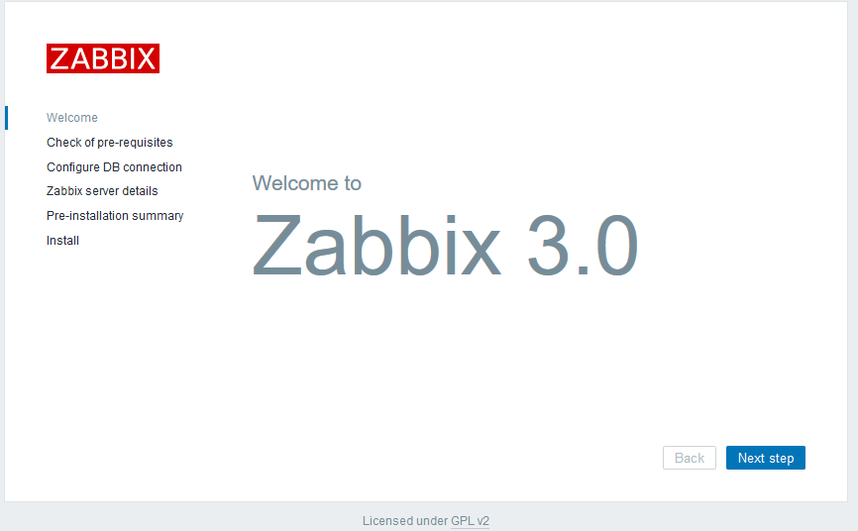
点击next会出现检查状态：
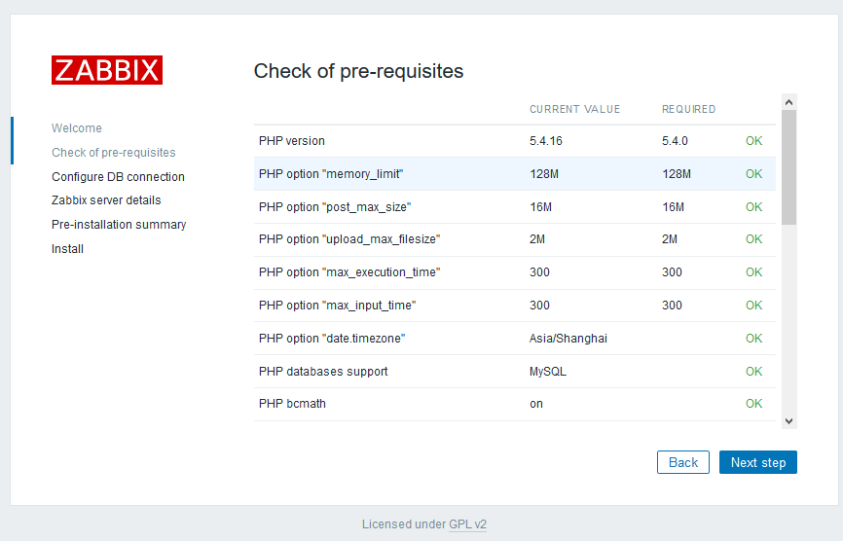
点击next配置mysql:
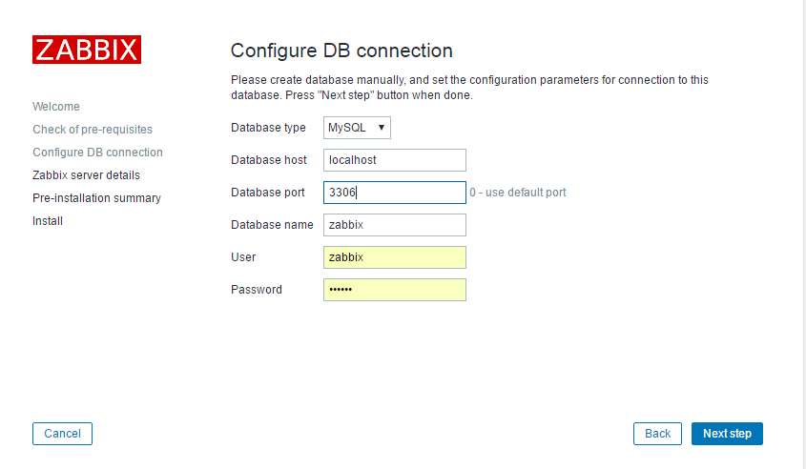
端口改为3306，Password：zabbix
点击下一步。
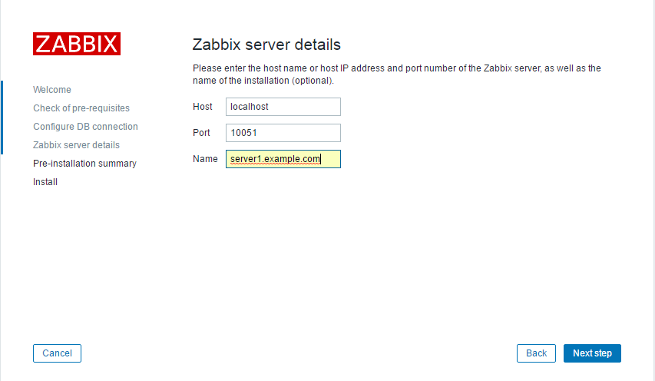
Name是web界面上显示的主机的名字，我这里设为：server1.example.com。
点击Next：
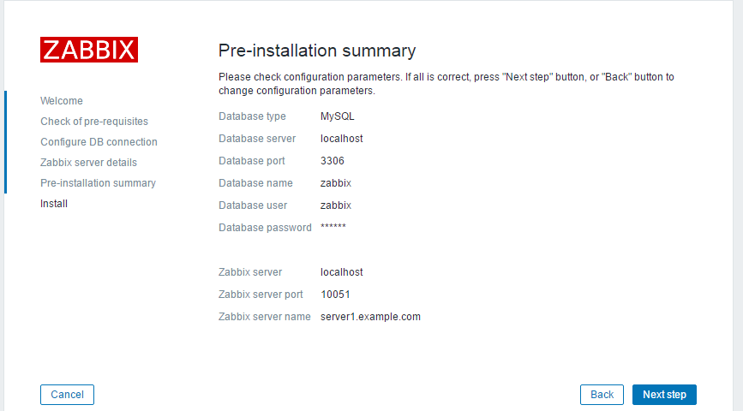
检查一下自己的设置信息。
点击next：
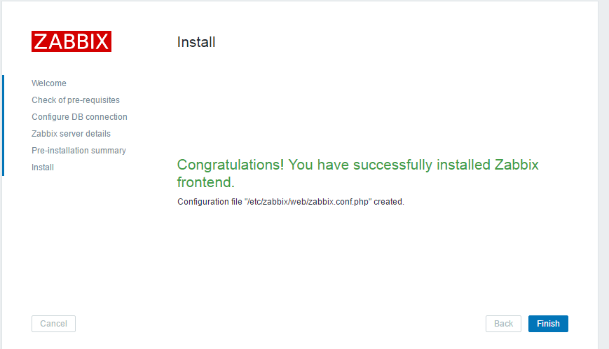
成功。
点击finish：
默认UserName：Admin
Password：zabbix
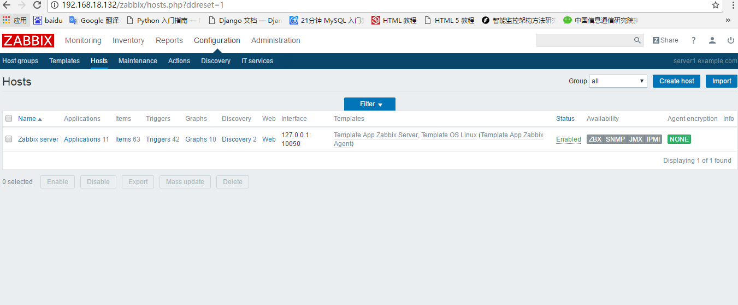
进入zabbix。可以懒到添加的本机，server1.example.com接下来进行自己的配置。

以下有报错！！！！！！！！
centos7.2安装zabbix3，安装好之后web一直出现这个问题



也监控不到数据。
查看zabbix-server.log如下：
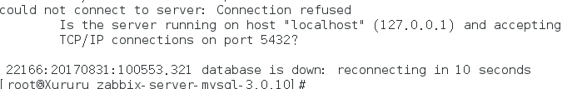
数据库使用的是mysql，也显示有内容：
[root@Xururu ~]# mysql -u zabbix -p zabbix
Enter password: zabbix
Reading table information for completion of table and column names
You can turn off this feature to get a quicker startup with -A

Welcome to the MySQL monitor. Commands end with ; or \g.
Your MySQL connection id is 121
Server version: 5.6.37 MySQL Community Server (GPL)

Copyright (c) 2000, 2017, Oracle and/or its affiliates. All rights reserved.

Oracle is a registered trademark of Oracle Corporation and/or its
affiliates. Other names may be trademarks of their respective
owners.

Type 'help;' or '\h' for help. Type '\c' to clear the current input statement.

mysql> show databases;
+--------------------+
| Database |
+--------------------+
| information_schema |
| zabbix |
+--------------------+
2 rows in set (0.00 sec)

原来安装zabbix3.0过程中默认安装了zabbix-server-pgsql zabbix-web-pgsql导致端口 冲突，需要删除。
# yum remove zabbix-server-pgsql zabbix-web-pgsql
显示如下：
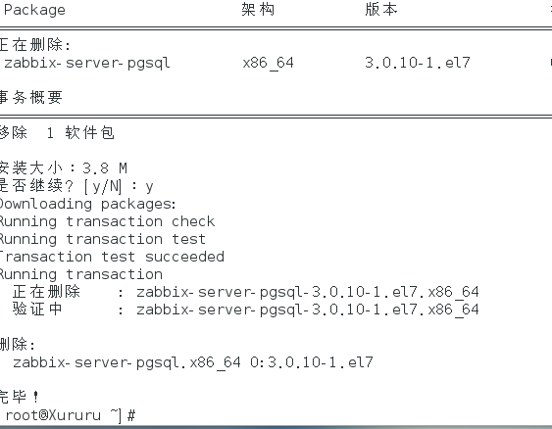
果然！！！！！！！！由于系统安装了pgsql！！！
删除后重启：
systemctl restart zabbix-server.service
systemctl restart zabbix-agent.service
Mysql
Httpd
然后重新打开web显示如下:
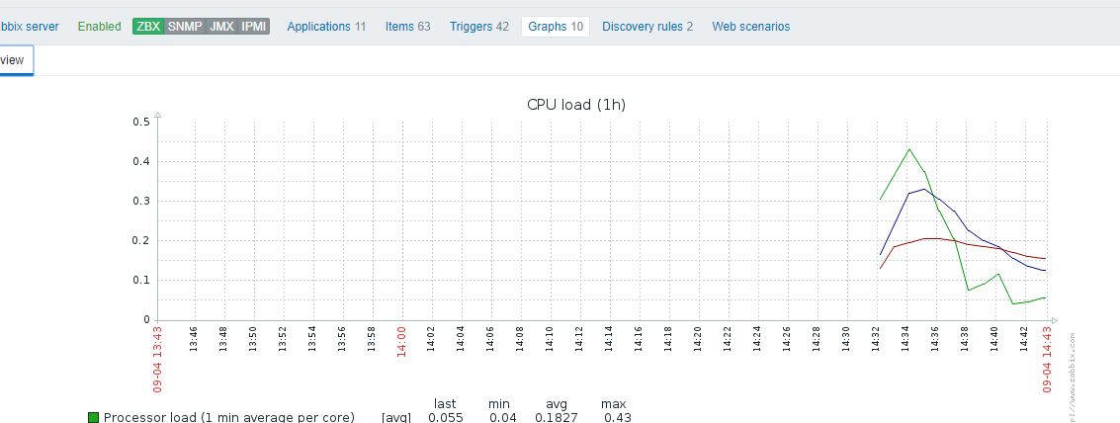

!!!!!!!!!!!!!!!!!!!!!!排错成功！！！！！！！！

