BIT 55469– Mobile Application Development
ENHANCED PROFESSIONAL STUDENT LOGBOOK
Student Name: JOHN WAWERU
Admission Number: BIT/2024/55469
School/Faculty: COMPUTING & INFORMATICS
Programme: BSCIT
Academic Year: 3
Semester: 2
Lecturer: MICHEAL NYORO
Phone Number: 0702154545

Instructions
This logbook is used to document weekly learning activities, practical exercises, skills acquired, challenges encountered, solutions applied, and reflections. Students should complete all sections every week.
Each week to follow remarks in week 1 section.

Autogenerated Table of content

Week 1: Introduction to Mobile Application Development

Practical Activities Undertaken
only screenshots needed and labeling
Screenshots/Evidence Attached (Yes/No)

Tools/Software Used
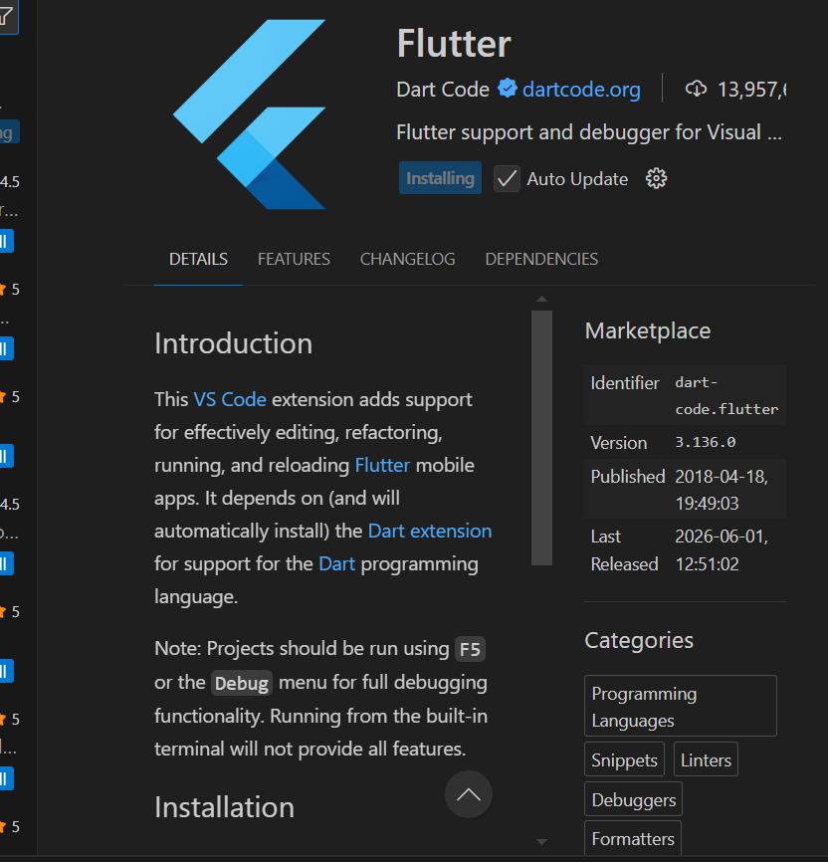
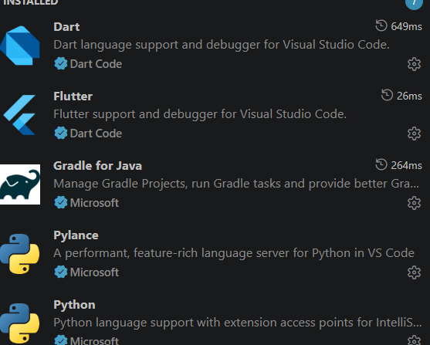

Personal Reflection (not more than 50 words)
Learned how to set up Flutter, VS Code, and Android studio emulator. Gained understanding of project initialization and environment configuration.

Week 2: Mobile Development Environment
Same as week 1
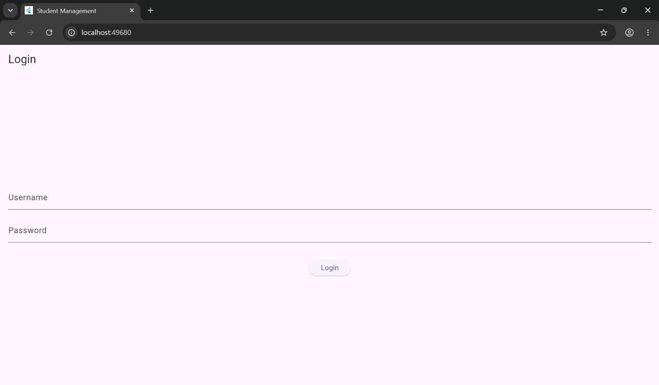
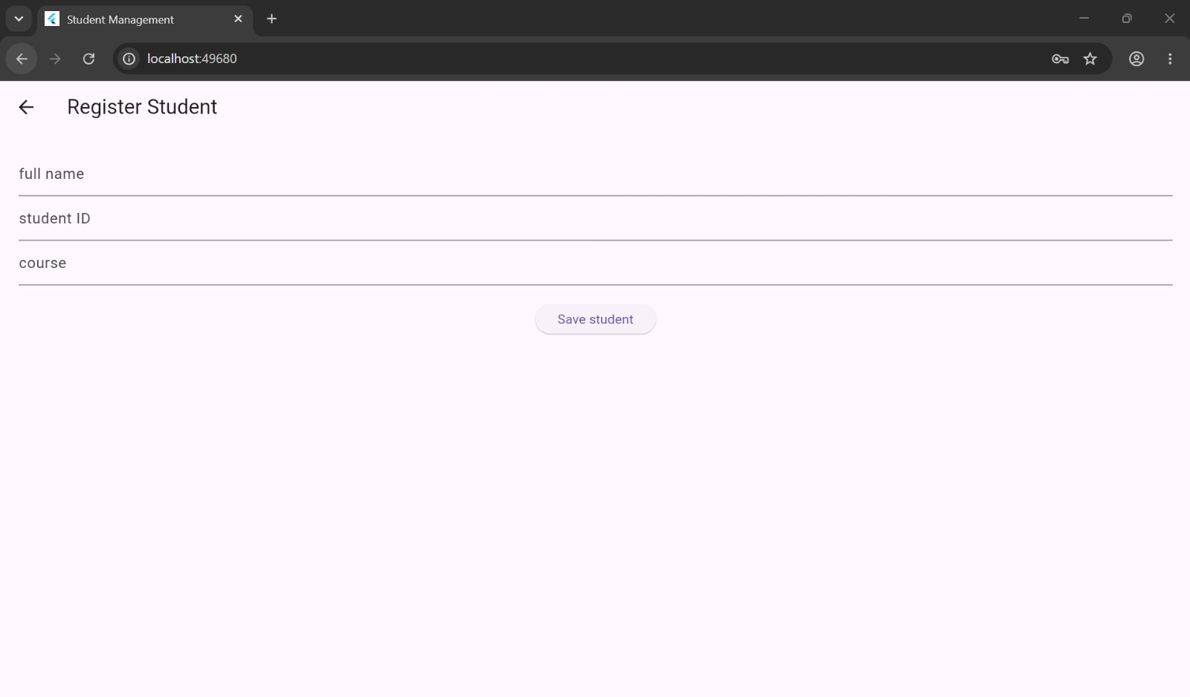

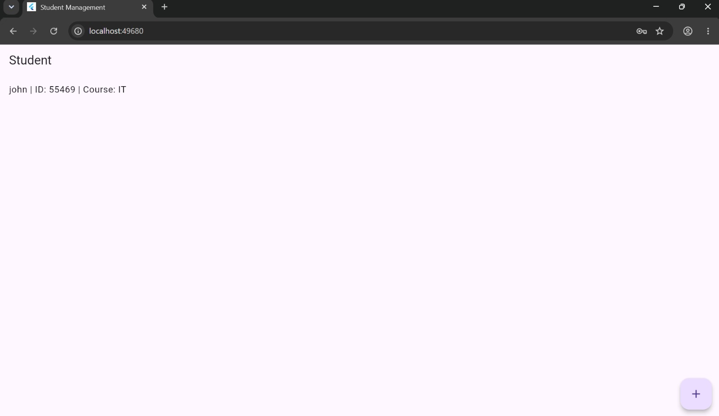
PERSONAL REFLECTION
Learned Flutter UI development and navigation between multiple screens. Improved understanding of widgets and layout design while building the login, role, and dashboard screens.

Week 3: User Interface Design
Login page
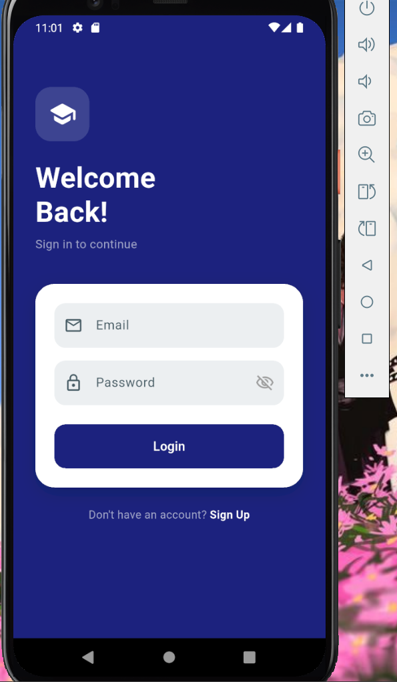

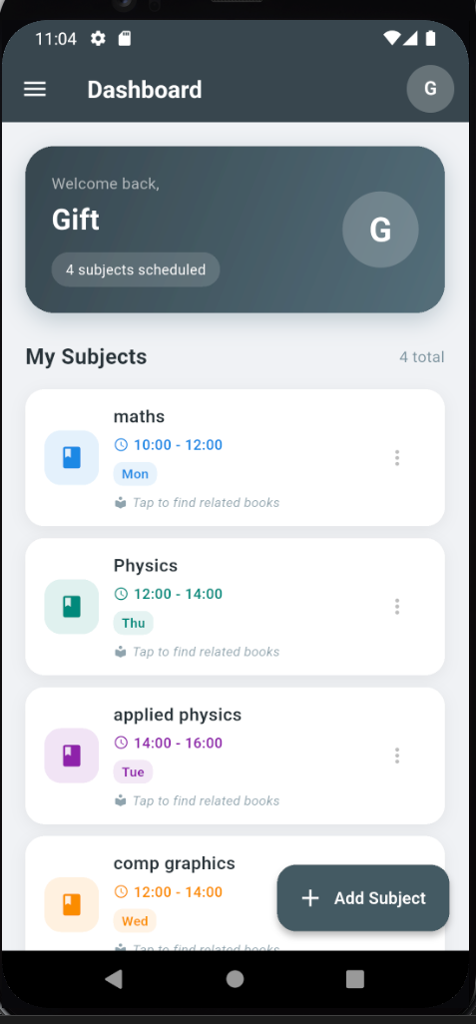

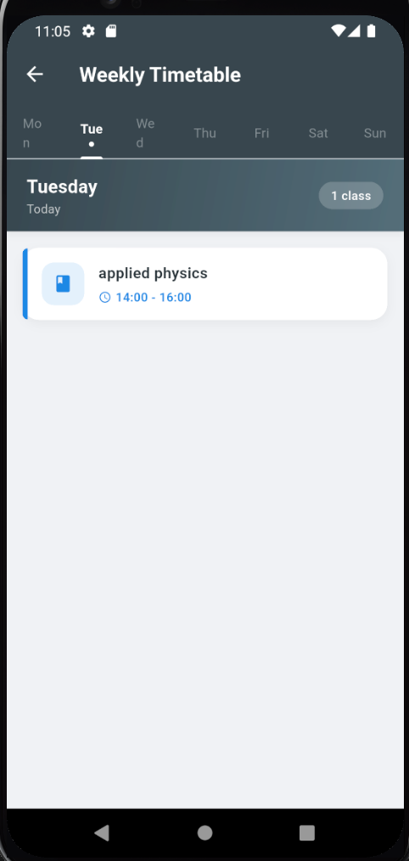

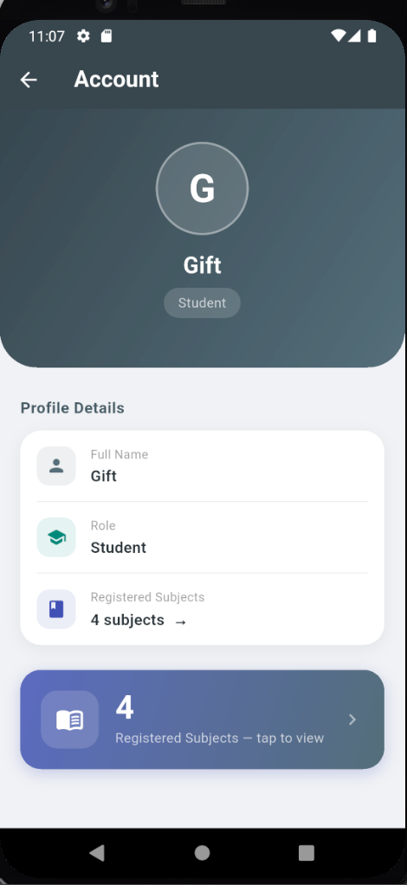

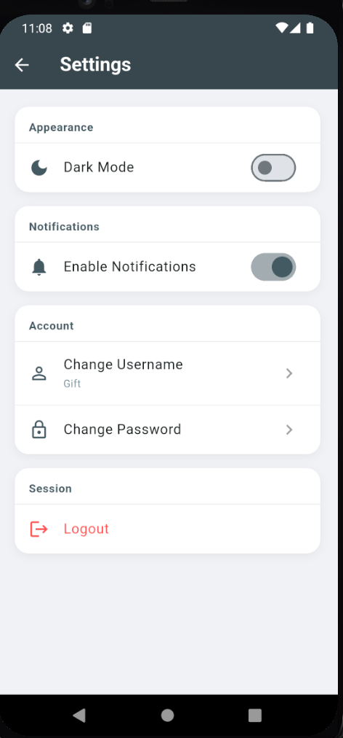

PERSONAL REFLECTION
Gained experience in UI/UX design using Figma.

Week 4: Event Handling and User Interaction
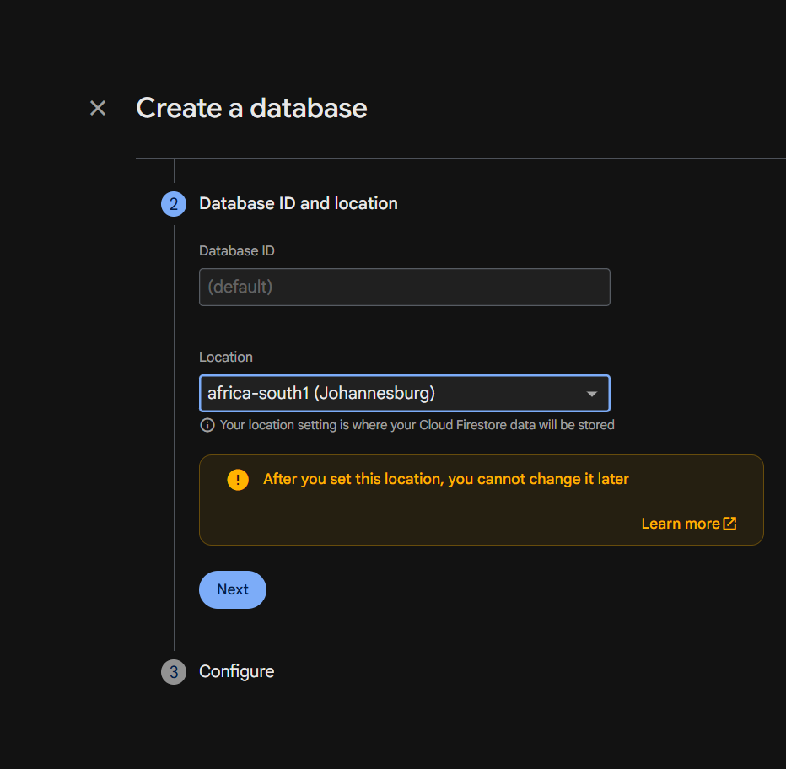

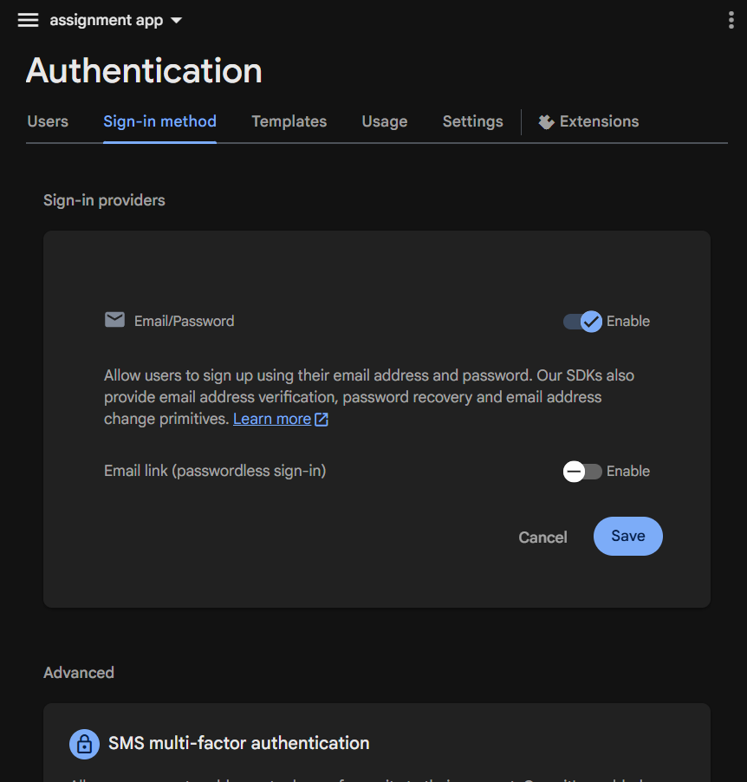

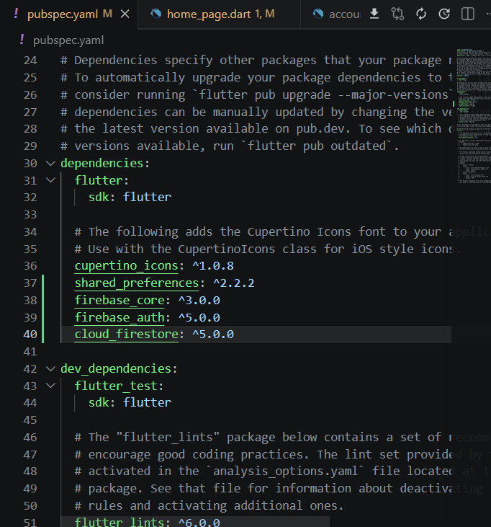
Addition of firebase dependancies
PERSONAL REFLECTION
Learnt how to add databases using firebase where I store login and signup data in cloud storage and how to integrate it to my app and how to delete data from the storage

Week 5: Networking and APIs

Added google api to my app so that I can be able to see books on the subjected registered/added

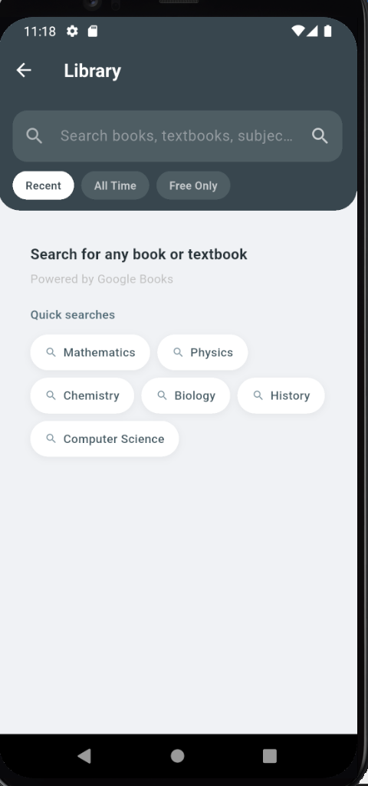

added url launcher inorder to call on Google API for finding and viewing books online

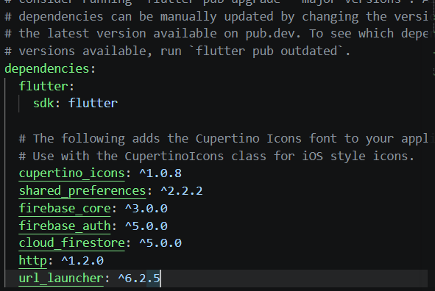
PERSONAL REFLECTON
Learnt how to connect my app yo exsting apis and networks

Week 6:

Same as week 1

Week 7: Application Architecture

Same as week 1

Week 8: Project Planning

Week 9: Device Features and Sensors

Same as week 1

Week 10: Notifications and Background Services

Same as week 1

Week 11: Mobile Security

Same as week 1

Week 12: Testing and Debugging

Same as week 1

Week 13: Application Deployment

Same as week 1

Week 14: Final Project Presentation

Same as week 1

Semester Project Tracking

Project Title

Project Objectives

Project Requirements

Development Milestones

Testing Results

Lessons Learned

Future Improvements

End of Semester Reflection

Summary of Skills Acquired

Most Interesting Topic

Major Challenges Faced

How Challenges Were Overcome

Professional Growth Achieved

Overall Course Experience

Final Approval
Student Name: __________________________
Student Signature: ______________________
Date: _________________________________
Lecturer Name: _________________________
Lecturer Remarks: _____________________
Date: _________________________________

