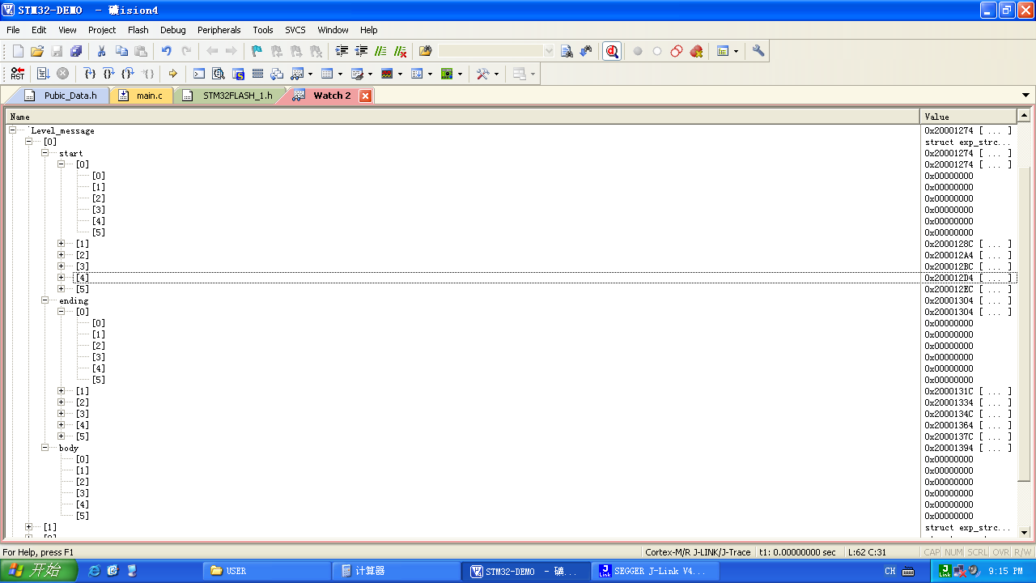
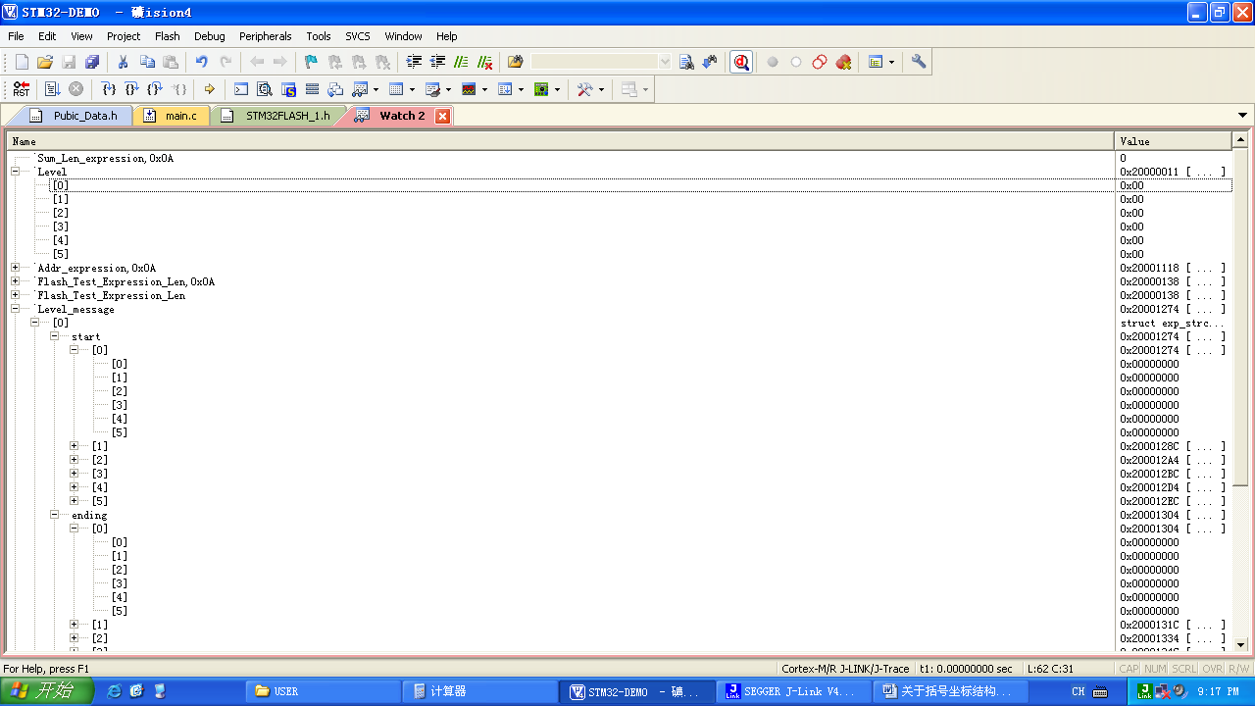
Level[i]:0-- Level[i] 即实际层数为Level[i]+1 i:是组序号数 组数i+1

2017-10-05
Build target 'Target 1'
linking...
Program Size: Code=50740 RO-data=1108 RW-data=2104 ZI-data=18336
FromELF: creating hex file...
"..\OUTPUT\主板LED.axf" - 0 Error(s), 0 Warning(s).

