Director’s Fee Database
Design Change Document
2.5.2 – Attendance Fee Reports
Version 1.1
Last Updated: 04/04/2008
DOCUMENT CHANGE RECORD
Date | Version | Updated by | Change Details
05/14/2008 | 1.0 | CONJHK | Initial change specification
05/22/2008 | 1.1 | CONJHK | Updated with the Messages table. New rules about the handling of the form of payment if none is supplied in the data.

APPROVAL RECORD
Name | Organization | Project Role | Signature | Date

An approval is required for compliance to provide evidence that design specifications (including appropriate application controls) and an appropriate development methodology were prepared and approved.
TABLE OF CONTENTS
JOhnIntroduction 5
Purpose 5
Scope 5
Definitions, Acronyms, and Abbreviations 5
References 5
Overview 5
Use Case Scenarios 6
Object Changes 7
Diagram: Object Model – Main Subsystem 7
Diagram: Object Model – Messaging Subsystem 8
Form: Menu Form (Switchboard: Print) 9
Form: frmAttdFeeReports 9
Query: qapdTempAttdFee_GetData 10
Query: qrptAttdFee 10
Query: qrptAttdFee_FeeRequest 10
Report: rptAttdFee (Attendance Fee Report) 10
Report: rptAttdFee_FeeRequest 10
Table: ttmpAttdFeeReports (Temporary Table) 10
Rules 10
Component Model 10
Data Model 11
Table: ttmpAttdFeeReports (Temporary Table) 11
Security 12

Introduction

Purpose
This document provides a comprehensive architectural overview of the changes to be made to the Director’s Fee Database system to implement the 2.5.2 functional requirements document.

Scope
The changes being made are limited to the Director’s Fee Database application as detailed in this document.

Definitions, Acronyms, and Abbreviations
<<None>>

References
<<None>>

Overview
The functional requirements for DFD version 2.5.2 are summarized as requesting:
- Creation of a new report to detail the Attendance Fees for Meetings and Retainers.
- Creation of a new report to summarize(total) the data from the previous report.
- Creation of a new form to access the reports and apply criteria to those reports.
- Modification of the Menu form to provide access to the new report selection form.

Use Case Scenarios
The following Use Case Scenarios only cover scenarios affected by this change.

Scenario Name | Description
Open Selection Form | User opens the Attendance Fee Report Selection form
<Includes>  -> Validate Input | Validates the options set on the selection form. Confirms that at least one option for fees is selected.
<Extends>  -> View Fee Report | The Attendance Fee Report is opened in preview mode and is available for printing
<Extends>  -> View Fee Request Report | The Fee Request Report is opened in preview mode and is available for printing

Object Changes
To support the request several objects will have to be created with special design decisions being made.
The data for both of the reports are logically derived from the same dataset. The Fee Request Report is a summarization of the records in the Attendance Fee Report. It is necessary for this data to be synchronized. A race condition for these reports exists in which data entry may cause differences in the datasets. To prevent this issue, data will be first extracted and stored into a temporary table thereby causing a static dataset. The reports will then be based upon the data stored in the temporary table.
Additionally, a separate message logging subsystem will be created to log and report messages related to the validity of the data used for the Attendance Fee and Fee Request Reports. Messages will be created in a message table using queries which perform checks on the data in the temporary table.

Diagram: Object Model – Main Subsystem
A high level view of the object model for the main subsystem, can be seen in the following diagram. This subsystem directly addresses the functional requirements.

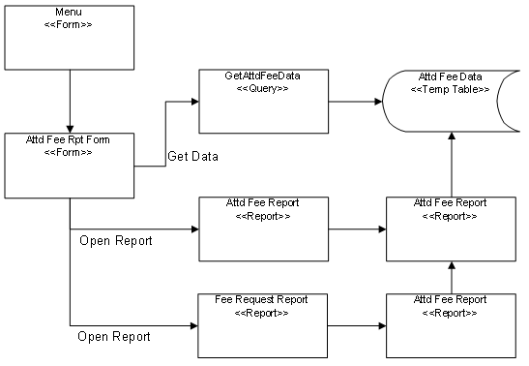

Diagram: Object Model – Messaging Subsystem
A high level view of the object model for the messaging subsystem, can be seen in the following diagram. The requirement for this subsystem was discovered during the technical design phase.
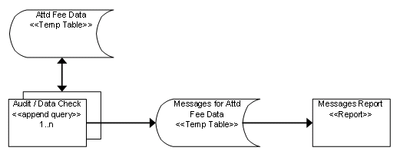

Form: Menu Form (Switchboard: Print)
This existing form will be modified by adding a new button which opens the new form.

Type: | Command Button
Name: | AttdFeeReports_BTN
Caption: | Attendance Fee Reports
Default Value: | N/A
Usage | Opens the new form Attendance Fee Reports Form (frmAttdFeeReports)

Form: frmAttdFeeReports
New form used to set the criteria and open the reports.
Form
Type: | Form
Name: | frmAttdFeeReports
Caption: | Attendance Fee Reports
RecordSource: | None (Unbound)
Usage | Accepts criteria used to retrieve data for the reports. Retrieves the data and appends it to a temporary table.

This form will contain fields as detailed in the Functional Requirements document. The following additional information applies to the button CreateReports_BTN.
Type: | Command Button
Name: | CreateReports_BTN
Caption: | Create Reports
Usage | When this button is clicked the following actions will be taken.  - The temporary table ttmpAttdFeeReports will be emptied  - The temporary table ttmpAttdFeeReports will be populated  - The report rptAttdFee will be opened in print preview mode  - The report rptAttdFee_FeeRequest will be opened in preview mode

Query: qapdTempAttdFee_GetData
This query will append data into the temporary table tmpAttdFeeReport. It will accept several parameters which are used to filter the records that are appended.
Parameters:
- parmBeginDate (Date) – Earliest date of period which MeetingDate must be in
- parmEndDate (Date) – Latest date of period which MeetingDate must be in
- parmInclMeetFees (Boolean) – flag for including Meeting Fees
- parmInclRetFees (Boolean) – flag for including Retainer Fees
- parmFundInitials (Text) – Fund Initials
- parmDirector (Text) – Director Name
Rules:
- Only one

Query: qrptAttdFee
Used by the report rptAttdFee (Attendance Fee Report). The query which retrieves data from the temporary table (tmpAttdFeeReport)

Query: qrptAttdFee_FeeRequest
Used by the report rptAttdFee_FeeRequest (Fee Request). This query summarizes data from the query qrptAttdFee.

Report: rptAttdFee (Attendance Fee Report)
Provides detailed fee information per Director, per Fund. Layout and formulas are detailed in the Functional Requirements document.

Report: rptAttdFee_FeeRequest
Provides totals by Director of the same data found in the report rptAttdFee (Attendance Fee Report). Layout and formulas are detailed in the Functional Requirements document.

Table: ttmpAttdFeeReports (Temporary Table)
This is a table used to temporarily store the data used for the Attendance Fee Reports. See the Data Model section for details.

Rules
<<No Changes>>

Component Model
<<No Changes>>

Data Model

Table: ttmpAttdFeeReports (Temporary Table)
This is a table used to temporarily store the data used for the Attendance Fee Reports.

Field List
Name | Data  Type | Size | Source | Description
RecordID | Long | 8 | Autonumber | Record ID
Crit_DateTimeRun | Date | 8 | System | Date/Time dataset was created
Crit_BeginDate | Date | 8 | Attendance Fee Report Form | Criteria: Begin Date used to filter the dataset
Crit_EndDate | Date | 8 | Attendance Fee Report Form | Criteria: End Date used to filter the dataset
Crit_Fund | Text | 10 | Attendance Fee Report Form | Criteria: Fund code used to filter the dataset
Crit_DirectorName | Text | 50 | Attendance Fee Report Form | Criteria: Director Name used to filter the dataset
DirectorName | Text | 50 | Meetings2.[Attendee Name] | Name of Director that attended the meeting
FundNumber | Integer | 2 | Meetings1.[Fund Number] | Record ID for the current record’s Fund Code
FundInitials | Text | 12 | [Fund Name].[Fund Initials] | Fund Code/Initials
MeetingType | Text |  | Meetings1.[Type of Meeting] | Meeting Type
MeetingDate | Date | 8 | Meetings1.[Date of Meeting] | Meeting Date
MeetingLocation | Text | 30 | Meetings1.[Location of Meeting] | Meeting Location
MeetingUS | Yes/No | 1 | Meetings1.[US Meeting] | Meeting is in the US
MeetingFee | Currency | 8 | Meetings2.[Meeting Fee] | Fee amount for this meeting
MeetingFeeDeferred | Currency | 8 | Meetings2.[Deferred Meeting Fees] | Amount of the MeetingFee that is deferred
Withholding_CA | Currency | 8 | Meetings2.[CA Withholding] | Amount of to withhold from the MeetingFee for CA Withholding
Withholding_Fed | Currency | 8 | Meetings2.[FedWithholding] | Amount of to withhold from the MeetingFee for Federal Withholding
Name | Data  Type | Size | Source | Description
Payment_CheckAmt | Currency | 8 | Meetings2.[CheckAmt] | Amount of the Fees being paid by check
Payment_DirectDepositAmt | Currency | 8 | Meetings2.[DirectDepositAmt] | Amount of the Fees being paid by direct deposit
Payment_WireAmt | Currency | 8 | Meetings2.[WireFeesAmt] | Amount of the Fees being paid by wireless transfer

Security
<<No Change>>

