x
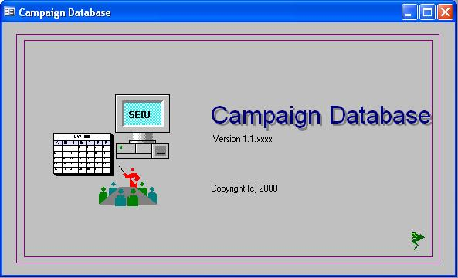

Lead Developer: | Johni A. Kim
Client:
Project: | Campaign Database
Project Sponsor:
Project Manager:

Table of Contents
Table of Contents 2
Synopsis 3
Background 3
System Overview 4
CAMP-DB Application Domain 5
Directory Structure 6
Directory Descriptions/File Locations 6
Documentation 7
Change Log 8
Versioning 9
Business Rules 10
Person Lookup 11
Person Form 14
Comments 15
Notes tab 16
Application Dependencies 17

Synopsis

Background
[Company] maintains information on employees of an organization which [Company] wishes to represent as the labor union for those employees. This information is initially received via various methods such as direct contact, referrals, and information from the employer organization.

The Campaign Database (CAMP-DB) application is being initiated to address the need to maintain data that as part of a campaign effort. The main abilities of CAMP-DB are:

- Storage of Employee demographic information such as contact info
- Storage of information regarding the target organizations structure and work units
- Receive data files from an Employer’s system containing employee information.
- View and Edit Person data
- Log Assessments over time, with full history.

_________________________________________

System Overview
CAMP-DB is currently comprised of a single stand alone application plus data files. The stand alone application provides a specific and well-defined set of functionality for managing CAMP-DB records.
The primary files that make up CAMP-DB are:
- CAMP_FE.mdb – Campaign Database Front End (Main Application file) : user interface and application functionality.
- CAMP_BE.mdb : Main Backend File (Production Data) : official data store for the CAMP-DB application.
- CAMP_Temp.mdb : Temporary Data. Used for storing non-permanent data that is utilized as part of a process such as loading data files.
- Campaign.mdw : Security Workgroup File. Defines Users and Groups and is used by the other files to establish permissions.

A overview of the application domain including applications and data files can be seen in figure 1.

CAMP-DB Application Domain
Primary Applications and data stores that comprise CAMP-DB
Date: 2007.11.04
=
CAMP_BE
<<Main Data>>
CAMP_Temp
<<Temporary Data>>
Application
Data
HR Data
<<text file>>
CAMP_FE.mdb
<<Main App>>
Figure 1: CAMP-DB Applications and Data Files

Directory Structure
A standardized directory structure is used to clearly isolate system components, supporting documentation, and data files.

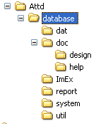
Figure 2: Sample Directory Structure

Directory Descriptions/File Locations
database directory : Application root directory. The main user application file is stored here.

dat directory: contains the backend data files: <<todo: determine file names>>

doc directory: contains system documentation such as design, modeling, and reference documents.

ImEx directory: contains files imported into or exported from CAMP-DB.

report directory: contains reports generated from CAMP-DB in the Microsoft Snapshot format.

system directory: contains the security workgroup file and supplemental library used by CAMP-DB.

util directory: contains adhoc applications that were run against the system. This provides the ability to see the exact steps performed when doing a one-time action.

Documentation
A two tiered approach has been used in documentation. Both approaches are designed to supplement each other. The two approaches are:

- Internal – includes populating object properties where applicable with descriptive information, an application Change Log which stores changes made to the application, and Data Model reports which display the data model being used.
- External – includes documents that are stored externally to the application. These can include different file types such as MS Word or MS Excel files. Documents such as ER diagrams, flow charts, data dictionaries, and User Manuals fall into this category.

Documentation, other than the User Manuals, is geared towards administration and development teams. The purpose is to provide functional information on application intended behavior.

Change Log
Each application includes a Change Log that contains information on changes made to the application. This change log is stored locally within the application. This insures that information on the applications change history is always available and helps to identify the version of an application.

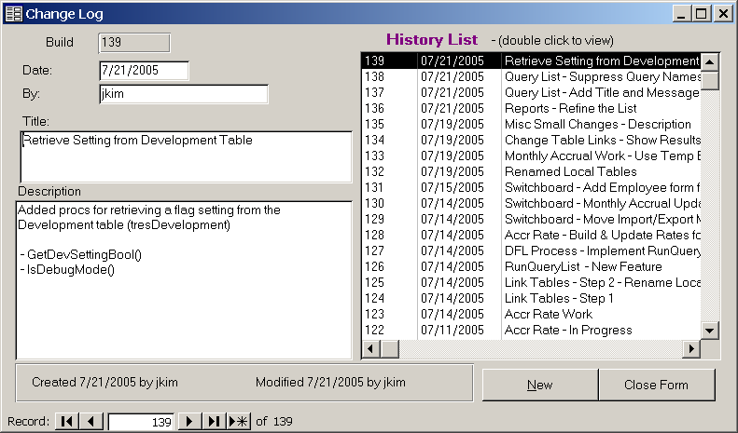
Figure 3: The Change Log

The following information is included in each change log record.

- Build Number/Change Number
- Developer’s Name
- Title – short description of the change
- Description – free text memo entered by the developer

The Build Number is automatically assigned to each entry and is used as a portion of the application’s version number.

The standard method for entering the Description is to provide a summary of the purpose of the change and the objects that were changed.

The Change Log can be printed using the Change Log report, which is available in each application, or may be exported to an Excel file.

Versioning
Each application is versioned using Major Revision, Minor Revision, Build Number in the format #.#.####. Each of these numbers is stored internally within the application and is set by the development/production release team.

- Major Revision – denotes a major interface or functional change form a prior version. This includes the addition or removal of high profile functionality.
- Minor Revision – denotes a change, addition, or extension of application functionality that has minor impact on the application as a whole.
- Build Number – denotes the revision history of the application. This the actual number of changes logged within the application. This value is obtained from the Change Log discussed earlier.

The version number of an application can be located in the following locations:

- Main Switchboard
- Application Startup/Splash screen

Business Rules
The definitions of Business Rules are stored locally within the application. When a rule is defined it is entered into the application using the Business Rules form. This insures that Business Rules used to design an application are available for review or reference.

The rule as defined by an authority is entered, along with development team notes on the intended implementation plan for that rule. This is an invaluable aide when maintaining the application. This provides a mechanism for validating application design by comparing application behavior with the Business Rule definition. It also provides a reference when a developer or application administrator needs to determine what actions should be taken in a particular scenario.

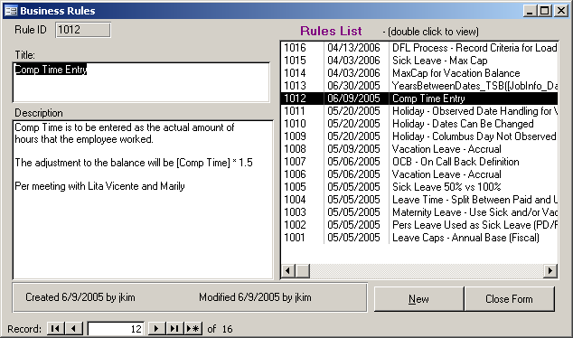
Figure 4: Business Rules form

Person Lookup
Selecting “Person Lookup” from the Main Switchboard opens the Person Lookup form.

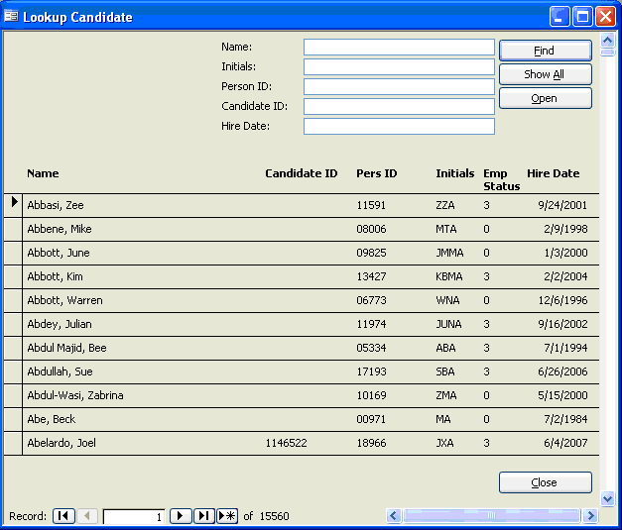
Figure 2: The Person Lookup form

The Person Lookup form allows searching for an associate by any combination of the following criteria:
- Name
- Initials
- Person ID – (Internal Database ID)
- Employee/Candidate ID – (Assigned by the Employer Organization)
- Hire Date

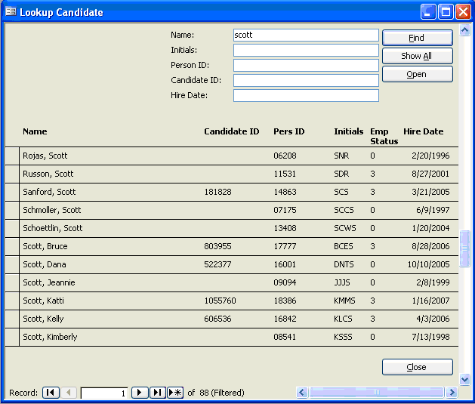
Figure 3a: Employee Lookup form after entering search criteria of “scott”

The text base search fields (Name, Initials) incorporates search logic which will find the text entered anywhere within the field being searched. For example; figure 3a displays the result of looking for the text ‘scott’ in the name. The results include records where ‘Scott’ is the first name, as well as records that include ‘Scott’ as the last name.

Each additional character refines the results even further. For example; to limit the list to only those records that have the last name of Scott you would simply add a comma after the name such as in figure 3b below.

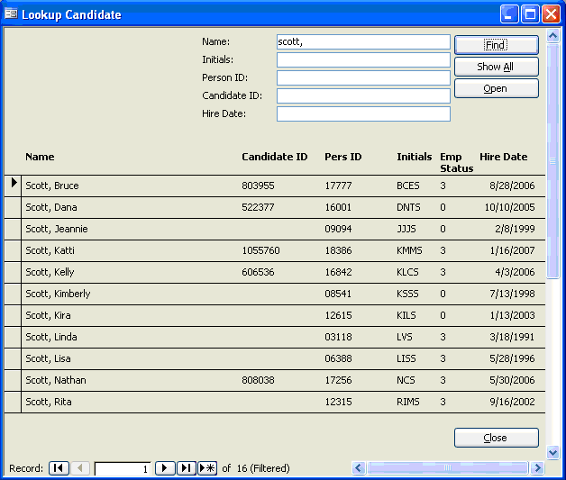
Figure 3b: Employee Lookup form after entering search criteria of “scott,”

Double-clicking a Person record, or selecting it and clicking the “Open” button, will open the Person form at the selected Person’s record.

Person Form
The Person form is accessed by selecting “Person Form” from the Main Switchboard or opening it from the Person Lookup form.

Figure 4: The Person Form

The Person form contains primary fields which are always visible as well as additional fields located on various tabs. Various features can be accessed by selecting the appropriate tab on the Person form.

The top of the form and the first tab displays demographic and contact information for that Person.

Comments
The Comments is a free text field that displays the Comments which should be highly visible for a Person’s record. This comment is specific to the Person record that is currently loaded into the tab control.

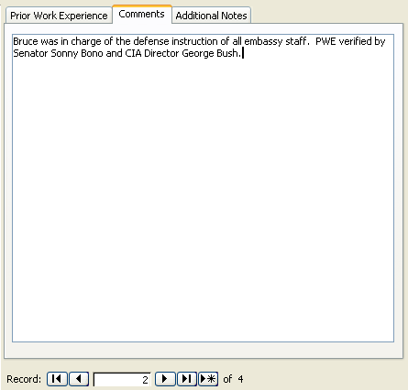
Figure 6: The Comments tab on the Person Form

Notes tab
The Notes tab allows an unlimited number of notes to be entered for a Person record. These notes are free form and have a character limit exceeding 65,000 characters. Multiple users will be able to enter individual notes without effecting notes entered by other users.

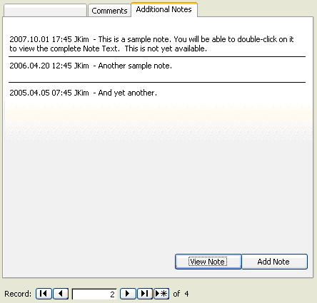
Figure 7: The Additional Comments tab on the Person Form

Application Dependencies
<<<To Be Completed>>

