LMS IPPS Update

DTS Diagram
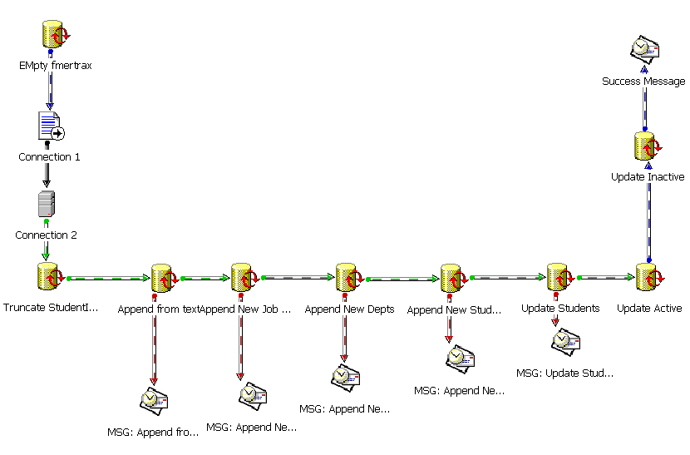

Empty fmertrax
--------------------------------------------------------------------------------------------------------------------------------------------
TRUNCATE TABLE fmertrax

Connection 1
--------------------------------------------------------------------------------------------------------------------------------------------
Text File (Source)
File Name: \\redacted\apps$\LMS\Production\Data\fmertrax.txt

Connection 2
--------------------------------------------------------------------------------------------------------------------------------------------
Server: redacted
Database: lms
Authentication: SQL Server

1) Transform Data
--------------------------------------------------------------------------------------------------------------------------------------------
Copy Data from fmertrax to [lms].[dbo].[fmertrax] Task. Direct Copy
Source: Connection 1
Destination: Connection 2
Destination Table: [lms].[dbo].[fmertrax]

2) Truncate StudentImport
--------------------------------------------------------------------------------------------------------------------------------------------
TRUNCATE TABLE StudentImport

3) Append from text to Student Import - spAppendStudentImport
--------------------------------------------------------------------------------------------------------------------------------------------
Run procedure spAppendStudentImport

CREATE PROCEDURE dbo.spAppendStudentImport
AS INSERT INTO dbo.StudentImport
(StudFirst, StudMI, StudLast, StudBadge, DeptCode, JCID, StudTitle, StudEmpType, StudStatus, DivID, dtStudHire, dtStudBirth)
SELECT RTRIM(Col002) AS Expr1, RTRIM(Col004) AS Expr2, RTRIM(Col006) AS Expr3, CONVERT(int, Col008) AS Expr4, Col010, CONVERT(int, Col012) AS Expr5,
Col014, Col022, Col024, CONVERT(int, Col026) AS Expr6, CONVERT(datetime, Col028, 121) AS Expr7, CONVERT(datetime, Col030, 121) AS Expr8
FROM dbo.fmertrax

GO

4) Append New Job Classes - spAppendNewJobClasses
--------------------------------------------------------------------------------------------------------------------------------------------
CREATE PROCEDURE dbo.spAppendNewJobClasses
AS INSERT INTO dbo.JobClass
(JCID, JCTitle, fActive, userCreated, dtCreated, userModified, dtModified)
SELECT DISTINCT
dbo.StudentImport.JCID, dbo.StudentImport.StudTitle, 1 AS Expr1, 'LMS' AS Expr2, GETDATE() AS Expr3, 'LMS' AS Expr4, GETDATE() AS Expr5
FROM dbo.StudentImport INNER JOIN
dbo.vwNewJobClasses ON dbo.StudentImport.JCID = dbo.vwNewJobClasses.JCID

GO

5) Append New Depts - spAppendNewDept
--------------------------------------------------------------------------------------------------------------------------------------------
CREATE PROCEDURE dbo.spAppendNewDept
AS INSERT INTO dbo.Dept
(DeptCode, fActive, DeptDesc, userCreated, dtCreated, userModified, dtModified)
SELECT DISTINCT
dbo.StudentImport.DeptCode, 1 AS Expr1, 'NEW-FILL IN DEPT DESC' AS Expr2, 'LMS' AS Expr3, GETDATE() AS Expr4, 'LMS' AS Expr5, GETDATE()
AS Expr6
FROM dbo.StudentImport INNER JOIN
dbo.vwNewDeptCodes ON dbo.StudentImport.DeptCode = dbo.vwNewDeptCodes.DeptCode

GO

6) Append New Students - spAppendNewStudent
--------------------------------------------------------------------------------------------------------------------------------------------
CREATE PROCEDURE dbo.spAppendNewStudent
AS INSERT INTO dbo.Student
(WebLogin, StudBadge, StudFirst, StudLast, StudMI, fOCTA, DeptCode, DivID, JCID, StudTitle, StudStatus, StudEmpType, dtStudHire, dtStudBirth,
userCreated, dtCreated, userModified, dtModified)
SELECT dbo.StudentImport.StudBadge, dbo.StudentImport.StudBadge AS Expr1, dbo.StudentImport.StudFirst, dbo.StudentImport.StudLast,
dbo.StudentImport.StudMI, dbo.StudentImport.fOCTA, dbo.StudentImport.DeptCode, dbo.StudentImport.DivID, dbo.StudentImport.JCID,
dbo.StudentImport.StudTitle, dbo.StudentImport.StudStatus, dbo.StudentImport.StudEmpType, dbo.StudentImport.dtStudHire,
dbo.StudentImport.dtStudBirth, N'LMS' AS Expr2, GETDATE() AS Expr3, N'LMS' AS Expr4, GETDATE() AS Expr5
FROM dbo.StudentImport INNER JOIN
dbo.vwNewStudent ON dbo.StudentImport.StudBadge = dbo.vwNewStudent.StudBadge

GO

7) Update Students - spUpdateStudent
--------------------------------------------------------------------------------------------------------------------------------------------
CREATE PROCEDURE dbo.spUpdateStudent
/*
** ObjectName: dbo.spUpdateStudent
**
** Description: Used as to Update information from the Lawson
** download text file.
**
** Notes: Run automatically from DTS package as a batch process nightly.
**
**
** Revision History:
** ----------------------------------------------------------------------------
** Date Name Description
** ----------------------------------------------------------------------------
** XXX XXXXXX Initial Creation
** 4/29/05 Johni A. Kim Added 4 more fields to update
**
*/
AS
UPDATE dbo.vwUpdateStudent

SET StudFirst = StudFirstX,
StudLast = StudLastX,
StudMI = StudMIX,
fOCTA = fOCTAX,
DeptCode = DeptCodeX,
DivID = DivIDX, JCID = JCIDX,
StudTitle = StudTitleX,
dtStudHire = dtStudHireX,
dtStudBirth = dtStudBirthX,
userModified = N'LMS',
dtModified = GETDATE(),
/* Added the following 4 fields - JKim 4/29/05*/
StudTypeID=StudTypeIDX,
StudStatus=StudStatusX,
StudEmpType=StudEmpTypeX,
fActive=fActiveX
GO

8) Update Active - spUpdateActiveStudent
--------------------------------------------------------------------------------------------------------------------------------------------
CREATE PROCEDURE dbo.spUpdateActiveStudent
AS UPDATE dbo.Student
SET fActive = 1
WHERE (StudStatus = 'A')

GO

9) Update Inactive - spUpdateInActiveStudent
--------------------------------------------------------------------------------------------------------------------------------------------
CREATE PROCEDURE dbo.spUpdateInActiveStudent
AS UPDATE dbo.Student
SET fActive = 0
WHERE (StudStatus = 'T')

GO

