**TASK 1**

Importing OSM points and exporting them to a geojson file.

To import 50 points representing Alpine huts, I installed the Overpass API on my python working environment (Jupyter) IDE environment.

After, I used the API codes to query 50 Alpine huts in Europe using the Tag: tourism=alpine_hut. The results include OSM data which was extracted as shown in figure 1.

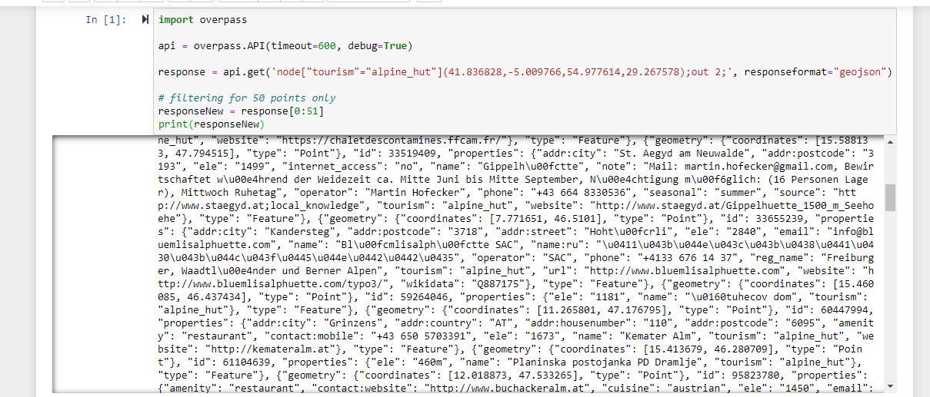

Figure 1: Extracted Open Street Map data

After, I copied the OSM data features to <http://geojson.io/> to visualize the “Alpine hut” located in Europe on the Map. As shown in figure 2, most of the alpine huts are located in Austria, Switzerland and Bulgaria. The OSM data was copied and saved on a notepad as a geojson file. The python working environment was saved as OSM_Overpass.ipynb.

**Bonus:** I created a leaflet page to visualize the map on the web which makes it more interactive for potential users.

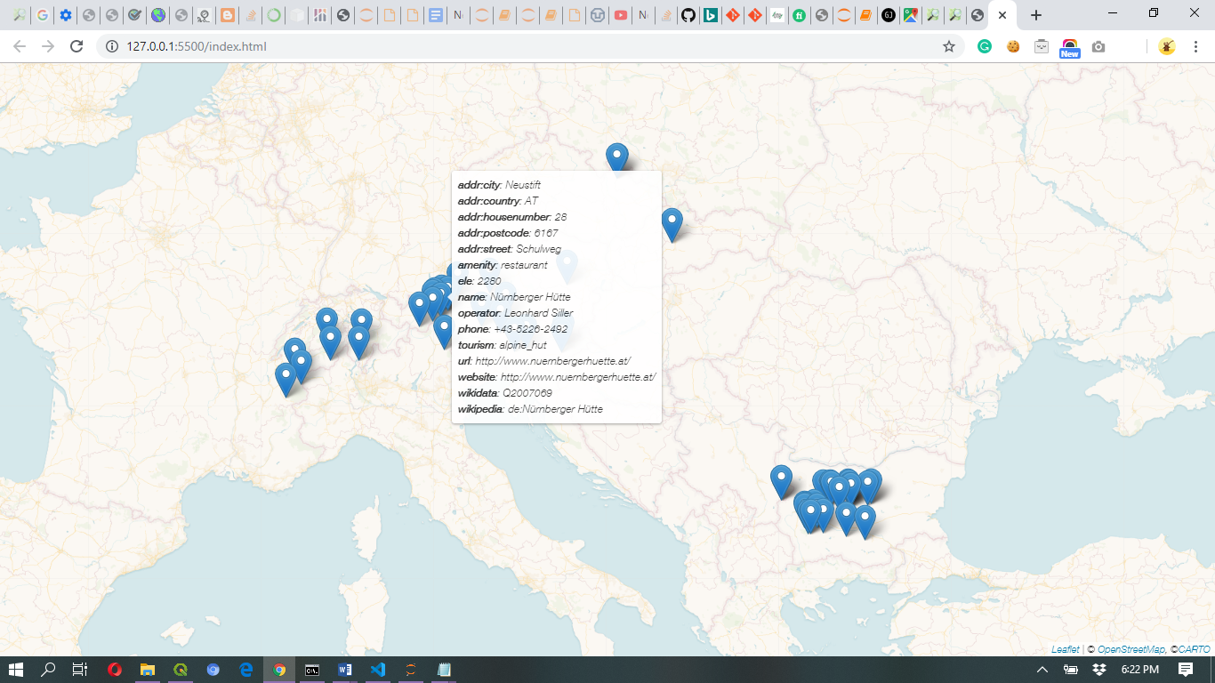

Figure 2: Showing 50 Alpine huts location in Europe.

**TASK 2**

Splitting of Raster Image using GDAL

**- #To split the image into GDAL, I generated a terminal command line**

Something like this…

“gdal2tiles.py --zoom=9 lasvegas_tm5_07jun04_crop_geo.tif output”

Note: Image name is “lasvegas_tm5_07jun04_crop_geo.tif output”

- **#To get the general info of the image I used a command line…**

Something like this…..

“gdalinfo lasvegas_tm5_07jun04_crop_geo.tif”

- **#To get the SRS of the image, I used a command line…**

Something like this….

“gdalsrsinfo lasvegas_tm5_07jun04_crop_geo.tif”

The info extracted include:

'''

PROJ.4 : '+proj=utm +zone=11 +datum=WGS84 +units=m +no_defs '

OGC WKT :

PROJCS["WGS 84 / UTM zone 11N",

GEOGCS["WGS 84",

DATUM["WGS_1984",

SPHEROID["WGS 84",6378137,298.257223563,

AUTHORITY["EPSG","7030"]],

AUTHORITY["EPSG","6326"]],

PRIMEM["Greenwich",0,

AUTHORITY["EPSG","8901"]],

UNIT["degree",0.0174532925199433,

AUTHORITY["EPSG","9122"]],

AUTHORITY["EPSG","4326"]],

PROJECTION["Transverse_Mercator"],

PARAMETER["latitude_of_origin",0],

PARAMETER["central_meridian",-117],

PARAMETER["scale_factor",0.9996],

PARAMETER["false_easting",500000],

PARAMETER["false_northing",0],

UNIT["metre",1,

AUTHORITY["EPSG","9001"]],

AXIS["Easting",EAST],

AXIS["Northing",NORTH],

AUTHORITY["EPSG","32611"]]

'''

-**# For reprojection of the SRS EPSG 3857, resampled using cubic resampling and compressed using LZW, I used a command line…**

“gdalwarp -t_srs EPSG:3857 -r "cubic" -co "COMPRESS=LZW" lasvegas_tm5_07jun04_crop_geo.tif output.tif”

'''

Creating output file that is 2187P x 2197L.

'''