Crop Experiment ANOVA & LSD Report

# rep

ANOVA Table:

|  |  |  |  |  |
| --- | --- | --- | --- | --- |
| Source | sum_sq | df | F | PR(>F) |
| C(mulch_rate) | 0.0000 | 4.0000 | 0.0000 | 1.0000 |
| Residual | 10.0000 | 10.0000 | - | - |

# perc_emergence

ANOVA Table:

|  |  |  |  |  |
| --- | --- | --- | --- | --- |
| Source | sum_sq | df | F | PR(>F) |
| C(mulch_rate) | 979.1667 | 4.0000 | 1.4687 | 0.2827 |
| Residual | 1666.6667 | 10.0000 | - | - |

# plant_height_2was

ANOVA Table:

|  |  |  |  |  |
| --- | --- | --- | --- | --- |
| Source | sum_sq | df | F | PR(>F) |
| C(mulch_rate) | 6.6873 | 4.0000 | 0.3620 | 0.8302 |
| Residual | 46.1814 | 10.0000 | - | - |

# no_of_leaves_2was

ANOVA Table:

|  |  |  |  |  |
| --- | --- | --- | --- | --- |
| Source | sum_sq | df | F | PR(>F) |
| C(mulch_rate) | 1.7333 | 4.0000 | 0.5098 | 0.7302 |
| Residual | 8.5000 | 10.0000 | - | - |

# stem_girth_2was

ANOVA Table:

|  |  |  |  |  |
| --- | --- | --- | --- | --- |
| Source | sum_sq | df | F | PR(>F) |
| C(mulch_rate) | 4.3448 | 4.0000 | 3.1449 | 0.0645 |
| Residual | 3.4538 | 10.0000 | - | - |

# leaf_area_2was

ANOVA Table:

|  |  |  |  |  |
| --- | --- | --- | --- | --- |
| Source | sum_sq | df | F | PR(>F) |
| C(mulch_rate) | 94.6418 | 4.0000 | 4.7156 | 0.0213 |
| Residual | 50.1754 | 10.0000 | - | - |

LSD Grouping:

|  |  |  |
| --- | --- | --- |
| mulch_rate | Mean | Group |
| 0 | 6.13 | c |
| 8000 | 10.71 | a |
| 10000 | 10.57 | b |
| 12000 | 13.73 | a |
| 14000 | 8.64 | a |

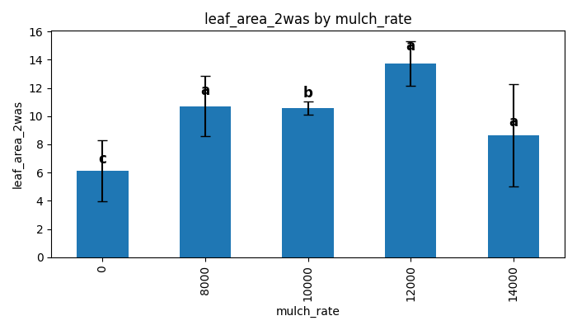

# plant_height_4was

ANOVA Table:

|  |  |  |  |  |
| --- | --- | --- | --- | --- |
| Source | sum_sq | df | F | PR(>F) |
| C(mulch_rate) | 111.3950 | 4.0000 | 0.7635 | 0.5724 |
| Residual | 364.7300 | 10.0000 | - | - |

# no_of_leaves_4was

ANOVA Table:

|  |  |  |  |  |
| --- | --- | --- | --- | --- |
| Source | sum_sq | df | F | PR(>F) |
| C(mulch_rate) | 12.9333 | 4.0000 | 1.5039 | 0.2731 |
| Residual | 21.5000 | 10.0000 | - | - |

# stem_girth_4was

ANOVA Table:

|  |  |  |  |  |
| --- | --- | --- | --- | --- |
| Source | sum_sq | df | F | PR(>F) |
| C(mulch_rate) | 30.0875 | 4.0000 | 3.2653 | 0.0587 |
| Residual | 23.0355 | 10.0000 | - | - |

# leaf_area_4was

ANOVA Table:

|  |  |  |  |  |
| --- | --- | --- | --- | --- |
| Source | sum_sq | df | F | PR(>F) |
| C(mulch_rate) | 885.2532 | 4.0000 | 1.9569 | 0.1774 |
| Residual | 1130.9391 | 10.0000 | - | - |

# plant_height_6was

ANOVA Table:

|  |  |  |  |  |
| --- | --- | --- | --- | --- |
| Source | sum_sq | df | F | PR(>F) |
| C(mulch_rate) | 1281.1860 | 4.0000 | 1.8101 | 0.2035 |
| Residual | 1769.5033 | 10.0000 | - | - |

# no_of_leaves_6was

ANOVA Table:

|  |  |  |  |  |
| --- | --- | --- | --- | --- |
| Source | sum_sq | df | F | PR(>F) |
| C(mulch_rate) | 371.2667 | 4.0000 | 1.5767 | 0.2544 |
| Residual | 588.6667 | 10.0000 | - | - |

# stem_girth_6was

ANOVA Table:

|  |  |  |  |  |
| --- | --- | --- | --- | --- |
| Source | sum_sq | df | F | PR(>F) |
| C(mulch_rate) | 18.7021 | 4.0000 | 0.9525 | 0.4737 |
| Residual | 49.0875 | 10.0000 | - | - |

# leaf_area_6was

ANOVA Table:

|  |  |  |  |  |
| --- | --- | --- | --- | --- |
| Source | sum_sq | df | F | PR(>F) |
| C(mulch_rate) | 628.6336 | 4.0000 | 0.1672 | 0.9502 |
| Residual | 9398.8197 | 10.0000 | - | - |

# no_of_fruits

ANOVA Table:

|  |  |  |  |  |
| --- | --- | --- | --- | --- |
| Source | sum_sq | df | F | PR(>F) |
| C(mulch_rate) | 31.7667 | 4.0000 | 0.4974 | 0.7385 |
| Residual | 159.6667 | 10.0000 | - | - |

# fresh_weight

ANOVA Table:

|  |  |  |  |  |
| --- | --- | --- | --- | --- |
| Source | sum_sq | df | F | PR(>F) |
| C(mulch_rate) | 125130.8167 | 4.0000 | 0.9527 | 0.4736 |
| Residual | 328341.7917 | 10.0000 | - | - |