Crop Experiment ANOVA & LSD Report

# rep

ANOVA Table:

|  |  |  |  |  |
| --- | --- | --- | --- | --- |
| Source | sum_sq | df | F | PR(>F) |
| C(mulch_rate) | 0.0000 | 4.0000 | 0.0000 | 1.0000 |
| Residual | 10.0000 | 10.0000 | - | - |

# perc_emergence

ANOVA Table:

|  |  |  |  |  |
| --- | --- | --- | --- | --- |
| Source | sum_sq | df | F | PR(>F) |
| C(mulch_rate) | 756.6667 | 4.0000 | 0.7323 | 0.5903 |
| Residual | 2583.3333 | 10.0000 | - | - |

# plant_height_2was

ANOVA Table:

|  |  |  |  |  |
| --- | --- | --- | --- | --- |
| Source | sum_sq | df | F | PR(>F) |
| C(mulch_rate) | 7.8292 | 4.0000 | 3.1059 | 0.0729 |
| Residual | 5.6717 | 9.0000 | - | - |

# no_of_leaves_2was

ANOVA Table:

|  |  |  |  |  |
| --- | --- | --- | --- | --- |
| Source | sum_sq | df | F | PR(>F) |
| C(mulch_rate) | 11.0893 | 4.0000 | 1.5122 | 0.2779 |
| Residual | 16.5000 | 9.0000 | - | - |

# leaf_area_2was

ANOVA Table:

|  |  |  |  |  |
| --- | --- | --- | --- | --- |
| Source | sum_sq | df | F | PR(>F) |
| C(mulch_rate) | 0.1647 | 4.0000 | 2.8281 | 0.0899 |
| Residual | 0.1310 | 9.0000 | - | - |

# plant_height_4was

ANOVA Table:

|  |  |  |  |  |
| --- | --- | --- | --- | --- |
| Source | sum_sq | df | F | PR(>F) |
| C(mulch_rate) | 5.1697 | 4.0000 | 2.7665 | 0.0944 |
| Residual | 4.2046 | 9.0000 | - | - |

# no_of_leaves_4was

ANOVA Table:

|  |  |  |  |  |
| --- | --- | --- | --- | --- |
| Source | sum_sq | df | F | PR(>F) |
| C(mulch_rate) | 14.5893 | 4.0000 | 1.8111 | 0.2109 |
| Residual | 18.1250 | 9.0000 | - | - |

# stem_girth_4was

ANOVA Table:

|  |  |  |  |  |
| --- | --- | --- | --- | --- |
| Source | sum_sq | df | F | PR(>F) |
| C(mulch_rate) | 2.9790 | 4.0000 | 4.9304 | 0.0221 |
| Residual | 1.3595 | 9.0000 | - | - |

LSD Grouping:

|  |  |  |
| --- | --- | --- |
| mulch_rate | Mean | Group |
| 0 | 6.05 | a |
| 8000 | 5.73 | a |
| 10000 | 6.05 | a |
| 12000 | 4.88 | b |
| 14000 | 6.00 | a |

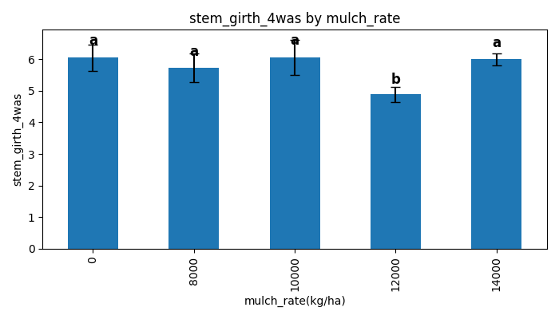

# leaf_area_4was

ANOVA Table:

|  |  |  |  |  |
| --- | --- | --- | --- | --- |
| Source | sum_sq | df | F | PR(>F) |
| C(mulch_rate) | 11.6192 | 4.0000 | 1.6837 | 0.2369 |
| Residual | 15.5272 | 9.0000 | - | - |

# plant_height_6was

ANOVA Table:

|  |  |  |  |  |
| --- | --- | --- | --- | --- |
| Source | sum_sq | df | F | PR(>F) |
| C(mulch_rate) | 2.1847 | 4.0000 | 0.8339 | 0.5365 |
| Residual | 5.8946 | 9.0000 | - | - |

# no_of_leaves_6was

ANOVA Table:

|  |  |  |  |  |
| --- | --- | --- | --- | --- |
| Source | sum_sq | df | F | PR(>F) |
| C(mulch_rate) | 18.3750 | 4.0000 | 2.1202 | 0.1605 |
| Residual | 19.5000 | 9.0000 | - | - |

# stem_girth_6was

ANOVA Table:

|  |  |  |  |  |
| --- | --- | --- | --- | --- |
| Source | sum_sq | df | F | PR(>F) |
| C(mulch_rate) | 21.4652 | 4.0000 | 1.0718 | 0.4247 |
| Residual | 45.0593 | 9.0000 | - | - |

# leaf_area_6was

ANOVA Table:

|  |  |  |  |  |
| --- | --- | --- | --- | --- |
| Source | sum_sq | df | F | PR(>F) |
| C(mulch_rate) | 20.3538 | 4.0000 | 10.3831 | 0.0020 |
| Residual | 4.4106 | 9.0000 | - | - |

LSD Grouping:

|  |  |  |
| --- | --- | --- |
| mulch_rate | Mean | Group |
| 0 | 6.60 | b |
| 8000 | 6.15 | a |
| 10000 | 6.90 | b |
| 12000 | 8.24 | a |
| 14000 | 9.47 | a |

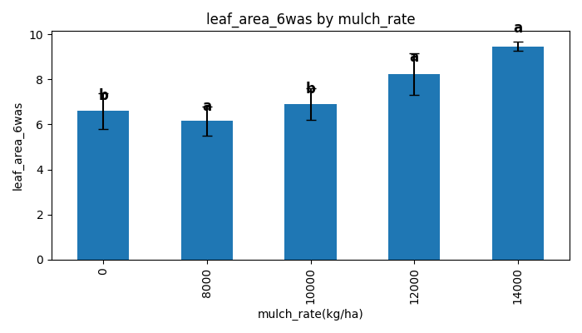

# plant_height_8was

ANOVA Table:

|  |  |  |  |  |
| --- | --- | --- | --- | --- |
| Source | sum_sq | df | F | PR(>F) |
| C(mulch_rate) | 3.3558 | 4.0000 | 2.4217 | 0.1244 |
| Residual | 3.1179 | 9.0000 | - | - |

# no_of_leaves_8was

ANOVA Table:

|  |  |  |  |  |
| --- | --- | --- | --- | --- |
| Source | sum_sq | df | F | PR(>F) |
| C(mulch_rate) | 7.7143 | 4.0000 | 1.0848 | 0.4194 |
| Residual | 16.0000 | 9.0000 | - | - |

# stem_girth_8was

ANOVA Table:

|  |  |  |  |  |
| --- | --- | --- | --- | --- |
| Source | sum_sq | df | F | PR(>F) |
| C(mulch_rate) | 19.8648 | 4.0000 | 1.1484 | 0.3941 |
| Residual | 38.9202 | 9.0000 | - | - |

# leaf_area_8was

ANOVA Table:

|  |  |  |  |  |
| --- | --- | --- | --- | --- |
| Source | sum_sq | df | F | PR(>F) |
| C(mulch_rate) | 116.3431 | 4.0000 | 1.3456 | 0.3256 |
| Residual | 194.5402 | 9.0000 | - | - |