Crop Experiment ANOVA & LSD Report

# rep

ANOVA Table:

|  |  |  |  |  |
| --- | --- | --- | --- | --- |
| Source | sum_sq | df | F | PR(>F) |
| C(mulch_rate) | 0.0000 | 4.0000 | 0.0000 | 1.0000 |
| Residual | 10.0000 | 10.0000 | - | - |

# perc_emergence

ANOVA Table:

|  |  |  |  |  |
| --- | --- | --- | --- | --- |
| Source | sum_sq | df | F | PR(>F) |
| C(mulch_rate) | 2395.8333 | 4.0000 | 5.7500 | 0.0115 |
| Residual | 1041.6667 | 10.0000 | - | - |

LSD Grouping:

|  |  |  |
| --- | --- | --- |
| mulch_rate | Mean | Group |
| 0.0 | 58.33 | b |
| 8000.0 | 54.17 | b |
| 10000.0 | 75.00 | a |
| 12000.0 | 79.17 | a |
| 14000.0 | 45.83 | b |

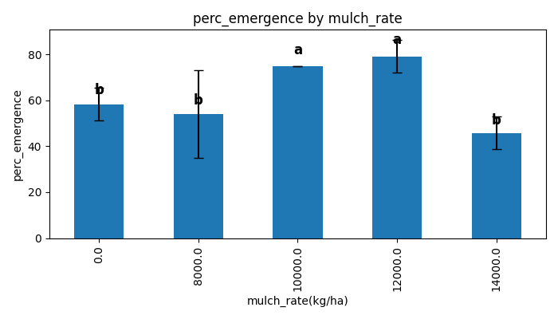

# plant_height_2was

ANOVA Table:

|  |  |  |  |  |
| --- | --- | --- | --- | --- |
| Source | sum_sq | df | F | PR(>F) |
| C(mulch_rate) | 30.5843 | 4.0000 | 1.7707 | 0.2112 |
| Residual | 43.1817 | 10.0000 | - | - |

# no_of_leaves_2was

ANOVA Table:

|  |  |  |  |  |
| --- | --- | --- | --- | --- |
| Source | sum_sq | df | F | PR(>F) |
| C(mulch_rate) | 4.1667 | 4.0000 | 8.9286 | 0.0025 |
| Residual | 1.1667 | 10.0000 | - | - |

LSD Grouping:

|  |  |  |
| --- | --- | --- |
| mulch_rate | Mean | Group |
| 0.0 | 5.33 | b |
| 8000.0 | 5.83 | b |
| 10000.0 | 6.33 | a |
| 12000.0 | 6.50 | a |
| 14000.0 | 6.83 | a |

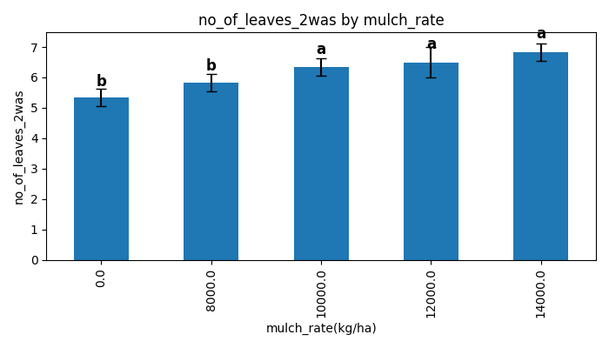

# stem_girth_2was

ANOVA Table:

|  |  |  |  |  |
| --- | --- | --- | --- | --- |
| Source | sum_sq | df | F | PR(>F) |
| C(mulch_rate) | 6.7944 | 4.0000 | 5.2529 | 0.0153 |
| Residual | 3.2337 | 10.0000 | - | - |

LSD Grouping:

|  |  |  |
| --- | --- | --- |
| mulch_rate | Mean | Group |
| 0.0 | 4.09 | b |
| 8000.0 | 3.88 | b |
| 10000.0 | 4.72 | a |
| 12000.0 | 5.68 | a |
| 14000.0 | 5.20 | a |

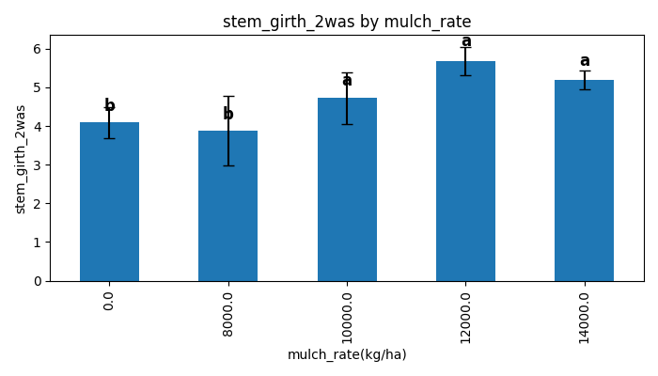

# leaf_area_2was

ANOVA Table:

|  |  |  |  |  |
| --- | --- | --- | --- | --- |
| Source | sum_sq | df | F | PR(>F) |
| C(mulch_rate) | 52.3840 | 4.0000 | 8.4524 | 0.0030 |
| Residual | 15.4938 | 10.0000 | - | - |

LSD Grouping:

|  |  |  |
| --- | --- | --- |
| mulch_rate | Mean | Group |
| 0.0 | 5.19 | c |
| 8000.0 | 5.82 | b |
| 10000.0 | 7.58 | b |
| 12000.0 | 10.56 | a |
| 14000.0 | 7.70 | a |

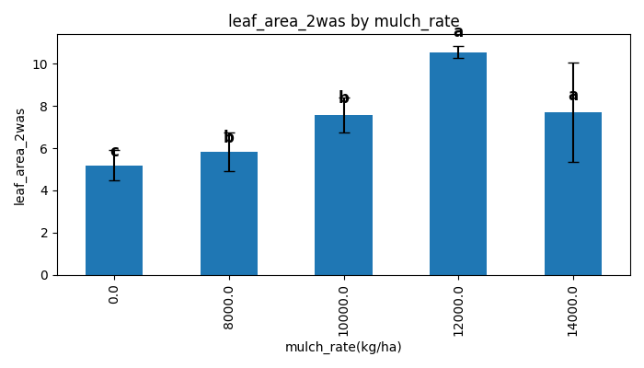

# plant_height_4was

ANOVA Table:

|  |  |  |  |  |
| --- | --- | --- | --- | --- |
| Source | sum_sq | df | F | PR(>F) |
| C(mulch_rate) | 214.3707 | 4.0000 | 4.8764 | 0.0193 |
| Residual | 109.9017 | 10.0000 | - | - |

LSD Grouping:

|  |  |  |
| --- | --- | --- |
| mulch_rate | Mean | Group |
| 0.0 | 15.25 | b |
| 8000.0 | 15.95 | a |
| 10000.0 | 20.82 | a |
| 12000.0 | 25.75 | a |
| 14000.0 | 19.55 | a |

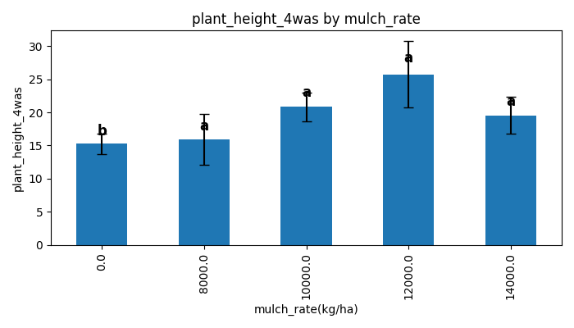

# no_of_leaves_4was

ANOVA Table:

|  |  |  |  |  |
| --- | --- | --- | --- | --- |
| Source | sum_sq | df | F | PR(>F) |
| C(mulch_rate) | 14.7333 | 4.0000 | 8.8400 | 0.0026 |
| Residual | 4.1667 | 10.0000 | - | - |

LSD Grouping:

|  |  |  |
| --- | --- | --- |
| mulch_rate | Mean | Group |
| 0.0 | 8.33 | c |
| 8000.0 | 8.00 | c |
| 10000.0 | 9.83 | a |
| 12000.0 | 9.67 | b |
| 14000.0 | 10.67 | a |

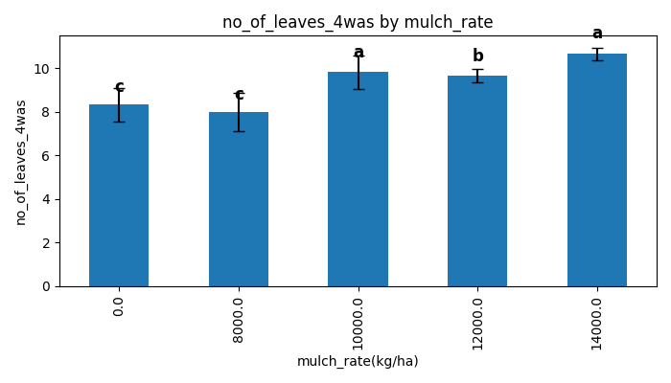

# stem_girth_4was

ANOVA Table:

|  |  |  |  |  |
| --- | --- | --- | --- | --- |
| Source | sum_sq | df | F | PR(>F) |
| C(mulch_rate) | 22.6584 | 4.0000 | 15.4350 | 0.0003 |
| Residual | 3.6700 | 10.0000 | - | - |

LSD Grouping:

|  |  |  |
| --- | --- | --- |
| mulch_rate | Mean | Group |
| 0.0 | 5.36 | c |
| 8000.0 | 5.41 | c |
| 10000.0 | 7.11 | b |
| 12000.0 | 8.33 | a |
| 14000.0 | 7.86 | a |

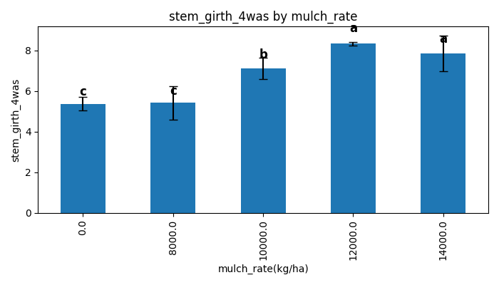

# leaf_area_4was

ANOVA Table:

|  |  |  |  |  |
| --- | --- | --- | --- | --- |
| Source | sum_sq | df | F | PR(>F) |
| C(mulch_rate) | 899.0374 | 4.0000 | 9.3360 | 0.0021 |
| Residual | 240.7450 | 10.0000 | - | - |

LSD Grouping:

|  |  |  |
| --- | --- | --- |
| mulch_rate | Mean | Group |
| 0.0 | 20.71 | b |
| 8000.0 | 19.13 | b |
| 10000.0 | 28.73 | b |
| 12000.0 | 40.17 | a |
| 14000.0 | 32.42 | a |

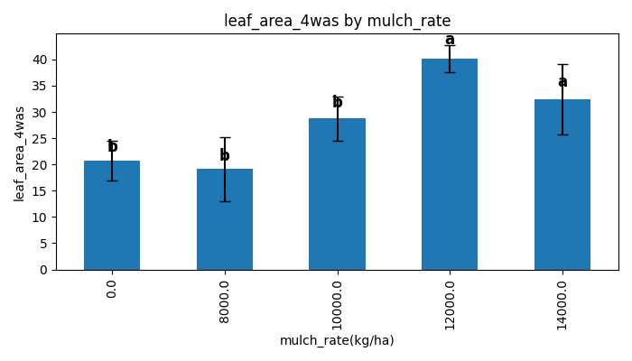

# plant_height_6was

ANOVA Table:

|  |  |  |  |  |
| --- | --- | --- | --- | --- |
| Source | sum_sq | df | F | PR(>F) |
| C(mulch_rate) | 3712.7693 | 4.0000 | 6.5183 | 0.0076 |
| Residual | 1423.9750 | 10.0000 | - | - |

LSD Grouping:

|  |  |  |
| --- | --- | --- |
| mulch_rate | Mean | Group |
| 0.0 | 55.95 | b |
| 8000.0 | 51.75 | b |
| 10000.0 | 81.87 | a |
| 12000.0 | 88.42 | a |
| 14000.0 | 86.38 | a |

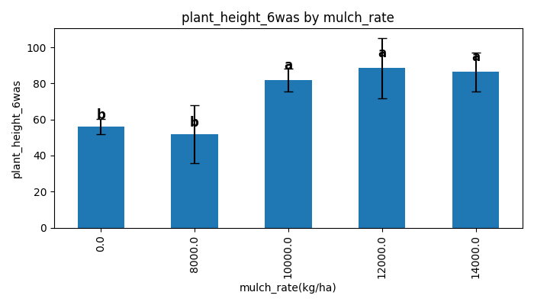

# no_of_leaves_6was

ANOVA Table:

|  |  |  |  |  |
| --- | --- | --- | --- | --- |
| Source | sum_sq | df | F | PR(>F) |
| C(mulch_rate) | 296.9000 | 4.0000 | 2.7339 | 0.0898 |
| Residual | 271.5000 | 10.0000 | - | - |

# stem_girth_6was

ANOVA Table:

|  |  |  |  |  |
| --- | --- | --- | --- | --- |
| Source | sum_sq | df | F | PR(>F) |
| C(mulch_rate) | 31.3016 | 4.0000 | 1.5730 | 0.2553 |
| Residual | 49.7467 | 10.0000 | - | - |

# leaf_area_6was

ANOVA Table:

|  |  |  |  |  |
| --- | --- | --- | --- | --- |
| Source | sum_sq | df | F | PR(>F) |
| C(mulch_rate) | 4777.3668 | 4.0000 | 1.8961 | 0.1878 |
| Residual | 6298.9632 | 10.0000 | - | - |

# no_of_fruits

ANOVA Table:

|  |  |  |  |  |
| --- | --- | --- | --- | --- |
| Source | sum_sq | df | F | PR(>F) |
| C(mulch_rate) | 19.7667 | 4.0000 | 1.6027 | 0.2481 |
| Residual | 30.8333 | 10.0000 | - | - |

# fresh_weight

ANOVA Table:

|  |  |  |  |  |
| --- | --- | --- | --- | --- |
| Source | sum_sq | df | F | PR(>F) |
| C(mulch_rate) | 169347.1000 | 4.0000 | 3.7563 | 0.0408 |
| Residual | 112709.5000 | 10.0000 | - | - |

LSD Grouping:

|  |  |  |
| --- | --- | --- |
| mulch_rate | Mean | Group |
| 0.0 | 475.67 | c |
| 8000.0 | 432.67 | c |
| 10000.0 | 547.50 | b |
| 12000.0 | 734.50 | a |
| 14000.0 | 610.17 | b |

