DS3002: MongoDB Lab Terminal Screenshots:

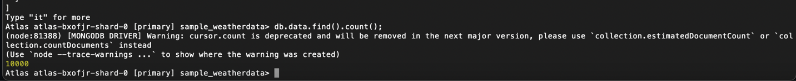

Exercise 1 part 6: we can retrieve the document by running db.data.find().pretty(); and then finding the object ID of the document we just created (it was "5553a998e4b02cf7151195d3"). Then we run db.data.find(ObjectId(“5553a998e4b02cf7151195d3")).pretty(); and it retrieves the document.

