char(79)char(73)char(109)char(115)char(119) char(64)char(6)

char(109)char(115)char(119)char(55)char(55)char(64)char(48)

char(79)char(73)char(109)char(115)char(119) char(64)char(48)

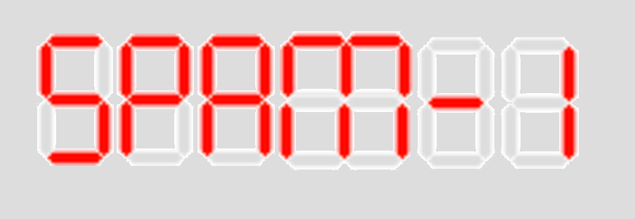

<https://www.dcode.fr/7-segment-display>