UNIVERSITY OF EDUCATION WINNEBA

COLLEGE OF TECHNOLOGY EDUCATION KUMASI

FACULTY OF TECHNICAL EDUCATION

DEPARTMENT OF INFORMATION TECHNOLOGY EDUCATION



**SHOPPING/E-COMMERCE WEBSITE**

**DECLARATON**

**Candidate’s Declaration**

We hereby declare that this project work is the result of our original research and that no part of it has been presented to the University of Education, Winneba, or elsewhere.

**Index Number Candidate’s signature**

5171040104 ……………………………………

5171040059 ……………………………………

5171040048 ……………………………………

5171040040 ……………………………………

5171040039 …………………………………

**Supervisor’s Declaration**

I hereby declare that the preparation and presentation of this project work were supervised in accordance with guidelines on supervision of project work laid down by the University of Education, Winneba.

**Name of Supervisor:** Mr. George Asante.

Signature…………………………………… Date…………………………………………

* Title Page
* Declaration
* Acknowledgement
* Abstract
* Table of Content
* The main body
* Chapter One: Introduction
* Chapter Two: Literature Review
* Chapter Three: System Design
* Chapter Four: Software Product
* Chapter Five: Summary, Conclusions, and Recommendation.
* Reference
* Appendices

**CHAPTER ONE: INTRODUCTION**

* Background of the project
* Statement of the problem
* Aim of the project
* Significant of the project
* Scope of the project
* Organization of the project

**CHAPTER TWO: LITREATURE REVIEW**

* The candidate is expected to review the relevant literature on software development process and technologies that would add in the design and implementation of the chosen application domain.
* What do you think about what has been done?
* Relate what you are proposing to do, to what others have done to date.

**CHAPTER THREE: SYSTEM DESIGN**

* The candidate explains details on requirement engineering relevant to the chosen topic.
* The chosen software development process or methodologies with appropriate diagrams are vividly described here.
* The candidate presents the blueprint of the system in the form of flowcharts, DFD’s, UML diagrams, and database schema.

**CHAPTER FOUR: SOFTWARE PRODUCT**

* The real implementation of the solution.
* Testing and evaluation of the software product.
* Presentation of key screen shots emanating from the testing and evaluation.

**CHAPTER FIVE: SUMMARY, CONCLUSION, AND RECOMMENDATION**

* Summary: briefsummary of the software product.
* Conclusion: what has the project achieved.
* Recommendation: what more could be done.

**REFERENCES**

* APA style shall be used.

**APPENDICES**

* Key samples codes, Source documents and some diagrams.

BACKGROUNG OF THE PROJECT.

University of Education Winneba campus has a lot of facilities such as residential area, campus and “the Broad walk”. However, there is still some problems faced by students about shopping.

Online shopping is the process consumers go through to purchase products or services over the internet. An online shop, e-shop, e-store, internet shop, web shop or virtual shop cause the physical analogy of buying products or services at in a shopping mall. All types of stores have retail web sites, including those that do and do not have a physical storefronts and proper catalogs. Online shopping is a type of electronic commerce used for business-to-business and business-to-consumer transactions. Commonly, the teenagers, especially students are interested to shopping through the online because they more time to sit in front of their computers and surfing internet when campus. Costumers, for that matter students purchase in order to satisfy needs.

STATEMENT OF THE PROBLEM

There are many online businesses at the internet. People have many choices to but through at the internet. Many types are there on the internet or online business, such as shoes, attire, phones, ear piece, and so on.

Nowadays people are so busy that they have no time to engage with the physical mediums or go to shopping malls buy their stuffs. Everyone likes to do online shopping. That’s why importance of online shopping is increasing with passage of time and one cannot deny this fact.

Online shopping gives us a lot of discounts that are barely found by shopping in stores locations.

Moreover, many shopping websites not only give you huge discounts on different products but provides you with free delivery as well. So online shopping does not relieve the time factor but it saves a lot of time by not going to shops and wastes fuel.

Online shopping gives you benefit of comparing same products at different online stores at the same time, which under normal circumstances cannot be done in department stores. So you cannot only compare the quality of products but the prices to ensure cost effectivity. You can order anything from the whole world and they will deliver it to your door steps.

When you go to normal stores to purchase products, you cannot know customer’s feedback about any product but with online shopping you can read customers feedback about any product and this can help make the purchase with ease.

AIM OF THE PROJECT

1. Promoting a service or product online.

The main aim of this project is to promote a company’s product, services or events on the internet

1. Selling services and or product.

This is basically the main reason behind the inception of this project. Selling products is the main common objective this project.

1. Providing product support or customer support.

Due to its world-wide nature, the internet is flexible structure allowing users to choose from thousands of similar products they are just one click away.

What actually makes the difference between online shopping websites are the price and customer support they provide. Most businesses usually have outstanding customer services and assistance 24 hours/day, 7 days/week, 365 days a year. Not only the customer service is important to provide support to actual customers but it can generate sales while communicating with prospective clients, answering their questions and offering all the necessary information they need. By offering your clients the possibility to solve their problems in an easy, you increase the loyalty of customers and build a solid base of perspective customers. So placing a new order is just a matter of time.

SIGNIFICANT OF THE PROJECT.

To finding out the project will help the people know about the online shopping,

as we the information of customer buy behavior (buy behavior is an individual or household that buy product for personal consumption.) through online shopping. This will provide way how to improve customer buy behavior. Online shopping help people to get the product easily. They need not go far to get it, only search the internet.

SCOPE OF PROJECT

The system can be implemented to any shop in the locality or other branded shops having retail outlet chains. The system recommends a facility to accepts orders 24/7 and a home delivery system which can make customer happy.

ORGANIATION OF THE PROJECT

The system can be identified to be presented with the following modules and roles.

* Administrator
* Users

ADMINISTRATOR

The admin is the super user of this system.

Only the administrator can access the admin page.

He may be the owner of the shop.

The administrator has all the information about the users and all products.

This module is further divided into sub-modules.

1. Manages Products.
2. Manages Users.
3. Manages Orders.

Admin

MANAGES PRODUCTS.

Add Products

Delete Products

View Products

* Add Products

The shopping cart project contains different kinds of products. The products can be classified into different categories and brands by name. the administrator can add new products into the existing system with all its details including image.

* Delete Products

Administrator can delete the product based on the stock of that particular product.

* View Products

The administrator will have a list view of all the existing products.

MANAGES USERS

Block/unblock user

Add user

Delete user

View user

* Delete users

The admin has the privilege to delete a user directly.

* View user

The admin will have a view of all the users registered in the system. The admin can view all the details of the all the registered users except the password.

* Add user

The admin has the privilege to delete a user directly.

MANAGE ORDERS

View order

Delete order

* Delete order

Admin can delete a product from orders list when the product is taken for delivery.

* View order

Admin can view orders which is generated by the users. He can view details of the purchases.

USERS

Purchase

product

View product

Search product

USERS

Edit profile

* Registration

A new user will have to register in the system b providing essential details in order to view the products in the system.

* Login

The user must login with its username and password after registration.

* View products

The user can view products based on their names and images after a successful login.

* Search products

Users can search for a particular product in the list by name.

* Add to cart

The user can add the desired product into the cart by clicking add to cart option on the product.

He can view his cart by clicking on the cart button. All products added to the cart can be view in the cart. You can remove an item from the cart by clicking on delete/remove button.

* Submit Cart

After confirming the item in the cart the user can submit the cart by providing a delivery address. On successful submitting the cart becomes empty.

LITERATURE REVIEW

ABSTRACT.

This project is a web based shopping system for an existing shop. The project objective is to deliver the online shopping application into android platform.

This project is an attempt to provide the advantages of online shopping to thus the customer customers of a real shop. It helps buying the products in the shop anywhere through internet by using an android device.

will get the service of online shopping and home delivery from his favorite shop. This system can be implemented to any shop in the locality or to multinational branded shops having retail outlet chains.

If shops are providing an online portal where their customers can enjoy easy shopping from anywhere, the shops won’t be losing any more

customers to the trending online shops such as flip cart or eBay. Since the application is available in the Smartphone it is easily accessible and always available.

REFERENCES

[1] JavaScript Enlightenment, Cody Lindley-First Edition, based on JavaScript 1.5, ECMA-262, Edition

[2] Mc GrawHill’s, Python: The complete reference 7thEdition, Herbert Schildit

[3] Complete CSS Guide, Maxine Sherrin and John Allsopp-O'Reilly Media; September 2012

[4] http://www.w3schools.com/html/defualt.asp,

[5] http://www.w3schools.com/css/default.asp,

[6] http://www.w3schools.com/js/default.asp

[7] http.//en.wikipedia.org/wiki/Online shopping

[8] http.//site.google.com

SYSTEMD ESIGN.

System design is the solution for the creation of a new system.

This phase focuses on the detailed implementation of the feasible system.

It emphasis on translating design. Specifications to performance specification. System design has two phases of development

➢ Logical design

➢ Physical design

During logical design phase the analyst describes inputs (sources), output s(destinations), databases (data sores) and procedures (data flows) all in a format that meets the user requirements. The analyst also specifies the needs of the user at a level that virtually determines the information flow in and out of the system and the data resources. Here the logical design is done through data flow diagrams and database design. The physical design is followed by physical design or coding.

Physical design produces the working system by defining the design specifications, which specify exactly what the candidate system must do. The programmers write the necessary programs that accept input from the user, perform necessary processing on accepted data and produce the required report on a hard copy or display it on the screen.

INPUT AND OUTPUT DESIGN

INPUT DESIGN:

Input design is the link that ties the information system into the world of its users. The input design involves determining the inputs, validating the data, minimizing the data entry and provides a multi-user facility.

Inaccurate inputs are the most common cause of errors in data processing. Errors entered by the data entry operators can be controlled by input design. The user-originated inputs are converted to a computer based format in the input design. Input data are collected and organized into groups of similar data. Once identified, the appropriate input media are selected for processing. All the input data are validated and if any data violates any conditions, the user is warned by a message. If the data satisfies all the conditions, it is transferred to the appropriate tables in the database. In this project the student details are to be entered at the time of registration. A page is designed for this purpose which is user friendly and easy to use. The design is done such that users get appropriate messages when exceptions occur.

3.1.2 OUTPUT DESIGN:

Computer output is the most important and direct source of information to the user. Output design is a very important phase since the output needs to be in an efficient manner. Efficient and intelligible output design improves the system relationship with the user and helps in decision making. Allowing the user to view the sample screen is important because the user is the ultimate judge of the quality of output. The output module of this system is the selected notifications.

3.2 DATABASE

DATABASE DESIGN:

Databases are the storehouses of data used in the software systems. The data is stored in tables inside the database. Several tables are created for the manipulation of the data for the system. Two essential settings for a database are

- the field that is unique for all the record occurrences.

-the field used to set relation between tables.

Normalization is a technique to avoid redundancy in the tables.

SYSTEM TOOLS

The various system tools that have been used in developing both the front end and the back end of the project are being discussed in this chapter.

FRONT END:

HTML, CSS and JAVA SCRIPT are utilized to implement the frontend.

HTML (Hyper Text Markup Language)

HTML is a syntax used to format a text document on the web.

CSS (Cascading Style Sheets)

CSS is a style sheet language used for describing the look and formatting of a document written in a markup language.

JAVA SCRIPT

JS is a dynamic computer programming language. It is most commonly used as part of web browsers, whose implementations allow client-side scripts to interact with the user, control the browser, communicate asynchronously, and alter the document content that is displayed.

Java Script is used to create pop-up windows displaying different alerts in the system like “User registered successfully”,” Product added to cart” etc.

BACK END

The back end is implemented using SQLITE3 which is used to design the databases and python flask.

The most common framework used is flask framework. Flask is framework used to develop web pages.

SQLITE3

SQLITE3 is the world's second most widely used open-source relational database management system (RDBMS). The SQL phrase stands for Structured Query Language.

An application software called Navigate was used to design the tables in SQLITE3.

DATA FLOW DIAGRAM

A Data Flow Diagram (DFD) is a structured analysis and design tool that can be used for flowcharting. A DFD is a network that describes the flow of data and the processes that change or transform the data throughout a system. This network is constructed by using a set of symbols that do not imply any physical implementation. It has the purpose of clarifying system requirements and identifying major transformations. So it is the starting point of the design phase that functionally decomposes the requirements specifications down to the lowest level of detail. DFD can be considered to an abstraction of the logic of an information-oriented or a process-oriented system flow-chart. For these reasons DFD’s are often referred to as logical data flow diagrams.

EXTERNAL ENTITY

An external entity is a source or destination of a data flow. Only those

entities which originate or receive data are represented on a data flow diagram. The symbol used is a rectangular box.

PROCESS

A process shows a transformation or manipulation of data flow within the system. The symbol used is an oval shape.

DATAFLOW

The data flow shows the flow of information from a source to its destination. Data flow is represented by a line, with arrowheads showing the direction of flow. Information always flows to or from a process and may be written, verbal or electronic. Each data flow may be referenced by the processes or data stores at its head and tail, or by a description of its contents.

DATA STORE

A data store is a holding place for information within the system: It is

represented by an open ended narrow rectangle. Data stores may be long-term files such as sales ledgers, or may be short-term accumulations: for example, batches of documents that are waiting to be processed. Each data store should be given a reference followed by an arbitrary number.

LOGIN

DB

LOGIN DFD.

REGISTRATION DFD.

HOME PAGE

USER

REGISTRATION

DB

ADMIN DFD.

LOGIN PAGE

USER

USER DETAIL DB

PRODUCT DETAILS

PRODUCT ORDER

DB

ADMIN

E-R DIAGRAMS.

* LOGIN

LOGIN

USER ID

USERNAME

USER TYPE

PASSWORD

STATUS

* USER DETAILS

USER DETAILS

LOGIN NAME

EMAIL ID

USER ID

* PRODUCT DETAILS

PRODUCT DETAILS

PRODUCT NAME

PRICE

DESCRIPTION

PRODUCT ID

COLOR

IMAGE

STOCK

* PRODUCT ORDERS

DELIVERY ADDRESS

USER ID

PRODUCT ID

ORDER ID

COMPLETE DIAGRAM.

PRODUCTS

ORDER

USER

System analysis is the process of gathering and interpreting facts, diagnosing problems and using the information to recommend improvements on the system. System analysis is a problem solving activity that requires intensive communication between the system users and system developers.

System analysis or study is an important phase of any system development process. The system is viewed as a whole, the inputs are identified and the system is subjected to close study to identify the problem areas. The solutions are given as a proposal. The proposal is reviewed on user request and suitable changes are made. This loop ends as soon as the user is satisfied with the proposal.

2.1 EXISTING SYSTEM

The current system for shopping is to visit the shop manually and from the available product choose the item customer want and buying the item by payment of the price of the item.

1. It is less user-friendly.

2. User must go to shop and select products.

3. It is difficult to identify the required product.

4. Description of the product limited.

5. It is a time consuming process

6. Not in reach of distant users.

2.2 PROPOSED SYSTEM

In the proposed system customer need not go to the shop for buying the products. He can order the product he wish to buy through the application in his Smartphone. The shop owner will be admin of the system. Shop owner can appoint moderators who will help owner in managing the customers and product orders. The system also accesses the web service from his Smartphone. Web application should be able to help the customer for selecting his item and to help the owner in managing the orders from the customers.

2.3 SYSTEM REQUIREMENT SPECIFICATION

2.3.1 GENERAL DESCRIPTION

Product Description:

The system consists of two parts. A web application which can provide the online shopping service and an android application for the customer to access the web service from his Smartphone. Web application should be able to help the customer for selecting his item and to help the owner in managing the orders from the customers.

Problem Statement:

As online shopping became a trend nowadays the regular shops are losing their customers to online brands. Customers have effortless shopping experience and saving time through shopping online. For competing with those online brands, if shops are providing an online portal where their customers can shop through internet and get the products at their doors it will increase the number of customers.

SYSTEM OBJECTIVES

➢ To provide an android application for online shopping of products in an existing shop.

➢ To provide a online shopping web site for the same shop.

SYSTEM REQUIREMENTS

NON FUNCTIONAL REQUIREMENTS

EFFICIENCY REQUIREMENT

When an online shopping cart android application implemented customer can purchase product in an efficient manner.

ii. RELIABILITY REQUIREMENT

The system should provide a reliable environment to both customers and ease of use.

iii. USABILITY REQUIREMENT

The android application is designed for user friendly environment and ease of use.

iv. IMPLEMENTATION REQUIREMENT

Implementation of the system using CSS and html in front end with jsp as back end and it will be used for database connectivity. And the database part is developed by SQLite3. Responsive web designing is used for making the website compatible for any type of screen.

v. DELIVERY REQUIREMENT

The whole system is expected to be delivered in four months of time with a weekly evaluation by the project guide.

FUNCTIONAL REQUIREMENTS

USER

➢ USER LOGIN

Description of feature

This feature used by the user to login into system. A user must login with his user name and password to the system after registration. If they are invalid, the user not allowed to enter the system.

Functional requirement

- Username and password will be provided after user registration is confirmed.

- Password should be hidden from others while typing it in the field

➢ REGISTER NEW USER

Description of feature

A new user will have to register in the system by providing essential details in order to view the products in the system. The admin must accept a new user by unblocking him.

Functional requirement

- System must be able to verify and validate information.

- The system must encrypt the password of the customer to provide security.

➢ PURCHASING AN ITEM

Description of feature

The user can add the desired product into his cart by clicking add to cart option on the product. He can view his cart by clicking on the cart button.

All products added by cart can be viewed in the cart. User can remove an item from the cart by clicking remove. After confirming the items in the cart the user can submit the cart by providing a delivery address. On successful submitting the cart will become empty.

Functional requirement

- System must ensure that, only a registered customer can purchase items.

ADMIN

➢ MANAGE USER

Description of feature

The administrator can add user, delete user, view user and block user.

➢ MANAGE MODERATOR

Description of feature

The administrator can add moderator, delete moderator, block moderator access that account

➢ MANAGE PRODUCTS

Description of feature

The administrator can add product, delete product and view product.

➢ MANAGE ORDERS

Description of feature

The administrator can view orders and delete orders.

Functional requirements

-The system must identify the login of the admin.

-Admin account should be secured so that only owner of the shop can access that account

SOFTWARE DEVELOPMENT METHODOLOGIES OR PROCESS.

Agile methodologies are the best candidates for e-commerce or shopping website that incorporates systems that incorporate the innovative and dynamic nature of the web. Agile web development is a development model for web applications that follows the same concept as the agile methodologies.

This approach is more efficient and powerful to ensure every piece of functionality is improving throughout the life of the web application.

Agile web development has the following characteristics.

Interactive and incremental development methods that is aimed to deliver the application at shorter period of time. The production progress is measured based on the complete and tested during the schedule release of the application.

Task are broken down into smaller increments that make it more adaptable to some changes.

This methodology follows planning requirements analysis, designing, coding, testing and documentation in parallel during the stage of production process by getting their feedback improves the confidence of making changes, error free, and customer-oriented approach.

SOFTWARE PRODUCT.

IMPLEMENTATION OF SOFTWARE.

There are several ways to implementing the site with all sorts of variations in between.

Enterprise Hosting.

This means that you purchase hardware and software and hire a staff of developers to create your e-commerce web site.

* You have a large database that holds your catalog of products.
* You have immensely high traffic millions of visitors per month.
* You have a complicated sales cycles that requires a lots of customized forms, pricing tables, etc.
* REGISTRATION

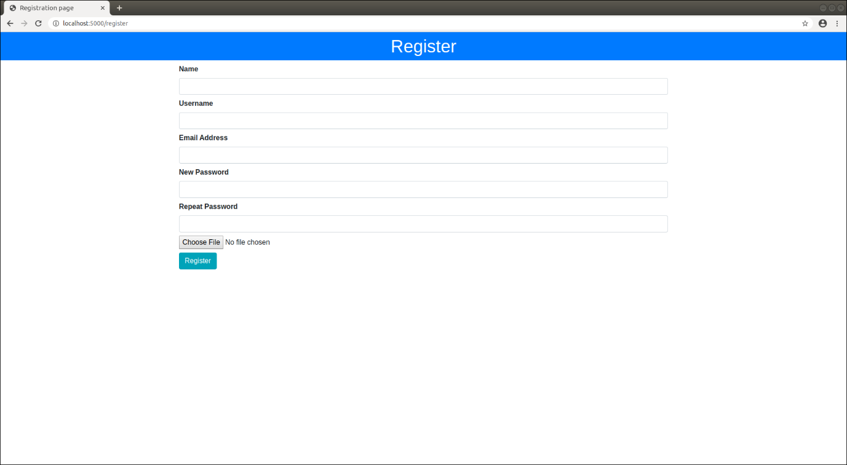

* LOGIN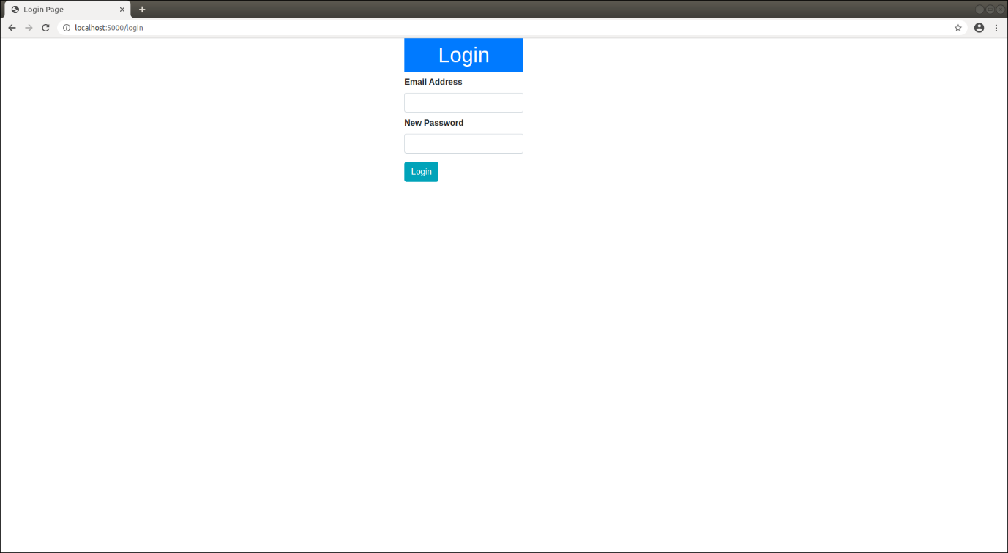
* ADD PRODUCT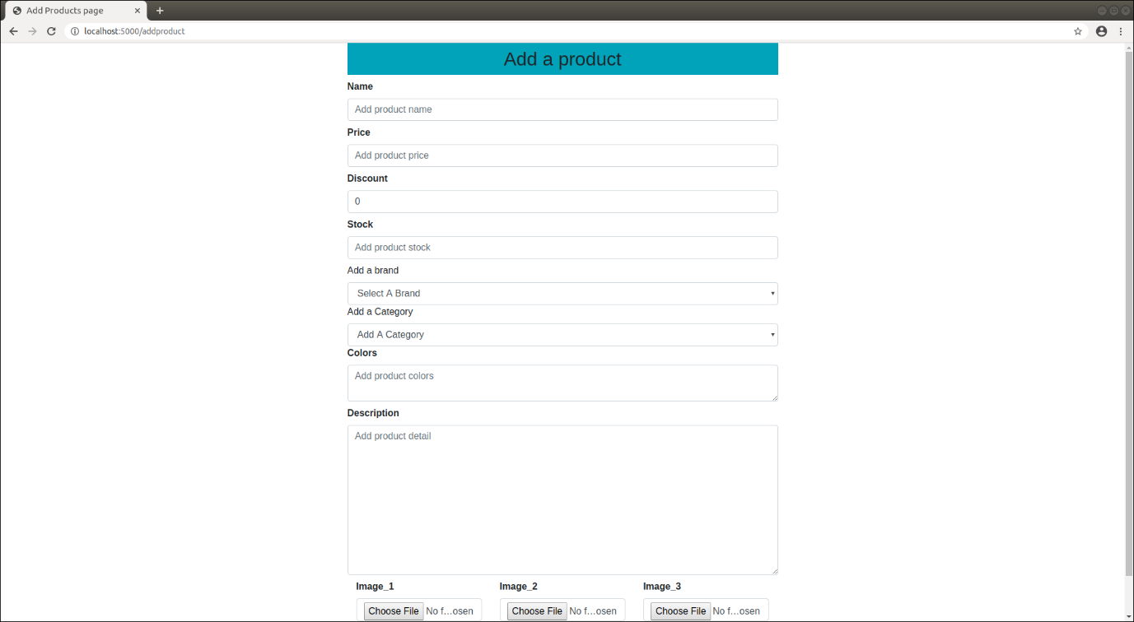
* ADD BRAND

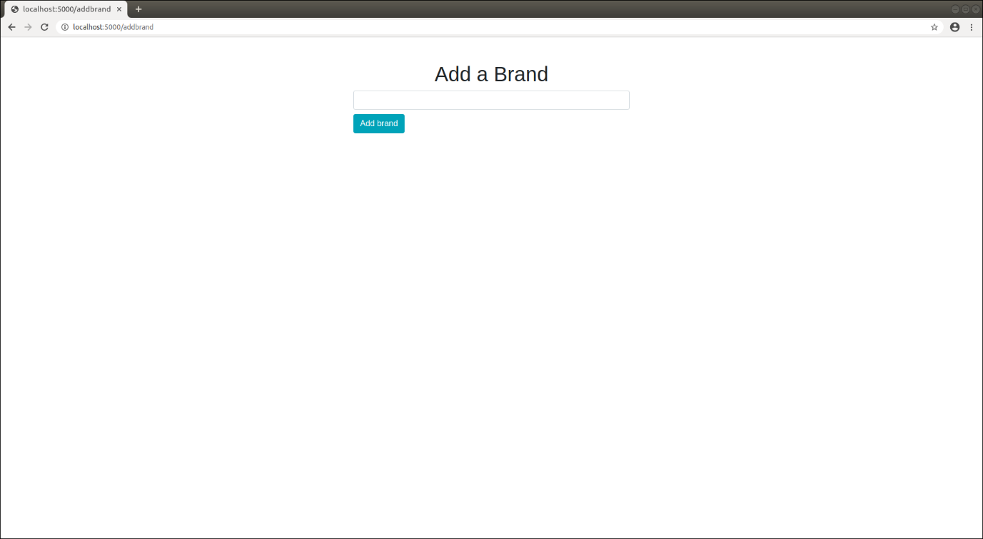

* ADD CATEGORY

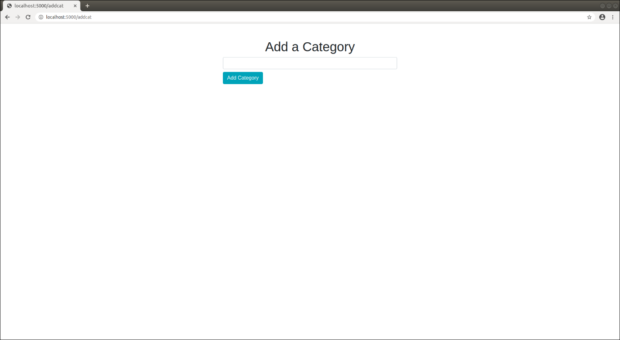

* CATEGORIES

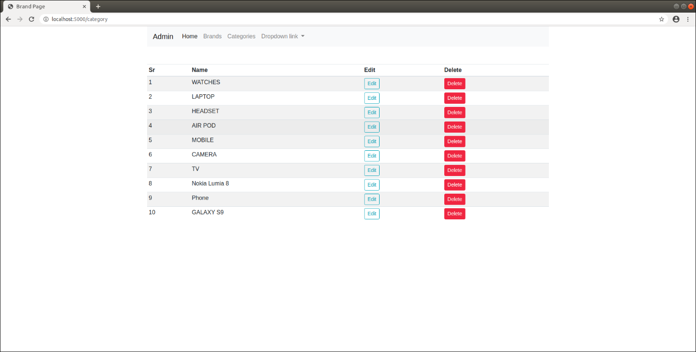

* ADMIN PAGE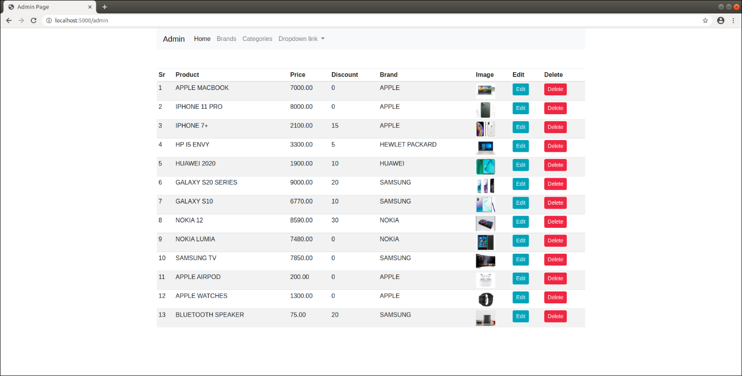
* HOME PAGE

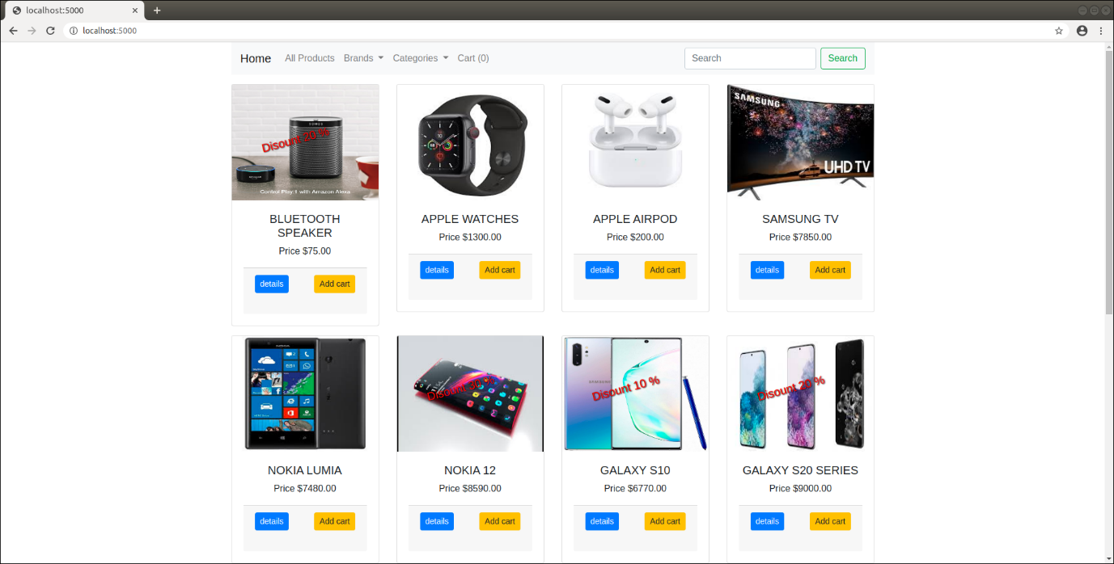

CONCLUSION

The project entitled Online shopping system was completed the same time it is efficient and less time consuming. The purpose of this project was to develop a web application and an android application for purchasing items from a shop.

The system has been developed with much care and free of errors and at the same time it is efficient and less time consuming. The purpose of this project was to develop a web application and an android application for purchasing items from a shop.

This project helped us in gaining valuable information and practical knowledge on several topics like designing web pages using html & CSS, usage of responsive templates, designing of android applications, and management of database using sqlite3 . The entire system is secured.

Also the project helped us understanding about the development phases of a project and software development life cycle. We learned how to test different features of a project.

This project has given us great satisfaction in having designed an application which can be implemented to any nearby shops or branded shops selling various kinds of products by simple modifications.

There is a scope for further development in our project to a great extent. A number of features can be added to this system in future like providing moderator more control over products so that each moderator can maintain their own products. Another feature we wished to implement was providing classes for customers so that different offers can be given to each class. System may keep track of history of purchases of each customer and provide suggestions based on their history. These features could have implemented unless the time did not limited us.

APPENDIX.

