CERTIFICATE OF INDIGENCY
OF INDIGENCY

BARANGAY OFFICIALS

HON. MARIO F. MOJICA
PUNONG BARANGAY

BARANGAY KAGAWAD

KAG. ERICKSON E. SERVIDA
Kagawad

KAG. DENNIS Q. AZUR
Kagawad

KAG. MELODY L. MERCINE
Kagawad

KAG. JOSE E. OSERA
Kagawad

KAG. MARLON B. MALILLIN
Kagawad

KAG. ROGELIO S. VILLENA JR.
Kagawad

KAG. CAYETANA F. VILLANUEVA
Kagawad

KIM MARINELA L. MERCINE
SK Chairperson

TRICIA MAE NAVIDAD
Secretary

RANILO G. ARENDELA
Treasurer

To whom it may concern:

This is to certify that, __________________________resident of Street Barangay 3 Gen. Emilio Aguinaldo Dalahican, Cavite City. Is belongs to an Indigent Family, that ________________Has no regular monthly income or any resource of livelihood

This Certification is being issued upon request of said person in connection with his/her application for, _______________

Issued on _______ ^{th} day of ________ , 2024

_______________________
Punong Barangay
Barangay 3

VALID FOR SIX (6) MONTHS ONLY/DON’T ACCEPT WITHOUT DRY SEAL

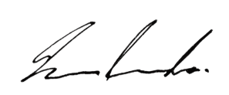
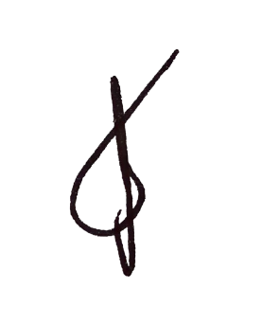
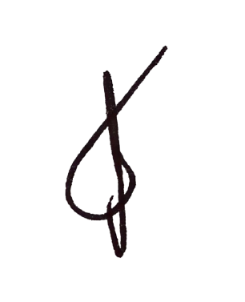
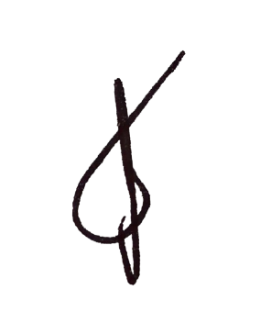
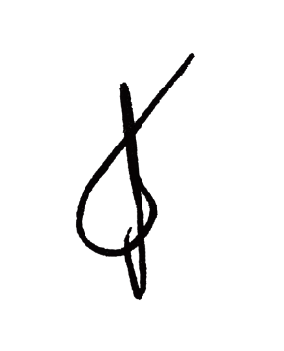
Minerva A . Enri Marissa G. Oncinian
HON. CESAR A. ORTEGA
BARANGAY CHAIRMAN
BARANGAY 3

