B A R A N G A Y C L E A R A N C E

TO WHOM IT MAY CONCERN:

THIS IS TO CERTIFY THAT, ______________
AGE: __ YRS OLD /SEX: ____ NATIONALITY: FILIPINO
CIVIL STATUS: ________ DATE OF BIRTH: _____________
PLACE OF BIRTH: CAVITE CITY AND PRESENTLY RESIDING
STREET BARANGAY 3 GEN. EMILIO AGUINALDO DALAHICAN, CAVITE CITY.
THIS INDIVIDUAL IS KNOWN TO ME TO BE A RESIDENT OF THIS BARANGAY, A LAW-ABIDING CITIZEN HAVING A GOOD MORAL CHARACTER AND NOT CONNECTED WITH ANY SUBVERSIVE ORGANIZATION.

THIS BARANGAY CLEARANCE IS BEING ISSUED UPON REQUEST OF THE SUBJECT THIS __^{th} DAY OF ________________
FOR, _____________

Res. Cert. No.: ______________
Place Issued: _Cavite City____
Date Issued: ______________

__________________
Applicant Signature

_________________
Punong Barangay Barangay 3

VALID FOR SIX (6) MONTHS ONLY/DON’T ACCEPT WITHOUT DRY SEAL
BARANGAY OFFICIALS

HON. MARIO F. MOJICA
PUNONG BARANGAY

BARANGAY KAGAWAD

KAG. ERICKSON E. SERVIDA
Kagawad

KAG. DENNIS Q. AZUR
Kagawad

KAG. MELODY L. MERCINE
Kagawad

KAG. JOSE E. OSERA
Kagawad

KAG. MARLON B. MALILLIN
Kagawad

KAG. ROGELIO S. VILLENA JR.
Kagawad

KAG. CAYETANA F. VILLANUEVA
Kagawad

KIM MARINELA L. MERCINE
SK Chairperson

TRICIA MAE NAVIDAD
Secretary

RANILO G. ARENDELA
Treasurer

LUZVIMINDA H. I

6

BUSS
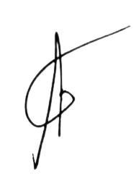
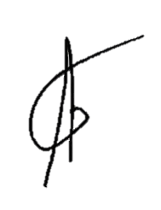
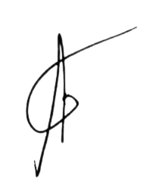
P0 ``````````````````````````````````

