C E R T I F I C A T E
OF RESIDENCY
BARANGAY OFFICIALS

HON. MARIO F. MOJICA
BARANGAY CAPTAIN

BARANGAY COUNCILORS

KAG. ERICKSON E. SERVIDA
Councilor

KAG. DENNIS Q. AZUR
Councilor

KAG. MELODY L. MERCINE
Councilor

KAG. JOSE E. OSERA
Councilor

KAG. MARLON B. MALLILLIN
Councilor

KAG. ROGELIO S. VILLENA JR.
Councilor

KAG. CAYETANA F. VILLANUEVA
Councilor

LORRAINE MAE C. VELUSTRIA
SK Chairperson

ANTONITA C. VELUSTRIA
Secretary

RANILO G. ARENDELA
Treasurer

To whom it may concern:

Be it known whose information appear hereunder is a resident Barangay

Name:

Address:

Date of Birth:

Nationality:

Civil Status:

Years of Residency in Barangay:

HEREBY CERTIFY UNDER OATH THE FOREGOING DATA IS TRUE AND CORRECT

______________
Signature of Applicant

This individual is known to me to be a resident of this barangay, a law-abiding citizen having a good moral character and not connected with any subversive organization.

This Certificate of Residency is being issued upon request of the subject this
________________, 2025 for, _______________

____________________________
Punong Barangay

VALID FOR SIX (6) MONTHS ONLY/DON’T ACCEPT WITHOUT DRY SEAL.

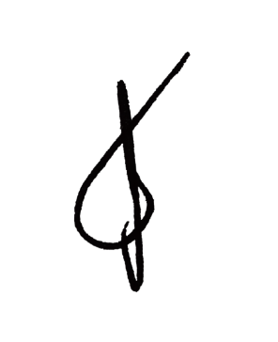
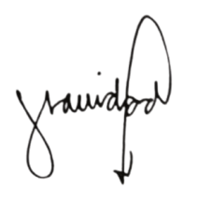
HON. CESAR A. ORTEGA
BARANGAY CHAIRMAN
BARANGAY 3

