**NEOM**

Student’s Name

Affiliation

Course

Tutor

Due Date

Contents

NEOM 7

Executive Summary 7

Project Introduction 7

Objectives and Goals 8

Importance within Vision 2030 8

Business Case 9

Project Overview 9

Financial Viability 9

Strategic Importance 10

Triple Constraints 10

Time Constraint 11

Cost Constraint 11

Scope Constraint 11

Other Constraints 11

Environmental Factors 11

Geopolitical and Socioeconomic Factors 12

Technological and Innovation Challenges 12

Project Charter 12

Project Information 12

Background 12

Project Components 13

Vision and Goals 13

Project Significance 13

Project Scope defining NEOM’s Boundaries and Objectives 14

Boundaries 14

Objectives 14

Milestones Schedule 15

Initial Planning and Infrastructure Development 15

Sector Development and Economic Initiatives 16

Sustainability and Environmental Impact 16

Completion and Progress Review 16

Project Deliverables 17

Economic Diversification and Sector Development 17

Technological Innovation and Knowledge Exchange 17

Technological Innovation and Knowledge Exchange 18

Sustainable Practices and Renewable Energy 18

Integrated Smart City Solutions 19

Social and Cultural Advancements 19

Risk Management 22

Risk Identification and Categorization 22

Risk Mitigation Strategies 23

Contingency Planning and Response Mechanisms 23

Continuous Improvement and Evaluation 24

Communication Strategy 25

Stakeholder Identification and Engagement 25

Transparency and Clarity in Messaging 25

Multi-Channel Approach 26

Regular Progress Reports and Updates 26

Two-Way Communication and Feedback Mechanisms 26

Crisis Communication Plan 26

Cultural Sensitivity and Adaptation 27

Training and Capacity Building 27

Sign-off; Final Approval of the NEOM Project Charter 27

Engagement of Key Stakeholders 27

Alignment with Vision 2030 Goals 27

Review and Approval Process 28

Clear Ownership and Responsibility Assignment 28

Commitment to Communication and Reporting 28

Formal Approval and Authorization 28

Project Stakeholders 29

Power/Interest Grid analyzing stakeholder power and interest in the project. 31

Gantt Chart & Tasks List 32

Phase 2: Infrastructure Development 33

Phase 3: Sector Development and Innovation 33

Phase 4: Smart City Implementation 34

Phase 5: Environmental Sustainability and Community Integration 34

Phase 6: Continuous Evaluation and Adaptation 34

Task Scheduling Table for NEOM Project 36

Explanation 37

The Cost Baseline Table 43

Work Breakdown Structure (WBS 44

Network Diagram 47

Activity-on Node illustration for NEOM 47

Activity-on- Arrow illustration for NEOM 47

Importance within the NEOM Project 49

Critical Path 49

Understanding the Vital Path in NEOM Project 49

Significant Task on the Critical path 50

Significant of Vital path of NEOM Project 51

Reduction of risk in the Critical Path 51

Responsibility Assignment Matrix 53

Role of RACI Matrix 53

Application within the NEOM project 53

Explanation 54

Benefits of the Responsibility Assignment Matrix 54

Project Analysis/Conclusion/Recommendation 55

Recommendations for NEOM Project success 56

Conclusion 59

Key Aspect for Consideration for Success of NEOM Onwards 60

References 62

# **NEOM**

# **Executive Summary**

Saudi Arabia's Vision 2030 is paving the way for an innovative initiative known as NEOM. This revolutionary project represents a significant transformation in Saudi Arabia's economic outlook by creating a sustainable and technologically advanced city located in the northwest region. With its emphasis on utilizing renewable energy sources, NEOM strives to balance progress with environmental responsibility for lasting impact.  
 The aims of the project are wide-ranging and multifaceted, spanning numerous industries such as healthcare, biotechnology, tourism, and entertainment. The ultimate goal is to promote a symbiotic relationship between urban development and natural surroundings in NEOM while positioning Saudi Arabia at the forefront of innovation globally by creating a hub that will not only attract international investment but also diverse talent through knowledge sharing opportunities fostering collaboration across different fields.  
 A comprehensive strategy has been developed by the leadership of the project in partnership with stakeholders. To guarantee a clear course and unyielding dedication to success, having distinct project charters, engaged stakeholders and flexible communication frameworks are essential components.  
 By using advanced project management software such as Microsoft Project, NEOM is able to monitor its progress and effectively allocate resources. This results in a well-planned strategy for overcoming the challenges of the project.

# **Project Introduction**

NEOM represents Saudi Arabia's utmost dedication to transform its economic and global position as part of Vision 2030. This ambitious endeavor lies in the immaculate northwest section of the country, serving not solely as a metropolis but an innovative concept that aims to embody a novel epoch for sustainable and futuristic urban lifestyles (Hridjikj, 2022).

## ***Objectives and Goals***

The NEOM project has a range of key goals. Foremost among these is its intention to ignite economic diversification, counterbalancing Saudi Arabia's heavy dependence on oil-generated revenues through the creation of novel industries and employment prospects. By building a self-sustaining economy with an environment that encourages long-term growth, these efforts aim to kindle development in multiple dimensions (Bosch, 2020).  
 NEOM aims to lead the way in sustainability through its use of renewable energy, according to (Alkeaid, 2018). By prioritizing environmentally-friendly practices, NEOM is committed to decreasing its carbon footprint and setting an example for future sustainable urban planning.  
 NEOM's ambition is to become a leading center for innovation and knowledge sharing on the global stage. Its strategy involves attracting international talent and investments of various kinds, with an emphasis on fostering collaboration across cultures in order to promote cutting-edge ideas as well as technological advances that can drive progress around the world.

## ***Importance within Vision 2030***

The importance of NEOM in the larger Vision 2030 initiative cannot be emphasized enough. It represents a flagship undertaking that embodies the fundamental principles of economic diversification, social advancement, and cultural inclusivity promoted by this vision. By striving towards becoming a global investment superpower as well as an innovative hub for growth, NEOM is effectively aligned with these overarching goals shared by Saudi Arabia's transformation efforts.

The realization of Vision 2030's mission to decrease Saudi Arabia's reliance on oil and secure a prosperous future rest significantly on the triumph of NEOM (Horne, 2023). This initiative prioritizes renewable energy while demonstrating its commitment to promoting economic diversity across multiple sectors globally. These efforts align seamlessly with the overarching goal of achieving sustainable growth and progress envisioned by this ambitious strategy.  
 NEOM intends to establish a precedent for urban development across the globe, not just within Saudi Arabia, by combining innovation, sustainability and technology in such a way that it harmoniously balances environmental responsibilities with human needs.

# **Business Case**

# ***Project Overview***

The central objective of NEOM is to expand the scope of Saudi Arabia's economy. Given its heavy reliance on oil profits in the past, there has been a pressing need for creating alternative and sustainable revenue streams. This initiative seeks to build an autonomous economic framework by encouraging fresh industries, generating employment opportunities and facilitating investment prospects that will redefine the nation's fiscal trajectory.  
 The key to NEOM's economic promise lies in its emphasis on multiple industries. Through nurturing developments in healthcare, biotech, entertainment and tourism domains, the initiative aims to establish Saudi Arabia as a frontrunner worldwide while fostering creativity and generating abundant job opportunities.

## ***Financial Viability***

Despite the significant upfront costs, NEOM holds great potential for financial success in the future. Its aim to diversify its economy should attract foreign investments and foster innovative industries that will yield continuous revenue streams. This strategy is anticipated to reduce Saudi Arabia's dependence on oil gradually while promoting sustainable growth.  
 Additionally, NEOM's dedication to sustainability by relying on 100% renewable energy sources not only demonstrates a concern for the environment but also indicates possible cost-effective benefits in the future. By decreasing dependence on conventional energy resources, NEOM aims to create an economically sustainable and environmentally conscious tomorrow.

## ***Strategic Importance***

The strategic importance of NEOM in the context of the Vision 2030 initiative is immense. It represents a strong resolve to broaden Saudi Arabia's economy and serves as an embodiment of the overarching goals outlined by this vision (Alam et al., 2021). The achievement of its objectives would serve as proof that it is possible for Saudi Arabia to become a successful global investment hub, thus aligning with Vision 2030's primary objective -- transforming the Kingdom into a prosperous economic force on an international level.  
 NEOM's potential to drive economic growth and global collaboration is highlighted by its focus on technological innovation and the establishment of a worldwide center for exchanging knowledge. The project enables transformative change, not only within the country but also globally, as it attracts international talent while cultivating an environment conducive to fostering innovative ideas.

## **Triple Constraints**

The accomplishment of the NEOM project hinges on three essential elements: time, cost, and scope - just like any substantial endeavor. These limitations are integral to managing the project and impact its evolution, advancement and eventual attainment.

*Time Constraint:* The NEOM initiative adheres to a predetermined schedule, marked by set targets and deadlines. It is imperative that the project progresses timely so that all of its elements, including infrastructure improvements and economic expansion measures, advance as planned. Any setbacks in execution may jeopardize overall project success or hinder achievement of predefined goals.

*Cost Constraint*: The NEOM project places great importance on financial considerations. It is crucial to handle the allocated funds with care, ensuring efficiency across various sectors within NEOM. Striking a balance between expenses and quality while making steady progress must be prioritized in order to avoid exceeding budget limits and achieve the intended financial objectives of the project.

*Scope Constraint*: Defining the NEOM project's boundaries and objectives sets its limits, including sectors such as biotechnology, healthcare, entertainment tourism among others. Deviating from this scope can result in extra expenses or delays that could ultimately impact overall outcome of the development. Hence a balance is crucial between achieving set goals while also accommodating any potential modifications along the way.

## **Other Constraints**

In addition to the typical triple constraints, NEOM confronts supplementary hurdles that may impact its trajectory of growth.

*Environmental Factors***:** Environmental considerations are brought to the forefront through the project's dedication to sustainability. Maintaining a balance between development and ecological preservation presents an ongoing challenge. The execution of measures aimed at safeguarding nature while simultaneously creating an urban landscape poses distinctive difficulties for the project team.

*Geopolitical and Socioeconomic Factors*: The triumph of NEOM is reliant on several socioeconomic and geopolitical elements. These factors comprise harmonious conditions within the vicinity, political backing, societal cohesion as well as proficiency in enticing competent personnel and financial resources. The undertaking's advancement or prosperity may be affected by aspects like regional steadiness and political milieu too.

*Technological and Innovation Challenges:* As an innovative project, integrating state-of-the-art technology presents both prospects and obstacles. Nimbly adjusting to the fast-paced changes in technological advancements while guaranteeing dependability and interoperability may present a daunting challenge.

# **Project Charter**

# **Project Information**

# ***Background***

*Location*: Located in the northwestern area of Saudi Arabia, NEOM is envisioned as a pioneering metropolis that signifies a notable change in the nation's endeavors for economic diversification under Vision 2030.

*Foundational* *Principles*: NEOM represents a courageous initiative that aims to establish a sustainable and technology-oriented future. The project puts great emphasis on environmental accountability, creativity, as well as financial advancement-all of which are intricately interconnected within the infrastructure.

## ***Project Components***

*Sectors*: NEOM's expansion incorporates various industries, such as healthcare, biotechnology, entertainment and tourism with meticulous planning to propel economic advancement through innovation while enhancing the city's active ambience.

*Renewable* *Energy*: NEOM's commitment to running solely on renewable energy highlights its dedication towards environmental consciousness and sustainability.

*Infrastructure*: The city has developed a comprehensive infrastructure plan that includes numerous innovative features including smart cities, eco-friendly residential areas, advanced research and innovation hubs, entertainment districts, and sustainable transportation systems.

## ***Vision and Goals***

*Economic* *Diversification*: NEOM plays a significant role in redirecting Saudi Arabia's economy from its reliance on oil. Its efforts to cultivate novel sectors, generate employment opportunities, and develop viable income sources aspire towards establishing an autonomous economic milieu.

*Sustainability*: NEOM aims to lead the way in sustainable urban development, emphasizing environmentally conscious and responsible city planning as part of its mission for minimal environmental impact.

*Innovation* *Hub*: NEOM aims to become a hub for innovation on the world stage, enticing foreign investments and promoting cooperation while cultivating an atmosphere suited to knowledge-sharing.

## ***Project Significance***

The establishment of NEOM is crucial in achieving the overarching objectives of Vision 2030. It represents a significant change that puts Saudi Arabia at the forefront as an international investment destination and leader in ecological, inventive, and economic variation. The triumphs accomplished by this endeavor demonstrate the dedication to advancement and renewal demonstrated by the nation.

# **Project Scope defining NEOM’s Boundaries and Objectives**

## ***Boundaries***

The focal point of NEOM is centered on constructing a forward-thinking and environmentally-friendly metropolis in the northwest section of Saudi Arabia. This urban area strives to go beyond traditional city planning by merging inventive technologies with an unwavering dedication toward sustainability. The primary objective is fostering peaceful coexistence between city expansion and nature, thus establishing revolutionary precedents for responsible living within urban regions.

## ***Objectives***

Economic Development: NEOM aims to stimulate economic diversification by promoting the expansion of various industries, including healthcare, biotechnology, entertainment and tourism. By establishing novel sectors and employment prospects it strives to position Saudi Arabia as a top contender within the global economy.

Sustainability: NEOM aims to set a major precedent for sustainable urban development by embracing eco-friendly practices and achieving the pivotal objective of powering an entire city with renewable energy, thereby reducing its environmental impact.

Innovation and Technology: With a focus on pioneering technological progress, NEOM strives to position itself as an epicenter for innovative research and knowledge sharing (Fallatah, 2019). Through the attraction of overseas investments and the establishment of an inventive culture, this ambitious initiative aims to emerge as a worldwide leader in cutting-edge technology.

Infrastructure Development: The endeavor involves strategically crafting and carrying out an elaborate structural plan that comprises of intelligent urban areas, progressive transportation systems, knowledge-based centers for development and exploration, recreational sectors, as well as eco-friendly residential sites - all intended to enhance an energetic and lively metropolis.

## ***Milestones Schedule***

Part of Saudi Arabia's Vision 2030, the NEOM project is built on pivotal milestones that mark significant moments in its progress (Altahtooh, 2019). These markers are crucial to plot and measure achievements as well as guide the development process. The milestone schedule has been meticulously planned and implemented to maintain a steady pace towards the successful completion of this ambitious endeavor.

## ***Initial Planning and Infrastructure Development***

Milestone 1 - Project Inception and Planning:

The year 2017 saw the commencement of a significant milestone, marking the inception phase. During this stage, crucial aspects such as establishing fundamental principles for the project, conducting feasibility studies and performing early planning were undertaken.

Milestone 2 – Starting in 2018, the commencement of infrastructure development signifies the start of a significant phase that will establish a solid foundation for an advanced metropolis. Smart city planning initiatives, renewable energy solutions and fundamental construction activities are launched during this milestone event.

## ***Sector Development and Economic Initiatives***

Milestone 3 – Sector Development Launch: The year 2020 set a significant milestone for NEOM, with the launch of diverse sectors including healthcare, biotechnology, entertainment and tourism. This event symbolizes the start of specific industry development and efforts towards economic diversification.

Milestone 4 – Innovation Hub Establishment: NEOM will solidify its position as a center for innovation and technology by 2022, with the establishment of research centers, innovation hubs and partnerships that promote technological progress. This achievement marks an important milestone in NEOM's growth journey.

## ***Sustainability and Environmental Impact***

Milestone 5 – 100% Renewable Energy Implementation: NEOM's steadfast dedication to environmental sustainability is highlighted as it attains a noteworthy accomplishment of entirely converting to 100% renewable energy sources by the year 2024.

Milestone 6 – Eco-Friendly Infrastructure Completion: In the year 2026, NEOM finishes building environmentally conscious and sustainable infrastructure. This encompasses intelligent urban centers, effective modes of transportation, and residential zones carefully planned to reduce the metropolis's ecological footprint.

## ***Completion and Progress Review***

Milestone 7 – Initial Phase Completion: The NEOM project's initial phase is scheduled for completion by 2028, signifying a critical juncture in the city's creation and demonstrating significant progress.

Milestone 8 – Continuing Assessment and Progression: After 2028, there will be a continued emphasis on assessing progress, advancing forward-thinking initiatives, as well as exploring potential expansions within NEOM. These efforts aim to ensure the city's steady evolution, flexibility and expansion for growth.

The NEOM project relies on important milestones to chart its course, offering a clear roadmap for progress. With each milestone accomplished, the vision and goals of the project come closer to fruition within the overarching context of Vision 2030.

# ***Project Deliverables***

The success of NEOM project is gauged by a broad spectrum of crucial accomplishments, each serving as an important milestone towards achieving the ultimate goals. These deliverables comprise different outcomes aimed at revamping Saudi Arabia's economic terrain and creating a self-sustaining, hi-tech metropolis.

## ***Economic Diversification and Sector Development***

One of the major objectives of NEOM is to develop a variety of industries in order to promote economic growth, generate employment opportunities and position Saudi Arabia as an international leader across various sectors. By prioritizing areas such as healthcare, biotechnology, tourism and entertainment among others, this project aims at fostering diversity within its industrial landscape (Hilmi et al., 2020).

One important aspect of NEOM is the generation of numerous employment opportunities in diverse industries. The development of sectors within NEOM has the potential to create jobs for individuals from both local and international backgrounds, ultimately bolstering economic success in the region.

## ***Technological Innovation and Knowledge Exchange***

The central objective of the Industry Development plan is to promote and expand a variety of industries throughout NEOM. Through the cultivation of sectors including healthcare, biotechnology, entertainment, and tourism, this initiative strives to ignite economic progress by generating employment opportunities while also propelling Saudi Arabia towards becoming an eminent innovator in these particular fields (Qablan, 2021)

Generating employment opportunities in various industries is a prominent objective, as NEOM's sector development is expected to create jobs for local and international professionals. This will play a significant role in promoting economic growth across the region.

## ***Technological Innovation and Knowledge Exchange***

NEOM has achieved great success through its creation of innovation hubs and research centers, which facilitate the sharing of knowledge, promote state-of-the-art technological developments, encourage collaborations between various institutions and foster an environment conducive to revolutionary discoveries and inventions.  
 A significant output of this initiative is the establishment of a global platform that facilitates cooperation and idea-sharing among innovators, entrepreneurs, and researchers worldwide with the goal to spur technological progress.

## ***Sustainable Practices and Renewable Energy***

100% Renewable Energy Transition: The successful shift towards 100% reliance on renewable energy sources is a significant output that demonstrates an unprecedented dedication to preserving the environment, diminishing carbon emissions, and creating a benchmark for upcoming urban plans.

Eco-Friendly Infrastructure: The sustainable urban planning of NEOM is focused on providing eco-friendly infrastructure, such as smart cities and energy-efficient buildings. Its aim is to create a cohesive blend with the natural environment by also including green spaces and sustainable transport systems that reduce environmental impact.

## ***Integrated Smart City Solutions***

NEOM plans to implement smart city solutions by utilizing cutting-edge technology for efficient resource management, real-time data analysis and enhancing urban living experiences. The objective is to create a city where technology acts as an enabler in improving the quality of life. (Rashed & Mahmoud, 2018). Sophisticated and efficient transportation systems are developed to meet the unique needs of cities, ensuring convenient mobility while reducing environmental impact.

## **Social and Cultural Advancements**

The creation of dynamic cultural and entertainment districts in NEOM will offer a diverse range of activities and experiences, thereby stimulating an energetic social atmosphere (Arif & Aldosary, 2023).  
NEOM focuses on promoting health and wellness through its initiatives, which incorporate state-of-the-art healthcare facilities, comprehensive well-being programs, and an emphasis on cultivating a healthy lifestyle environment for both residents and tourists.

*Table format to highlight the expected deliverables of the NEOM project:*

| *Deliverables* | *Description* |
| --- | --- |
| Industry development | Establishment and growth of sectors such as healthcare, biotechnology, entertainment, and tourism. – Generating economic growth and creating job opportunities. |
| Employment Opportunities | Creation of a substantial number of jobs for local and international talent. |
| Employment Opportunities | Creation of innovative research centers and knowledge exchange platforms. – Encouraging collaboration for technological advancements and groundbreaking discoveries. |
| 100% Renewable Energy Transition | Successful transition to 100% renewable energy sources. – Reducing carbon emissions and setting a sustainability standard for future urban developments. |
| Eco-Friendly Infrastructure | Development of eco-friendly infrastructure and sustainable urban planning. – Incorporating smart cities, efficient transport systems, and energy-efficient buildings. |
| Smart city implementation | Integration of advanced technology for efficient resource management. – Real-time data analysis for better urban living experiences. |
| Advanced transportation systems | Development of sophisticated transport systems catering to the city’s unique needs. – Focusing on reducing the environmental impact through efficient transport. |
| Cultural and Entertainment Districts | Establishment of vibrant cultural and entertainment districts within NEOM. – Offering a wide array of activities and experiences for a dynamic social environment. |
| Health and Wellness Initiatives | Implementation of advanced healthcare facilities and wellness programs. – Focus on creating a healthy, balanced living environment for residents and visitors. |

# **Risk Management**

NEOM's ambitious project involves a large-scale, pioneering initiative that inherently carries multiple risks and uncertainties. To ensure its success, the identification and mitigation of such challenges are critical. Hence NEOM has implemented thorough risk management strategies to tackle potential setbacks effectively while significantly minimizing their impact on the progress of this endeavor (Rashed & Mahmoud, 2018).

## **Risk Identification and Categorization**

The initial stage of managing risks for NEOM involves identifying potential dangers. A thorough evaluation is carried out to encompass various dimensions, including:

* Technological Risks: This includes difficulties pertaining to the acceptance and incorporation of state-of-the-art technologies, possible malfunctions within systems, or technical obstacles.
* Environmental Risks: Some of the factors that are involved in this comprise of severe weather patterns, ecological regulations, and their effects on balancing ecology.
* Geopolitical and Socioeconomic Risks: The progress and success of the project may be influenced by crucial factors including regional stability, political support, and social integration.
* Financial and Economic Risks:   
  Critical elements that demand the implementation of strategies to mitigate their impact include funding challenges, budget overruns, and fluctuations in the global economy.

## **Risk Mitigation Strategies**

* Diversification and Redundancy Planning: To ensure constant operations with minimal technological and system failures, a variety of technological solutions will be implemented along with backup plans.
* Environmental Impact Assessments: Performing comprehensive evaluations of environmental impacts and implementing strategies to reduce the ecological impact, while maintaining strict adherence to rigorous environmental regulations.
* Stakeholder Engagement and Diplomacy: Engaging stakeholders actively, conducting diplomatic negotiations and collaborating to minimize geopolitical and socioeconomic risks.
* Financial Risk Management: Consistent surveillance of financial activities, precise budget planning, and guaranteeing effective distribution of resources to avoid exceeding the planned expenses while handling potential economic instability.

## **Contingency Planning and Response Mechanisms**

To tackle possible risks, NEOM incorporates response mechanisms and contingency strategies.

* Establishing Crisis Response Protocols: Creating and executing procedures to handle unexpected emergencies and effectively oversee crises.
* Regular Risk Assessment and Adaptation: Continuous assessment and reevaluation of potential hazards, enabling flexible adjustments and preemptive actions towards emerging risks.
* Scenario Planning and Simulation: By using scenario planning and simulation exercises, we can prepare for potential risks ahead of time instead of waiting for them to occur.

## **Continuous Improvement and Evaluation**

To ensure the success and resilience of NEOM, a continuous improvement cycle is employed in its risk management strategy. This includes regular assessments of risk management methods to identify any deficiencies that arise over time, as well as updating mitigation plans accordingly to remain adaptable in response to changing circumstances.  
 NEOM's risk management strategies go beyond merely detecting possible risks. They involve the proactive handling and minimization of these dangers for sufficient preparation. This comprehensive approach consists of multiple assessments, strategic planning techniques, and regular adjustments to maintain project resilience amidst uncertainty while striving towards the attainment of its visionary goals concerning Vision 2030 on a broader scale.

# **Communication Strategy**

Throughout the NEOM project, a strong communication plan is necessary to guarantee clarity and stakeholder participation. Effective communication is essential for controlling expectations, resolving difficulties, and bringing all stakeholders on board with the project's goals and vision, claims Kerzner (2022).

## *Stakeholder Identification and Engagement*

The communication strategy's initial stage is to identify and classify stakeholders (Englund & Graham, 2019). NEOM works with a wide range of stakeholders, such as international organizations, government agencies, and local communities. Ensuring active involvement and support from stakeholder groups can be achieved by customizing communication channels and messages.

## *Transparency and Clarity in Messaging*

It's critical to keep communication open and understandable. NEOM guarantees transparent and regular communication of all project-related data, updates, and milestones. This clarity ensures that everyone is aware of the project's status and any potential obstacles, and it also helps to align expectations.

## *Multi-Channel Approach*

Utilizing a wide variety of communication methods, NEOM serves many stakeholder groups. This combines more contemporary channels like social media, specialized project websites, webinars, and targeted industry conferences with more conventional techniques like newsletters and public announcements (Englund & Graham, 2019). These platforms make it easier to communicate with a variety of audiences and disseminate information effectively.

## *Regular Progress Reports and Updates*

A crucial part of the communication strategy is providing regular updates and progress reports (Shad et al., 2019). These reports go into detail on the accomplishments and difficulties encountered. They support maintaining communication and involvement as well as awareness among stakeholders of any changes to the project's scope or schedule.

## *Two-Way Communication and Feedback Mechanisms*

Encouraging two-way communication and feedback mechanisms is essential (Shad et al., 2019). NEOM provides opportunities for stakeholders to express their opinions, provide feedback, and raise concerns. This ensures that the project team can address issues promptly and adapt strategies as necessary, fostering a collaborative environment.

## *Crisis Communication Plan*

A well-defined crisis communication plan is integral to address unexpected events or challenges (Alves et al., 2021). NEOM prepares proactive communication strategies to manage crises effectively, maintain public trust, and ensure continuity in project activities.

## *Cultural Sensitivity and Adaptation*

Given NEOM’s diverse stakeholder groups, the communication strategy incorporates cultural sensitivity and adaptation (Englund & Graham, 2019). Tailoring messages to align with cultural nuances and specific audience preferences ensures effective communication and fosters positive relationships.

## *Training and Capacity Building*

NEOM invests in training and capacity building for its communication team to ensure they possess the necessary skills and knowledge to effectively implement the communication strategy.

## **Sign-off; Final Approval of the NEOM Project Charter**

The sign-off process for the NEOM project charter marks a critical milestone in the project’s initiation, demonstrating a collective acknowledgment and agreement on the outlined objectives, scope, strategies, and expectations (Kerzner, 2022). The sign-off, typically led by key stakeholders, ensures a shared understanding and commitment to the project’s trajectory.

## *Engagement of Key Stakeholders*

The sign-off involves engaging and gathering support from key stakeholders representing various entities such as government bodies, investors, technological partners, local communities, and project management teams (Dinnik et al., 2019). Their participation is crucial to validate the accuracy and alignment of the charter with their expectations and interests.

## *Alignment with Vision 2030 Goals*

The project charter is evaluated against the broader goals of Vision 2030, ensuring that the NEOM project aligns seamlessly with the overarching objectives of economic diversification, sustainability, and innovation. Sign-off signifies the integration of the project’s strategy within the national vision, ensuring strategic coherence.

## *Review and Approval Process*

The project charter is thoroughly reviewed during the sign-off process, encompassing objectives, scope, risk management, communication methods, and other essential factors (Dinnik et al., 2019). This thorough assessment ensures that all aspects of the project are sufficiently addressed and fulfill the stated requirements.

## *Clear Ownership and Responsibility Assignment*

Clear ownership and responsibility assignment are established the sign-off stage. This ensures that all stakeholders are aware of their roles, duties, as well as contributions to the success of the project. The assignment of responsibility encourages accountability and dedication from all parties concerned.

## *Commitment to Communication and Reporting*

The sign-off represents a commitment to continual communication and reporting which lays out the expectations for regular updates and any changes in the project's trajectory (Turner, 2022). This pledge strives to preserve stakeholder transparency and alignment.

## *Formal Approval and Authorization*

The final sign-off gives the project team the official go-ahead to move on with the planned strategy and execution plan, thus endorsing and authorizing the project charter. This endorsement denotes a consensus regarding the NEOM project's deliverables, milestones, and overall goal.

# **Project Stakeholders**

A wide range of stakeholders are involved in the NEOM project, and everyone is essential to its growth and success (Turner, 2022). Organizing these stakeholders into different categories makes it easier to understand their influences and roles as well as areas of interest. This facilitates strategic engagement and communication.

***Government Entities***

Local Government: Engaged in providing regulatory support, ensuring compliance, and offering infrastructural and administrative assistance to the project.

National Government Bodies: Play a critical role in providing policy support, legal frameworks, and financial assistance, aligning the project with national goals.

***Investors and Financial Entities***

Investment Firms: Contribute financial resources and have a significant stake in the project’s success and return on investment (Turner, 2022).

Banks and Financial Institutions: Provide financial support and funding, influencing the project’s economic sustainability and financial viability.

***Technology Partners and Innovators***

Tech Companies: Involved in providing innovative technological solutions, contributing to the project’s advancement in sustainable technology and smart city planning.

***Research and Development Institutions***

Contribute knowledge, innovation, and expertise in driving the technological advancements within the project.

***Local Communities and Residents***

Residents: The local population directly affected by the project, ensuring their concerns, needs, and wellbeing are addressed throughout the project’s development.

Community Groups: Represent the voice of various interest groups within the local community, advocating for their specific needs and concerns.

***International Entities and Organizations***

Global Corporations: Participate in various sectors, contributing expertise, investments, and global best practices to the project (Turner, 2022).

International Organizations: Contribute guidance, expertise, and potential funding from a global perspective, aligning the project with global standards and best practices.

***Infrastructure Development and Construction Partners***

Construction Companies: Responsible for the physical realization of the project’s infrastructure and development.

Engineering Firms: Provide expertise in designing and implementing various aspects of infrastructure, such as smart cities, transportation systems, and eco-friendly solutions.

***Media and Public Relations Entities***

Media Outlets: Influence public perception and awareness of the project, necessitating effective public relations strategies and media engagement (Turner, 2022).

Public Relations Firms: Engaged in managing communications, ensuring accurate portrayal and perception of the project to the public and various stakeholders.

***Environmental and Advocacy Groups***

Environmental Organizations: Engaged in assessing and advocating for the project’s environmental impact and sustainability measures.

Advocacy Groups: Voice concerns, advocating for specific issues and ensuring the project aligns with ethical and socially responsible practices.

***Project Management and Consultants***

Project Management Teams: Directly responsible for the planning, execution, and monitoring of the project’s progress and outcomes.

Consulting Firms: Provide expertise in various specialized areas, offering guidance and advice for specific project components.

# **Power/Interest Grid analyzing stakeholder power and interest in the project**.

| *Stakeholder Groups* | *Power* | *Interest* |
| --- | --- | --- |
| Government Entities | High | High |
| Investors and Financial Entities | High | High |
| Technology Partners and Innovators | High | High |
| Local Communities and Residents | Medium | High |
| International Entities | High | High |
| Infrastructure Development Partners | High | Medium |
| Media and Public Relations Entities | Medium | High |
| Environmental and Advocacy Groups | Medium | High |
| Project Management and Consultants | High | Medium |

The Power/Interest Grid categorizes stakeholders based on their level of influence (power) and their level of concern or engagement (interest) in the NEOM project. This analysis helps in tailoring communication, engagement strategies, and management approaches according to the unique needs and impact of each stakeholder group.

# **Gantt Chart & Tasks List**

***Phase 1: Project Initiation and Planning***

Task 1: Project Kickoff

Duration: 1 week

Responsible: Project Management Team

Task 2: Stakeholder Identification

Duration: 2 weeks

Responsible: Project Management Team

Task 3: Preliminary Budgeting and Resource Planning

Duration: 3 weeks

Responsible: Finance and Resource Management Team

# **Phase 2: Infrastructure Development**

Task 4: Infrastructure Blueprint Design

Duration: 10 weeks

Responsible: Engineering and Design Teams

Task 5: Renewable Energy Implementation

Duration: 15 weeks

Responsible: Technology and Energy Teams

# **Phase 3: Sector Development and Innovation**

Task 6: Healthcare Sector Development

Duration: 20 weeks

Responsible: Healthcare Development Team

Task 7: Biotechnology Sector Establishment

Duration: 18 weeks

Responsible: Biotechnology Development Team

Task 8: Innovation Hub Launch

Duration: 25 weeks

Responsible: Innovation and Research Teams

# **Phase 4: Smart City Implementation**

Task 9: Smart City Solutions Integration

Duration: 20 weeks

Responsible: Technology and Infrastructure Teams

Task 10: Advanced Transportation System Setup

Duration: 15 weeks

Responsible: Transportation Development Team

# **Phase 5: Environmental Sustainability and Community Integration**

Task 11: Environmental Impact Assessments

Duration: 12 weeks

Responsible: Environmental Assessment Team

Task 12: Community Engagement Programs

Duration: Ongoing

Responsible: Community Engagement Team

# **Phase 6: Continuous Evaluation and Adaptation**

Task 13: Ongoing Progress Review and Adaptation

Duration: Throughout project duration

Responsible: Project Management and Monitoring Team

*Gantt chart diagram to visually represents the project timeline, interdependencies, and task sequences, providing a comprehensive overview of the project’s schedule and progress.*

**GANTT CHART & TIMELINE**

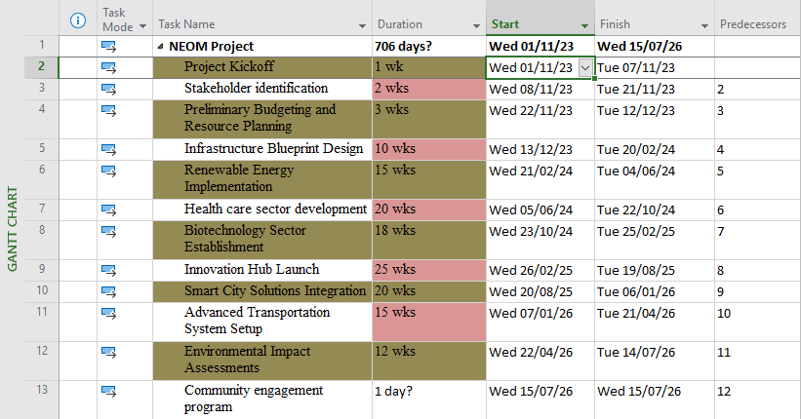

**GANTT CHART & TASKS LIST (MEASUREMENT OF PROGRESS)**

**Microsoft Project Professional Application**

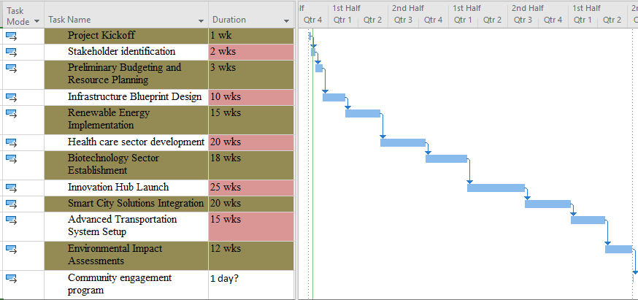

# **Task Scheduling Table for NEOM Project**

| Task ID | Task Description | Duration | Start date | End date | Responsible | Dependencies |
| --- | --- | --- | --- | --- | --- | --- |
| 1 | Project Kickoff | 1 week | Nov 1, 2023 | Nov 7, 2023 | Project Management Team | - |
| 2 | Stakeholder identification | 2 weeks | Nov 8, 2023 | Nov 21, 2023 | Project Management Team | 1 |
| 3 | Preliminary Budgeting and Resource Planning | 3 weeks | Nov 22, 2023 | Dec 12, 2023 | Finance and Resource Management Team | 2 |
| 4 | Infrastructure Blueprint Design | 10 weeks | Dec 13, 2023 | Feb 21, 2024 | Engineering and Design Teams | 3 |
| 5 | Renewable Energy Implementation | 15 weeks | Feb 22, 2024 | Jun 6, 2024 | Technology and Energy Teams | 4 |
| 6 | Health care sector development | 20 weeks | Jun 7, 2024 | Nov 1, 2024 | Healthcare Development Team | 5 |
| 7 | Biotechnology Sector Establishment | 18 weeks | Nov 2, 2024 | Mar 29, 2025 | Biotechnology Development Team | 5 |
| 8 | Innovation Hub Launch | 25 weeks | Mar 30, 2025 | Sep 12, 2025 | Innovation and Research Teams | 7,6 |
| 9 | Smart City Solutions Integration | 20 weeks | Sep 13, 2025 | Feb 6, 2026 | Technology and Infrastructure Teams | 8 |
| 10 | Advanced Transportation System Setup | 15 weeks | Feb 7, 2026 | May 29, 2026 | Transportation development team | 9 |
| 11 | Environmental Impact Assessments | 12 weeks | May 30, 2026 | Aug 21, 2026 | Environmental Assessment Team | 10 |
| 12 | Community engagement program | Ongoing | Throughout project duration | Throughout project duration | Community engagement team | 11 |

**Explanation:**

The task scheduling table outlines various activities, their durations, start and end dates, responsible teams, and dependencies for the NEOM project (Turner, 2022). Each task is sequentially arranged with specific start and end dates, forming a comprehensive timeline for the project’s phases.

* Task ID: Unique identifier for each task.
* Task Description: A brief description of the task or activity.
* Duration: Estimated duration required for completing the task.
* Start Date/End Date: Scheduled start and end dates for each task.
* Responsible: Team or department responsible for task execution.
* Dependencies: Tasks on which the current task depends, indicating the task sequence.

**Timeline**

Represents a structured and extensive roadmap outlining the sequential execution of various phases and activities aimed at establishing a futuristic city (Nicholas & Steyn, 2020). This transformative initiative unfolds over a span of multiple years, spanning several interconnected stages focused on infrastructure development, economic diversification, technological innovation and sustainability.

**Phase 1: Project Initiation and Planning (Nov 2023 – Dec 2023)**

The project commences with the initial phase involving the project’s kickoff, stakeholder identification, and preliminary budgeting. This phase sets the foundation for subsequent activities, solidifying the project’s scope, resources, and overall direction (Nicholas & Steyn, 2020). It marks the collaborative efforts of the project management team and various stakeholders in defining the project’s primary objectives and strategies.

**Phase 2: Infrastructure Development (Dec 2023 – Jun 2024)**

The subsequent phase concentrates on the blueprint design of the city’s infrastructure and the implementation of renewable energy sources. This phase aims to lay the groundwork for a sustainable and technologically advanced city by incorporating innovative designs and environmental considerations, emphasizing smart and eco-friendly solutions.

**Phase 3: Sector Development and Innovation (Jun 2024 – Sep 2025)**

The project further delves into sector-specific development that includes healthcare and biotechnology highlighting the establishment of sectors crucial for economic diversification and technological advancements (Turner, 2022). The phase culminates in the launch of innovation hubs, fostering collaborative efforts and research initiatives, establishing NEOM as a hub for technological innovation.

**Phase 4: Smart City Implementation (Sep 2025 – May 2026)**

Advancing towards establishing NEOM as a smart city, this phase primarily focuses on integrating technological solutions and setting up an advanced transportation system. The objective is to create a city that operates efficiently and offers enhanced living experiences through state-of-the-art technology and sustainable mobility solutions.

**Phase 5: Environmental Sustainability and Community Integration (May 2026 – Aug 2026)**

In this phase, there is a concentrated effort on conducting environmental impact assessments and initiating community engagement programs. This highlights NEOM’s commitment to environmental stewardship and creating an inclusive community, ensuring that the project’s development aligns with sustainable practices and incorporates the needs of the local population (Turner, 2022).

**Ongoing Phase: Continuous Evaluation and Adaptation**

Throughout the project’s lifecycle, continuous monitoring, progress review, and adaptation remain crucial (Nicholas & Steyn, 2020). Regular evaluations and adaptations ensure that the project remains aligned with its goals and allows for dynamic adjustments based on changing circumstances and emerging needs.

*Project timeline within the software.*

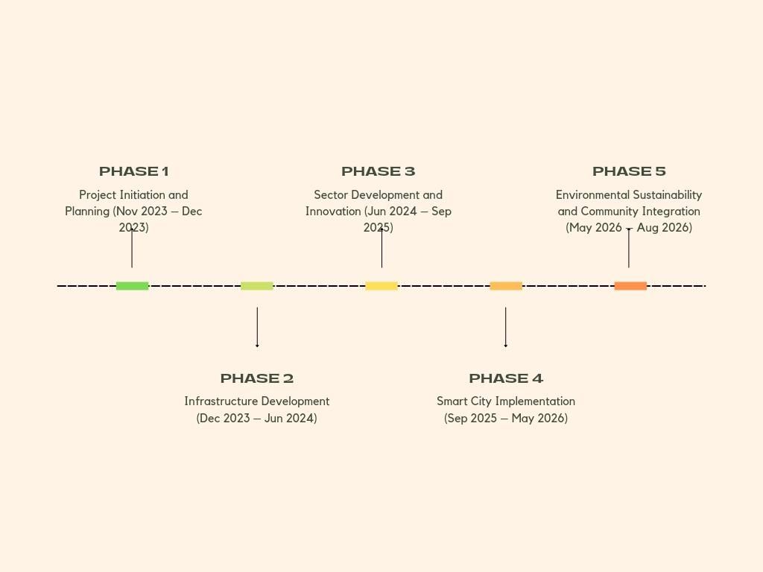

**Cost Baseline**

It functions as a key reference point against which the actual costs are measured, monitored, and controlled throughout the project’s lifecycle.

**Significance of Cost Baseline:**

***Strategic Financial Planning:***

The Cost Baseline serves as the project's financial blueprint by providing a thorough description of estimated costs for all stages and activities. It is developed in collaboration with stakeholders, project managers and financial professionals (Varajão et al., 2022). This strategic planning ensures a methodical approach to managing and distributing funds.

***Basis for Budget Management:***

The baseline, which acts as a standard for monitoring and controlling project spending, generates the approved budget. If real costs are higher than anticipated, it provides a clear standard by which to measure variances and allows for timely corrective action (Kerzner, 2019). This component keeps financial discipline throughout the project by guaranteeing financial management and preventing budget overruns.

***Reference for Decision-making:***

Project managers use the Cost Baseline as a reference point for making decisions that helps them prioritize tasks and allocate cash to different areas (Varajão et al., 2022). It makes well-informed resource allocation decisions easier by enabling modifications based on deviations from the budgeted amount and cost performance metrics.

***Monitoring Performance and Variances:***

Assessing the cost performance of the project in relation to the baseline yields important information about its financial stability (Varajão et al., 2022). Differences between actual and baseline costs make it possible to spot problem areas and take preventative action to reduce risks, keep expenses under control, and preserve financial stability.

***Communication and Reporting:***

The Cost Baseline offers a structured platform for communication and reporting regarding financial aspects (Al-Hodiany & Misztal, 2022). Regular updates and financial reports comparing actual expenditures to the baseline aid in transparent communication with stakeholders, ensuring alignment with the approved financial plan.

***Components of Cost Baseline:***

The Cost Baseline encompasses several critical components:

1. Direct Costs: Explicit expenses directly attributed to project activities such as infrastructure development, sector establishment, and technological integration.
2. Indirect Costs: Indirect expenses associated with project management, administrative overheads, and supporting activities (Turner, 2022).
3. Contingency Reserve: A portion of the budget allocated to manage unforeseen circumstances or changes during project execution.
4. Management Reserve: An additional allocation for unplanned changes or risks that may not be covered within the contingency reserve.

# ***The Cost Baseline Table***

| Cost category | Planned Cost (in USD) | Actual Cost (in USD) |
| --- | --- | --- |
| Infrastructure | $50,000,000 | $52,000,000 |
| Sector Development | $30,000,000 | $28,500,000 |
| Technology integration | $40,000,000 | $41,500,000 |
| Contingency Reserve | $10,000,000 | $9,800,000 |
| Management reserve | $5,000,000 | $5,200,000 |
| Total | $135,000,000 | $136,000,000 |

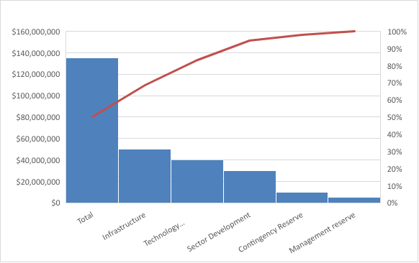

The table includes planned costs against actual costs, offering a clear comparison between the budgeted amounts and the actual expenditures incurred during the project’s execution.

**Work Breakdown Structure (WBS)**

***Level 1: Project Phases***

Infrastructure Development

Sector Development and Innovation

Smart City Implementation

Environmental Sustainability and Community Integration

***Level 2: Deliverables Within Each Phase***

*Infrastructure Development*

1.1 Urban Planning

1.2 Energy Grid Establishment

1.3 Transportation System

1.4 Utility Services Development

*Sector Development and Innovation*

2.1 Healthcare Infrastructure

2.2 Biotechnology Center Setup

2.3 Innovation Hub Establishment

*Smart City Implementation*

3.1 Technology Integration

3.2 Advanced Transportation System Setup

3.3 Infrastructure Smart Solutions

*Environmental Sustainability and Community Integration*

4.1 Environmental Impact Assessments

4.2 Community Engagement Programs

**Level 3: Detailed Tasks Within Deliverables**

*Urban Planning (1.1)*

1.1.1 City Layout Design

1.1.2 Zoning and Land Use Planning

1.1.3 Infrastructure Design

*Energy Grid Establishment (1.2)*

1.2.1 Renewable Energy Integration

1.2.2 Grid Connectivity

*Transportation System (1.3)*

1.3.1 Public Transportation Setup

1.3.2 Traffic Management Solutions

*Utility Services Development (1.4)*

1.4.1 Water Supply and Treatment Systems

1.4.2 Waste Management Solutions

*Healthcare Infrastructure (2.1)*

2.1.1 Hospital Construction

2.1.2 Medical Facilities Setup

*Biotechnology Center Setup (2.2)*

2.2.1 Research Labs Establishment

2.2.2 Innovation Incubation Spaces

*Innovation Hub Establishment (2.3)*

2.3.1 Research and Development Facilities

2.3.2 Collaborative Innovation Spaces

The breakdown highlights the progressively detailed tasks within each deliverable. For instance, under the “Urban Planning” deliverable (1.1), tasks involve the design of the city layout, zoning and land use planning, and detailed infrastructure design.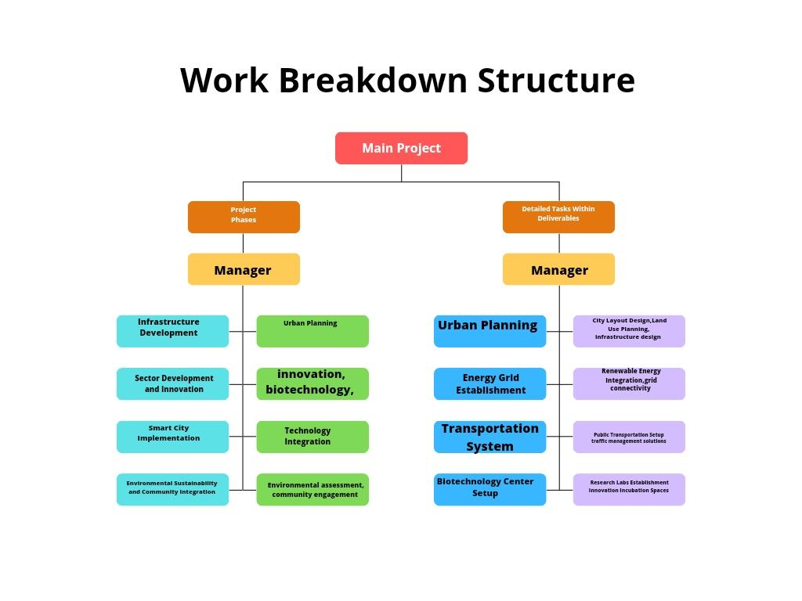

# **Network Diagram**

A comprehensive explanation of how AOA and AON methods could be used to illustrate the task and their relation within NEOM project.

# **Activity-on Node illustration for NEOM**

*Task order:*

1. (Node 1) Urban Planning: This significant task involves infrastructure planning, zoning, and designing the city arrangement, serving as a primary node due to its vital use in shaping the whole project development and layout (Shuvo, 2022).
2. (Node 2) Energy Grid Formation: Once the urban planning starts, the energy system formation initiated as a simultaneous activity but it relies on the accomplishment of the urban planning stage. Therefore, it divides off from Node 1.
3. (Node 3) Transport System: This is another simultaneous task developing from urban planning, Transportation system relies on the infrastructure planning completion (Node 1).
4. (Node 4) Technology Integration: Dependent on the completion of (Node 2) that is Energy Grid Formation, and (Node 3) that is Transport System. After completion of Node 2 and Node 3 the next phase is Technology integration.
5. (Node 5) Environmental Effect Assessment: Running simultaneously to technology integration the next phase is Environmental Impact Assessment which depends on different preceding activities (Ren et al., 2021)

**Activity-on- node illustration for NEOM:**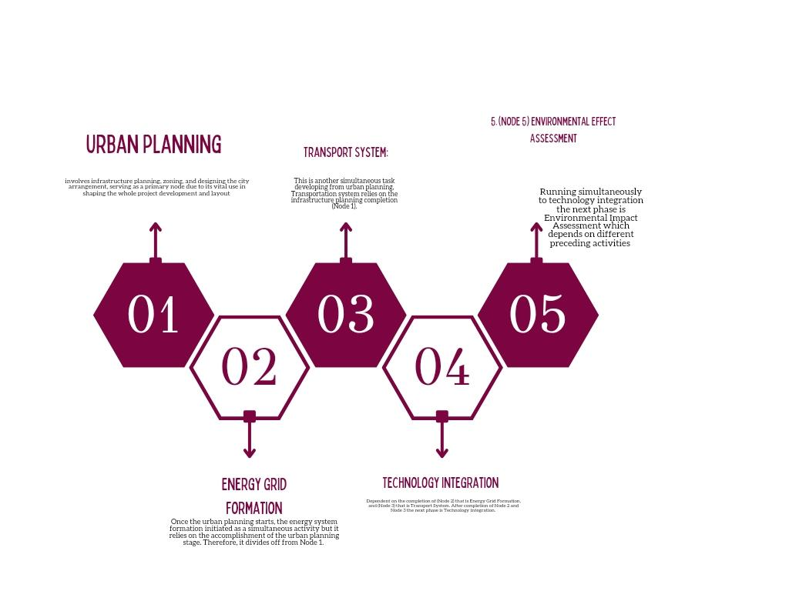

*Task Sequencing:*

1. Urban Planning: This task is represented by an arrow, with node showing the end and the start of this task, specifying its completion and duration.
2. Energy Grid Development: The activity arrow comes from the urban planning point, demonstrating its flow and the dependency of this task once the urban planning process is completed.
3. System of Transport: The same arrow starts after the arrow of urban planning, indication the pattern development of transportation system, following the accomplishment of infrastructure planning.
4. Technology Integration: The arrow enlarges from transportation system and energy grid, showing the succeeding start point of technology integration after both preceding activitie are completed (Mitra et al., 2020)
5. Environmental Effect Assessments: This process run simultaneously with technology integration, indicating its initiation while other activities progress, indicating its rely on different previous activities.

***Activity-on –Arrow diagram for NEOM:***

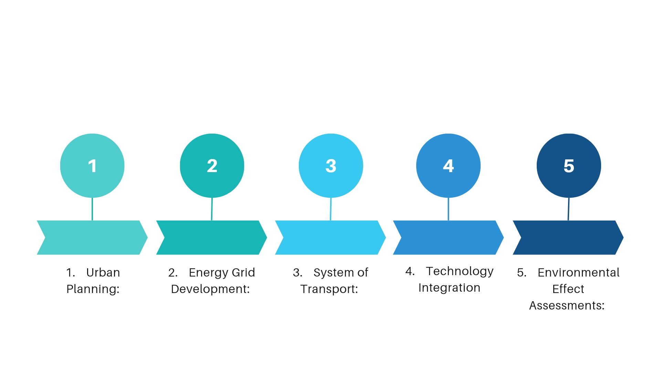

**Importance within the NEOM Project**:

1. Identification of Critical Path: Both AOA and AON diagrams help in identification of the crucial path, showing the pattern of critical task for the task completion.
2. Task Dependencies: Understanding activity pattern help in comprehending dependencies, helping the manager of the project in decision making which are informed regarding managing delays and resources allocation that might influence subsequent task.
3. Recourse Management: The illustration helps the rational allocation of resources by understanding the logical flow of tasks, making sure the activities are organized in an optimal way.
4. Execution ad Planning Aligning: The two diagrams contribute to execution and planning, aligning with the goal of NEOM project within the Vision 2030 border.

# **Critical Path**

The Critical path plays a fundamental role in the NEOM project. It consists of tasks that if they are not done on time, they would directly affect the overall completion of project (Aldusari, 2023). Having the knowledge of critical path is essential min making sure the risks are properly managed and timely delivery of project or delays that may affect the success of project.

# **Understanding the Vital Path in NEOM Project**

**Task Dependencies and Sequencing**

In NEOM project, activities and multiple tasks are dependent and interrelated on one another. The significant path comprises a pattern of activities that if they are not done on time would directly affect the deadline of the project.

**Determination Process:**

*Activity Duration Estimation*: Step number one involve estimating the lapse of each task within the project, putting into consideration some factors like dependencies, task complexity, and availability.

*Identifying Dependencies:* The task dependencies are examined so as to understand the activity which need to be accomplished before the starting of subsequent task.

*Critical Path Calculation*: Once dependencies and durations are established, then the critical path calculation follows, noting the longest sequence of activity with no slack time, for example the total duration time of the project.

**Significant Task on the Critical path:**

In the project of NEOM, certain activities may primarily affect the project’s period if delayed.

1. Infrastructure Design and Urban Planning: Beginning the project with the infrastructure designs and urban planning forms a foundation of critical path. The delays here primarily affect the subsequent tasks, impacting the whole project timeline.
2. Transportation System Setup and Energy Grid Establishment: Following the infrastructure design, the execution of the transportation system and energy grid makes a critical path, affecting further city development and technology integration.
3. Environmental Effect Assessment and Technology Integration: Environmental Assessment and Technology Integration run simultaneously but are significant in the subsequent phase. Occurrence of any kind of delay affect the progress of project.

# **Significant of Vital path of NEOM Project**

1. Project Timeline Management: Knowledge of the critical path helps in control and management of the project schedule. Managers of the project focus on managing and monitoring this critical task to make sure the dateline of the project is achieved.
2. Recourse Allocation: Knowledge of critical path allows betters allocation of resources. Recourses quantity are more found on critical activity to make sure the project is successfully done and no delays occurs.
3. Risk Management: Having the knowledge of critical path aids in identifying delays and potential risks.
4. Decision making and communication: Communications becomes plays a vital role in project’s stakeholders. Project decision making and progress updates always evolve the critical activity.
5. Adaptation and Project Control: The critical path plays as a control machine. Any changes or deviation in the timeline are well monitored while making sure the project runs successful.

**Reduction of risk in the Critical Path:**

In the project of NEOM, a proactive approach is vital in reducing risks which may affect the crucial path:

1. Recourse Allocation: Ensuring enough resources are allocated to critical activity so as no delay occurs.
2. Contingency Planning: With contingency plans in place of obstacle or unforeseen issue that may increase within this crucial task.
3. Control and Regular Monitoring: Continuous control and monitoring of crucial path ensures the management of risks and adjust to changes promptly.

*Critical path diagram*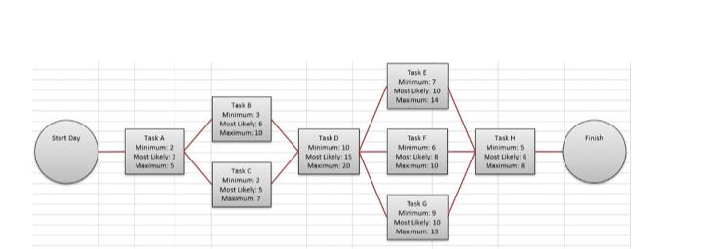

# 

# **Responsibility Assignment Matrix**

The RAM also known as RACI matrix, is a tool that is structured used in project management to clarify and define the responsibility and roles of members in completing. Activity and deliverable of a project (Mesquita et al., 2020). The abbreviation (RACT) stands for Responsible, Accountable, Consulted, and Informed, standing for different levels and roles of involvement in a given activity or a task.

**Role of RACI Matrix:**

* **Responsibility:** The team or individual responsible for completing the activity or task. They are the workers who execute the work.
* **Accountable:** This is the person who is eventually answerable for the activity failure or success. This person makes the approval of the work and make the decision.
* **Consulted**: Group or individual who requires to provide expertise or input for the activity to be accomplished successfully.
* **Informed:** These are groups or people who requires to be kept in the circle regarding task outcome or progress. They are not straight involved in the activity but need to be alert of its status.

**Application within the NEOM project:**

**Responsibility Assignment Matrix for NEOM Project Activity**:

| Task | R (Responsible) | A (Accountable) | C (Consulted) | I (Informed) |
| --- | --- | --- | --- | --- |
| Urban planning | Engineering team | Project Manager | Urban Planners | Stakeholder |
| Energy Grid Establishment | Energy Specialists | Project director | Infrastructure team | Stakeholder |
| Transportation System Setup | Transportation Team | Project Manager | Urban Planners | Stakeholder |
| Technology integration | IT and tech team | CTO | Innovation experts | Stakeholder |

## **Explanation**

**Urban Planning**: The urban planning work is rationed accordingly with the engineering team tackling the most of urban planning. On the other hand, a project manager is tasked with approving the final plan.

**Energy Grid Establishment**: Most work at this level is handled by energy experts and the Project Director with consultation from the Infrastructure Team.

**Transportation System Setup**: At this level, the Transportation Team handles the task while the project manager is held accountable. Additionally, the team consults urban planners at this stage.

**Technical Integration**: For this task, the Information Technology and Tech teams are the performers while at the same time, the Project manager is accountable as like in the others.

**Benefits of the Responsibility Assignment Matrix:**

1. Efficiency and accountability: Giving specific assignments to individuals or teams ensures there is good task completion and accountability.

2. Efficient communication: through clearly describing parties involved in decision making, the matrix is able to facilitate better communication.

3. Project control: It enables project managers to monitor and manage tasks more effectively due to defined responsibilities.

4.Clear expectations and roles: The RACI matrix ensures individuals understand their purpose and involvement in each assignment.

5. Efficiency and accountability: giving specific assignments to individuals or teams ensures good task completion and accountability (Balakrishna et al., 2019).

6. Control of project: It enables managers to observe and manage tasks more effectively.

**Project Analysis/Conclusion/Recommendation.**

NEOM Project is a foundation of Saudi Arabia’s Vision 2030 which portrays and ambitious venture to change urban technology and development. With a keen look into the projects progress one can clearly see the remarkable achievements and limitations it faces in its development. The project’s multifaceted nature includes infrastructure development, environmental stability and integration of tech which has made it very complex and bizarre in the world landscape.

The project has made extensive steps towards urban planning and setting up of infrastructure. The project’s zoning schemes, and accurate architectural blueprints highlight a comprehensive approach to city planning. The project is committed to sustainable energy and innovative mobile solutions that resonate with Saudi Arabia’s Vision 2030 Agenda. Additionally, the venture into technology integration shows that the project’s aspires to be a home for bizarre technological advancements.

However, besides the projects visible progress, it continues to face various limitations which necessitate a careful balance between fast development and accurate planning. Such limitations have resulted to interdependencies among various sectors which pose execution and logistics challenges. These challenges require constant coordination in the disciplinary teams. The Environmental Impact Assessments and community integration also faces challenges that demand more community engagement initiatives.

To ensure the project’s success, various recommendations and strategies are important for navigating the complex areas. The NEOM project advocates for collaboration among the teams involved with enhanced communication channels and good workflows which are imperative to overcome the limitations encountered. In order to secure the project from unforeseen limitations, they should emphasize a healthy risk management strategy that anticipates potential obstacles.

A clear distinction between stakeholder engagement and community involvement is very important. A more seamless integration of NEOM within the region will be ensured by persistent efforts to establish an open and inclusive conversation with local people, which will enhance their active engagement and support. It will be essential to continuously improve and modify the project plan in response to stakeholder comments and continuing evaluations if NEOM is to achieve its intended success.

From the projects analysis and evaluation, it reflects a unique mixture of challenges and opportunities. The current complexities and challenges facing the project can only be addressed by strategic adjustments, risk management, community engagement and through emphasizing collaboration. In conclusion, for NEOM to pioneer the model for future urban planning there will be need for steady commitment to innovation and sustainable development.

**Recommendations for NEOM Project success:**

**1. Enhanced Interdepartmental Coordination.**

To improve coordination and communication between teams in the project they need to facilitate continuous interdepartmental meetings. Implementation of a centralized platform for sharing progress and challenges is crucial for more cohesive approach to the projects development.

**2. Healthy risk management strategies.**

To cope with changing circumstances there is need for regular risk assessment and contingency planning for the project.

To cope with the projects variety and diverse sectors, it is crucial to develop and maintain an overall risk management plan that foresees and mitigates potential limitations.

**3. Stakeholder participation and community engagement.**

For active participation and inclusivity in the project, there is need for regular town hall meetings and forums which can be organized (Algumzi, 2022). There is also need to establish transparent and consistent channels for ongoing negotiations and engagements with local personnel and stakeholders which fosters their participation in decision making.

**4. Sustainability focus and environmental impact.**

Implementing green technologies as well as renewable energy solutions is key to match with the project’s environmental sustainability. This can also be achieved through strengthening Environmental Impact Assessment through promoting practices that are ecologically responsible.

**5. Adaptive strategy and Iterative planning.**

Adopt a flexible and adaptable planning strategy that takes stakeholder input, ongoing evaluations, and technology developments into account.

Encourage a culture of responsiveness and agility so that the project can quickly adjust to opportunities and changes in the quickly changing urban development context (Chen et al., 2020).

**6. Innovation emphasis and technology.**

To ensure NEOM’S status a leading in advanced technologies, there is need to encourage collaboration with other crucial tech companies. To keep NEOM a center for innovation and technology throughout the world, it is important to invest in cutting-edge research and development as well as technology.

**7. Quality assurance and regular Project Review.**

To make sure that defined standards and quality benchmarks are being followed, conduct recurring project reviews and quality assurance inspections.

Establish a culture of ongoing development by encouraging creativity and best practices in all facets of the project's progress.

**8. Talent Development and Skill Enhancement**: Provide personnel with training and programs that will help them enhance their skills and knowledge so they can successfully contribute to the success of the project.

In order to maximize the potential and abilities that are present within the project teams, promote a culture of learning, creativity, and knowledge exchange.

**9. International Collaboration and Partnerships**: To maximize knowledge, resources, and a range of viewpoints in influencing NEOM's growth, cultivate international collaborations and strategic partnerships with international organizations, governments, and investors.

Make use of worldwide best practices and knowledge to guarantee that NEOM complies with global norms for sustainability, technology, and urban development.

**10. Public-private synergy and long-term vision**

Coordinate long-term planning and vision between the public and private sectors to guarantee a cohesive and harmonious approach to achieving NEOM's goals. By utilizing the cooperation of public and private sectors, develop policies that foster private investment and long-term economic growth (Cruxên, 2022).

If put into practice, these suggestions have the potential to greatly enhance the NEOM project's performance and long-term viability. They will also complement Vision 2030's overarching goals and establish NEOM as a leading example of innovation, sustainability, and cutting-edge urban living worldwide.

**Conclusion.**

The NEOM project is like no other project in the world and is the most ambitious and innovative project within the vision 2030 framework. The NEOM project aims or change the future of urban planning and sustainability forever. The NEOM project is also powered by bizarre urban planning and tech innovation as well as extreme environmental sustainability (Farag, 2019). The project has shown significant progress and it has also faced variety challenges and unlocked opportunities. This has shaped the projects unique trajectory to redefine urban planning paradigms.

From its accurate and strategic approach to urban and infrastructural development there is evidence of good progress for the NEOM project. The integrated technology projects promise to establish NEOM as a global center for innovation and technological developments, promoting digital infrastructure and clever solutions, in addition to serving as a symbol of cutting-edge progress.

When evaluating NEOM Project, there is clear evidence that success of such a project is determined by concerted strategy to address its challenges and also take advantage of its strengths. The project's proactive methods and overarching goal have the potential to establish a standard for future urban development endeavors.

# **Key Aspect for Consideration for Success of NEOM Onwards**

1. Synergy and Collaboration: Creating and enhancing avenues for ongoing communication and smooth cooperation will promote a culture of shared accountability and creativity.

2. Sustainability and innovation: Building a city that can endure future difficulties requires striking a careful balance between sustainability and progress.

3. Community Engagement and Transparency: Putting in place systems for proactive community involvement and involvement will open the door for smooth integration and local community support (Le Corre, 2021).

4. Flexibility and adaptive planning: A flexible strategy that adapts in response to continuing evaluations and input from stakeholders will put NEOM in a position to take advantage of opportunities and overcome obstacles.

NEOM’S Project success is the solution to the paradigm of cities of the future and will become a model for technology advancement and inclusive urban development. However, the journey for NEOM is files with many challenges and opportunities that will determine the projects’ ability to redefine the future of urban development.

# **References**

Alam, T., Khan, M. A., Gharaibeh, N. K., & Gharaibeh, M. K. (2021). Big data for smart cities: a case study of NEOM city, Saudi Arabia. *Smart cities: a data analytics perspective*, 215-230.

Aldusari, A. N. (2023). Strategic Development Plan Proposed for the Future City NEOM. In *Cities of the Future: Challenges and Opportunities* (pp. 57-74). Cham: Springer International Publishing.

Algumzi, A. (2022). Risks and challenges associated with NEOM project in Saudi Arabia: A marketing perspective. *Journal of Risk and Financial Management*, *15*(9), 381.

Alkeaid, M. M. G. (2018). Study of NEOM city renewable energy mix and balance problem.

Altahtooh, U. A. (2019). A model of the critical success factors for the Neom project in the context of a project management information system. *Journal of Management and Strategy*, *10*(1), 1-12.

Alves, J. L., Ferreira, E. A., & de Nadae, J. (2021). Crisis and risks in engineering project

management: A review. *Brazilian Journal of Operations & Production*

*Management*, *18*(4), 1-17.

<https://bjopm.emnuvens.com.br/bjopm/article/download/991/983>

Al-Hodiany, Z. M., & Misztal, A. (2022). Influential Factors of Project Success In The Fuel

Companies. *Polish Journal of Management Studies*, *25*(1), 72-91.

<https://pjms.zim.pcz.pl/api/files/view/1898433.pdf>

Arif, M., & Aldosary, A. S. (2023). Urban Spatial Strategies of the Gulf Cooperation Council: A Comparative Analysis and Lessons Learned. *Sustainability*, *15*(18), 13344.

Balakrishna, R., Ben-Akiva, M., & Koutsopoulos, H. N. (2019). Time-dependent origin-destination estimation without assignment matrices. In *Transport Simulation* (pp. 201-213). EPFL Press.

Chen, X., Wang, H., Ma, Y., Zheng, X., & Guo, L. (2020). Self-adaptive resource allocation for cloud-based software services based on iterative QoS prediction model. *Future Generation Computer Systems*, *105*, 287-296.

Cruxên, I. A. (2022). The limits of insulation: The long-term political dynamics of public-private service delivery. *International Development Planning Review*, *44*(3), 317-343.

Dinnik, D. I., Grigoryeva, N. S., & Galoyan, Y. E. (2019, August). Improving project

management of socio-economic development of the region with the use of soft

computing. In *International Conference on Theory and Application of Soft Computing,*

*Computing with Words and Perceptions* (pp. 214-220). Cham: Springer International

Publishing. <https://link.springer.com/chapter/10.1007/978-3-030-35249-3_27>

Englund, R., & Graham, R. J. (2019). *Creating an environment for successful projects*. Berrett-

Koehler Publishers.

<https://www.academia.edu/download/60636407/Creating_Environment_highlights20190918-57673-7dculh.pdf>

Fallatah, K. (2019). *Guide for sustainable design of NEOM City*. Rochester Institute of Technology.

Farag, A. A. (2019). The story of NEOM city: Opportunities and challenges. *New cities and community extensions in Egypt and the Middle East: Visions and challenges*, 35-49.

Hilmi, N., Farahmand, S., & Belaid, F. (2020). Why Should Saudi Arabia Diversify Its Economy?. *Economic Development in the Gulf Cooperation Council Countries: From Rentier States to Diversified Economies*, 89-109.

Horne, R. (2023). 2 Employment and social trends by region. *World Employment and Social Outlook*, *2023*(1), 57-85.

Hridjikj, D. (2022). An incomplete" dialogue" about tomorrow.

Kerzner, H. (2019). *Using the project management maturity model: strategic planning for*

*project management*. John Wiley & Sons.

<https://books.google.co.ke/books?hl=en&lr=&id=4vyGDwAAQBAJ&oi=fnd&pg=PR11&dq=project+management&ots=UbFoD1d2qW&sig=CTPyzHyoBcOWmsdkxY_VXsApx0Q&redir_esc=y#v=onepage&q=project%20management&f=false>

Kerzner, H. (2022). *Project management metrics, KPIs, and dashboards: a guide to measuring*

*and monitoring project performance*. John Wiley & Sons.

<https://thuvienso.hoasen.edu.vn/bitstream/handle/123456789/7391/Contents.pdf?sequence=4>

Le Corre, N., Pepin, P., Han, G., & Ma, Z. (2021). Potential impact of climate change on northern shrimp habitats and connectivity on the Newfoundland and Labrador continental shelves. *Fisheries Oceanography*, *30*(3), 331-347.

Mesquita, D., Souza, A., & Kaski, S. (2020). Rethinking pooling in graph neural networks. *Advances in Neural Information Processing Systems*, *33*, 2220-2231.

Mitra, P. K., Joshi, B., & Prasad, A. (2020). Identification of pre-flare processes and their possible role in driving a large-scale flux rope eruption with complex M-class flare in the active region NOAA 12371. *Solar Physics*, *295*(2), 29.

Nicholas, J. M., & Steyn, H. (2020). *Project management for engineering, business and*

*technology*. Routledge.

Qablan, S. A. (2021). Mega-Projects to Drive Tourism Development in Saudi Arabia.

Rashed, R., & Mahmoud, R. (2018). Urban Social Sustainability in the Era of Digital Technology: the case of NEOM, the World’s Future Global Hub across Three Countries. In *The International conference of Sustainable Design of the Built Environment SDBE18*.

Ren, R., Zhang, J., & Jiang, Y. (2021). New automated activity-on-node calculation grading method for construction management education innovation. *Journal of Civil Engineering Education*, *147*(3), 04021004.

Shad, F., Shah, F. A., Jan, S., & Ahmad, S. (2019). Importance of communication in project

management: A case study of communication & works department Peshawar. *Sarhad*

*Journal of Management Sciences*, *5*(2), 267-280.

<https://www.researchgate.net/profile/Fazaila-Shad-2/publication/343963614_Importance_of_communication_in_project_management_a_case_study_of_communication_and_works_department_Peshawar/links/6257f3dd1c096a380d038bd5/Importance-of-communication-in-project-management-a-case-study-of-communication-and-works-department-Peshawar.pdf>

Shuvo, B. D. (2022). Enhancing Activity-on-Node Network Diagramming Technique for Modeling Interdependent Workflows in Planning Fabrication Projects.

Turner, J. R. (2022). *The handbook of project-based management*. Prentice Hall.

<http://portal.belesparadisecollege.edu.et:8080/library/bitstream/123456789/1809/1/1GZFVNWJZB34QIXLR4WF.pd>

van den Bosch, H. (2020). Humane by choice, smart by default: 39 building blocks for cities of the future. *IET Smart Cities*, *2*(3), 111-121.

Varajão, J., Marques, R. P., & Trigo, A. (2022). Project management processes–impact on the

success of information systems projects. *Informatica*, *33*(2), 421-436.

<https://content.iospress.com/articles/informatica/infor488>