AI ROAST GENERATOR

PROMPT 1: To get the necessary code with all the requirements.

Write a beginner-friendly C++ console program that generates funny roast messages.

Requirements for the code are as follows:

1.Ask the user to input their name
2.Store at least 10 roast templates using a vector of strings
3. Each template must include a placeholder
4.Randomly select one roast each time the program runs
5. Replace {name} with the user’s actual name
6.Ensure different output on every run
7. Add comments to explain each part of the code clearly

Keep the code simple and easy to understand for beginners in c++.

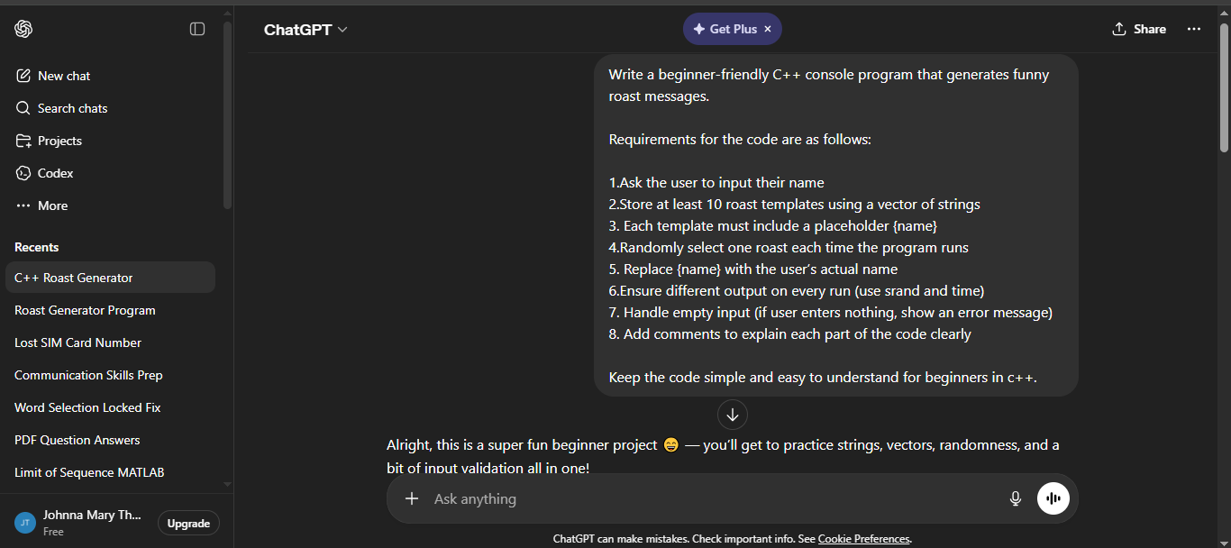

PROMPT 2: Modifying the code ( personalisation)

the code given should be modified . Make it interactive as it is an ai roast generator .It should have fun elements like a welcome message in a fun manner or a joke as a welcome . Add more interesting elements to make it funnier
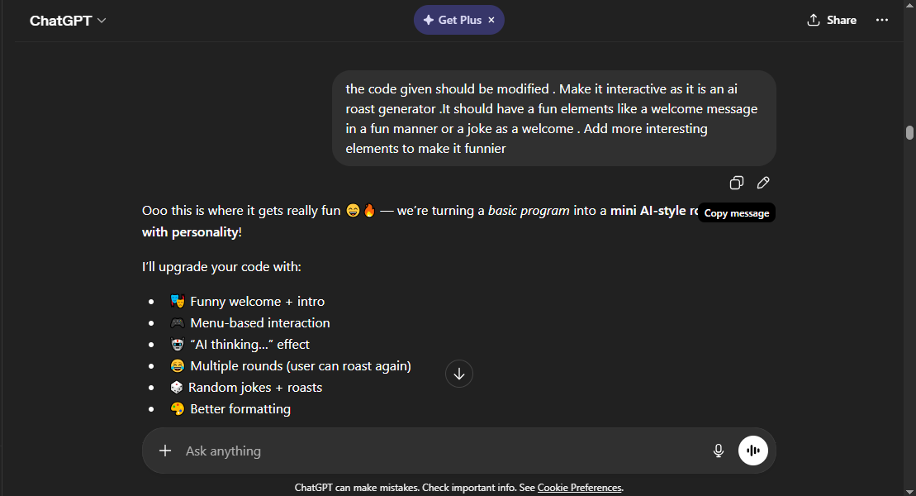

Bug Fixing
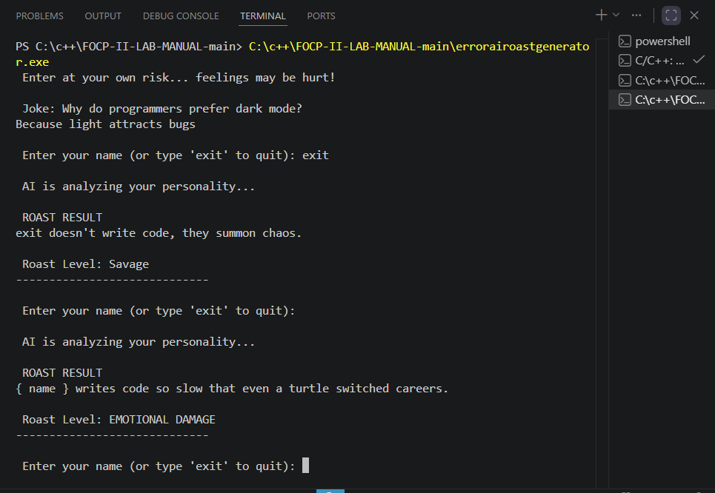

Prompt for correcting both the bugs
The code has an option to exit but when the user opts to exit , the code doesnt stop. It prints the joke with the exit word in case with both uppercase and
lowercase and uppercase exit word. rectify that.

also blank input is also considered it prints the original joke template

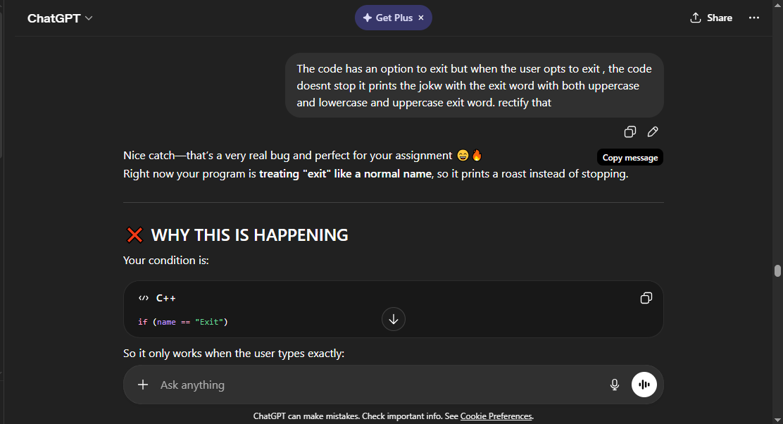

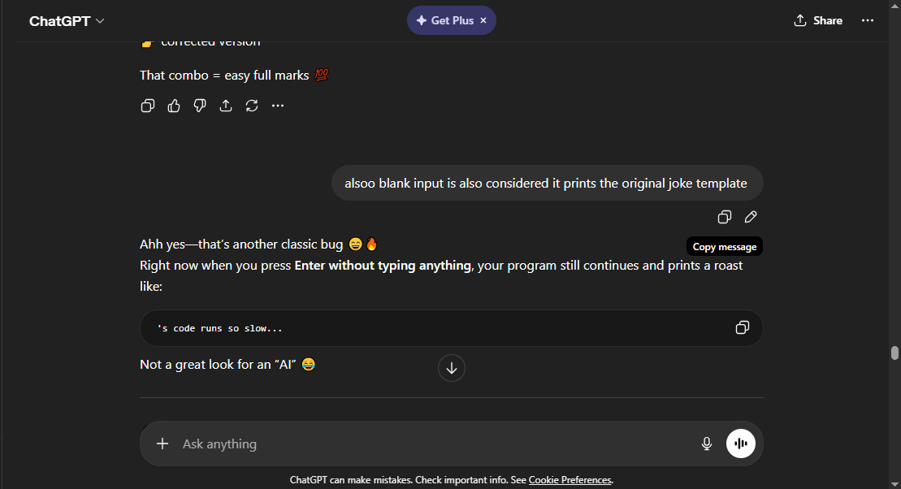
Corrected output
