STUDENT EXCUSE GENERATOR

PROMPT 1: To get the necessary code with all the requirements.
Write a beginner-friendly C++ console program that generates creative excuses for missing homework.
Requirements:
- Ask the user to input their name
- Store at least 10 excuse templates using a vector of strings
- Each template must include a placeholder {name}
- Randomly select one excuse each time the program runs
- Replace {name} with the user’s actual name
- Ensure different output on every run
- Add fun elements like a welcome message and a joke
- Handle empty input properly
- Add comments for better understanding

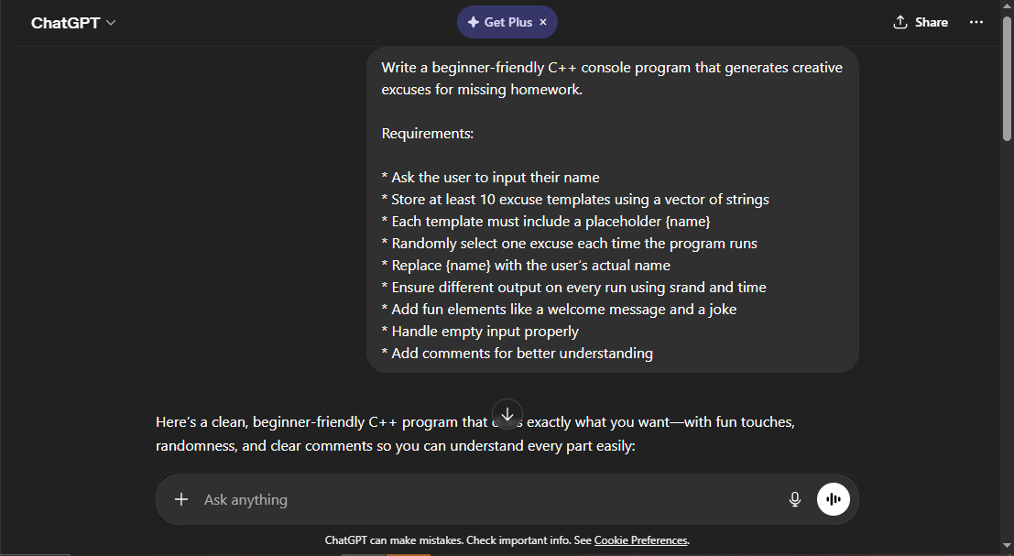

PROMPT 2: Modifying the code ( personalisation)

add the following excuses as excuse templates in the code to make it funnier 1. printer ran out of black ink 2.My computer started a 3-hour forced update right when I opened your assignment link. 3.completely mixed up the due dates ..

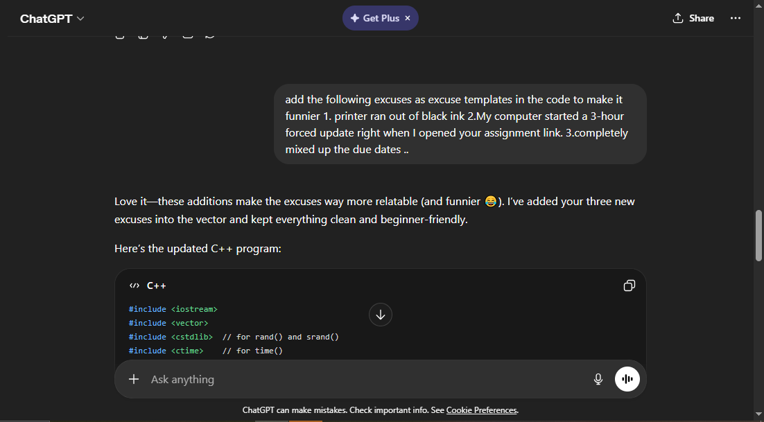

Bug Fixing
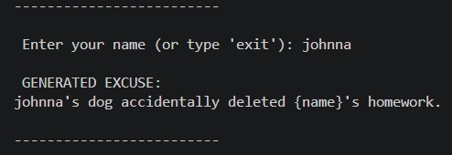.

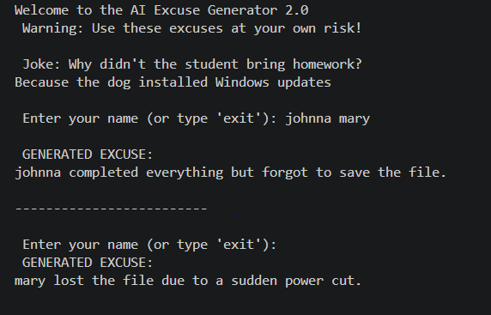

Prompt for correcting both the bugs
1. program replaces {name} only once in a string. If {name} appears multiple times, the rest are not replaced.

2..My program is not reading full names. If I enter "Johnna Mary", it reads Johnna and mary separately. How do I fix this?

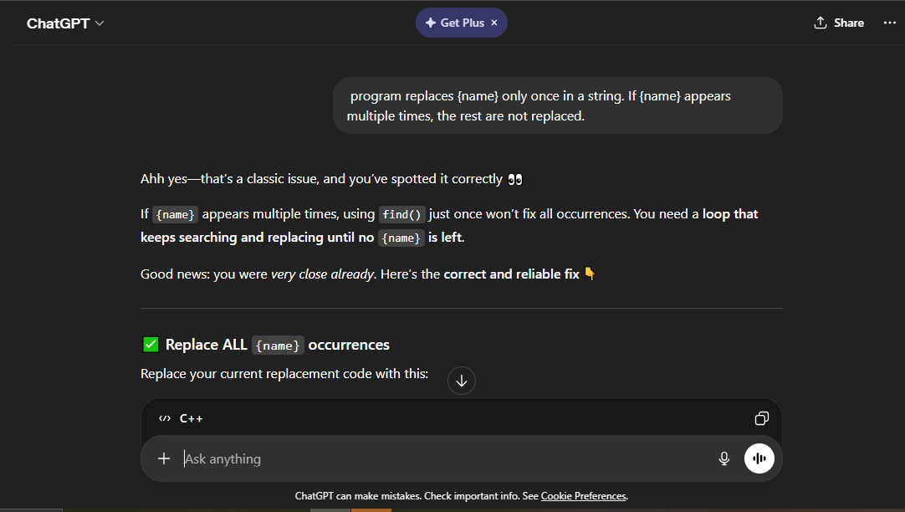
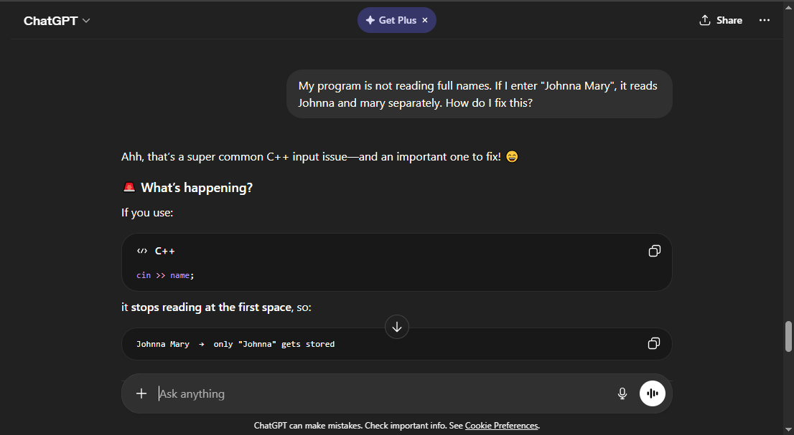
Corrected output
