PHYS5033

COUNCIL
SUSTAINABILITY
REPORT
A consumption-based carbon footprint assessment
and practical pathways for reducing emissions
Prepared for: [Sustainability Manager / Council name]
Report details | Details
Prepared by | [Student name]
Student ID | [Student ID]
Council / study area | Redfern, City of Sydney, NSW, Australia
Assessment period | November 2025 – October 2026 (12 months)
Submission date | [Date]
Main-text word count | Current draft ≈ 1,333 words including figure text; target ≤ 3,000. Recheck before submission.

Contents
1. Introduction
2. Methodology
3. Results
4. Discussion
5. Recommendations
6. Conclusion
References
Supplementary Information

1. Introduction

1.1 Why greenhouse gas emissions must be reduced
[Write introduction here.]

1.2 Why quantify consumption-based footprints?
[Write rationale here.]

1.3 Purpose and scope of this report
This report assesses the annual consumption-based carbon footprint of a hypothetical adult resident of Redfern within the City of Sydney local government area. The resident shares an apartment, does not own a private car and primarily uses public transport. The assessment covers November 2025 to October 2026 and uses realistic illustrative expenditure data rather than personal financial records. Shared household expenses are allocated to the individual. Using the supplied 2018 Australian input-output dataset, the assessment will identify major emissions sources and inform practical recommendations for the resident and the council.

2. Methodology

2.1 Study boundary, data sources and assumptions
The study covers one hypothetical adult’s annual private consumption. Shared household costs are allocated equally between two adults. No private vehicle, flights, paid accommodation, major appliance purchase or tuition expenditure is assumed for this illustrative year. These are scenario boundaries, not claims of zero wider environmental impact.

2.2 Annual expenditure and sector mapping

The illustrative budget totals AUD 29,760 per person per year, including AUD 15,600 in rent (AUD 300 per week). Rounded monthly personal amounts are annualised by multiplying by 12. Shared bills assume two adults dividing costs equally; the recorded amounts are already the resident’s share. Twenty expenditure items are split into 40 allocations and mapped to the original 345-sector order. The mapping reconciles to the budget total. Expenditure assumptions and allocation details are provided in Supplementary Information S1–S3.

2.3 Input-output model and footprint equations
A = T x̂⁻¹; Aᵢⱼ = Tᵢⱼ / xⱼ (1)
T records transactions between 345 Australian sectors, x their total outputs, and Q their CO₂-equivalent emissions. Diagonalising x gives x̂. Dividing each transaction column by its sector output yields A, the inputs required per unit of output. T and x are expressed in AUD million and Q in kilotonnes CO₂-e (course-supplied dataset; see Supplementary Information S4).
L = (I − A)⁻¹ (2)
The Leontief inverse L captures the cumulative output required throughout the supply chain to meet final demand, including both immediate suppliers and successive upstream production layers. Excel array calculations are documented in Supplementary Information S4.
q = Q x̂⁻¹; m = qL (3)
Direct intensity q divides sector emissions by output. Multiplying q by L gives total supply-chain intensity m, measured in kt CO₂-e per AUD million. The implemented matrix calculations are shown in Supplementary Information S5.
F = qLy = my (4)
The personal final-demand vector y contains 345 annual expenditures converted from AUD to AUD million. The scalar qLy gives the consumption-driven footprint in kt CO₂-e; multiplying by 1,000 converts it to tonnes per person per year.

2.4 Sector analysis and validation
Consumption-category contribution: cⱼ = mⱼyⱼ; Σⱼcⱼ = F (5)
Emitting-sector contribution: eᵢ = qᵢ(Ly)ᵢ; Σᵢeᵢ = F (6)

2.5 Comparison data and methodological limitations
National references use OWID’s consumption_co2_per_capita series, based on Global Carbon Budget (2025) emissions and OWID population data. Consumption accounting adjusts production emissions for trade. The series covers fossil-fuel and industrial CO₂, excluding land-use change and non-CO₂ gases; international aviation and shipping are not allocated to individual countries (Our World in Data, n.d.). The primary comparison uses 2018, matching the IO reference year; 1990–2023 histories provide context. Countries illustrate contrasting consumption contexts rather than an exhaustive world ranking. These references differ from the resident’s CO₂-e estimate and national final demand includes expenditure beyond a private shopping basket. The personal estimate also uses nominal 2025–26 spending without deflation, assumes purchaser spending can proxy sector demand, and has unresolved insurance valuation and household direct-combustion coverage. Consequently, the comparison is contextual, not like-for-like.

3. Results

3.1 Annual expenditure and total carbon footprint

The provisional footprint is 9.54 t CO₂-e per person per year for annual expenditure of AUD 29,760. Consumption-category and emitting-sector contributions reconcile to this total. The estimate reflects the supplied model and stated assumptions; it is not a complete, valuation-adjusted personal inventory.

3.2 Sector-level contributions and hotspots
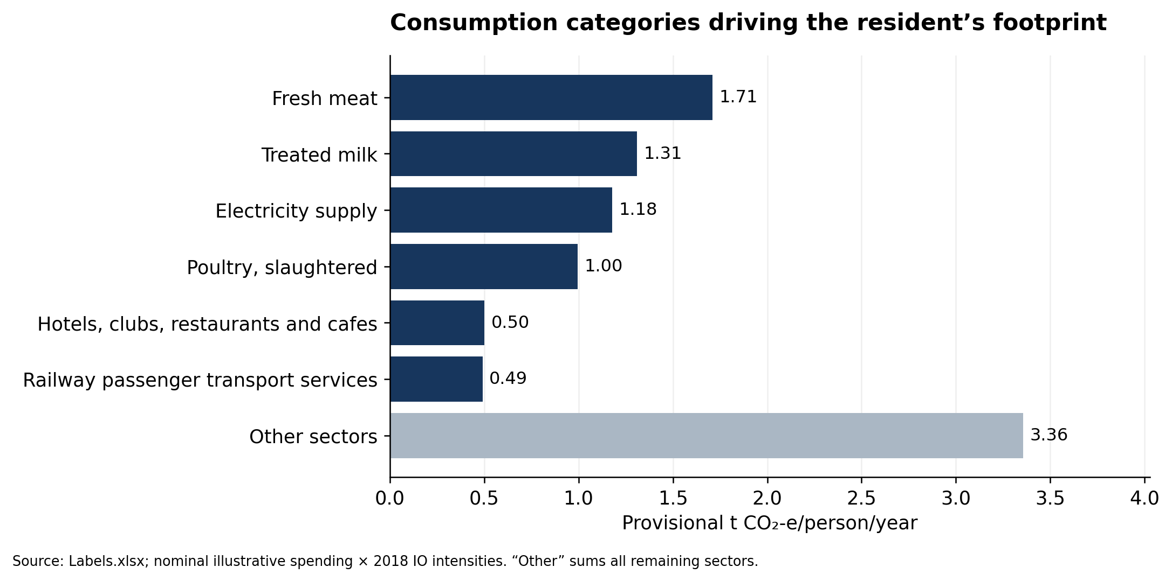
Figure 1. Provisional footprint by consumption category; remaining sectors are aggregated as “Other”. Source: Labels.xlsx.

Fresh meat, milk, electricity and poultry together account for approximately 54% of the estimated footprint (Figure 1). These categories identify purchases driving supply-chain emissions, rather than the sectors where emissions physically occur. Their prominence reflects both spending and emissions intensity; because food allocations are hypothetical, these priorities should be checked against alternative realistic allocations before final recommendations are made.

3.3 Australian and international per-capita comparison
Figure 2 places the resident’s 9.54 t CO₂-e estimate alongside clearly separated national CO₂ references. In 2018, Australian consumption-based CO₂ emissions were 15.38 t per person, compared with 16.97 in the United States; the other selected countries range from 1.63 in India to 10.04 in Japan (Our World in Data, n.d.; Global Carbon Project, 2025). Although the personal estimate is numerically below the Australian CO₂-only reference, this is not evidence of an equivalent reduction in a comparable greenhouse-gas footprint. Different gas coverage, expenditure boundaries, prices and periods prevent a defensible percentage-gap calculation. The trend lines show each country’s trajectory through 2023, with 2018 marked; they do not estimate the resident’s historical emissions.
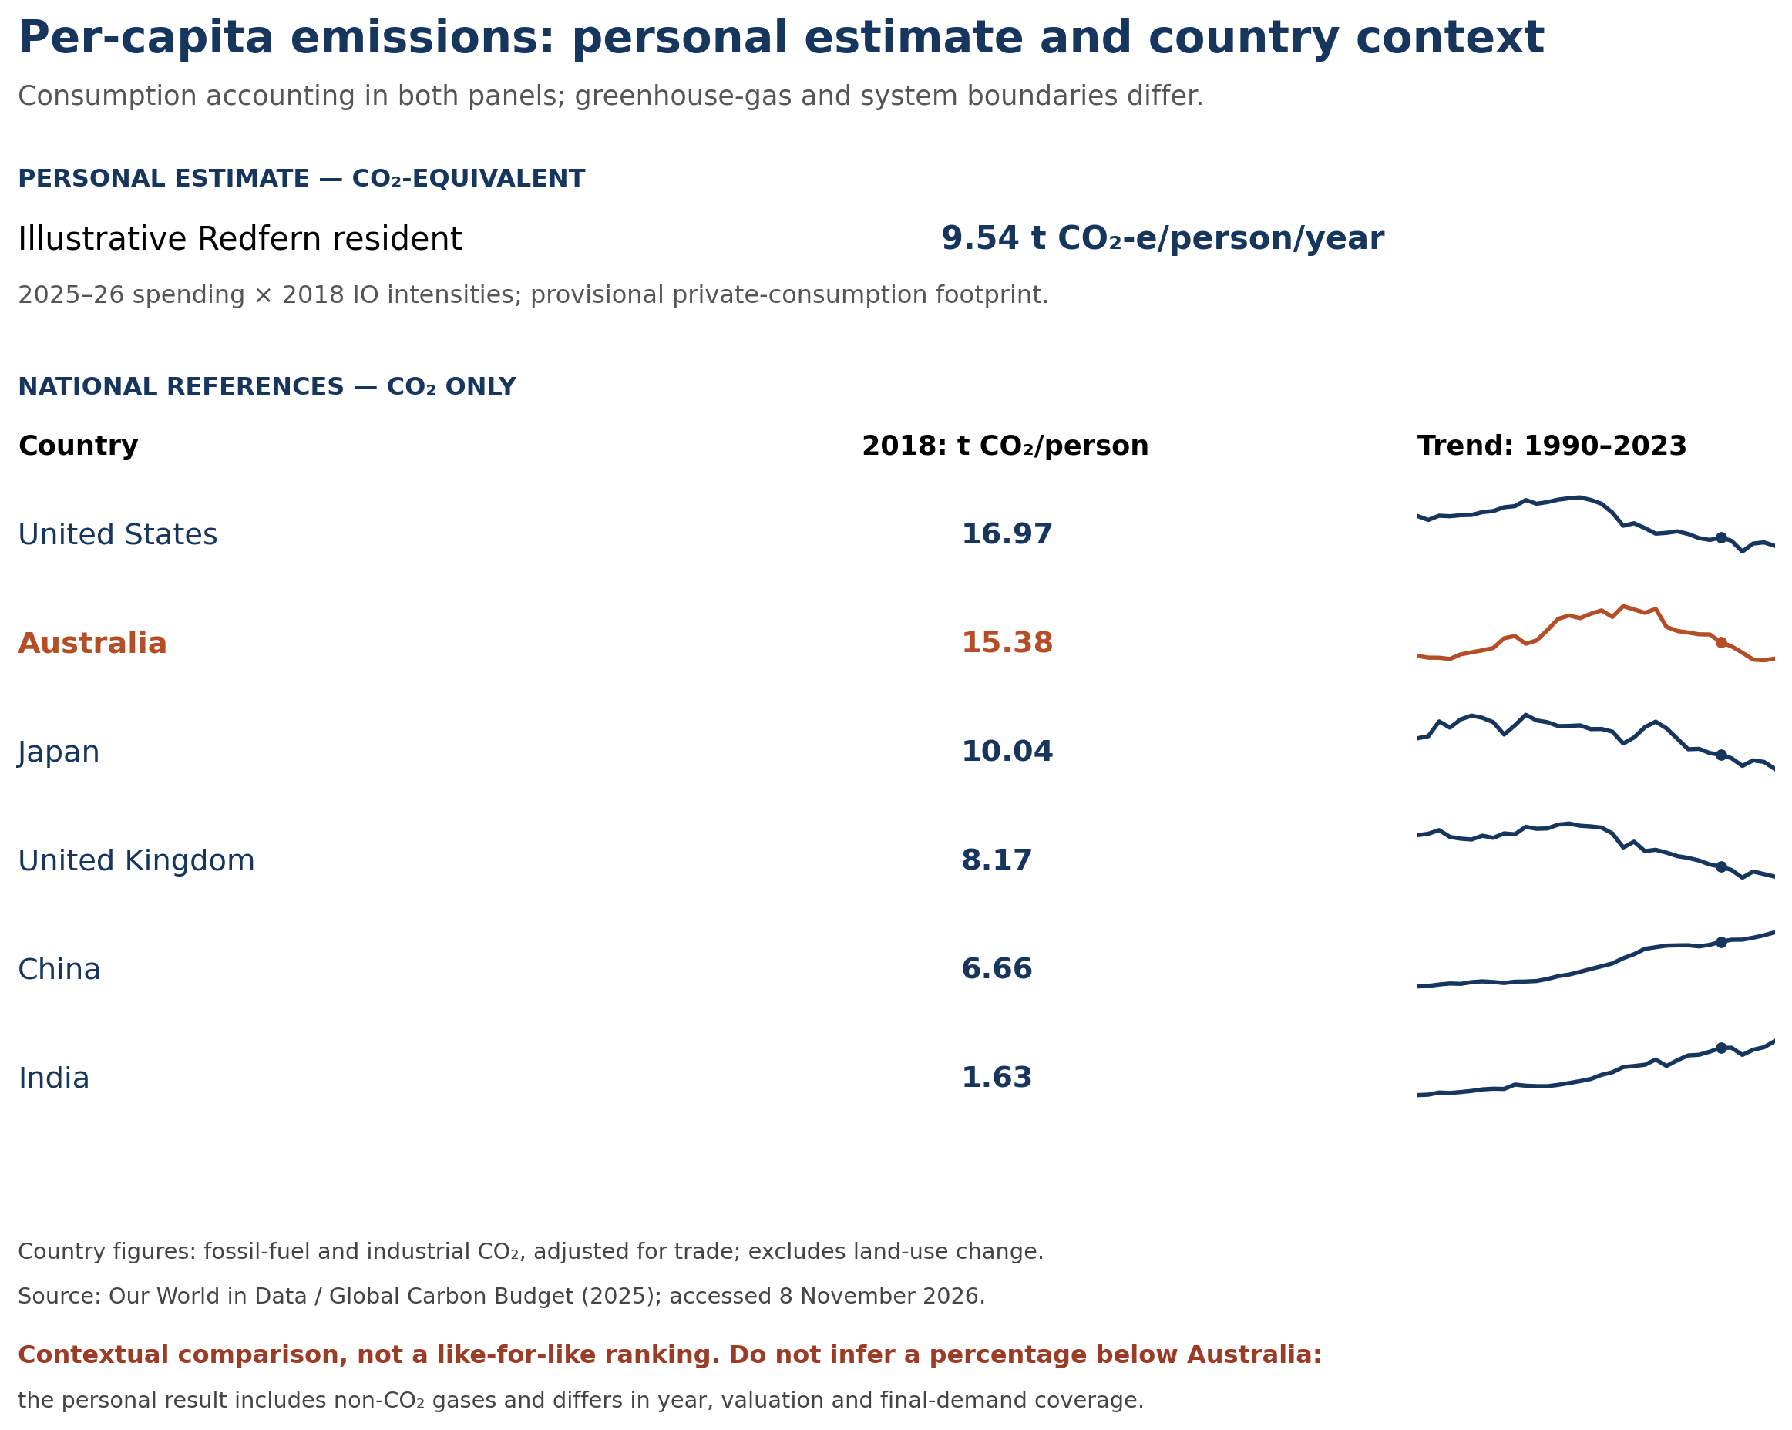
Figure 2. Contextual per-capita comparison. Personal CO₂-e and national CO₂ appear in separate panels; values are not a like-for-like ranking. Country data: OWID/Global Carbon Budget (2025), accessed 8 November 2026. Sparklines use individual vertical scales; dots mark 2018.

4. Discussion

4.1 Interpretation of the footprint and its drivers
Among the national CO₂-only references, Australia lies above Japan, the United Kingdom, China and India, but below the United States. This establishes a relatively high national consumption-emissions context; it does not show that the hypothetical resident is a specified percentage cleaner than an average Australian. The resident’s consumption-category results provide the stronger basis for identifying personal actions.

4.2 Meaning for sustainability and local action
[Write discussion here.]

4.3 Uncertainty and implications for decisions
The calculated precision should not be mistaken for certainty. Sector averages cannot distinguish individual suppliers or product variants, and fixed input coefficients omit behavioural and technological responses. Price-year and valuation assumptions can change the estimated level, while hypothetical food and travel allocations affect its composition. The country comparison therefore supports context rather than a personal performance ranking. Recommendations should prioritise robust hotspots and feasible changes, with numerical savings reported only after a transparent scenario calculation.

5. Recommendations

5.1 Actions for the resident
[Write prioritised resident actions linked to the measured food, electricity and transport hotspots.]

5.2 Actions for the council
[Write feasible City of Sydney support measures, implementation priorities and progress indicators.]

6. Conclusion
[Write conclusion here.]

References
Global Carbon Project. (2025). Global Carbon Budget 2025 [Data set]. https://globalcarbonbudget.org/ (National consumption-based CO₂ data accessed via Our World in Data.)
Our World in Data. (n.d.). CO₂ and greenhouse gas emissions [Data set and codebook]. Retrieved November 8, 2026, from https://github.com/owid/co2-data/tree/382ee6c662b0ece26e111f263b44c029afad7787
The University of Sydney. (n.d.). PHYS5033: Australian 345-sector input-output teaching dataset (2018 economy) [Course-supplied teaching data]. Labels.xlsx.

Supplementary Information

S1. Annual personal expenditure
All 20 spending items, monthly-to-annual calculation and total; source: Annual expenditure. Worksheet snapshots rendered by LibreOffice Calc from Labels.xlsx.
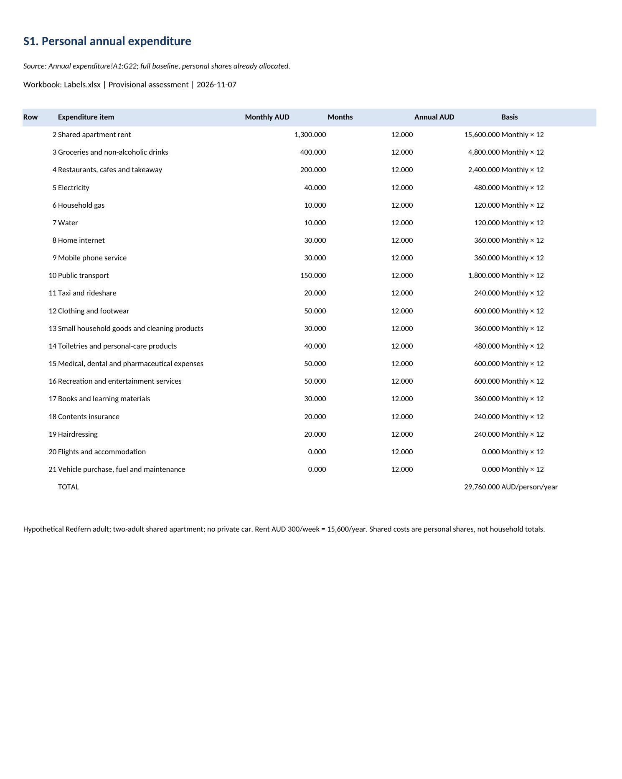

S2a. Expenditure mapping — part 1
First 20 allocation rows; source: Expenditure split. All shares are illustrative assumptions. Worksheet snapshots rendered by LibreOffice Calc from Labels.xlsx; not Microsoft Excel window captures.
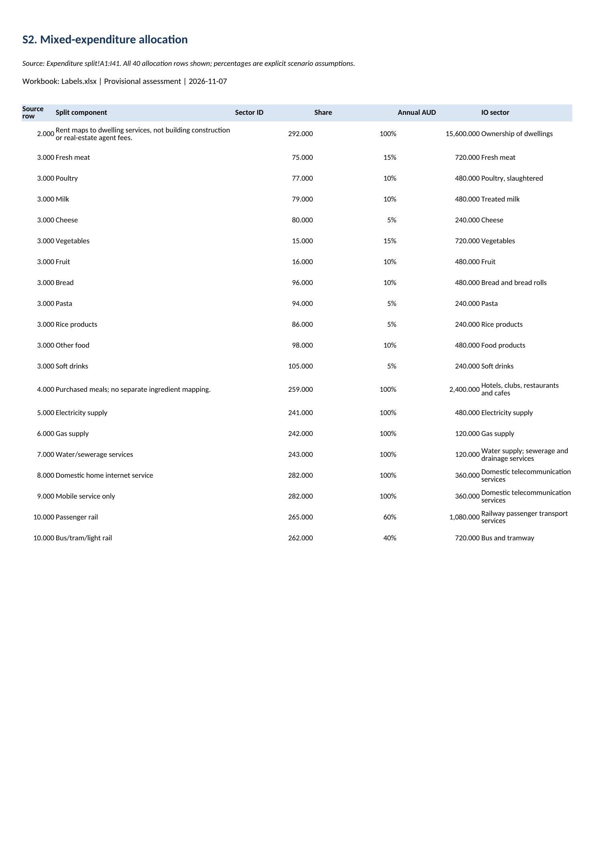

S2b. Expenditure mapping — part 2
Remaining 20 allocation rows; source: Expenditure split. Both parts together show all 40 allocations. Worksheet snapshots rendered by LibreOffice Calc from Labels.xlsx.
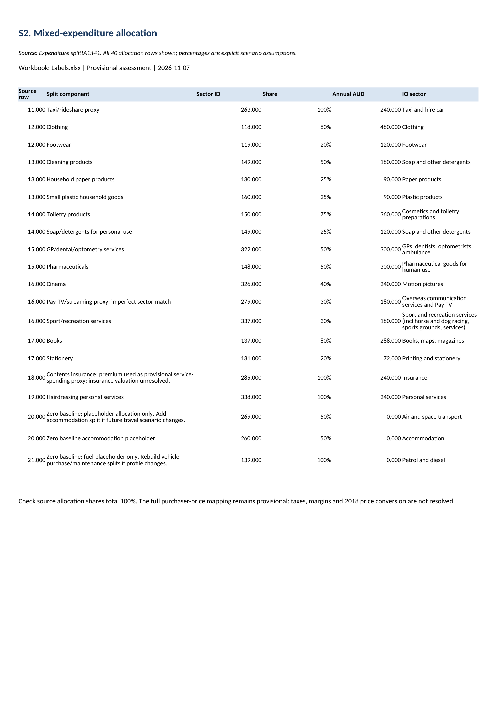

S3. Final-demand vector
Nonzero sectors only are displayed; IO_345 demand retains all 345 sectors, including zero entries. Worksheet snapshots rendered by LibreOffice Calc from Labels.xlsx.
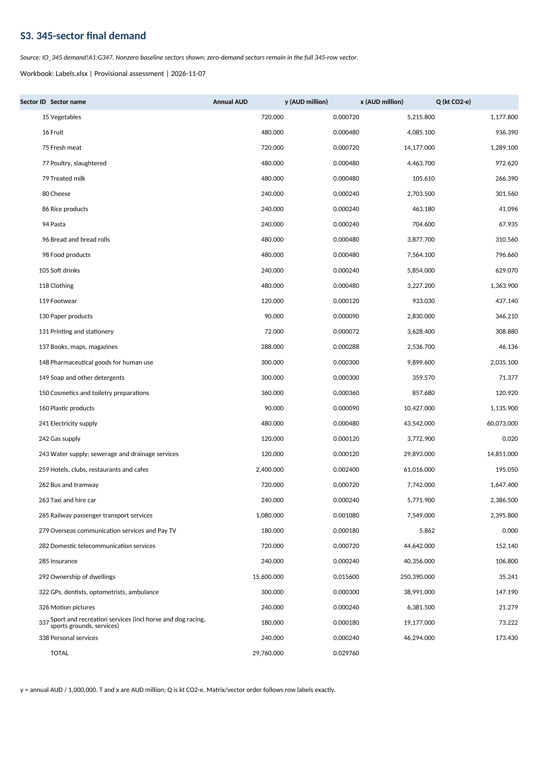

S4. Matrix construction
Actual MUNIT/MINVERSE formulas and labelled excerpts of X̂, X̂⁻¹, A and L. Worksheet snapshots from Microsoft Excel.
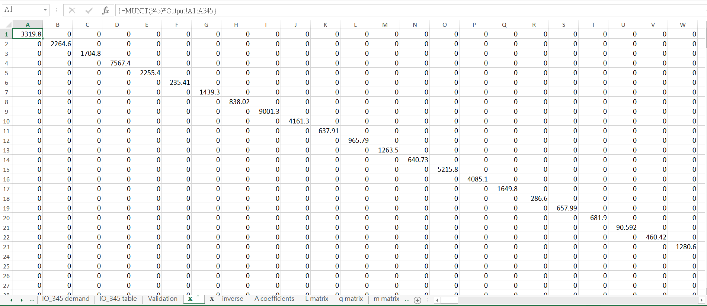
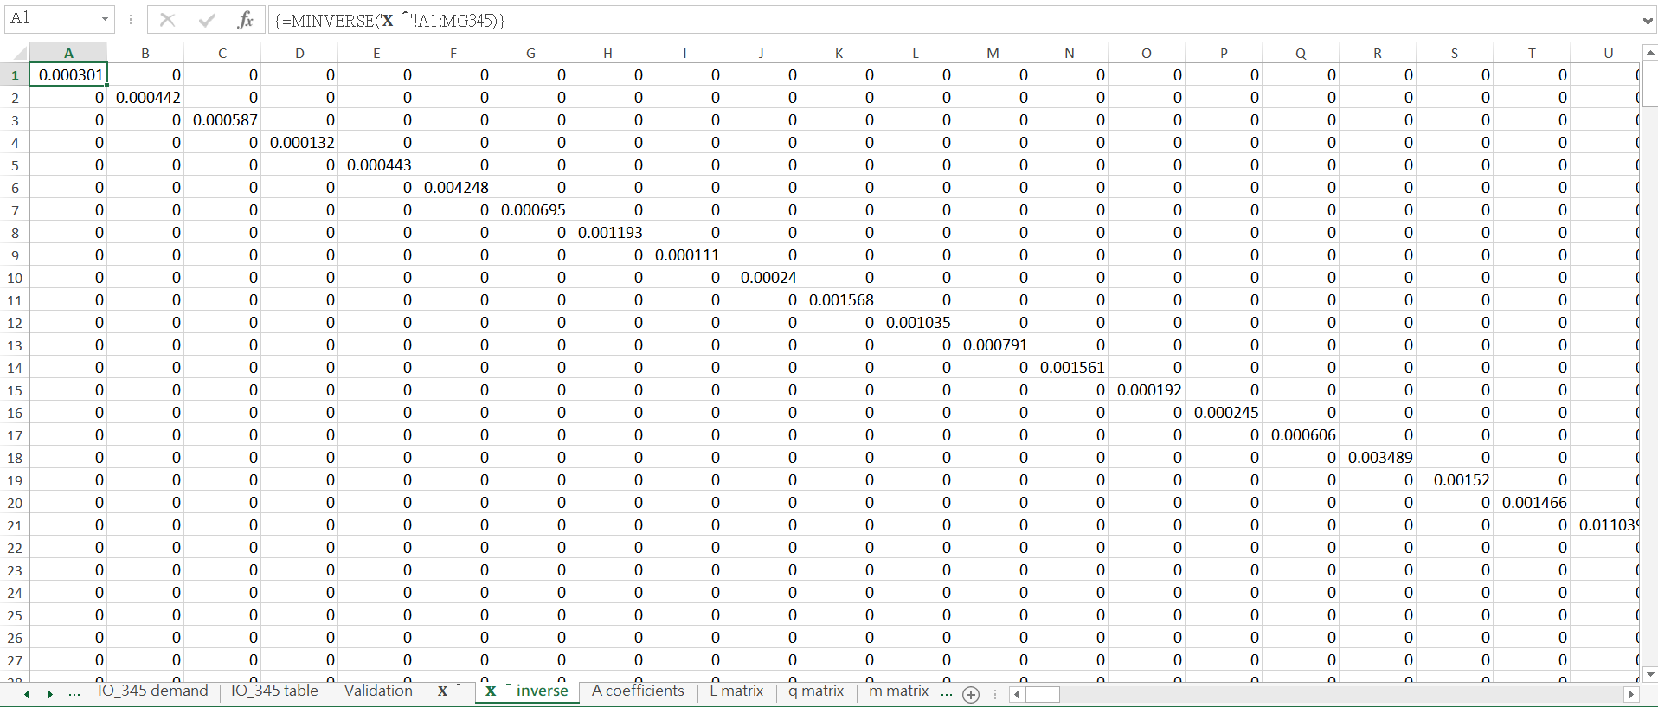
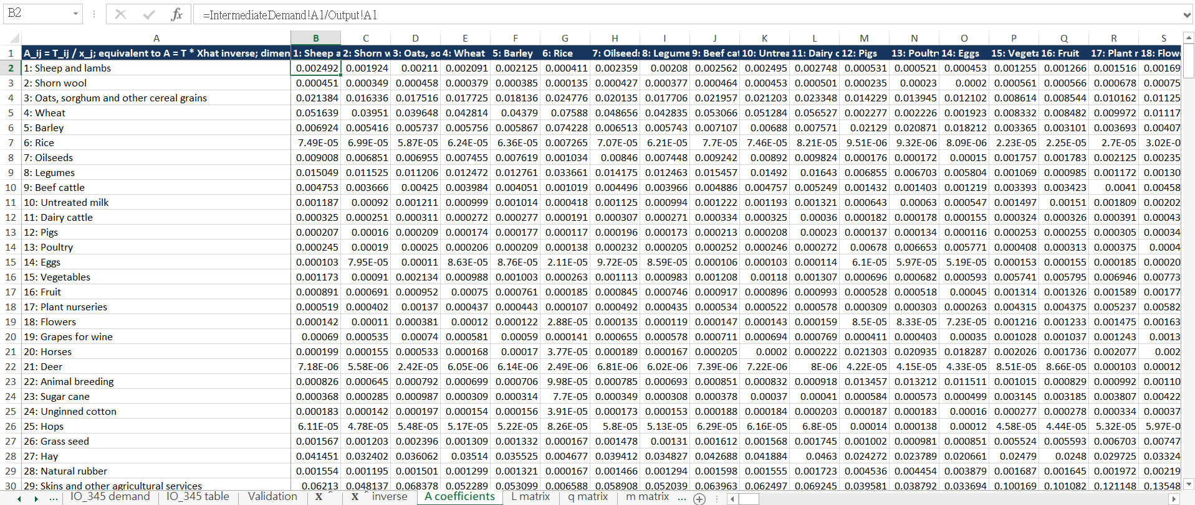
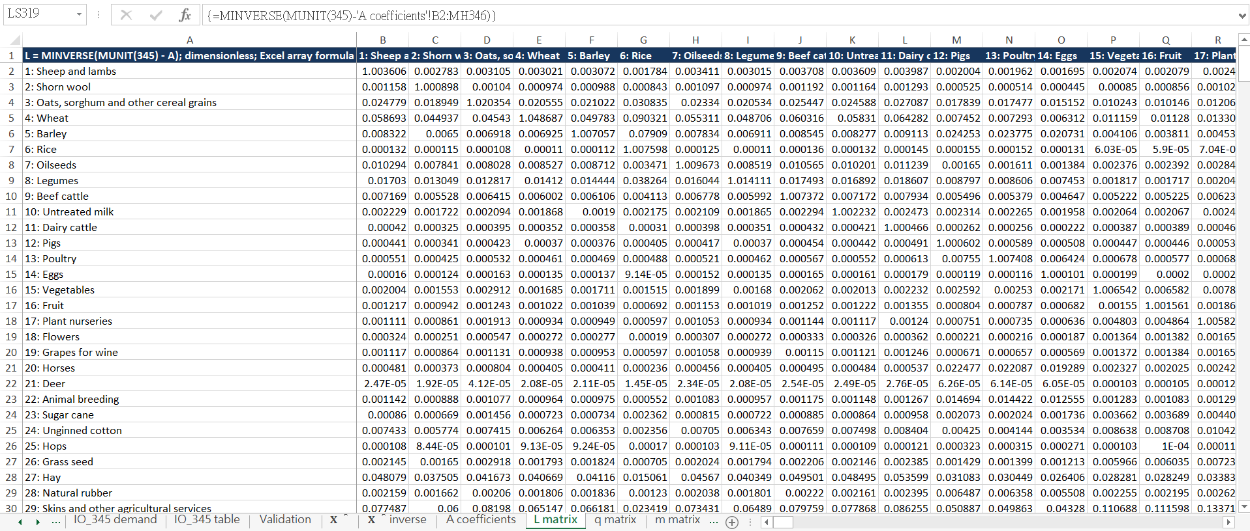

S5. Emissions intensities and footprint
Actual MMULT formulas for q, m and induced output, selected contributions and total footprint. Worksheet snapshots from Microsoft Excel.
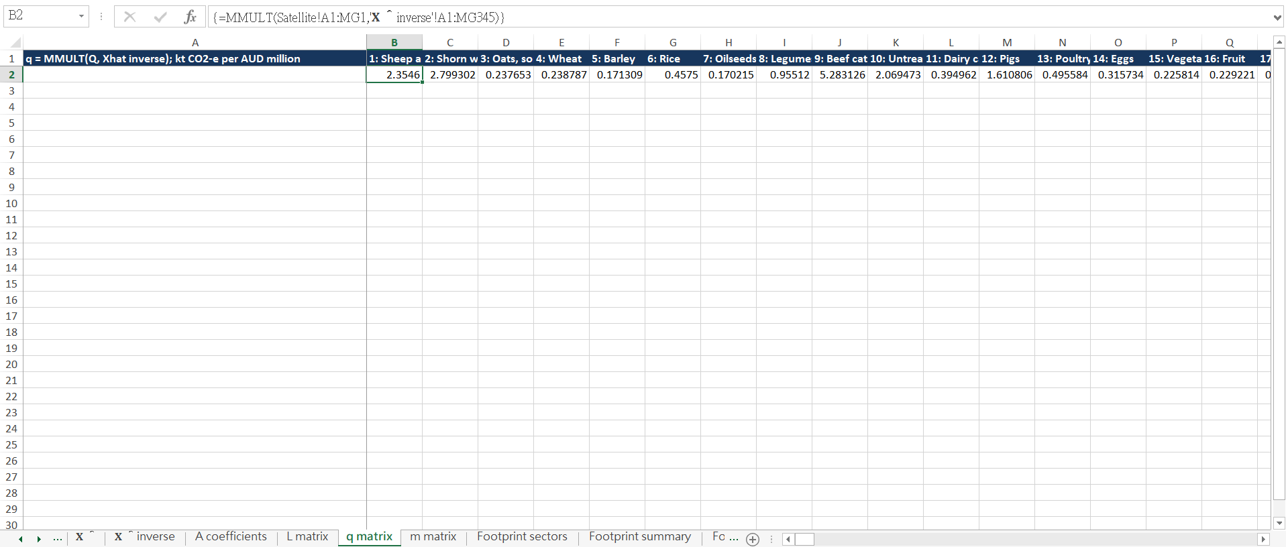
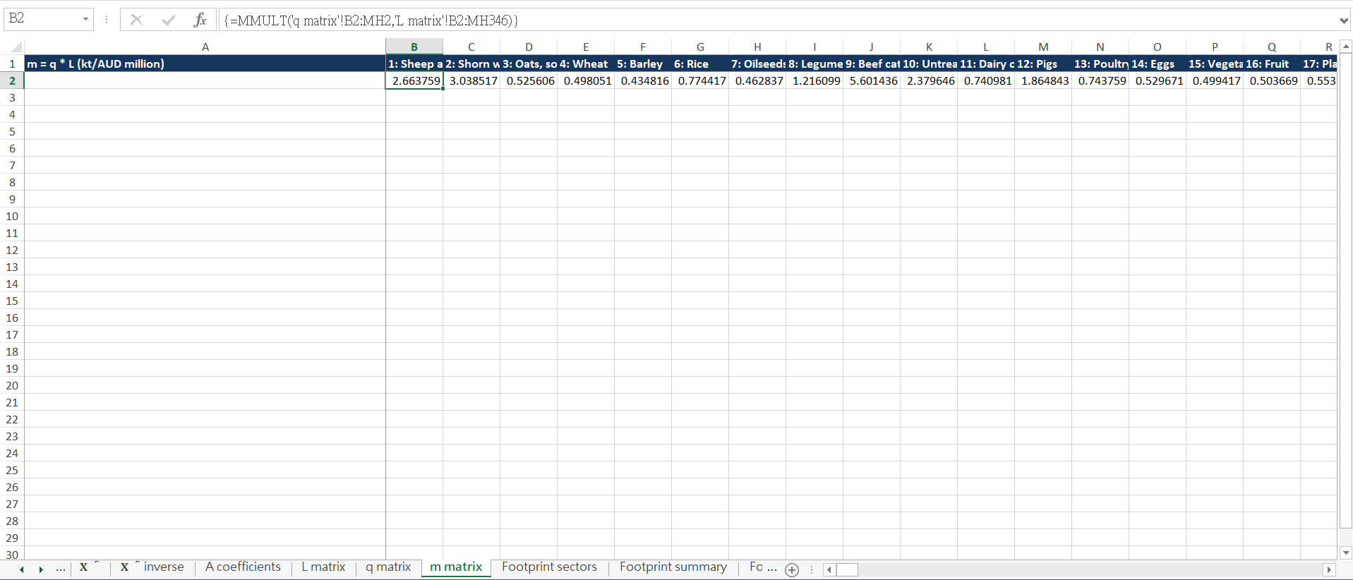
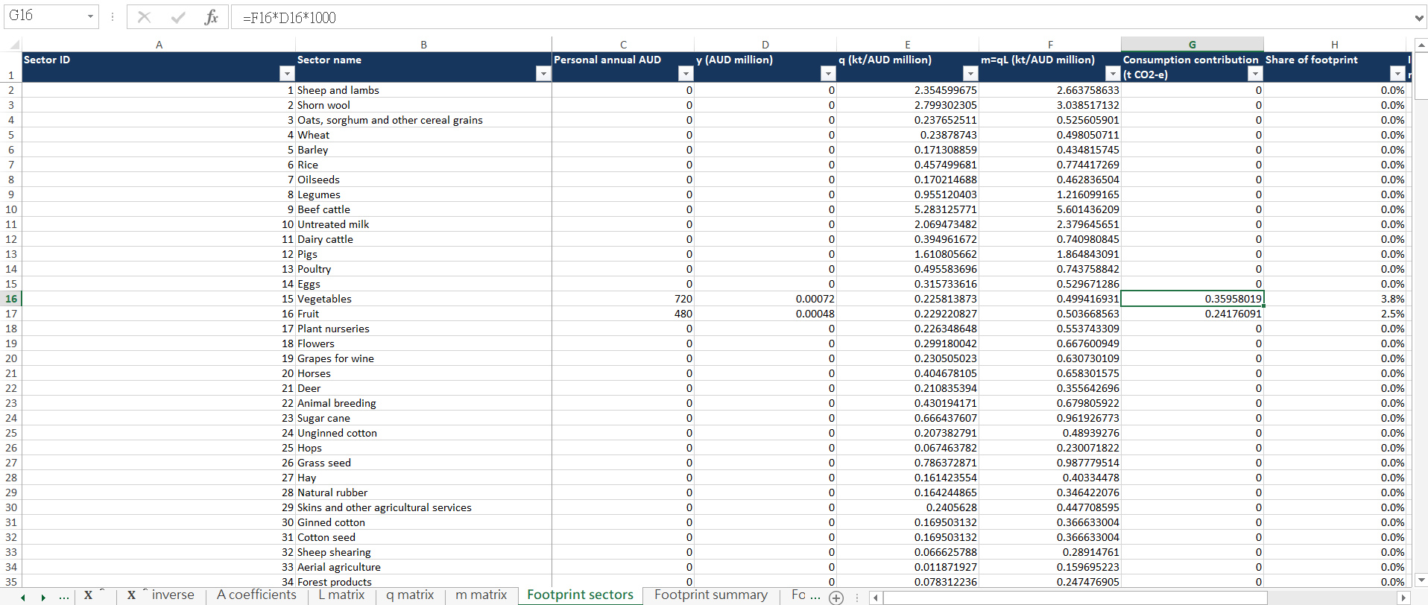
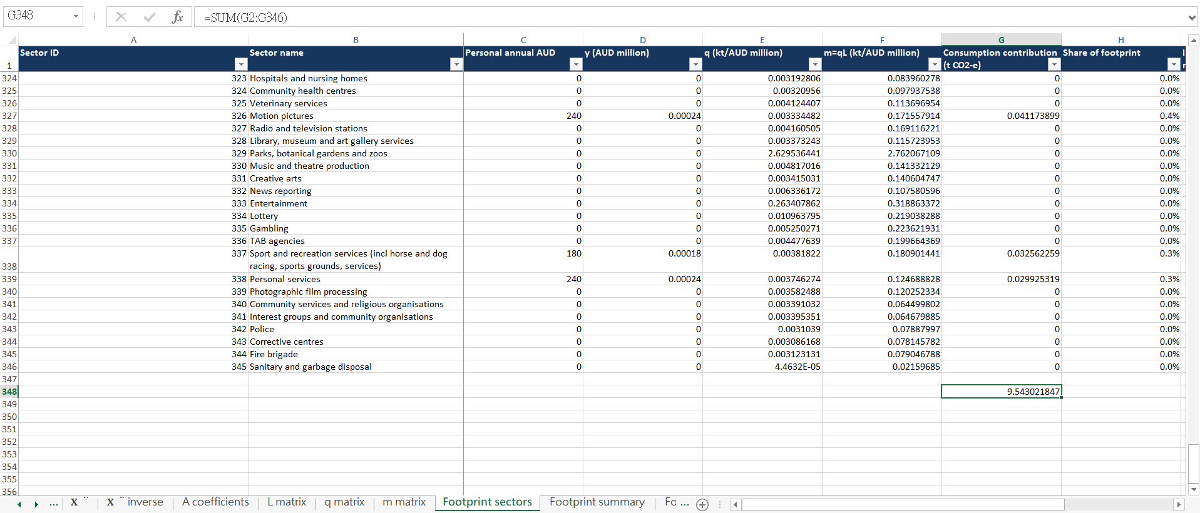
Worksheet snapshots rendered by LibreOffice Calc from Labels.xlsx.
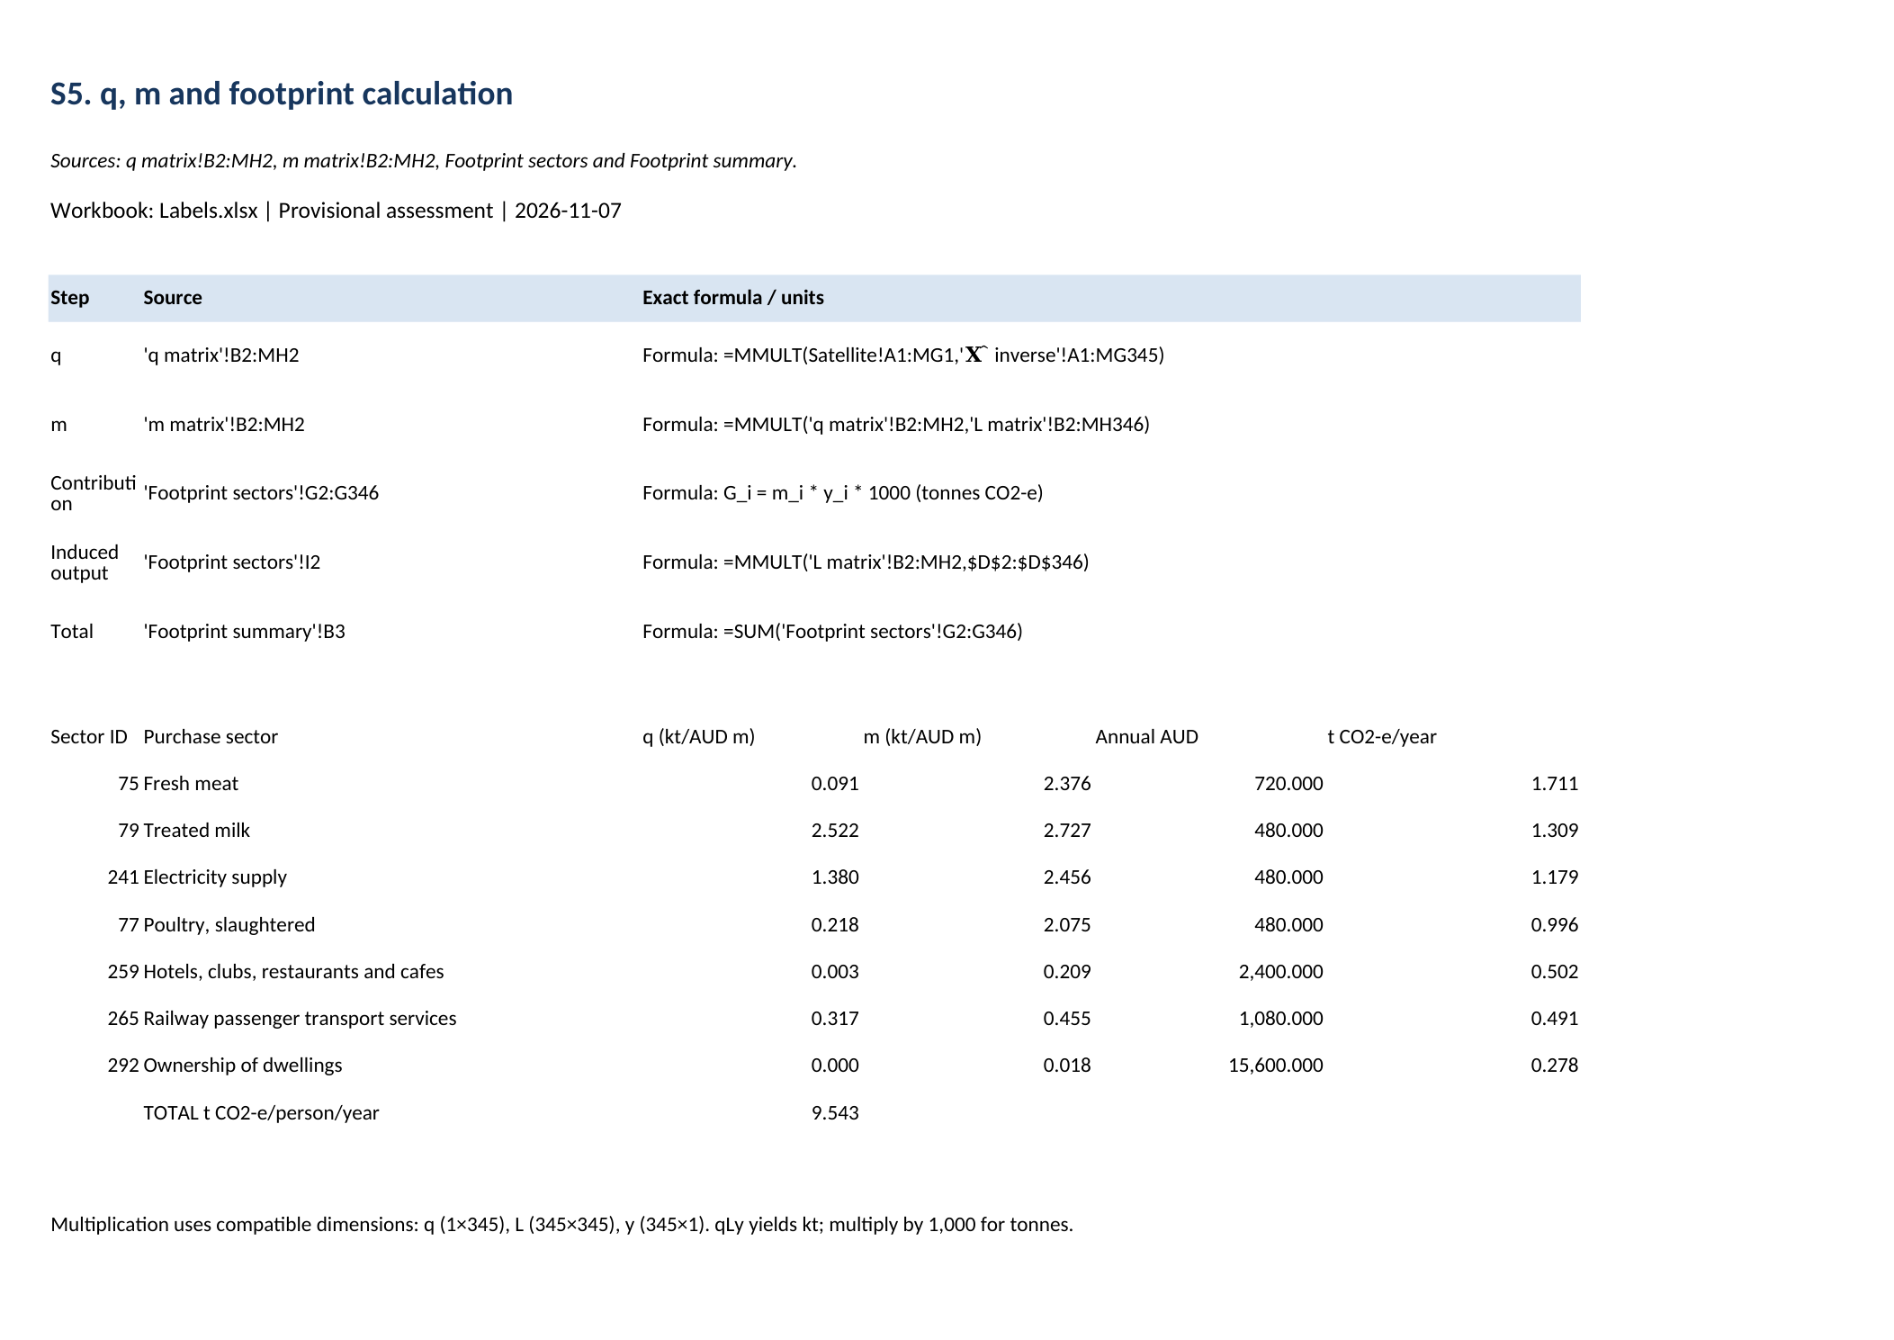

S6. Provisional sector results
Top ten consumption categories. This is not the required Australian/international comparison. Worksheet snapshots rendered by LibreOffice Calc from Labels.xlsx; not Microsoft Excel window captures.


