Name: Chen Hao Cheng

AI, CSCI3202, PS2

1)The SIM game

The approach I have is I made two players, one AI, one the real player. For the user part, I check if the move is free, meaning that doesn’t get the duplicate move that has already been in the list, and then check if that move will make the user lose the game. For AI part, I made the AI not to lose out of choosing the move, if it still chooses the move that makes AI lose, then it really loses the game.

#!bin/env python

import random

def whoGoFirst():

turn = raw_input("Are you playing Red? (Y/N) \n").upper()

if turn == 'Y':

return 'Player'

else:

return 'Computer'

def getPlayerMove():

move1, move2 = raw_input("RED move: (with a comma)\n").upper().split(",")

if move1 not in nodeList or move2 not in nodeList:

print ("invalid input!")

getPlayerMove()

else:

return move1, move2

def connectMove(move1, move2):

line.append([move1, move2])

print line

def isEdgeFree(move1, move2):

if [move1, move2] not in line and [move2, move1] not in line:

connectMove(move1, move2)

return True

else:

print ("This move is not valid")

return False

def getComputerMove():

randomNode1, randomNode2 = random.sample(xrange(0,7), 2)

if randomNode1 == 0:

randomNode1 = 'A'

if randomNode1 == 1:

randomNode1 = 'B'

if randomNode1 == 2:

randomNode1 = 'C'

if randomNode1 == 3:

randomNode1 = 'D'

if randomNode1 == 4:

randomNode1 = 'E'

if randomNode1 == 5:

randomNode1 = 'F'

if randomNode1 == 6:

randomNode1 = 'G'

if randomNode1 == 7:

randomNode1 = 'H'

if randomNode2 == 0:

randomNode2 = 'A'

if randomNode2 == 1:

randomNode2 = 'B'

if randomNode2 == 2:

randomNode2 = 'C'

if randomNode2 == 3:

randomNode2 = 'D'

if randomNode2 == 4:

randomNode2 = 'E'

if randomNode2 == 5:

randomNode2 = 'F'

if randomNode2 == 6:

randomNode2 = 'G'

if randomNode2 == 7:

randomNode2 = 'H'

return randomNode1, randomNode2

def isLoser(loserMove1, loserMove2):

for key1 in line:

if key1[0] == loserMove1:

for key2 in line:

if key2[0] == key1[1]:

if key2[1] == loserMove2:

return True

print (loserMove1, loserMove2)

else:

return False

def playAgain():

return raw_input("Play again? (y/n)").lower().startswith('y')

# dictionary

nodeList = {"A": 0, "B": 1, "C": 2, "D": 3, "E": 4, "F": 5, "G": 6, "H": 7 }

startGame = True

isEdgeSafe = False

line = []

print ("Welcome to the SIM game!")

while True:

turn = whoGoFirst()

print (turn + " go first")

while startGame:

if turn == 'Player':

playerMove1, playerMove2 = getPlayerMove()

print ("RED move: " + playerMove1 + playerMove2)

isEdgeSafe = True

#check if the edge if free first, then check if the chosen moves

# would make userself lose

if isEdgeFree(playerMove1, playerMove2):

print "player select right edge"

if isLoser(playerMove1, playerMove2):

print ("Player loses!")

startGame = False

else:

turn = 'Computer'

else:

**#Check if the AI's moves makes AI lose the game first, if not, check**

**#if the edge is available. If moves make AI lose, then game over**

computerMove1, computerMove2 = getComputerMove()

print ("BLUE move: " + computerMove1 + computerMove2)

if not isLoser(computerMove1, computerMove2):

if isEdgeFree(computerMove1, computerMove2):

print "Computer select right edge"

turn = 'Player'

elif isLoser(computerMove1, computerMove2):

print ("Computer loses!")

startGame = False

else:

#This makes AI choose new moves again if the moves it chose makes

# Ai self lose

turn = 'Computer'

if not playAgain():

break

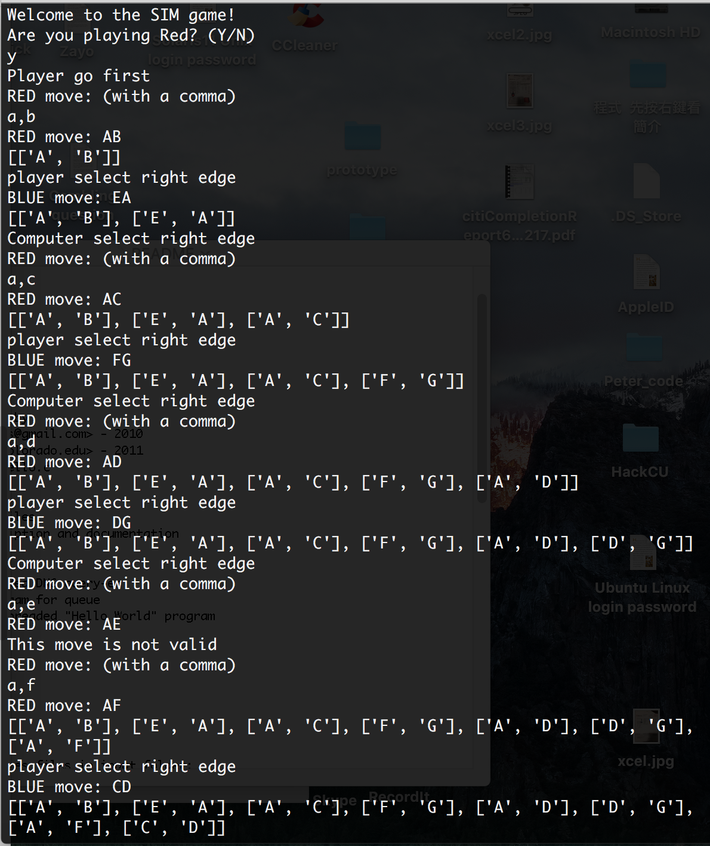

4) MasterMind Game

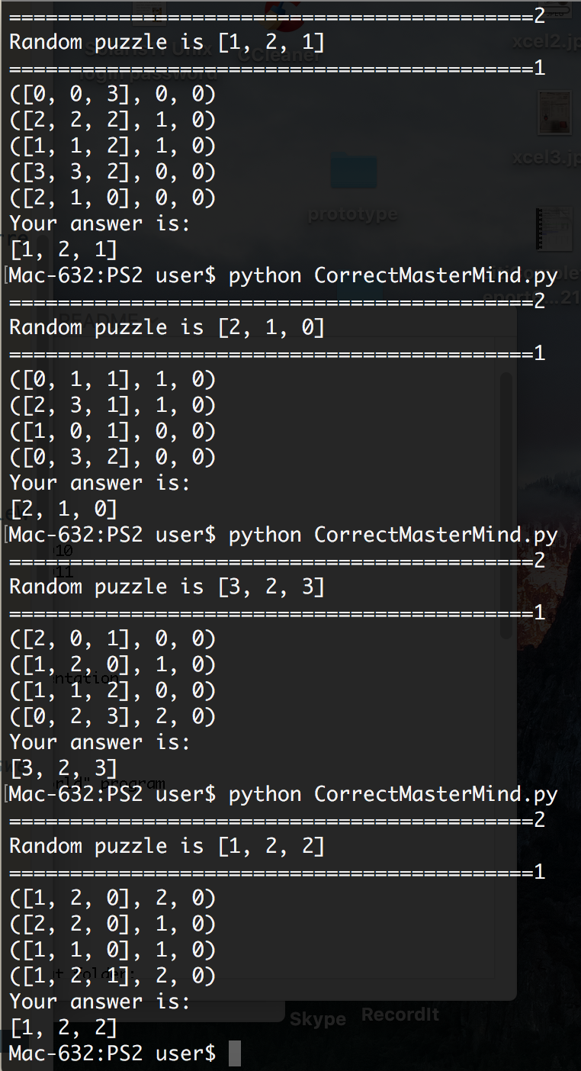

#!bin/env python

import random

ColorList = {'R': 0, 'B': 1, 'O': 2, 'W': 3}

puzzle = ['R', 'R', 'W']

numberColors = 4

numberPostions = len(puzzle)

def check(guess, checkPuzzle):

rightColor = 0

#right color and right position

rightPosition = 0

# initialize the Matrices all 0

MatrixPuzzleColor = [0 for i in range(numberColors)]

MatrixGuessColor = [0 for j in range(numberColors)]

#print MatrixPuzzleColor

for e in checkPuzzle:

MatrixPuzzleColor[e] = MatrixPuzzleColor[e] + 1

#print ("MatrixPuzzleColor is " + str(MatrixPuzzleColor[e]))

for f in guess:

MatrixGuessColor[f] = MatrixGuessColor[f] + 1

#print ("MatrixGuessColor is " + str(MatrixGuessColor[f]))

for g in range(len(checkPuzzle)):

colorCurrent = checkPuzzle[g]

#print colorCurrent

if colorCurrent == guess[g]:

rightPosition = rightPosition + 1

if MatrixGuessColor[colorCurrent] > 0:

rightColor + rightColor + 1

MatrixGuessColor[colorCurrent] = MatrixGuessColor[colorCurrent] - 1

rightColor = rightColor - rightPosition

if(rightColor < 0):

rightColor = 0

return (rightPosition, rightColor)

def guess(guessPuzzle, guessPossibleWays):

# randomly choose one from the 3D array

TryGuessing = guessPossibleWays[random.randint(0, len(guessPossibleWays) - 1)]

#print TryGuessing

guessX, guessO = check(TryGuessing, guessPuzzle)

getRidOf = []

for position in guessPossibleWays:

checkX, checkO = check(position, TryGuessing)

# 'or' for string, '|' for number

if(checkX != guessX) | (checkO != guessO):

# get rid of any possibility that contains a different answer

getRidOf.append(position)

# using remove function to help me

for i in getRidOf:

guessPossibleWays.remove(i)

if (guessX, guessO) == (numberPostions, 0):

print ("Your answer is: ")

print (TryGuessing)

else:

print (TryGuessing, guessX, guessO)

guess(guessPuzzle, guessPossibleWays)

print ("===========================================2")

# 3D arrays

possibilities = []

for a in range(numberColors):

for b in range(numberColors):

for c in range(numberColors):

possibilities.append([a, b, c])

puzzle = [random.randint(0, 4), random.randint(0,4), random.randint(0,4)]

print ("Random puzzle is " + str(puzzle))

print ("===========================================1")

guess(puzzle, possibilities)

mastermind is brute force program.

it starts with a list of all possible solutions and it guesses one at random and gets (x,o) feedback. It will look at all the possible solutions, and checks the guess against each of them. Any solution that gives the correct feedback is still a possibility and Any solution that gives different feedback is thrown out.