CSCI-3287

Name: Chen Hao Cheng

1)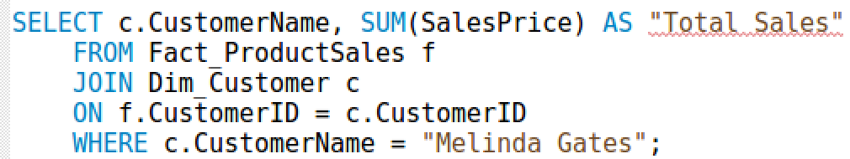

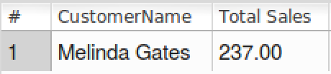

2)



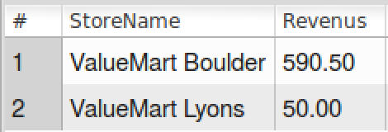

3)

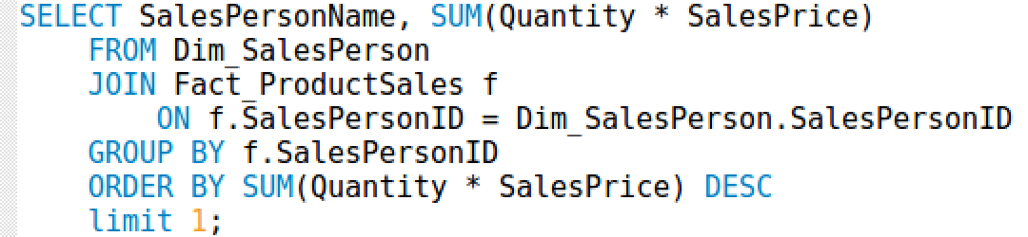

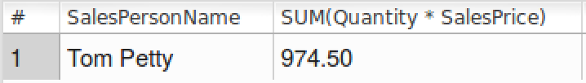

4)

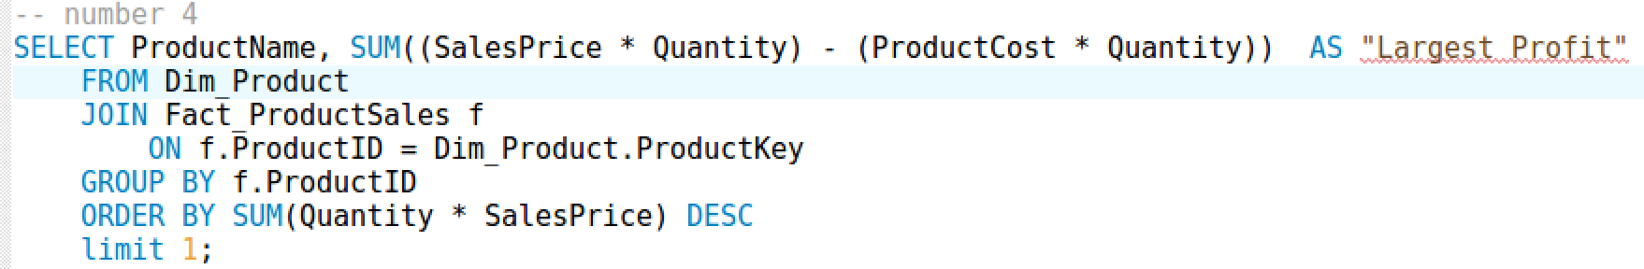

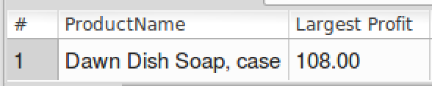

5)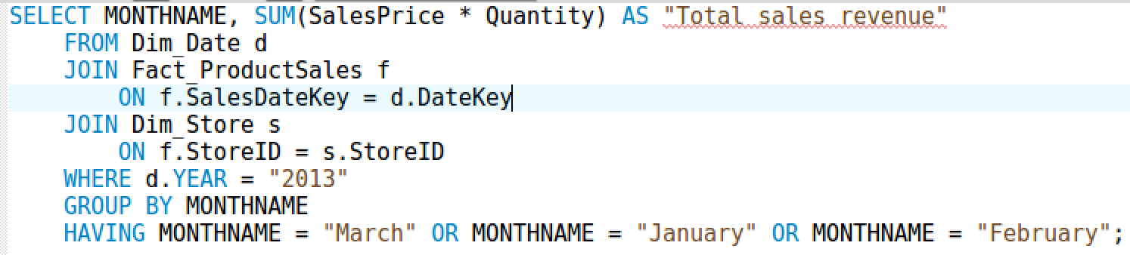

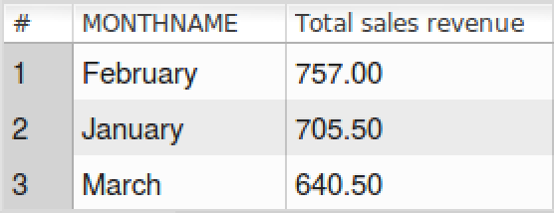

The company/warehouse employees might get lazy or their stock is decreasing since February because it was not bad in January, even better in February, but March, the sales is not good.