1) Create a database

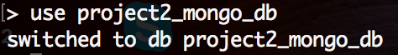

(If you use the *show dbs* command again, you will see that the database hasn’t been created yet.)

I create a database by a use command. If there’s no same name database, it will create one.

2) Drop a database

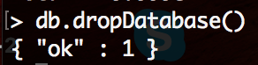

I drop a database by doing the command with a function, dropDatabase()

* A **database** holds a set of collections
* A **collection** holds a set of documents (table)
* A **document** is a set of fields
* A **field** is a key-value pair
* A **key** is a name (string)
* A **value** is a - basic type like string, integer, float, timestamp, binary, etc.,

db.createCollection(<name>, { capped: <**boolean**>,

autoIndexId: <**boolean**>,

size: <number>,

max: <number>,

storageEngine: <document>,

validator: <document>,

validationLevel: <string>,

validationAction: <string>,

indexOptionDefaults: <document>,

viewOn: <string>,

pipeline: <pipeline>,

collation: <document> } )

3) Creating a collection (table)

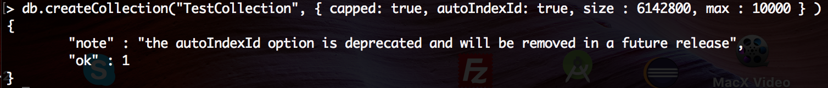

I create a collection(table) and give some initial options along with the “create” because it will useful.

Capped: To create a [capped collection](https://docs.mongodb.com/manual/reference/glossary/#term-capped-collection), specify true. If you specify true, you must also set a maximum size in the sizefield.

AutoIndexId: Specify false to disable the automatic creation of an index on the _id field

Max: The maximum number of documents allowed in the capped collection

Size: Specify a maximum size in bytes for a capped collection

Note: if you create a collection or insert a document, then you can see your new database.

To verify:

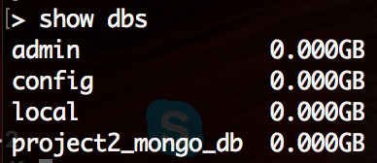

4) Dropping a collection

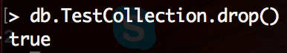

Since I’m still in selected database, then I can do drop() for the collection

5) Insert a document



I insert a document with title, description, and by whom into a collection.

Note: If the collection doesn't exist in the database, then MongoDB will create this collection and then insert a document into it.

Note: if we don't specify the _id parameter, then MongoDB assigns a unique ObjectId for this document.

6) Query a document



I test a Query for the document I just inserted.

7) Update a document

Before:



After:



I update title with a net set and description with a new set.

Note: By default, MongoDB will update only a single document. I thought using updateMany() can update multiple documents but it still cannot, same as setting a parameter ‘multi’ to true

8) Delete Document:

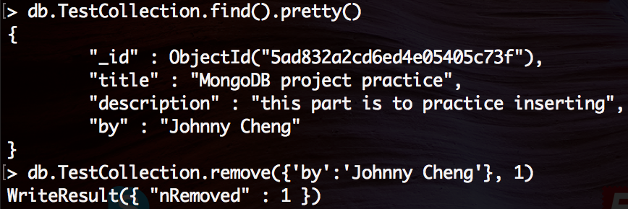

I delete the document and return 1, meaning it’s successful