Huynh, Peter  
October 20, 2016  
CSCI 3302

Homework 3  
Introduction to Robotics  
ncorrell@colorado.edu

1. An ultrasound sensor measures distance *x* = *c*∆*t* / 2. Here, *c* is the speed of sound and ∆t is the difference in time between emitting and receiving a signal. Let the variance of your time measurement ∆*t* be σ2t. What can you say about *x*, when *c* is assumed to be constant? Hint: how does a change in ∆*t* affect *x*?

If *c* is assumed constant, than the only variable to determine the x within a given moment is ∆*t*. That is to say, the larger ∆*t* is the larger *x* will be as well. Both are directly proportional in this aspect. Conceptually, the ultrasound sensor will measure the distance to be larger if the difference in time between emitting and receiving a signal is also larger, and vice versa.

1. Consider a unicycle that turns with angular velocity φ˙ and has radius *r*. Its speed is thus a function of φ˙ and *r* and is given by

*v* = *f*(φ˙, *r*) = *r* φ˙

Assume that your measurement of φ˙ is noisy and has a standard deviation σφ. Use the error propagation law to calculate the resulting variance of your speed estimate σ2v.

Using the Error Propagation law:

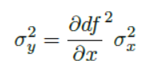

On page 133, equation 8.1, we can determine *v*’s variance. Since φ˙ has a variance standard deviation of σφ, the variance is simply σ2φ. We can also say that *v* will have a variance of σ2v = (𝛿df2/𝛿φ˙) *\** σ2φ, which equals 𝛿d(*r* φ˙)2/𝛿φ˙ *\** σ2φ

🡺 df2 = r2🡺 𝛿*r*2/𝛿φ˙ *\** σ2φ  🡺 **σ2v =r2 *\** σ2φ**

1. Assume that the ceiling is equipped with infra-red markers that the robot can identify with some certainty. Your task is to develop a probabilistic localization scheme, and you would like to calculate the probability *p*(*marker* | *reading*) to be close to a certain marker given a certain sensing reading and information about how the robot has moved.
   1. Derive an expression for *p*(*marker* | *reading*) assuming that you have an estimate of the probability to correctly identify a marker *p*(*reading* | *marker*) and the probability *p*(*marker*) of being underneath a specific marker.

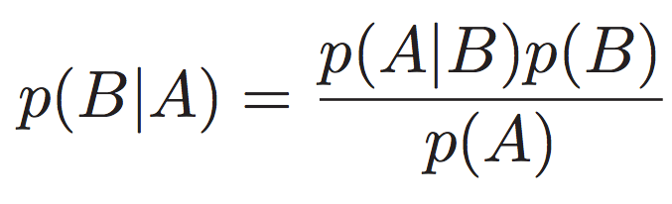

Using Bayes Theorem:

***p*(*marker* | *reading*) = (*p*(*reading* | *marker*) * *p*(*marker*)) / *p*(*reading*)**

This would be the best expression for *p*(*marker* | *reading*). Both *p*(*reading* | *marker*) and *p*(*marker*) are given, meaning that *p*(*reading*) is implicitly derivable from the two.

* 1. Now assume that the likelihood that you are reading a marker correctly is 90%, that you get a wrong reading is 10%, and that you do not see a marker when passing right underneath it is 20%. Consider a narrow corridor that is equipped with 4 markers. You know with certainty that you started from the entry closest to marker 1 and move right in a straight line. The first reading you get is “Marker 3”. Calculate the probability to be indeed underneath marker 3.

*p*(*marker* | *reading*) = (*p*(*reading* | *marker*) * *p*(*marker*)) / *p*(*reading*)

*p*(*marker*) = 25% = 0.25,

4 markers total, ¼ chance of being a specific marker

*p*(*reading*) = 90% = 0.9,

Correct reading chance in general

*p*(*reading* | *marker*) = 80% = 0.8,

Chance of reading given marker, opposite to 20% pass

*p*(*marker* | *reading*) = (0.8 * 0.25)/0.9 = 0.2222..

We must consider that this the first reading, meaning that there were two instances of passing and not seeing a marker (20%). Next, we must consider the chance that it does a reading without passing marker 3 (80%) and that it’s correctly marker 3 (90%):

.2 * .2 * .8 * .9 = **0.0288 = 2.88%**

* 1. Could the robot also possibly be underneath marker 4?

We must consider that there has been three passed markers (20%), and now we know for certain that the robot will do a reading at the fourth point, since we are getting a reading of a marker, thus skipping 80%.

.2 * .2 * .2 * .9 = **0.0072 = 0.72%**

It’s **unlikely** for the robot to be underneath marker 4. There’s also a chance for it to be marker 3 but falsely marked as 4. Percent below:

.2 * .2 * .8 * .1 * 1/3 = 0.001067 = 0.1067%