**Steps to Setup GNS3 for Wireshark in the Virtual Environment**

**Note**: The sudo password is netman

1. Start GNS3 by clicking on . Then enter the new project settings as below, and press the OK button.

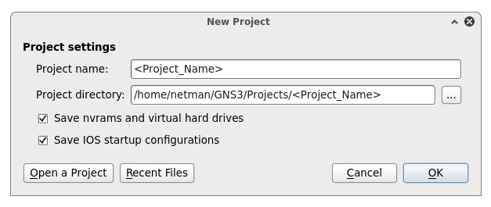

[Ensure you check the *Save nvrams and virtual hard drives* and *Save IOS startup configurations* boxes.]

1. Select the Router c3600 node type and drag it into the project. Then, select the Host node and drag it into the project. Then, do the below configuration, by Right clicking on the PC/Router and then selecting ‘Configure’ -

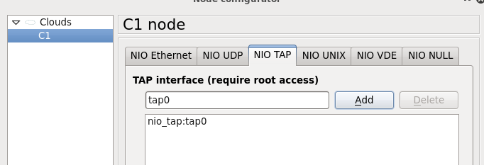

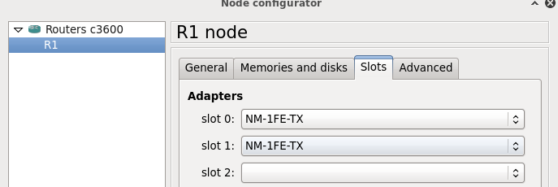

1. Click on ‘Add a link’  at the top left below ‘Annotate’ and select FastEthernet and select nio_tap0:tap0 on the Host and drag the wire to the router. Then you can right click to exit from the ‘add a link’.
2. Run ‘ifconfig’ on the terminal, at the bottom of the VirtualBox (not from GNS3) and from there you can find the IP address of the Virtual Terminal (inet addr:) and Subnetmask (Mask) of tap0 on C1 in VirtualBox.
   1. Select a different IP address from the one on the computer, but still in the same subnet, that you will configure on the router interface connected to tap0. (Typically, you can increase the last octet by 1. Such as from 198.51.100.2 to 198.51.100.3 in the example).

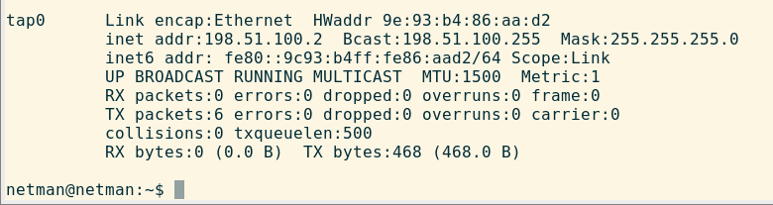

1. Move the cursor over the Green dot  on the router, it will show which interface is connected; for me it was fa0/0.
2. Click the ‘Start/Resume all devices’  and then click on ‘Console to all devices’ to enter R1.

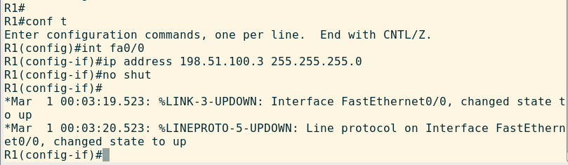

1. Exit from the configuration mode by typing ‘exit’ as shown below. After this check connectivity to the host by issuing a ping to the host’s IP address from the router –

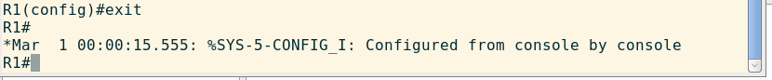

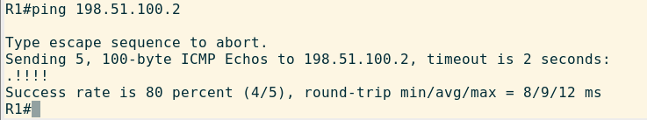

1. Start Wireshark on the terminal by using the terminal command as below –



1. If Wireshark is not present, it will show Wireshark not found or not installed after you run the above command. You can then install it using ‘sudo apt-get wireshark’ and then start it, using the previous step.

Click OK to the ‘Lua’ error displayed below and choose tap0 to monitor the interface for packets

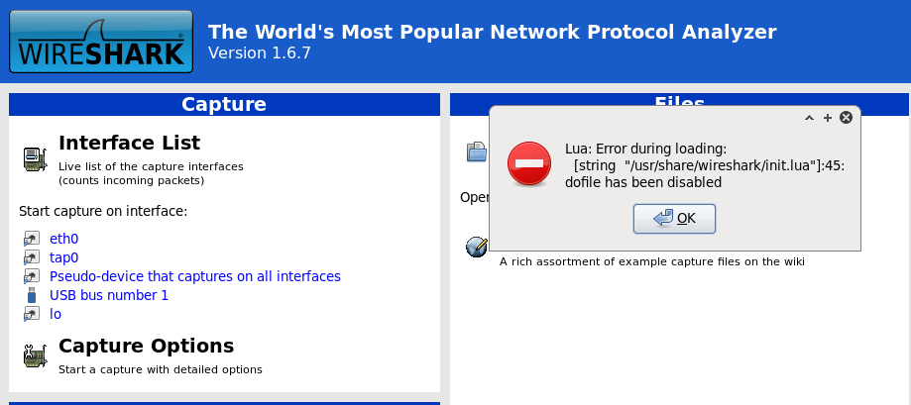

1. Ping the interface of the router and check Wireshark for ICMP packets.

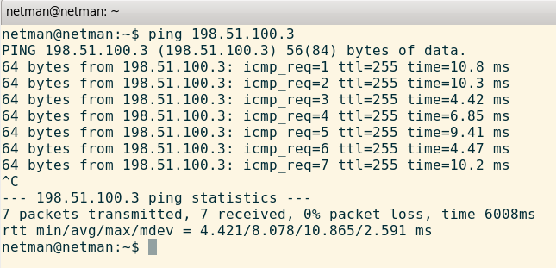

Example ICMP packets on Wireshark -

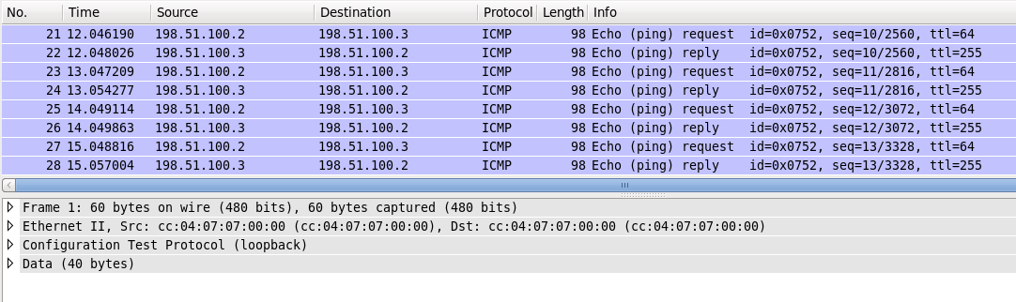

1. Update GNS3 to the latest available version (navigate to Help-->Check for Update and follow download instructions). Also update Wireshark (‘sudo apt-get upgrade wireshark’).

*\*Contact SA’s/TA or Professor for any assistance.*