TLEN 5410 – VIRTUAL MACHINE INSTALLATION

* **STEP 1 –**Install VirtualBox from this link <https://www.virtualbox.org/wiki/Downloads> for Windows/Unix/OS X hosts. After installation, proceed to STEP 2.
* **STEP 2 –**   
    
  Download and extract the contents of the file at - <https://drive.google.com/a/colorado.edu/uc?id=0B9sNJz9fm35ceWR1YUxOcTNJcEk&export=download> to a location on your computer. i.e. **TLEN 5410 VM v3-2.zip**
* **STEP 3 –**  
    
  Open the extracted folder & double-click on the file with the .vbox extension. In this case, **TLEN 5410 VM v3.vbox**. VirtualBox should start when you do this.   
    
  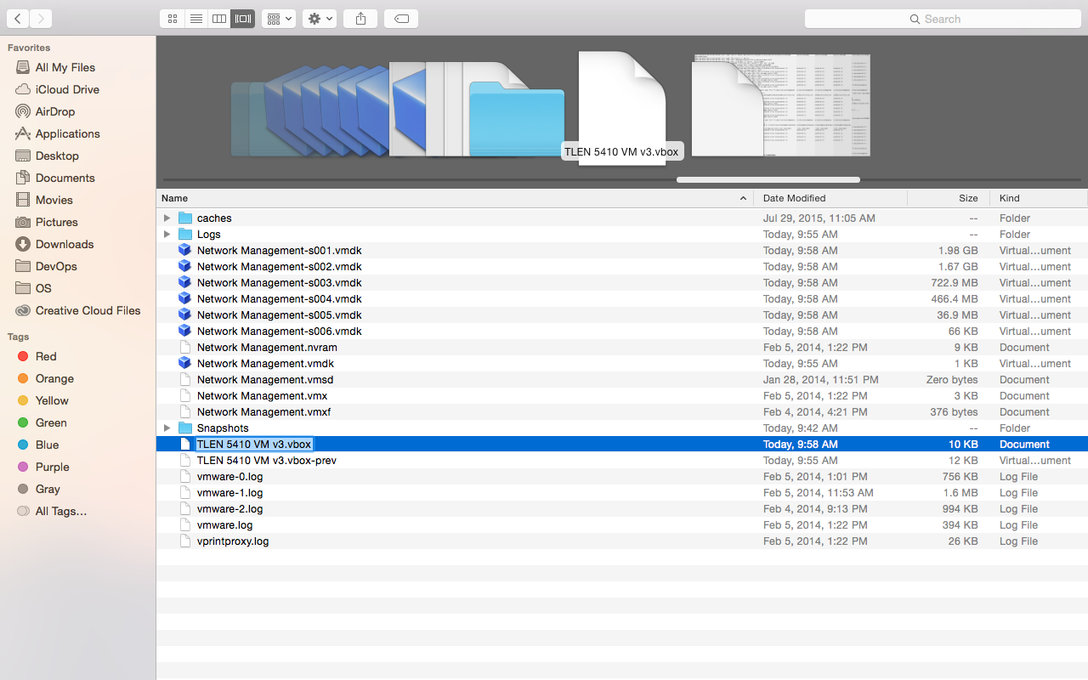  
    
  If VirtualBox does not start, right-click & try the open with option & then choose VirtualBox as the application.
* **STEP 4 –**  
    
  Wait till the VM boots up (this may take a few minutes) & you should land on the desktop screen after successful boot up.  
    
  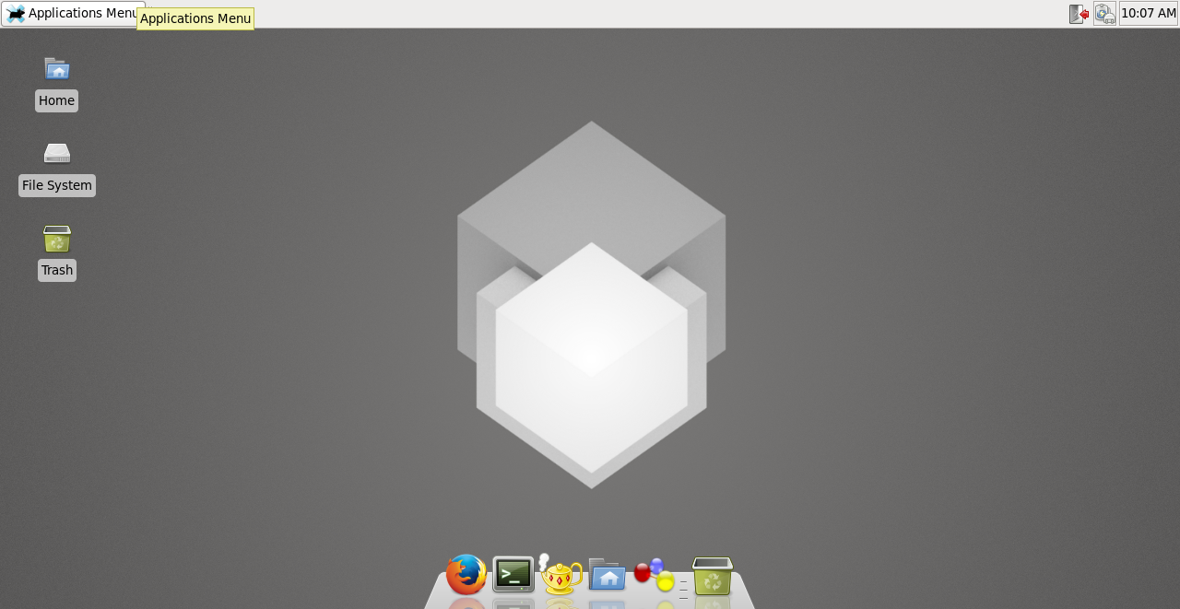
* **STEP 5 –**Click on the icon next to Firefox-browser in the dock below OR click Application Menu (Top-Left of the screen) > Terminal Emulator. This should open the Linux terminal.   
    
  Type **“ifconfig”** & check whether tap0 interface has an IP address of 198.51.100.2 assigned to it. Also type **“ping 8.8.8.8”** & check for ping replies. If you get successful replies you have successfully installed the VM, else proceed to STEP 6. Type “**sudo apt-get update -y**” to update the repos.  
    
  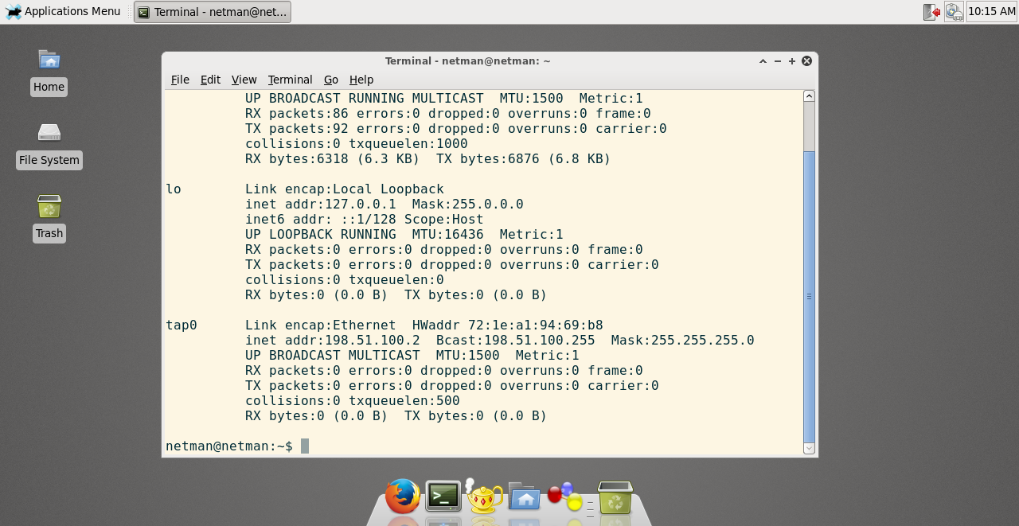
* **STEP 6 –**   
    
  If you cannot connect to the Internet, shut down the VM & in the VirtualBox menu, right click on TLEN 5410 VM v3 & choose settings.  
    
  Open the **Network Tab>Adapter 1** & ensure the Attached to setting is set to **NAT**.  
    
  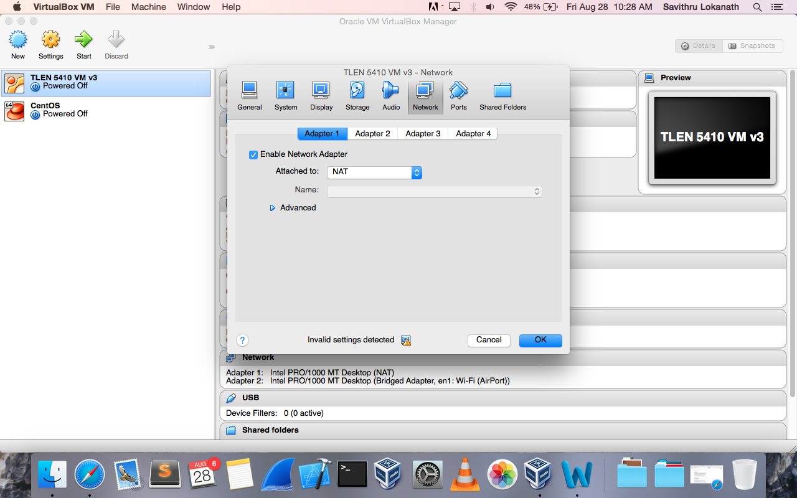  
    
  After finishing this, start the VM & repeat STEP 5.  
  *Contact SA’s/TA or Professor for any assistance.