Table of Contents

[2 Logging In 2](#_Toc440639255)

[2.1 I cannot log into Model Manager. Why are my login and password not working? 2](#_Toc440639256)

[2.2 How do I get “Select Configuration” options to show up? How do I configure Model Manager to connect to a different database or file server? 2](#_Toc440639257)

[2.3 Which configuration should I use? 3](#_Toc440639258)

[3 Modeling 3](#_Toc440639259)

[3.1 Model Manager->DB Properties (Masterdata) returns an error: “The model has no masterdata”, but there is Masterdata. Why? 3](#_Toc440639260)

[3.2 Why does Modeling “freeze” periodically after starting Model Manager? 4](#_Toc440639261)

[3.3 Why is an assembly shown as modified, even though it was not changed? 4](#_Toc440639262)

[3.4 Why are parts that I own locked so I can’t modify them? 5](#_Toc440639263)

[3.5 I have done an “Allow Edit” on a part, but why do I get an error “Selected item is read-only and cannot be modified.”? 5](#_Toc440639264)

[3.6 How do I “Allow Edit” if I don’t have Model Manager activated? 5](#_Toc440639265)

[3.7 How do I model parts that have to have various configurations (sheet metal part folded/unfolded, belt that has different shape in different places in the assembly, or cable straight/bent)? 6](#_Toc440639266)

[3.8 After activation of Annotation module, I don't get the usual viewport and after loading a drawing, the drawing doesn't become visible. 7](#_Toc440639267)

[4 Finding parts/models/drawings 7](#_Toc440639268)

[4.1 I’m looking for a part and can’t find it. Why? 7](#_Toc440639269)

[4.2 What does it mean when the Masterdata icon is red? Green? Grey? 8](#_Toc440639270)

[5 Loading/Reloading 8](#_Toc440639271)

[5.1 Why can’t I see my Model Manager Load window? Why does Model Manager hang when I try to load something? 8](#_Toc440639272)

[5.2 Why does it take so long to load an assembly? 8](#_Toc440639273)

[5.3 When I reload an assembly, why doesn’t it reload shared parts in other assemblies? 10](#_Toc440639274)

[5.4 Why does a model get loaded when I load a drawing-even though the model is already loaded? 10](#_Toc440639275)

[5.5 Why am I getting an error when trying to load-“mm\_load\_ar/filing/file\_not\_found”? 11](#_Toc440639276)

[5.6 What does it mean when I get an error like “physName=’AVEFMGEUYMBZM9’”? And how do I fix it so that I can load my assembly? 12](#_Toc440639277)

[6 Saving/Versioning 12](#_Toc440639278)

[6.1 Why does Model Manager hang when trying to save? 12](#_Toc440639279)

[6.2 I saved a model to the wrong project; how do I fix it? 13](#_Toc440639280)

[6.3 Why do I get a message about a conflict when trying to save a model? Why does Model Manager set the save type to “Conflict”? What does it mean if the status says “SysID Conflict”? And how do I fix it? 13](#_Toc440639281)

[6.4 What does it mean when “Name Conflicts Found” is displayed? 15](#_Toc440639282)

[6.5 How do I change the name/part number? 15](#_Toc440639283)

[6.6 I changed the Model Number, but the new version reverted back to the old number-why? 16](#_Toc440639284)

[6.7 When should I use overwrite/minor rev/major rev? 16](#_Toc440639285)

[6.8 The version for my model/drawing is not correct. How do I change the version? 16](#_Toc440639286)

[6.9 Is there a problem to save to local disc instead of to Model Manager? 17](#_Toc440639287)

[6.10 Can I skip revisions when saving? How do I get to rev “101.1”? 17](#_Toc440639288)

[7 Ownership 18](#_Toc440639289)

[7.1 A part belongs to one project, but a contractor who needs access to that part doesn’t have access to that project. How can we fix that? 18](#_Toc440639290)

[7.2 I transferred ownership to the wrong person-how can this be fixed? 19](#_Toc440639291)

[7.3 How do I put a part in a workgroup? 19](#_Toc440639292)

[7.4 How do I get added to a workgroup? 19](#_Toc440639293)

[7.5 How do I transfer ownership of a container? 20](#_Toc440639294)

[7.6 I transferred ownership of an assembly, but it did not transfer ownership of any of the parts. How do I transfer ownership of an assembly and all parts in the assembly? 20](#_Toc440639295)

[8 States 21](#_Toc440639296)

[8.1 Why can’t I change a model or drawing to RELEASE at rev A.1? 21](#_Toc440639297)

[8.2 When do I use each of the states? 22](#_Toc440639298)

[8.3 Why can’t I change my assembly to RELEASE? 23](#_Toc440639299)

[8.4 How do I change a part to be in REFERENCE state? 23](#_Toc440639300)

[8.5 I changed my model/drawing to the wrong state. How can this be fixed? 24](#_Toc440639301)

[9 Other 24](#_Toc440639302)

[9.1 How do I leverage an existing drawing for new part? 24](#_Toc440639303)

[9.2 How do I set up family parts? 24](#_Toc440639304)

[9.3 How do I add a Masterdata to a model or drawing that has none? 25](#_Toc440639305)

[9.4 Why does the Where-Used show no assembly when I know that the part is loaded as part of an assembly? 26](#_Toc440639306)

[9.5 Can non-CAD documents be added to Model Manager? 26](#_Toc440639307)

[9.6 Why can’t I delete a model? 27](#_Toc440639308)

# Logging In

## I cannot log into Model Manager. Why are my login and password not working?

The most common cause of this is that the person does not have an account set up in Model Manager. Accounts are set up only as requested, so if nobody has requested an account, there will not be one-hence you will have no ability to log in. Request an account with ME CAD Support.

If an account has been set up and you are not able to log in, first verify that your login and password are correct. If you are sure that they are correct, then you should contact ME CAD Support to diagnose further.

One of the issues that cannot log in MM, shown as below the reason is that JAVA environment is not functional .MM application rely on JAVA class . The solution is install and set JAVA correctly, then MM return normal.

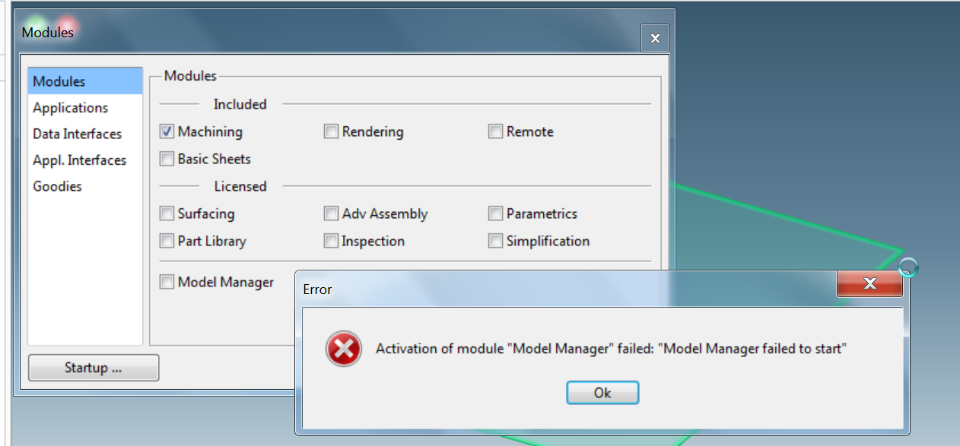

## How do I get “Select Configuration” options to show up? How do I configure Model Manager to connect to a different database or file server?

When you install Model Manager, you specify your site; this specifies which database server and file server you will be using to load and save. If you need to access a different database server or file server (normally because you are either travelling or have moved), you can add a configuration option to the Model Manager login screen. All of the available configurations are available in the Model Manager installation directory: C:\Program Files(x86)\PTC\Creo Elements\Direct Model and Drawing Manager 19.0\config\_all

Copy the required file from that directory to your local Model Manager customization directory: C:\Users\<your login>\AppData\Roaming\PTC\Creo Elements Direct Model Manager \19.0

## Which configuration should I use?

If there is more than one configuration available when you log in to Model Manager, you must choose one-although there will be a default.

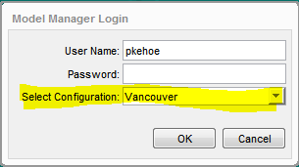

Which one you choose will be dependent on two factors.

First, choosing a configuration indicates which of the 3 Model Manager databases you will connect to. All 3 databases should have the same data on them (the data is replicated continuously, so they should all have the same data within an hour or so of there being a change on one of the databases). The one you choose should be the one closest to your computer for the best performance. Note that “closest” refers to the network path between your computer and the database. For example, if your computer is in China, and you are connecting to the HP network through a VPN gateway in Houston, the closest database will be in Houston, not the one in Singapore-even though it is physically closer.

The other factor is which file server you want to use. Normally you will want to use the file server that “closest” to your computer. But since files are not replicated between the file servers, there may be cases when you know that the files that you will be storing should be on another file server because the people that will be loading them will be using a different file server than the one “closest” to you.

# Modeling

## Model Manager->DB Properties (Masterdata) returns an error: “The model has no masterdata”, but there is Masterdata. Why?

When you load a model from Model Manager, there is an option “Load with Masterdata”. If this option is not checked, then no Masterdata information for that model is included. If you want that command to work, you need to have that option checked. There is an easy workaround if you have forgotten to do that. Instead of using “Model Manager->DB Properties (Masterdata)”, use “Model Manager->DB Properties (Model)->Masterdata”.

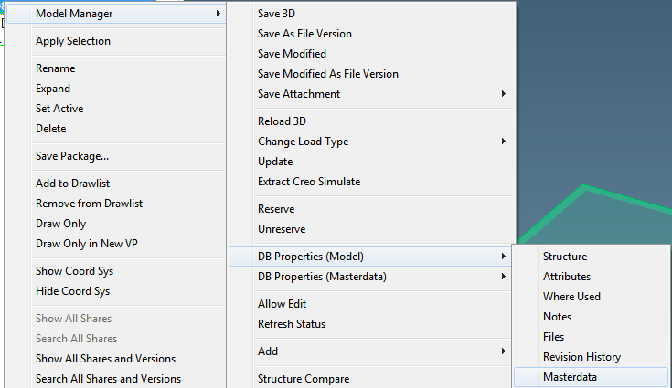

## Why does Modeling “freeze” periodically after starting Model Manager?

HP has implemented a utility to periodically verify that there is a “live connection” between Creo Elements/Direct Modeling and the Model Manager database. While this check is happening, your Modeling session will “freeze”-you will see a “spinning wheel” and not be able to perform any actions in your Modeling session.

If this check is happening more frequently than you would like, the time interval can be adjusted. In the Toolbox in Modeling there is a command “Check MM Connection Time”. Enter a time (in minutes) between these checks.

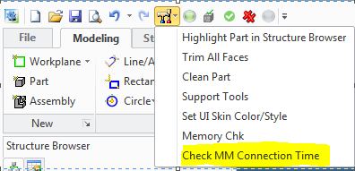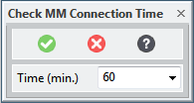

## Why is an assembly shown as modified, even though it was not changed?

An assembly is marked as modified if there is any change to the assembly. Changes to an assembly include adding or removing parts from the assembly, changing the position of a part in the assembly, or if there is a different version of a part in the assembly than when it was stored. If you load an assembly and choose versions of the models in it other than what was in it when it was stored (so a “Load Rule” other than “As Stored”), then the assembly will be marked as being modified.

## Why are parts that I own locked so I can’t modify them?

Even if you own the part, the model will be locked in Modeling if that version is not in the PERSONAL or WORK state. If that version is in another state, you need to use “Allow Edit” before you can make changes to it.

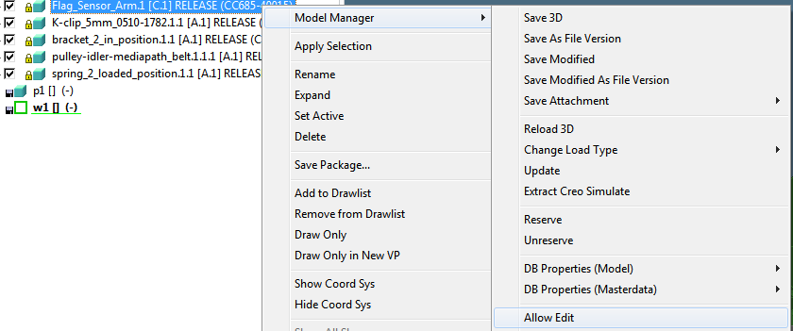

## I have done an “Allow Edit” on a part, but why do I get an error “Selected item is read-only and cannot be modified.”?

There are some changes to parts that are not stored with the part, but with the owning assembly. This includes the position of the part, its “Instance” properties, and its “Instanced Name” (the name in the Structure Browser). Since these pieces of information are stored with the assembly, you must have permission to modify the assembly in order to make those changes to the part. You may need to use the “Allow Edit” command on the assembly that owns the part before you can make your change.

## How do I “Allow Edit” if I don’t have Model Manager activated?

The “Allow Edit” command is only available if the Model Manager module has been activated. If it has not been activated, you can still remove the lock on a part or assembly to allow you to make changes. In the HomeBrew tab there is a “Part & Assy” group; in that group is a drop-down menu called “Unlock”. In that menu are two commands, one to unlock any single object (part or assembly), the other to unlock an assembly and all items in that assembly.

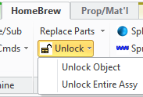

When using the “Unlock Object” command, you specify which object to unlock, then uncheck the “Read only” box in the Database section. After that, uncheck the “Read only” box in the “Internal” section, then press OK.

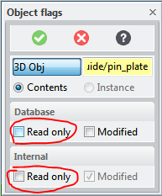

## How do I model parts that have to have various configurations (sheet metal part folded/unfolded, belt that has different shape in different places in the assembly, or cable straight/bent)?

There are several ways to deal with this depending on the situation and what is needed. But in most cases you will first need to have different models, one for each configuration. You can start with your original model, make a copy, and then make the change (like unfolding) to the copy.

* **Containers**. This is one of the most common methods of dealing with a scenario like that. Create a container under your part and place a copy of the part in a different configuration in that container. If you need more than one configuration of the part, you can either create a different container for each configuration, or put all of the configurations of the part in a single container. This allows you to have the different configurations always loaded when the part is loaded, but they won’t be displayed until they are turned on.
* **Multiple Part Numbers**. Using containers is fine if the alternate configurations are not normally part of an assembly. But when you have tubes, belts, or other flexible parts that need to be in assemblies in different configurations, using containers does not work as well. In these situations it is best to create different models for each configuration and save each separately. The best practice in this situation is to use the part number as part of the Model Name/Number for each part. For example, if the part CCC22-80011 has two different configurations in a product, create a model for each and assign a Model Number of “CCC22-80011-A” to one and “CCC22-80011-B” to the other. You can also create a model of the part that will be used for the drawing and assign the “CCC22-80011” part number to it. Using a part number like this (CCC22-80011-A) indicates that this model is not the model that will be used for the drawing of the part, but it indicates what the official part number is.
* **Stock/Finish**. This approach is similar to the approach of using a container, except, instead of creating a container, you use the “Stock/Finish” command (Structure tab) to create a link between the models. One advantage of this approach is that Model Manager knows about this link so you can search for a “stock” part in Model Manager and find all “finish” parts that are linked to it and vice-versa.

## After activation of Annotation module, I don't get the usual viewport and after loading a drawing, the drawing doesn't become visible.

Re-imaging for the HP-migration a wrong graphics driver had been installed.  
After looking for the problem in an online CoCreate forum, I found a suggestion to download the latest driver for my graphics card (NVIDIA) and install it, and that indeed solved the problem.

# Finding parts/models/drawings

## I’m looking for a part and can’t find it. Why?

There can be several reasons that you cannot find a particular part.

* The part doesn’t exist in Model Manager. If it is a commonly used part like a screw, it’s possible that nobody has modeled it-choosing to leave it out of the product (and just adding it to the BOM).
* If you are a contractor, you might not be able to find it because it belongs to a project that you don’t have permission to see. You may need to ask an HP colleague to verify that the part is in Model Manager. If it does exist, you can either request that you be given access to that project, or, if you just need access to a particular part, have that part be added to a project that you can access.
* Your search parameter(s) were not correct. Some people have entered both the part number and project that they thought the part was in. If that part number is in a different project, then Model Manager won’t find it. Only include a specific project name if you know exactly what it is. Or, the person who created the part included a description along with the part number in the part number field. If a search for a particular part number doesn’t find anything, try adding a “\*” before and after the part number (e.g. “\*CC680-50001\*”).
* Another possibility is that the part number was used as the Model Number, not the Part Number on the Masterdata. Using the “Quick Search” (upper right corner of the Model Manager workspace window), which searches Masterdata, Models, and Drawings, can help in this situation. (Note that the “Quick Search” automatically adds a “\*” before and after whatever you type in that field, so you don’t need to include them.)

## What does it mean when the Masterdata icon is red? Green? Grey?

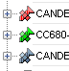

* If the icon for the Masteredata is **red**, it indicates that ownership of that part has been transferred, but the owner has not claimed ownership. Claiming ownership is necessary to be able to make changes to the Masterdata or creating new versions of the models or drawings.
* If the icon for the Masterdata is **green**, it means that it belongs to a workgroup that you are a member of.
* All others, Masterdata that are owned and claimed or belong to a workgroup that you are not a member of, will be **grey**.

# Loading/Reloading

## Why can’t I see my Model Manager Load window? Why does Model Manager hang when I try to load something?

Model Manager remembers the position of each window that it uses and positions them in that same position the next time they are needed. If you have a dual-screen setup (two monitors) one time, and then go to a single screen the next time you start Model Manager, Model Manager windows that were displayed on the second screen may not be visible. If this happens, there are several options:

* Add a second screen.
* Move the window so it is visible on the one screen. Windows can be moved even if they are not visible. First, use *Alt-Tab* to see all of the windows, and select the one that needs to be moved. Then, hold down the *Alt* key and press the *Spacebar* to bring up a menu. Press the *M* key to select the *Move* command. Then use the arrow keys to move the window to where it is visible.
* Reset the Model Manager window positions. Some of the Model Manager defaults like the position of the windows are saved in a file in your local Model Manager customization directory. If you delete or rename that file, the next time Model Manager starts it will position windows in a default location on whatever screens are available at that time. That file is C:\Users\<your login>\AppData\Roaming\PTC\Creo Elements Direct Model Manager \19.0\wmproperties.lst.

## Why does it take so long to load an assembly?

There are a lot of factors that can contribute to taking a long time to load an assembly including the number of parts in the assembly, the size of the parts, and how you are loading the parts. Here is a simplified representation of the process that Model Manager and Modeling use to load an assembly. Determining which step or steps is taking the most time may determine what is needed to speed up the load process.

* After you have selected the item to load from the Model Manager workspace, Model Manager should next bring up the Load Window allowing you to change the versions of the parts and assemblies being loaded as well as changing the load type (partial, lightweight, or full). If you are loading an assembly, it will take a while to find all of the components of that assembly to show in the Load Window. If your default load rule is not “As Stored”, it will take Model Manager longer to determine which versions of the parts should be shown in the Load Window. Note that it is possible to load for Model Manager and not have the Load Window displayed (double-clicking on a part instead of right-clicking and then selecting “Load”, for example). This is not recommended when loading large assemblies unless you know that your load defaults are adequate for the amount of memory you want to use.
* Model Manager uses your default load rule to determine which parts and assemblies are linked to it. Once it has done that, it will present the “Load Window” which allows you to adjust the versions of the parts/assemblies and specify the “Load Type” (Partial, Lightweight, or Full) for each. Note that if your assembly loads without bringing up the “Load Window”, then you may have double-clicked on the item to load instead of selecting it and then selecting the “Load” command. You should avoid using this if you are loading large assemblies or parts/assemblies where you need to adjust how they will be loaded.
* After adjusting any options in the “Load Window” and pressing the “Load” button, the next step for Model Manager is to find all of the files needed for your load. This step is highly dependent on the number of parts being loaded; this step will go much faster when loading an assembly of 10 parts than when loading an assembly of 1000 parts. If you have selected a “Load Rule” other than “As Stored” (such as “Load Highest by VERSION”) then you will see a window with “Finding Versions…” displayed. This portion can take some time depending on how many versions there are of all of the parts/assemblies that are being loaded. After it has found all of the versions, this message should change to “Finding Files”. Loading “As Stored” skips that “Finding Versions” step and can save some time. You may briefly see other messages in that window during this step; usually those indicate other steps which normally take only a few seconds.
* Once the files have been identified, the next step is to copy the files from the file server(s) to a temporary directory on your computer. During this step, the message in that window will show “Loading”. There are a lot of factors that can contribute to this step being slow:
  + The number of files to be loaded.
  + The sizes of the files to be loaded.
  + The network path between your computer and the file server(s). Network latency and bandwidth of every connection between your computer and the file server(s) will have an effect here. A
  + The speed of your disc.
* Once all of the files have been copied to your disc, Creo Elements/Direct Modeling will load them into your session. If you are using HomeBrew, at this point you will see a progress indicator on the status bar showing the progress of the load process. This step is also affected by the number of files to be loaded and the sizes of those files. Other factor at this point that can dramatically affect the speed of the load process is the amount of RAM in your computer that is available. If you do not have enough RAM available to hold all of the parts being loaded, then the Operating System will move some of the information in RAM to your disc to make room; this can add considerable time to the load process. If this is happening, the ways to speed this up are to either add more RAM to your computer, or to load smaller files (like loading partial or lightweight models instead of full models).
* The final step in the process can be to refresh the status on the items that have been loaded. This is a helpful step if you have loaded “As Stored” to know which parts may need to be reloaded to get higher versions. However, if you loaded “Highest by Version” or do not care if you have the highest versions, and you have loaded a very large assembly, the added time to complete this refreshing of the status can be wasted time. You can skip this step by turning the “Refresh status after load or save” option in the Model Manager preferences off. 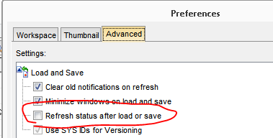

## When I reload an assembly, why doesn’t it reload shared parts in other assemblies?

When you reload an assembly, there is a “Type” option.

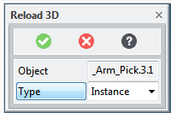 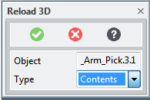

If you select the “Instance” type, the command will only reload that assembly and the parts in that assembly. If there are shares of those parts in other assemblies, they will remain at whatever version they were at. If you change the type to “Contents”, then the command will reload the assembly and the parts in it and update all shares in other assemblies.

## Why does a model get loaded when I load a drawing-even though the model is already loaded?

In version 19 of Model Manager, PTC introduced a “preference” that can cause Model Manager to automatically load the related 3D model when loading a drawing. If this is set, the 3D model will be loaded even if a version is already in your session. If you do not wish to have 3D models loaded automatically, in Model Manager go to File->Preferences and then turn off the “Load related models when loading drawings” option.

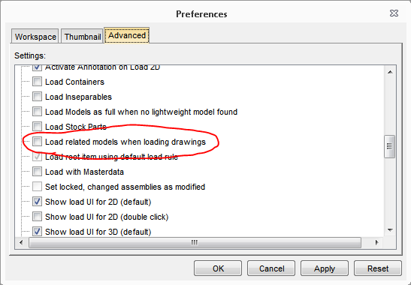

## Why am I getting an error when trying to load-“mm\_load\_ar/filing/file\_not\_found”?

This happens when an assembly is saved but a new part (or new version of a part) is not saved. Normally this should not happen, but it can happen in a couple of situations. First, if the assembly is saved to one database, sometimes the replication process which copies data to the other databases will copy the assembly but miss copying one or more parts. The other situation is if the save process is interrupted before it completes. The best solution is to have the owner of the assembly save it again (overwrite). 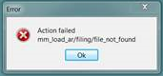

## What does it mean when I get an error like “physName=’AVEFMGEUYMBZM9’”? And how do I fix it so that I can load my assembly?

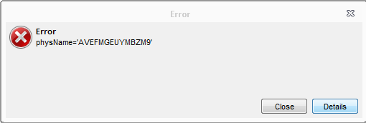

This error appears when loading a part as lightweight when there is no lightweight file for that part. The solution is to load that part fully, then use the **Add->Lightweight** command to add a lightweight file to that part. Note that you do not need to be the owner of the part to add a lightweight model to it.

# Saving/Versioning

## Why does Model Manager hang when trying to save?

The first thing to check is to make sure that you have created a “*project packet*”. If you have never created a “*project packet*”, you must first create one before you save anything into Model Manager. To create one, go to the **My Project** tab, right-click on a project and select **Create Project Packet…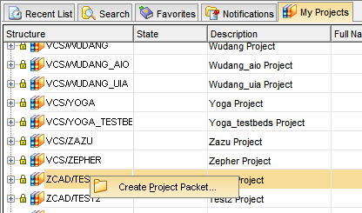**

Then go to the **Favorites** tab, expand **My packets**, then right click on the *project packet* that you created and select **Set to Working Packet**

**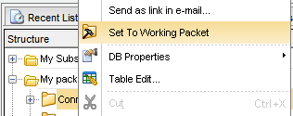**

Once you have done that, new models and drawings that you save will be saved in that *project packet* by default.

If you do have a *project packet*, and you do not see the Save window, see the answer to the question above about [Model Manager hanging when loading](#_Why_can’t_I).

## I saved a model to the wrong project; how do I fix it?

You can change the project on a part by right-clicking on the Masterdata, selecting **Project Actions->Change Main Project.** This will change the project for the Masterdata and all documents under the Masterdata. However, this will not change any documents that have already been changed to *UNDER\_REVIEW* or *RELEASE*.

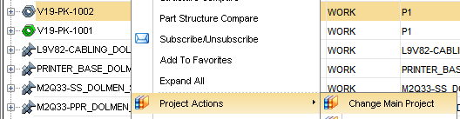

## Why do I get a message about a conflict when trying to save a model? Why does Model Manager set the save type to “Conflict”? What does it mean if the status says “SysID Conflict”? And how do I fix it?

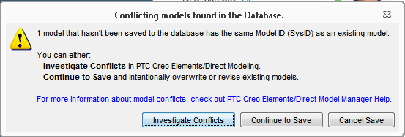

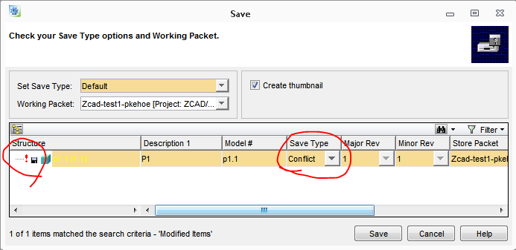

This message indicates that the Creo Elements/Direct Modeling thinks that the part has never been saved to Model Manager before, but Model Manager says that it has. This can happen if you load parts from old package files (files that contain the parts before they were saved to Model Manager) rather than by loading them from Model Manager. If this happens you have 3 choices:

* Load the model that is already saved in Model Manager to replace the one currently in your modeling session. (**Replace local model with DB model**).
* Save the model in your session as a new version of the one already in Model Manager, or overwrite the existing version. (**Replace DB model with local model (DB Overwrite or New Version)**).
* Change the “SysID” of the model in your session so that Model Manager will treat it as a new model in the database. (**Assign new SysID to local model**). You can optionally make a copy of your local model, then delete the original.

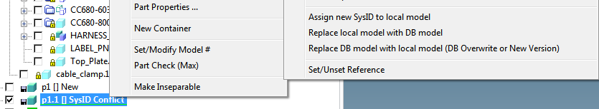

## What does it mean when “Name Conflicts Found” is displayed?

This warning appears whenever an object is being saved to Model Manager when there is already one in the database with the same Model Number and version. 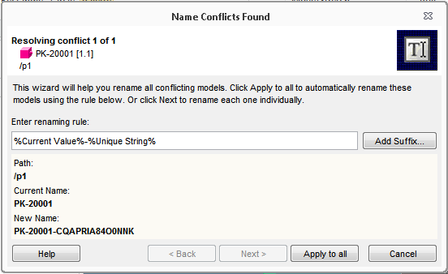

If you get this window, the default option is to add a suffix (unique string of 14 characters) to the Model Number that had been assigned to guarantee it is unique. Optionally you can change the new name by typing a new name or using the “Add Suffix” button to help build up a new value. Or, you can press “Cancel” to cancel the save command.

## How do I change the name/part number?

You can use the “Rename” command to change the Part Number on a Masterdata. You can also use the same command to change the Model Number on a 3D Model and the Drawing Number on a 2D Drawing.

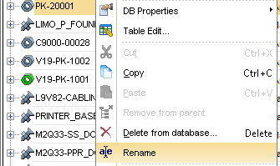

## I changed the Model Number, but the new version reverted back to the old number-why?

If you change the Model Number or Drawing Number in the Model Manager workspace and have that Model/Drawing loaded in your session, you will need to reload it so that it is updated in your session. If you don’t, then the Model/Drawing in your session will not have been changed, so it will still remember the old number.

## When should I use overwrite/minor rev/major rev?

* If nobody else on the design team has seen the previous version, you have not changed the state on it (so it is still in either PERSONAL or WORK state), and you do not need to even see the previous version again, you can use overwrite.
* If the previous version has been used by other members of the design team, then either the minor or major revision should be incremented.
* If the previous version has been seen by an outside supplier, then the major version will need to be changed before the next version is sent to the outside supplier. The exception to this is if the changes are for improved documentation due to DFM and not design changes; in those cases, minor revisions are acceptable.
* A major revision can also be used to denote a major change to the geometry of the part; for example, changing the location of holes in a plastic case part because the power supply moved.

## The version for my model/drawing is not correct. How do I change the version?

To change the version for a model or drawing, bring up the DB Properties window for that model/drawing. Click on “Edit”. In the **Version** field you can either type in a new version or use the drop-down menu to choose a version.

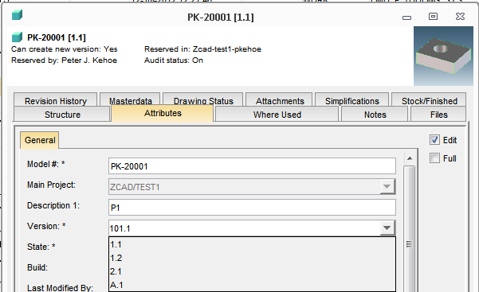

## Is there a problem to save to local disc instead of to Model Manager?

If you have loaded models or drawings from Model Manager, you can save them as Package files, Bundle files, or Drawing (MI) files to your local disc. Later you can load them up, work on them, and then store them back into Model Manager. Creo Elements/Direct Modeling will remember that they originally came from Model Manager so that they can be used to overwrite or create a new version of the model/drawing already in Model Manager.

## Can I skip revisions when saving? How do I get to rev “101.1”?

Yes, you can skip revisions when saving. When you save, the Save window shows you next *proposed* version depending on whether you have selected to change the Major version or the Minor version. But, you can change either that value. To skip a Major version, select the “Major Rev” Save Type, then type in the new version in the “Major Rev” field.

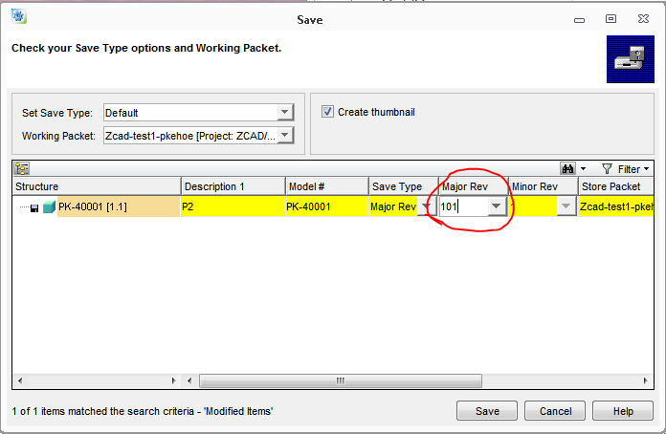

There are a few restrictions on skipping versions:

* The entered version (Major + Minor) cannot already exist for a document with that Model #/Drawing Number.
* The Major version should be either an integer or letters; you cannot mix letters and numbers.
* Once there is a version that has a Major revision that is a letter, you can no longer create a Major rev that is a number (i.e. once you have A.1, you cannot create another version that has a Major version that has a different number than any that currently exist).

# Ownership

## A part belongs to one project, but a contractor who needs access to that part doesn’t have access to that project. How can we fix that?

There are three ways to fix this.

* Use the **Change Main Project** command to change the project on the part to one that the contractor can access. In most cases, however, this is neither practical nor recommended because it may affect other contractors who need access to that part.
* Have the contractor added to that project by contacting one of the Model Manager administrators. This method should be used if the contractor needs access to not just that part, but potentially others in that same project.
* Use the command **Add Project** on the Masterdata for the part to add it to another project. In this way it will be linked to a second project so contractors who can access either project will be able to access that part.

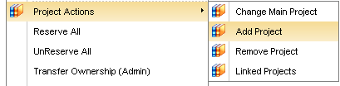

## I transferred ownership to the wrong person-how can this be fixed?

The only ways to fix this are to either have that new person transfer ownership back to you (or to the correct person), or have one of the Model Manager administrators transfer ownership.

## How do I put a part in a workgroup?

Use the **Transfer Ownership** command to transfer a part to a workgroup. At the bottom of this list of owners will be a list of all workgroups that you are a member of. (You can only transfer ownership to workgroups that you are a member of.)

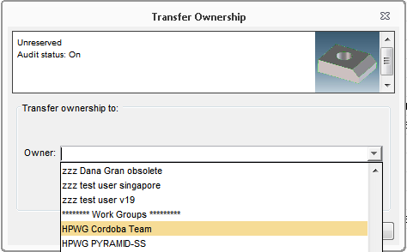

See [this document](file:///\\vcsrndweb.vcd.hp.com\mecad\tools\ModelManager_v19\Group_Ownership.htm) for more information about using workgroups.

## How do I get added to a workgroup?

Any “Workgroup Manager” can add a person to a workgroup. To get a list of “Workgroup Managers”, click on the “Work Groups” tab in Model Manager, then “Workgroup Managers”.

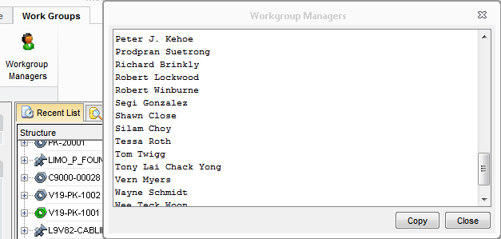

See [this document](file:///\\vcsrndweb.vcd.hp.com\mecad\tools\ModelManager_v19\Group_Ownership.htm) for more information about using workgroups.

## How do I transfer ownership of a container?

Containers do not get a Masterdata when they are saved, so there is no command to transfer ownership of containers. If you do need to transfer ownership of a container, you must first add a Masterdata to the container. You may be able to do this by right-clicking on the container and selecting **Add New->New Part (Parent)**. You can also create a new Masterdata using **File->New->Masterdata**; then you will need to copy/paste the container into that Masterdata. However, you may not have permission to do either of these, so you may need to contact one of the Model Manager administrators to do this.

## I transferred ownership of an assembly, but it did not transfer ownership of any of the parts. How do I transfer ownership of an assembly and all parts in the assembly?

Ownership of an assembly does not mean that the parts in the assembly are owned as well; each has a separate Masterdata and each can have a different owner. If you need to transfer ownership of an assembly and parts in the assembly, you must do that for each Masterdata. There are several ways to do that.

* One-by-one. The most straight-forward, but also most tedious, method is to search for the assembly and each part in the assembly and transfer each one-by-one.
* Search for all. Sometimes it is possible to do a Masterdata search that returns the assembly Masterdata and the Masterdata for all of the parts (for example, search for all Masterdata that you own that are in a particular project). Select all of the Masterdata (use Ctrl or Shift to select more than one Masterdata), then right-click to select **Transfer Ownership**.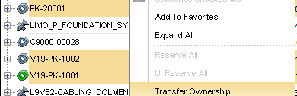
* Use the **BOM** module (**File->Modules->BOM Editor**) to create a “BOM” for the assembly. This will show the Masterdata for each of the parts in the assembly under the assembly. Once that is done, you can expand the “Masterdata” folder under the assembly, select the Masterdata for each part, plus the Masterdata for the assembly, right-click and select **Transfer Ownership**. 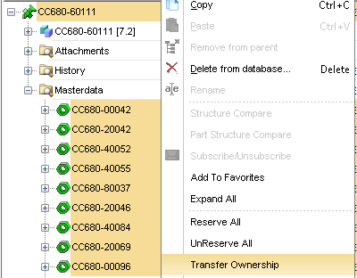

# States

## Why can’t I change a model or drawing to RELEASE at rev A.1?

There are several restrictions in Model Manager which can prevent changing the state of a 3D model or 2D drawing to RELEASE. This includes:

* Having another version already in RELEASE state
* For an assembly, having a part in the assembly not at either the RELEASE or REFERENCE state
* Not having a valid model number or drawing number
* Not having at least one Masterdata for the model or drawing

An additional restriction is specified for models and drawings which have a letter as the major version (i.e. “A”). For those models and drawings, before they can be changed to the RELEASE state, the “Change Number” attribute must be filled in. This should be filled in with the ECR/ECN/PCO/etc. number which specifies the change order number that validates that this part can be used in production. To fill in the value, open the **Attributes** tab for the model or drawing, select **Edit**, fill in the value, then press **OK**.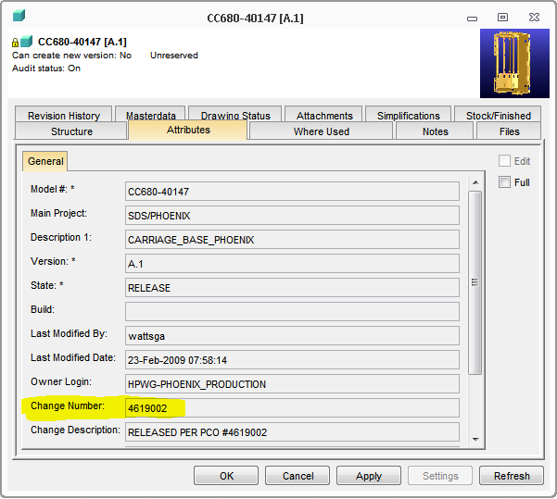

## When do I use each of the states?

Each state indicates how that version of the document should be used.

* **PERSONAL**. Use this state when you do not want any other Model Manager users to load the model or drawing.
* **WORK**. Use this state to indicate that this version of the design can be used, but the design is not yet complete. There may be newer versions that should be used instead.
* **CANCELED.** Use this state when this version of the model or drawing should not be used.
* **UNDER\_REVIEW**. Use this state to indicate that the document needs to be reviewed by someone outside of the design team.
* **RELEASE**. Use this version to designate the version should be used for making parts, either for the next prototype build or for production.
* **SUPPORT**. Use this version when it is still a valid version to use in a product, but is not the version that should be used to make new parts.
* **OBSOLETE**. Use this state when this version of the model or drawing should not be used.

## Why can’t I change my assembly to RELEASE?

An assembly can only be changed to the RELEASE state if all of the objects under that assembly are in the RELEASE state or the REFERENCE state.

## How do I change a part to be in REFERENCE state?

You cannot change the state of an existing part to REFERENCE. What you can do is to mark a model as being a “Reference Part”. When a “Reference Part” is saved, it will be put in the REFERENCE state. To mark a model as a “Reference Part”, you can right-click on the model in Creo Elements/Direct Modeling, go to the **Model Manger** menu, then select **Set/Unset Reference**.

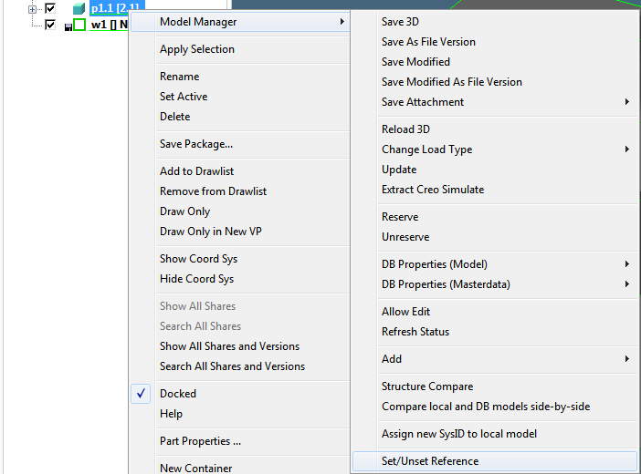

When the dialog comes up, check the “Reference” box. The next time that model is saved as a new version, that new version will be in the REFERENCE state.

## I changed my model/drawing to the wrong state. How can this be fixed?

Model Manager users do not have permission to change the state back, for example from RELEASE back to WORK. It is therefore important that you take care when changing the state on a model or drawing. You do have two options if you have mistakenly changed to the wrong state. First you can create a new version and put that version in the correct state. For example, if you changed the state from UNDER\_REVIEW to OBSOLETE when that version should have been changed to RELEASE, you can create a new version and change that to RELEASE. The other option is to have one of the Model Manager administrators change the state back. There are potential issues with doing this, so creating a new version should be the preference.

# Other

## How do I leverage an existing drawing for new part?

Any of the “Attach Drawing” commands can be used to leverage an existing drawing of one part for another part.

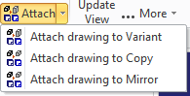

To use any of these commands, you must have the leveraged drawing loaded in Annotation. The original model used for that drawing must be loaded in Modeling. And the new model must also be loaded in Modeling.

* Use **Attach drawing to Mirror** if the new part is a mirror of the original part.
* Use **Attach drawing to Copy** if the new part is a copy of the original part. (The copy operation must have been done *after* the drawing was created to ensure that all of the views of the drawing will be linked to the new part.)
* Use **Attach drawing to Variant** in all other cases.

You can ignore the warning message (“The current drawing won’t be usable for the original assembly/part/workplane after this command. Please store this drawing first.”) as long as the drawing has been saved (either into Model Manager or to a local disc). The command will only link the drawing that is loaded to the new part and will not change any already-saved versions of the drawing.

Make sure that you change the **Drawing No** so that the drawing of the new part will not be used as a new version of the drawing for the original part.

## How do I set up family parts?

To specify that a model and drawing represent a family of parts requires two steps.

* Link all versions of the model and drawing to the additional Masterdata. One easy way to do this is to right-click on the Masterdata and use the **Add Family Parts…** command. Enter the part number of another part for that model. You can use this command to link multiple Masterdata at one time. Enter the number of new Masterdata to create, then enter a starting part number. In the Table Editor you can adjust the part numbers if they are not sequential. You can also link to a new Masterdata by expanding an existing Masterdata, right-clicking on a model or drawing, and then using the **Add New->New Part (Parent)** command. This will create a new Masterdata linked to all versions of the models and drawings that the other Masterdata was linked to.



* You will also need to make sure that the latest versions of the model and drawing have the “family number” (normally a “-9xxxx” number). You can either create a new version of each with the “family number”, or rename (renumber) the latest version. It is not necessary to rename previous versions.

It is not required or recommended to have a Masterdata with the “family number”.

## How do I add a Masterdata to a model or drawing that has none?

Normally Masterdata is added automatically when a model or drawing is saved for the first time, and then added to an existing Masterdata when a new version is created. There are, however, times when a model or drawing may get saved so that there is no Masterdata. There is a command in Model Manager to add a Masterdata to a model or drawing. Find the model or drawing, right-click on it to bring up the menu, find the “Add New” submenu, then select “New Part (Parent)”. Fill in the fields in the dialog that comes up. This only needs to be done to one version of the model or drawing; all versions will be linked to the new Masterdata. However if this was done to a model, it will not automatically link any of the drawings and if it was done to a drawing, it will not link to any of the models.

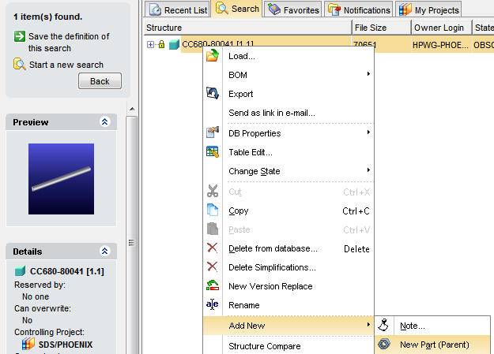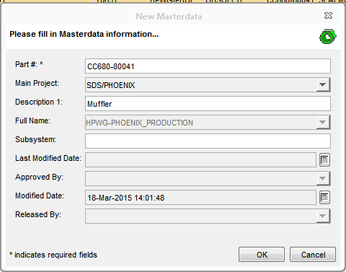

## Why does the Where-Used show no assembly when I know that the part is loaded as part of an assembly?

The Where-Used function only looks at the “As Stored” links between parts and assemblies. If a particular version of a part was not saved with an assembly, then it will not show as being “used by” that assembly. You might need to check other versions of the part to determine which assemblies can be loaded to get that part.

## Can non-CAD documents be added to Model Manager?

Yes, they can. First, use the **File->New->Document** command. If the document is a Creo Simulate document, select the **Creo Simulate** class; otherwise select the **Default Document** class.

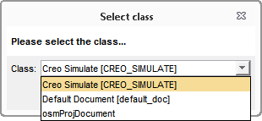

Select your file and enter a name for the file in the fields. Since the file extension will not be shown in Model Manager by default, it is helpful to include some indication of the type of file in the document name.

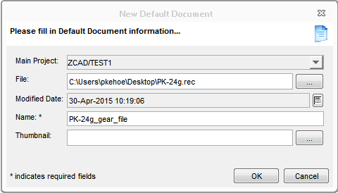

Once you have entered the document, you can then link it to an existing Masterdata. An easy way to do this is to open a second Model Manager workspace (**New Workspace** command). In one workspace window, search for the document that you just created (should be in the **Recent** tab). In the other workspace window, search for the Masterdata that you want it linked to. Use the **Copy** command on the document, then the **Paste** command on the Masterdata.

See [this document](file:///\\vcsrndweb.vcd.hp.com\mecad\tools\ModelManager_v19\Adding_non-CAD_doc.htm) for more information on the process.

## Why can’t I delete a model?

There are two restrictions on being able to delete a model from the Model Manager database.

* The first is that the model must be in the PERSONAL or WORK state to be deleted. If it is in another state, it cannot be deleted.
* The other restriction is that a model cannot be deleted if it is “used” by an assembly-that is, it is loaded when an assembly is loaded “As Stored”. You can find out if this is the case by looking at the “Where Used” for that version of the model; if that version shows no owning assembly, then that version can be deleted. If a version does show an owning assembly, there are two options. If the model is used by more than one assembly, then either of these options will be used for each assembly.
  + First, you can delete the owning assembly. However, this is often a problem because someone else may own the assembly, so you may not have permission. Or, that assembly could be “used” by an even higher-level assembly-and that can cascade up many levels.
  + The other option is to load the owning assembly (load “As Stored” to get the version of the model that you want to delete), delete the version of the model from that assembly (or load a different version) and then overwrite that version of the assembly. This will remove the link between the assembly and the model.

## Model Manager install issue:Key not valid for user in specified state

Machine generated alternative text:
Creo Elements/Direct  Select Neaœst HP Ste
Bacelona
metalIng [21 Ikdelng 64ta EduCe,
Boise
( HP Homebrew
Cebado
[21 Ibd& end tng Menan w! HP Cucwnirations
1 Corvalzs
Q Faite Benent Melyss 64ta Edten Pu. _co
‘Rehov
Q Pat Lbray
SanDiego
Q 3üLkcsy(lsgacy)
Shania
Creo Elements/Direct 2D CAD  Srgapce
E ftthflg ‘Vw,ccuyer
User Type
(ä) HPerçl:cc ::
L4 !

* Please uninstall a Windows Security Update Program **KB2918614**.
* Or install another Windows Security Update Program **KB2962490**.

If you want to uninstall a Windows Security Update Program **KB2918614** , please refer to the following steps:

1. Select the **Control Panel**

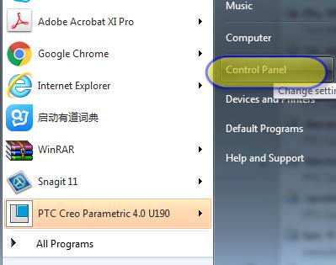

1. Select **Programs and Features**

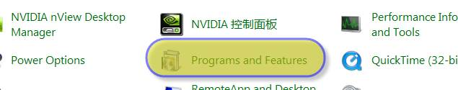

1. Click **View installed updates**, then find **KB2918614** and **uninstall**

