Book Homework 4

Jiaqi Li

17. The most important direct cash flow influence of accounting is the influence on the NPV analysis

18. Cash Flow statement is about flows and Income Statement is about stocks

19. Based on MACRS, we should use 5 years depreciation for computer equipment

$\frac{10000}{5}=2000⇒$ equipment depreciates 2000 dollars each year

20. , then each year, the accounting value of the residential investment property will be

$3-0.075×i$ for $i∈[1,40]$, for the rest of the 50 years, the property will have 0 value based on

accounting rule

21. Accrual arises for economic transactions that have delayed cash implications.

Primary long-term accrual is depreciation; short-term accrual includes account receivable,

income tax, tax payable, etc.

22.

IS:

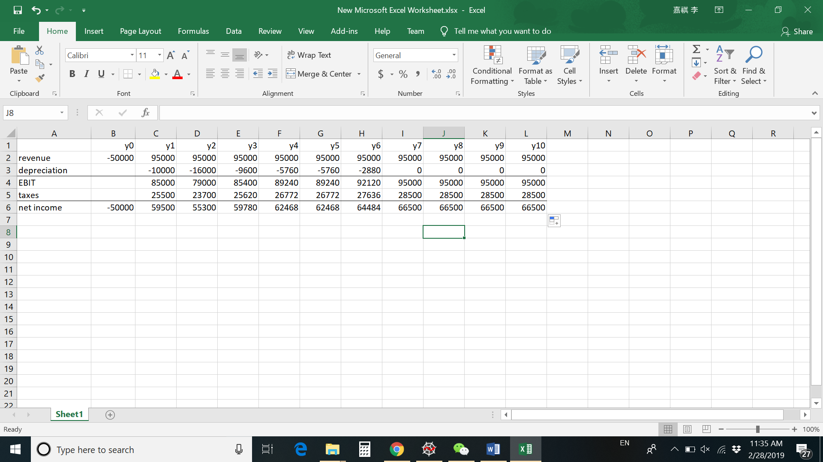

CFS:

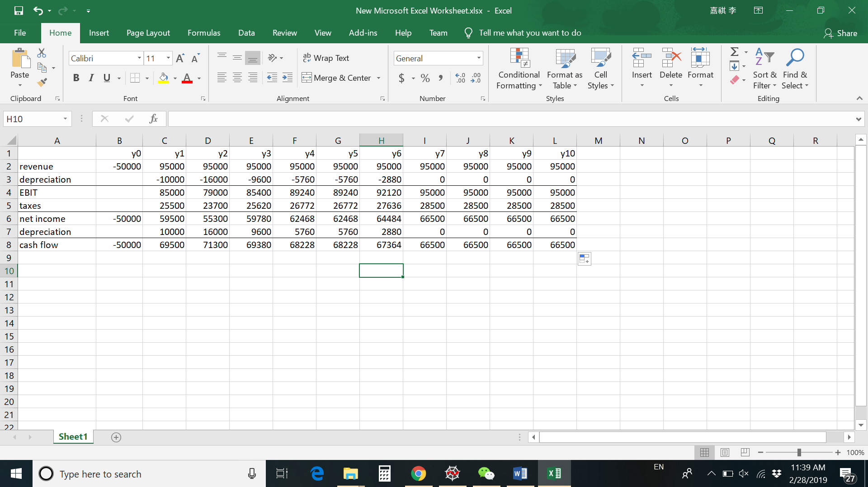

NPV = -50 + CF at y1/1.12 + CF at y2/1.12^2 + … =336810

23.

24. change of deferred income tax = 1496-1367=129

Actual payment = 1367-129 = 1238

25.

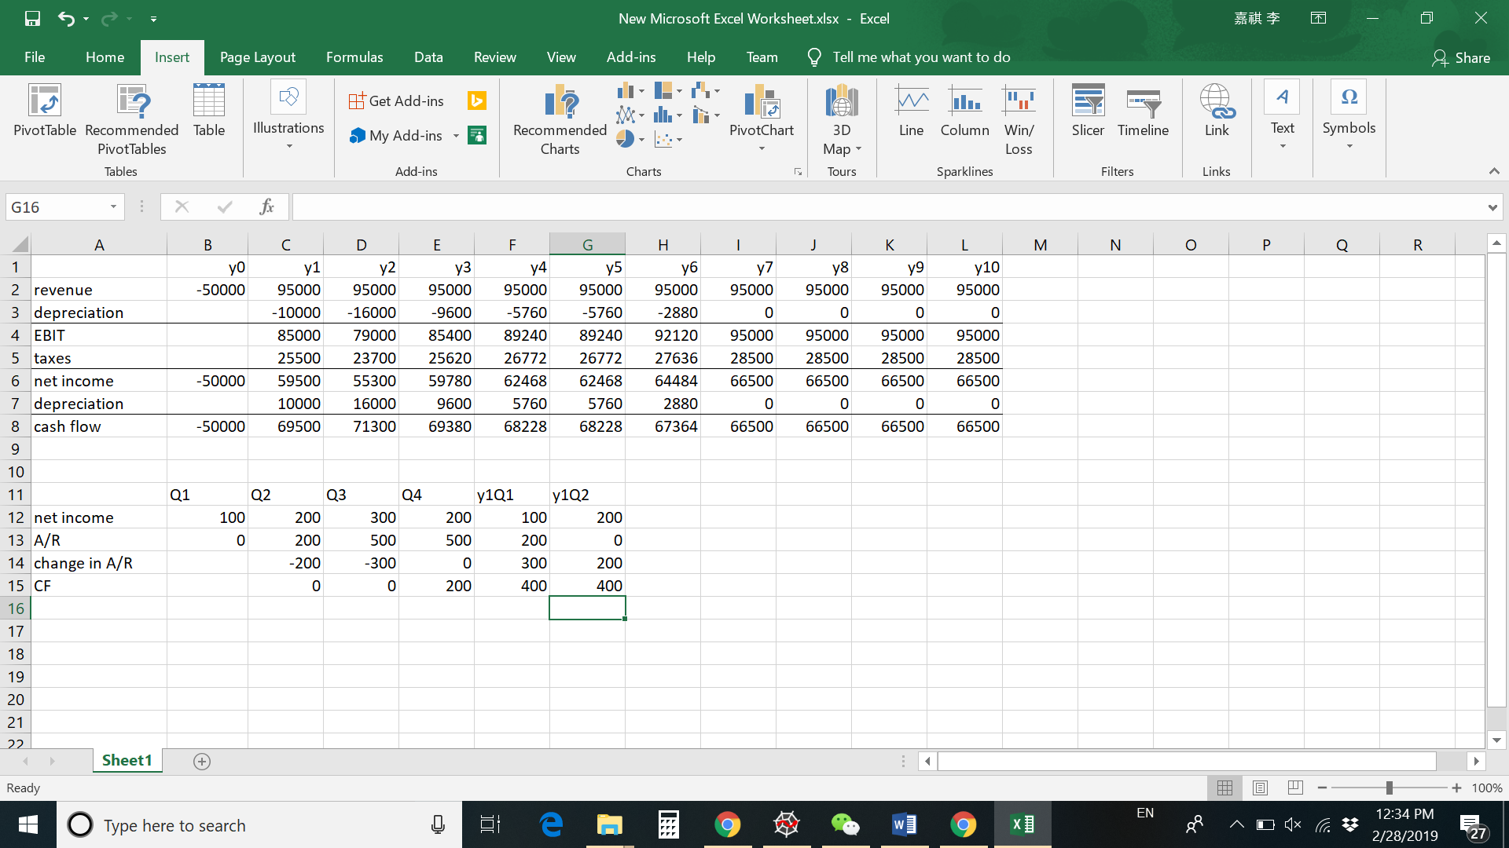

29. Use a short depreciation schedule so that at the beginning the cash flow will be low and but later the cash flow will become high.

30. We can manipulate EBIT by changing depreciation schedule, but EBITDA is earnings before any depreciation, which means it’s harder to manipulate.