Homework 4

Jiaqi Li

1.

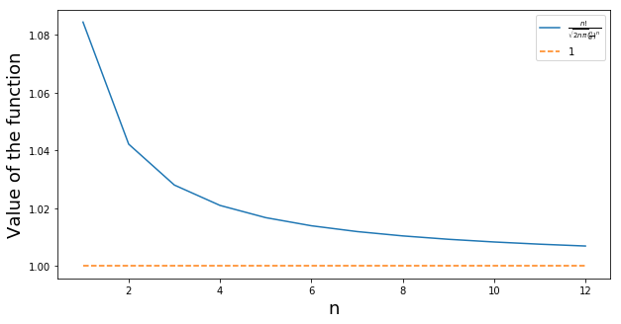

By observing the graph, we can say that as n becomes larger, the Stirling’s formula works better.

If n get big enough, the approximation will have very close results to factorials.

3.

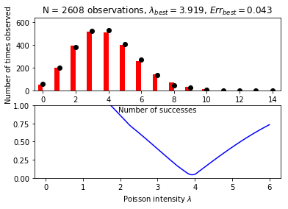

Best fit λ is 3.919.

This implies that the creation of α particle is a rare event because it fits Poisson distribution.

4.

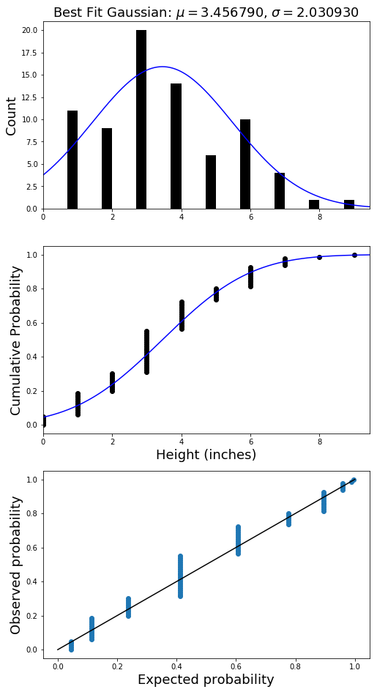

The best fit μ = 3.45679 with standard deviation σ = 2.03093.

5.

(a) the transformation process is on the written paper.

Best estimations for λ and n are 2.35 and 3.63.

(b)

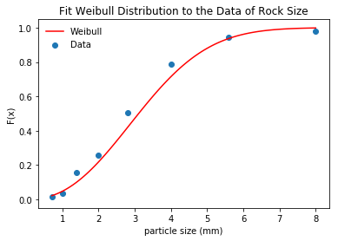

The Weibull distribution does not fit the data very well, but it has the right pattern.

9.

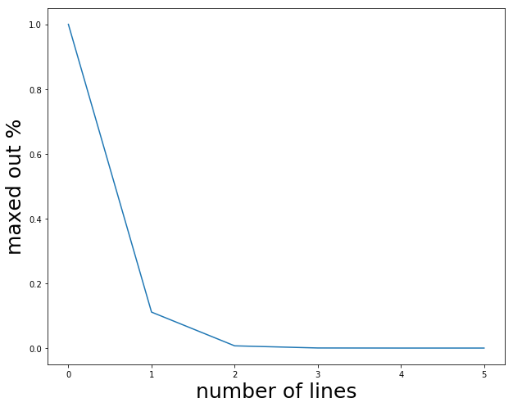The maxed out percentage are 1.0, 0.11, 0.0068, 0.00029, 8.977e-06, 2.244e-07 corresponding to 0, 1, 2, 3, 4, 5 lines. Thus, we can say that 2 lines will satisfy our need. Thus, we need 2 lines.

10.

(a). code is given

(b).

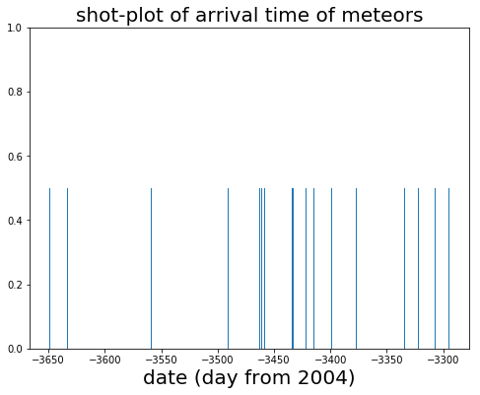

(c).

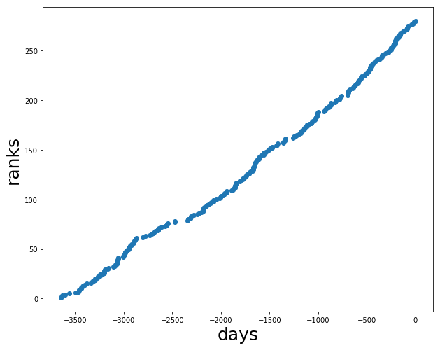

(d). The average arrival rate is 0.0767451803086 meteor per day

(e).

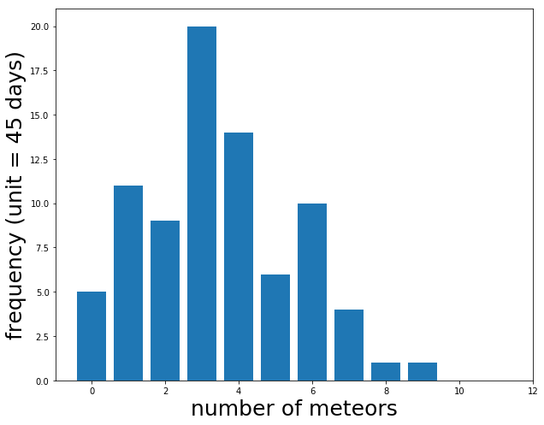

(f).

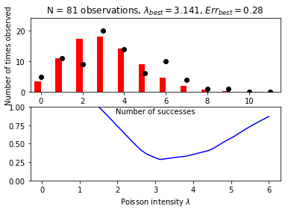

The best fit of λ is 3.141

(g).

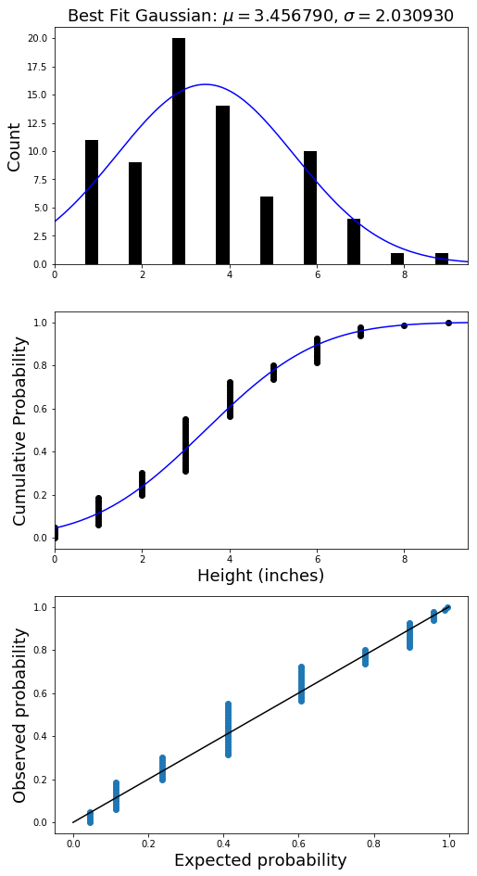

By observing the graph, we can tell the fit is fine.

(h).

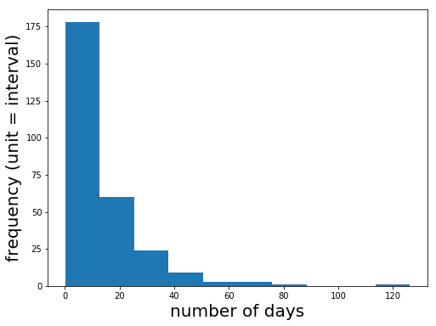

By observing the graph, we can tell that the time intervals between meteor arrivals are exponentially distributed.