**2.**

**(a)** Plotting code is shown on the transcript page. The graph is shown below:

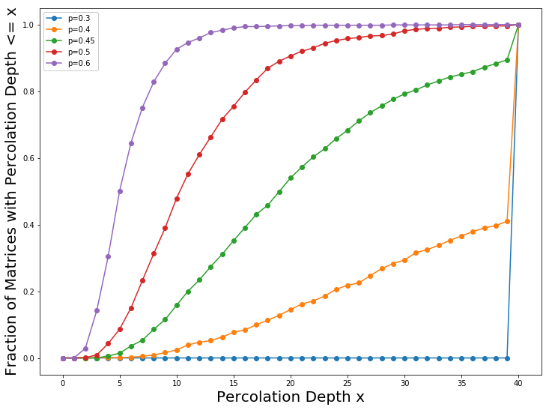

**(b)** By observing the graph above, we can see that for p < 0.45, the curve will jump to 100% when percolation depth (x) is approaching 40, this means that when fill fraction (p) is small, most of the matrixes have the maximum percolation depth equal to 40. For p = 0.45, there is also a jump when percolation depth approach to 40, but not as high as the curves for p < 0.45. This also means that many of the matrixes for p = 0.45 have the maximum percolation depth equal to 40. Therefore, we can conclude that when p is small, specifically when p < 0.5, percolation depth of a matrix usually can reach its maximum.

**(c)** Plotting code is shown on the transcript page. The graph is shown below:

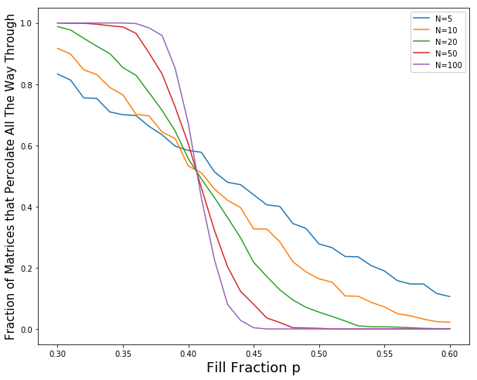

**(d)** By observing the graph above, we can see that when N grows larger, there gradually forms a big fall at a specific value for fill fraction p. Therefore, as p grows larger, $\lim_{N→∞}{h\left(p,N\right)}$ will suddenly change from 100% to 0% at a specific value of p. We may call such p value the percolation threshold.

**(e)** In reality, we live in a 3-dimentional world, which means that if a person is in a maze, he can go through the wall by climbing up the wall. This means that the reality is much more complex than the 2-dimensional world. Thus, in reality, the percolation threshold (a specific value of p) will become larger than that in 2-dimensional world.

|  |  |  |  |  |  |  |  |  |
| --- | --- | --- | --- | --- | --- | --- | --- | --- |
|  |  |  |  |  |  |  |  |  |
|  |  |  |  |  |  |  |  |  |
|  |  |  |  |  |  |  |  |  |

|  |
| --- |
|  |

**3.**

|  |
| --- |
|  |

**=** live cell = died cell

**Start:**

|  |  |  |  |  |  |  |  |  |
| --- | --- | --- | --- | --- | --- | --- | --- | --- |
|  |  |  |  |  |  |  |  |  |
|  |  |  |  |  |  |  |  |  |
|  |  |  |  |  |  |  |  |  |
|  |  |  |  |  |  |  |  |  |
|  |  |  |  |  |  |  |  |  |
|  |  |  |  |  |  |  |  |  |
|  |  |  |  |  |  |  |  |  |
|  |  |  |  |  |  |  |  |  |
|  |  |  |  |  |  |  |  |  |

**Step 1:**

|  |  |  |  |  |  |  |  |  |
| --- | --- | --- | --- | --- | --- | --- | --- | --- |
|  |  |  |  |  |  |  |  |  |
|  |  |  |  |  |  |  |  |  |
|  |  |  |  |  |  |  |  |  |
|  |  |  |  |  |  |  |  |  |
|  |  |  |  |  |  |  |  |  |
|  |  |  |  |  |  |  |  |  |
|  |  |  |  |  |  |  |  |  |
|  |  |  |  |  |  |  |  |  |
|  |  |  |  |  |  |  |  |  |

**Step 2:**

|  |  |  |  |  |  |  |  |  |
| --- | --- | --- | --- | --- | --- | --- | --- | --- |
|  |  |  |  |  |  |  |  |  |
|  |  |  |  |  |  |  |  |  |
|  |  |  |  |  |  |  |  |  |
|  |  |  |  |  |  |  |  |  |
|  |  |  |  |  |  |  |  |  |
|  |  |  |  |  |  |  |  |  |
|  |  |  |  |  |  |  |  |  |
|  |  |  |  |  |  |  |  |  |
|  |  |  |  |  |  |  |  |  |

**Step 3:**

**Equilibrium Configuration:**

|  |  |  |  |  |  |  |  |  |  |  |  |  |  |  |  |  |
| --- | --- | --- | --- | --- | --- | --- | --- | --- | --- | --- | --- | --- | --- | --- | --- | --- |
|  |  |  |  |  |  |  |  |  |  |  |  |  |  |  |  |  |
|  |  |  |  |  |  |  |  |  |  |  |  |  |  |  |  |  |
|  |  |  |  |  |  |  |  |  |  |  |  |  |  |  |  |  |
|  |  |  |  |  |  |  |  |  |  |  |  |  |  |  |  |  |
|  |  |  |  |  |  |  |  |  |  |  |  |  |  |  |  |  |
|  |  |  |  |  |  |  |  |  |  |  |  |  |  |  |  |  |
|  |  |  |  |  |  |  |  |  |  |  |  |  |  |  |  |  |
|  |  |  |  |  |  |  |  |  |  |  |  |  |  |  |  |  |
|  |  |  |  |  |  |  |  |  |  |  |  |  |  |  |  |  |
|  |  |  |  |  |  |  |  |  |  |  |  |  |  |  |  |  |
|  |  |  |  |  |  |  |  |  |  |  |  |  |  |  |  |  |
|  |  |  |  |  |  |  |  |  |  |  |  |  |  |  |  |  |
|  |  |  |  |  |  |  |  |  |  |  |  |  |  |  |  |  |
|  |  |  |  |  |  |  |  |  |  |  |  |  |  |  |  |  |
|  |  |  |  |  |  |  |  |  |  |  |  |  |  |  |  |  |
|  |  |  |  |  |  |  |  |  |  |  |  |  |  |  |  |  |
|  |  |  |  |  |  |  |  |  |  |  |  |  |  |  |  |  |

**4.**

**(a) $\left\{\begin{aligned}\dot{θ}=u \\ \dot{u}= -sinθ\end{aligned}\right.$**

**(b)**

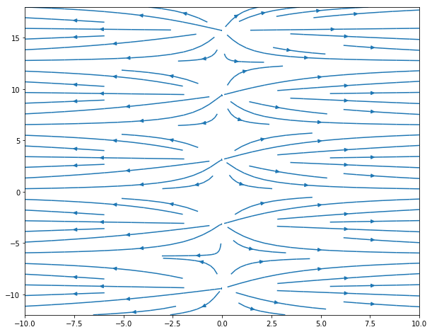

**5.**

**(a)** At steady state,

$\frac{d^{2}θ}{dx^{2}}+e^{θ}=0$ ⇒ $\frac{d^{2}θ}{dx^{2}} = -e^{θ}$

**(b)** Since the temperature is always decreasing as $x$ increases from the center ( $x$ = 0), the reactor will reach its maximum temperature at $x$ = 0. ( $x$ is the length from the center to the edge of the reactor)

**(c) $\left\{\begin{aligned}\frac{dθ}{dx} = u \\ \frac{du}{dx} = -e^{θ}\end{aligned}\right.$**

**(d)**

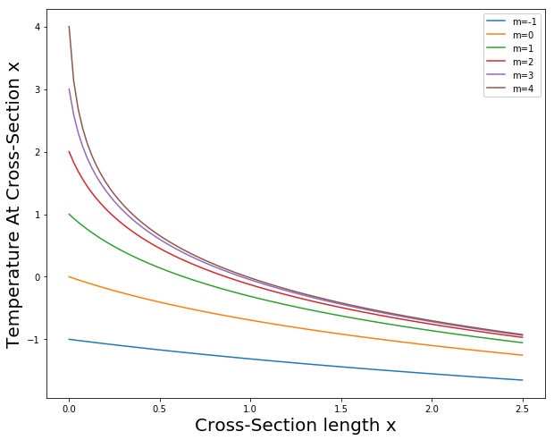

**(e)** As the maximum temperate increases at $x$ = 0, the cooling curve will approach to a certain value of x when temperature is 1. The calculation method for this x is shown as following:

for i in range(101):

if (M(m[5])[i,1] < 1.10 and M(m[5])[i,1] > 1):

n = i

print('At m=5 : %d' %(n+1))

L = 2*n*2.5/100

As I run the code, I will get $L$ = 0.65

**(f)**

By observing the graph, the cooling curve will behave very similar for $x$ > 1 when maximum temperature continues to grow (larger than 4). This means that if we have $L$ = 3, then at $x$ = 1.5, temperature will go below zero. Thus, if $L$ = 3 and the boundary temperature $B$ = 1, the cooling system’s maximum allowed temperature can be infinitely large for our steady-state temperature distribution.

**6.**

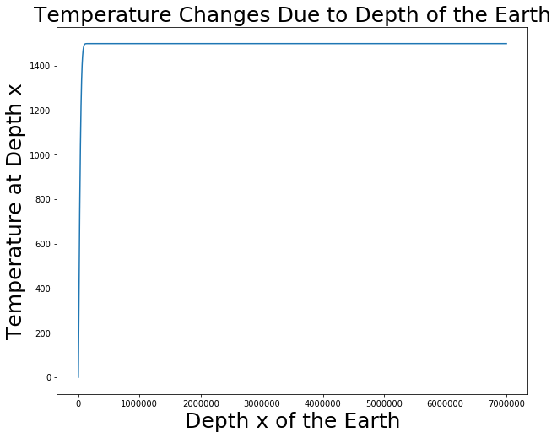

By observing the plot, we can see that when depth of the Earth approaches to a certain value of x, the temperature will stop increasing. Such value of x is relatively small compared to the radius of the Earth. This situation is not realistic in the real world. The center of the Earth is about 6000 Celsius degree estimated by scientists. Which means the curve should not stop increasing at temperature 1400. Thus, this model can only be used to estimate the temperature on the upper surface of the Earth and it cannot be used to estimate the temperature deep inside the Earth.