**Escaping alarm clock**

# Concept

Design of the alarm clock was based on the Star Wars’ Hailfire droid. In beginning of the designing phase, the idea of clocks looks were loose. It needed two tires and body. Into the body had to be fitted the battery, Arduino, a gyroscope and a piezo. No more precise sketching was made before hand and the appearance of the clock came along the modelling process.

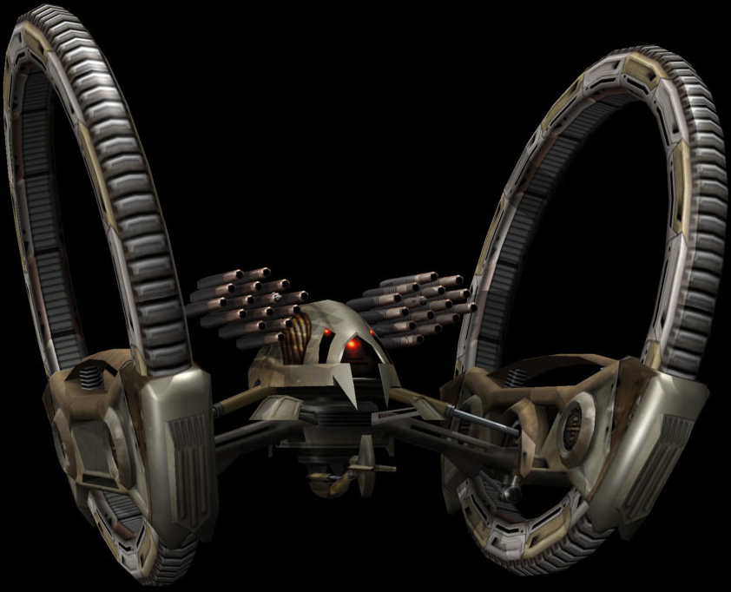

Source: <http://battlefront.wikia.com/wiki/Hailfire_Droid?file=Hailfire.png>

# The Designing

The modelling were done with FreeCAD. First thing to model were the tires and the power transmission. The tire itself is basically a ring with geared inner circle. Power is transmitted to the tires by a gear attached to motors axel. Motor is mounted near to the gear to remove need for any more complicated transmission structure.

The body of the clock had minimum requirements, to keep the electronics inside, rest the motors. The motorcycle tyre like shaped body seemed to fit the overall design.

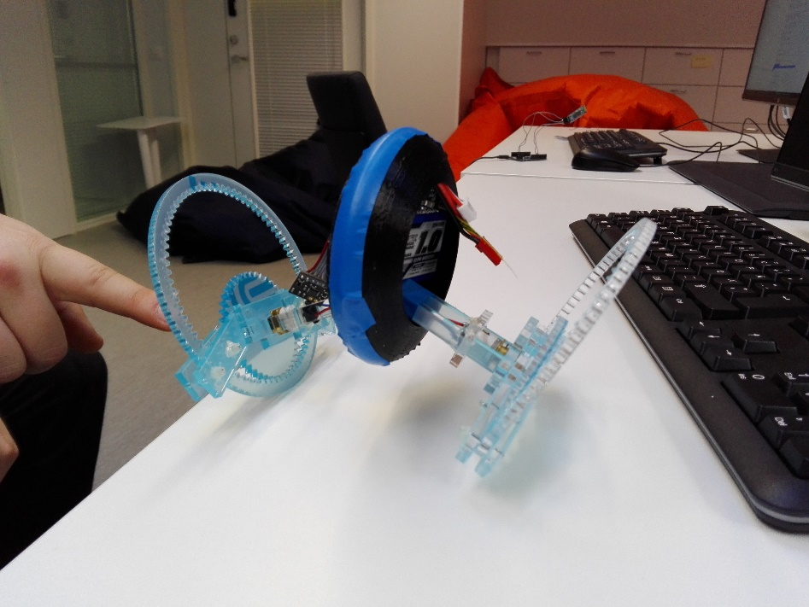

Parts assembled to test the fitting of design, not completed.

# Assemble

Excluding the body, the parts of the clock were cut with Epilog Laser Fusion laser cutter. Parts were drawn with FreeCAD and then exported to .pdf file. The body was printed from .stl file (FreeCAD) with Stratasys’s Fortus 380mc 3D-printer.

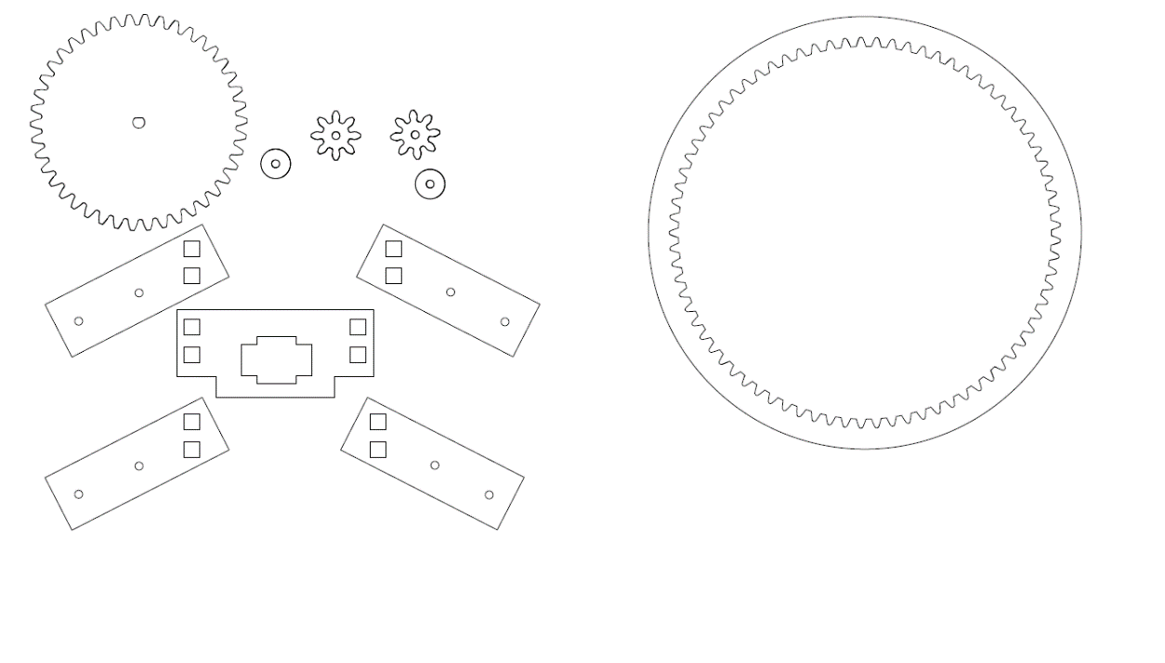

.pdf used to print wheels, power transmission and support structures.

Parts were connected together with hot- and super glue. Axis for smallest gears and rolls was created from nails. Square studs to hold the pieces together were also cut with laser cutter.

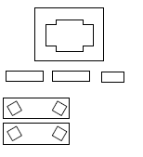

Studs for connections, middle support to hold tyres and motors frame.

# Conclusion

The ready model clearly fulfils criteria’s for prototype. Connection board used for wiring increased the total volume of electronics and therefore couldn’t fit inside of body.

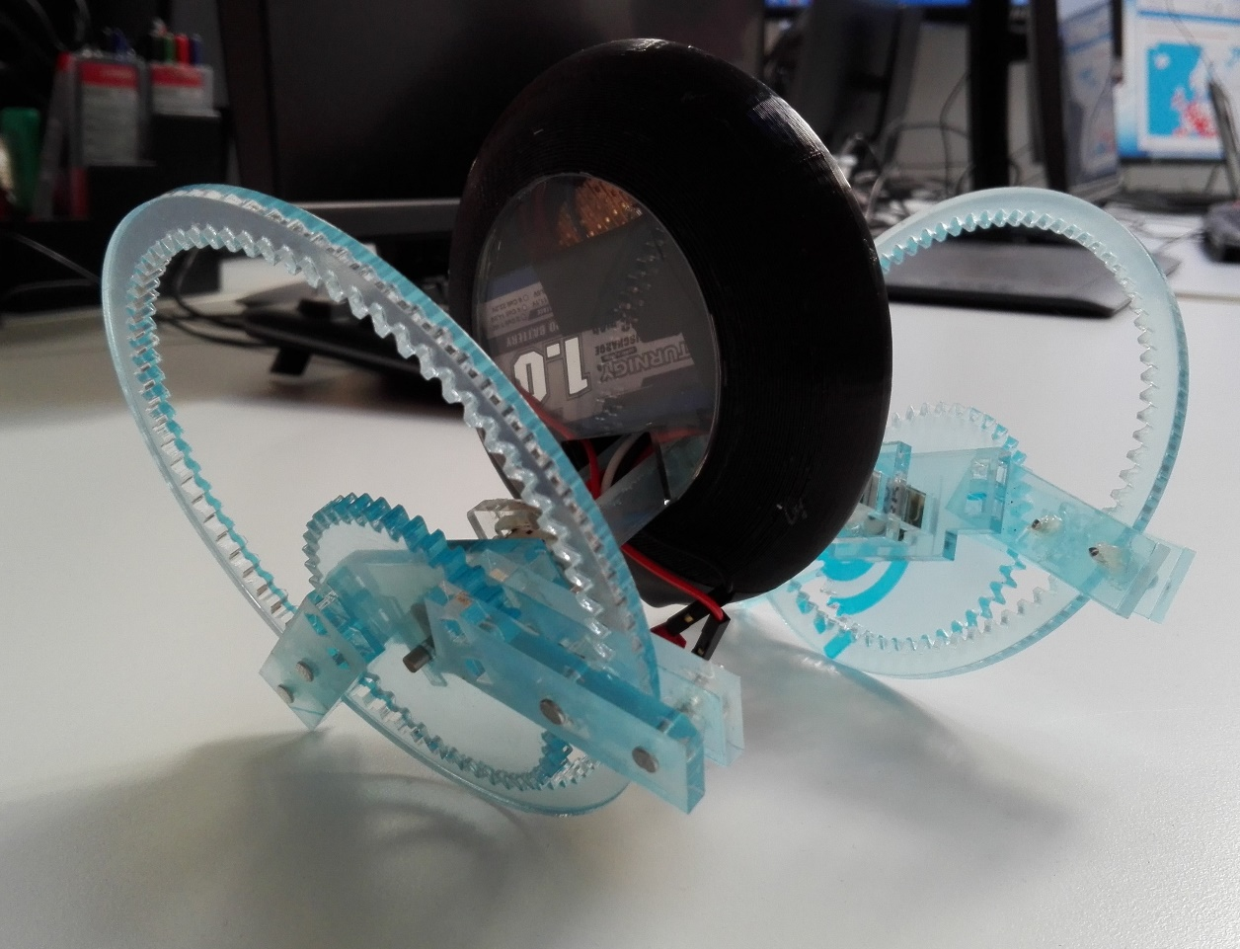

Ready clock with all parts in and code ready. Flattering side of it.

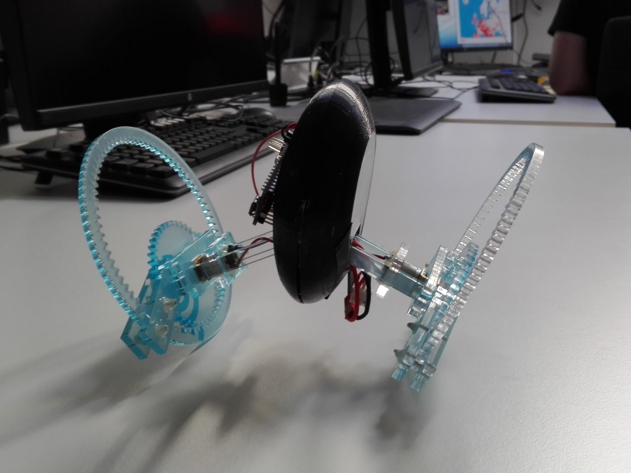

Ready clock with truthful view.