# One-way independent ANOVA

Compare 2 or more independent groups.

## Jet lag

Wright and Czeisler (2002) performed an experiment where they measured the circadian rhythm by the daily cycle of melatonin production in 22 subjects randomly assigned to one of three light treatments.

* Control condition (no light)
* Knees (3 hour light to back of knees)
* Eyes (3 hour light in eyes)

rm(list=ls())  
x.c = c( .53, .36, .2, -.37, -.6, -.64, -.68,-1.27) # Control   
x.k = c( .73, .31, .03, -.29, -.56, -.96,-1.61 ) # Knees  
x.e = c(-.78,-.86,-1.35,-1.48,-1.52,-2.04,-2.83 ) # Eyes  
x = c( x.c, x.k, x.e ) # Conditions combined

## Total variance

$${MS}_{total}=s_{x}^{2}$$

ms.t = var(x); ms.t

## [1] 0.7923732

sum( (x - mean(x))^2 ) / (length(x) - 1)

## [1] 0.7923732

$${SS}_{total}=s_{x}^{2}(N−1)$$

N = length(x)  
  
ss.t = var(x) * (N-1); ss.t

## [1] 16.63984

sum( (x - mean(x))^2 )

## [1] 16.63984

## Visual ${SS}_{total}$

# Assign labels  
lab = c("Control", "Knee", "Eyes")   
  
# Plot all data points  
plot(1:N,x,   
 ylab="Shift in circadian rhythm (h)",  
 xlab="Light treatment",  
 main="Total variance")  
  
# Add mean line  
lines(c(1,22),rep(mean(x),2),lwd=3)  
  
# Add delta lines / variance components  
segments(1:N, mean(x), 1:N, x)  
  
# Add labels  
text(c(4,11.5,18.5),rep(.6,3),labels=lab)

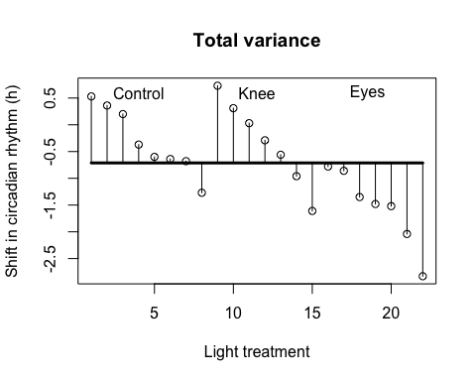

## Model variance

$${MS}_{model} = \frac{{SS}_{model}}{{df}_{model}} \\ {df}_{model} = k - 1$$

Where $k$ is the number of independent groups and



k = 3  
n.c = length(x.c)  
n.k = length(x.k)  
n.e = length(x.e)

ss.m.c = n.c * (mean(x.c) - mean(x))^2  
ss.m.k = n.k * (mean(x.k) - mean(x))^2  
ss.m.e = n.e * (mean(x.e) - mean(x))^2  
  
ss.m = sum(ss.m.c, ss.m.k, ss.m.e); ss.m

## [1] 7.224492

df.m = (k - 1)  
ms.m = ss.m / df.m; ms.m

## [1] 3.612246

## Visual ${SS}_{model}$

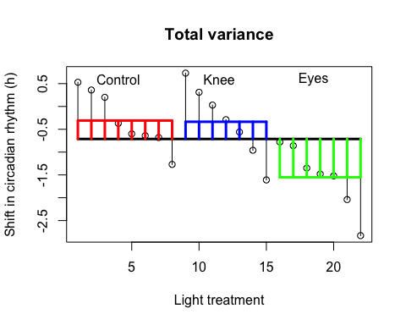

## Error variance

$${MS}_{error} = \frac{{SS}_{error}}{{df}_{error}} \\ {df}_{error} = N - k$$

where



ss.e.c = var(x.c) * (n.c - 1)  
ss.e.k = var(x.k) * (n.k - 1)  
ss.e.e = var(x.e) * (n.e - 1)  
  
ss.e = sum(ss.e.c, ss.e.k, ss.e.e); ss.e

## [1] 9.415345

$${MS}_{error} = \frac{{SS}_{error}}{{df}_{error}} \\ {df}_{error} = N - k$$

df.e = (N - k)  
ms.e = ss.e / df.e; ms.e

## [1] 0.4955445

## Visual ${SS}_{error}$

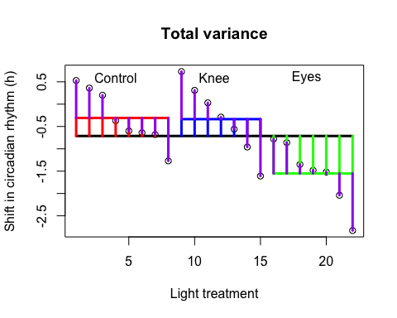

## Variance components

$${SS}_{total}={SS}_{model}+{SS}_{error}$$

$$16.6398364=7.2244917+9.4153446$$

$${MS}_{total}=\frac{{SS}_{total}}{{df}_{total}}=0.7923732$$

$${MS}_{model}=\frac{{SS}_{model}}{{df}_{model}}=3.6122459$$

$${MS}_{error}=\frac{{SS}_{error}}{{df}_{error}}=0.4955445$$

## F-ratio

$$F=\frac{{MS}_{model}}{{MS}_{error}}=\frac{SIGNAL}{NOISE}$$

F = ms.m / ms.e; F

## [1] 7.289449

## Reject $H_{0}$?

if(!"visualize" %in% installed.packages()) { install.packages("visualize") }  
library("visualize")  
  
visualize.f(F, df.m,df.e,section="upper")

