One-way independent ANOVA
Compare 2 or more independent groups.

Jet lag
Wright and Czeisler (2002) performed an experiment where they measured the circadian rhythm by the daily cycle of melatonin production in 22 subjects randomly assigned to one of three light treatments.
- Control condition (no light)
- Knees (3 hour light to back of knees)
- Eyes (3 hour light in eyes)
rm(list=ls())
x.c = c( .53, .36, .2, -.37, -.6, -.64, -.68,-1.27) # Control
x.k = c( .73, .31, .03, -.29, -.56, -.96,-1.61 ) # Knees
x.e = c(-.78,-.86,-1.35,-1.48,-1.52,-2.04,-2.83 ) # Eyes
x = c( x.c, x.k, x.e ) # Conditions combined

Total variance
$${MS}_{total}=s_{x}^{2}$$
ms.t = var(x); ms.t
## [1] 0.7923732
sum( (x - mean(x))^2 ) / (length(x) - 1)
## [1] 0.7923732

$${SS}_{total}=s_{x}^{2}(N−1)$$
N = length(x)
ss.t = var(x) * (N-1); ss.t
## [1] 16.63984
sum( (x - mean(x))^2 )
## [1] 16.63984

Visual ${SS}_{total}$
# Assign labels
lab = c("Control", "Knee", "Eyes")
# Plot all data points
plot(1:N,x,
ylab="Shift in circadian rhythm (h)",
xlab="Light treatment",
main="Total variance")
# Add mean line
lines(c(1,22),rep(mean(x),2),lwd=3)
# Add delta lines / variance components
segments(1:N, mean(x), 1:N, x)
# Add labels
text(c(4,11.5,18.5),rep(.6,3),labels=lab)
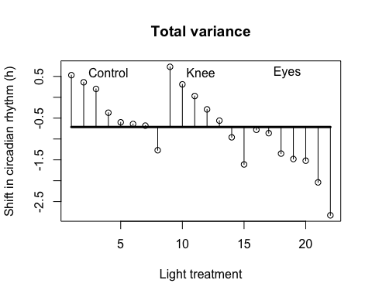

Model variance
$${MS}_{model} = \frac{{SS}_{model}}{{df}_{model}} \\ {df}_{model} = k - 1$$
Where $k$ is the number of independent groups and
SSmodel=nkk(Xk−X)2
k = 3
n.c = length(x.c)
n.k = length(x.k)
n.e = length(x.e)

ss.m.c = n.c * (mean(x.c) - mean(x))^2
ss.m.k = n.k * (mean(x.k) - mean(x))^2
ss.m.e = n.e * (mean(x.e) - mean(x))^2
ss.m = sum(ss.m.c, ss.m.k, ss.m.e); ss.m
## [1] 7.224492
df.m = (k - 1)
ms.m = ss.m / df.m; ms.m
## [1] 3.612246

Visual ${SS}_{model}$
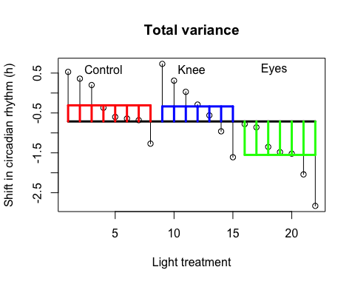

Error variance
$${MS}_{error} = \frac{{SS}_{error}}{{df}_{error}} \\ {df}_{error} = N - k$$
where
SSerror=sk2k(nk−1)=∑(xik−xk)2(nk−1)k(nk−1)
ss.e.c = var(x.c) * (n.c - 1)
ss.e.k = var(x.k) * (n.k - 1)
ss.e.e = var(x.e) * (n.e - 1)
ss.e = sum(ss.e.c, ss.e.k, ss.e.e); ss.e
## [1] 9.415345

$${MS}_{error} = \frac{{SS}_{error}}{{df}_{error}} \\ {df}_{error} = N - k$$
df.e = (N - k)
ms.e = ss.e / df.e; ms.e
## [1] 0.4955445

Visual ${SS}_{error}$
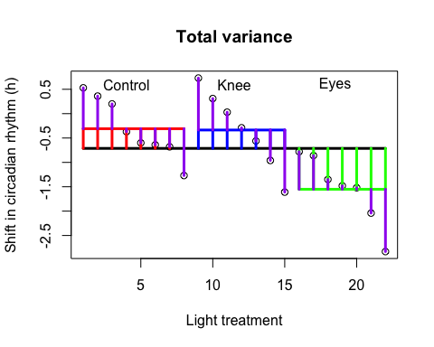

Variance components
$${SS}_{total}={SS}_{model}+{SS}_{error}$$
$$16.6398364=7.2244917+9.4153446$$
$${MS}_{total}=\frac{{SS}_{total}}{{df}_{total}}=0.7923732$$
$${MS}_{model}=\frac{{SS}_{model}}{{df}_{model}}=3.6122459$$
$${MS}_{error}=\frac{{SS}_{error}}{{df}_{error}}=0.4955445$$

F-ratio
$$F=\frac{{MS}_{model}}{{MS}_{error}}=\frac{SIGNAL}{NOISE}$$
F = ms.m / ms.e; F
## [1] 7.289449

Reject $H_{0}$?
if(!"visualize" %in% installed.packages()) { install.packages("visualize") }
library("visualize")
visualize.f(F, df.m,df.e,section="upper")
