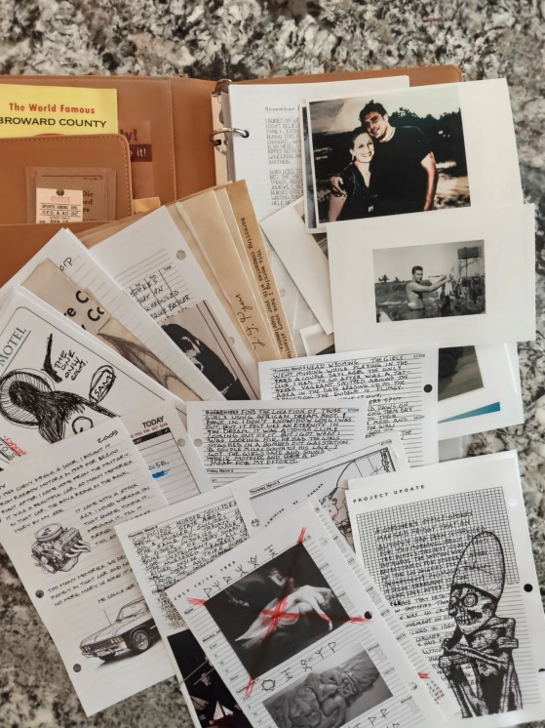
Henry/John Winchester Journal

This is the Supernatural John Winchester Replica Journal by ConQuest journals. I’ve taken this journal and added many new custom pages to make it more authentic.

Available in digital PDF form for 30 days here: https://github.com/JohnnyElectronic/Journal

This journal does not have the military metals but they can be acquired from Conquest Journals
https://conquestjournal.com/products/john-winchester-journal-medals-and-ribbons-pack

or the following Military supply sources
http://www.medalsofamerica.com/medals-and-ribbons/army-medals-and-ribbons/army-ribbons

https://aviation-museum-gift-shop.myshopify.com/products/army-aviation-flight-school-logo-lapel-pin

You will need:
Bronze Star Ribbon Mil-thin
Purple Heart Ribbon
Marine Corps Good Conduct
Vietnam Service Ribbon
+ USMC Rifle Expert Medal and US Army Aviation School Fort Rucker Pin

Page ordering:
The page ordering is as close as possible to that of the TV series. However the full ordering is difficult to determine.

News articles:
I added a number of news article pages which I think are more authentic that those included by conquest. The news print will age naturally over time. If you want to speed up the process place them in sunlight for a few hours.

Repetitive Story lines;
Through out the journal there are two stories that repeat regularly. These are The coroners report on the actors death and the In olden times in the West people used to say “I put my
hand and seal” on a document when signing it…

I have left a few of these pages blank so you can decide to add your own details or you can add the appropriate repeat story. For the coroners report on the actors death I created a longer version of the story that extended three pages so it can be read as you change the pages.

All the black and white creature pages have been left blank for this reason. The table below will list the story used in the TV series for the various pages.

Page | description
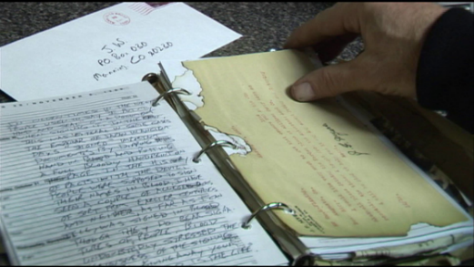 | October 29/November 4 1990 page  - Paired next to burner letter page (J.F. Myers)  - In olden times story
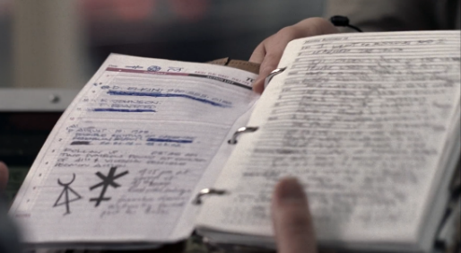 | November 16, 1983  - Paired with Dead mans blood page, Elkins.  - In olden times story with “I went to Missouri and I  - learned the truth” at the top.  - Also used as the first page of the journal.
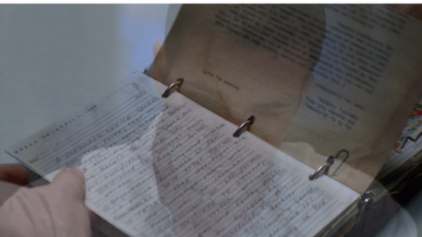 | March 26 / April 1, 1990  - Placed before the letter with 1246 A + 4 on bottom  - Coroner’s office story
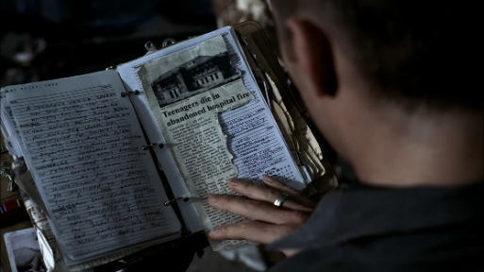 | May 21/27, 1990 page  - Paired with Asylum page  - Coroner’s office story
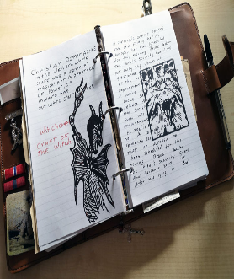   | Lion  - Ruled page  - Coroner’s office story  - Paired with Witchcraft page
 | Amphiptere  - July 30/August 5, 1990 Calendar page  - Coroner’s office story  - Unknown placement
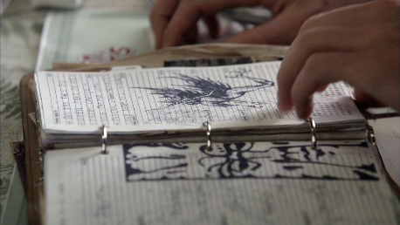 | Tiki head  - August 13/19, 1990 Calendar page  - Paired with roll the dice page  - Unknown text  - Jump the shark episode
 | Two legged dragon  - Project planner page  - Coroner’s office story  - Unknown placement
 | Dragon head  - Project planner page  - Coroner’s office story  - Unknown placement
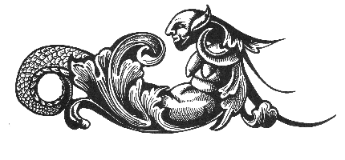  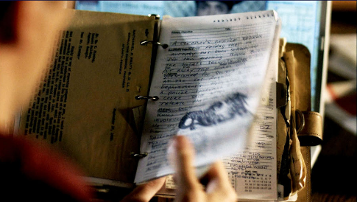  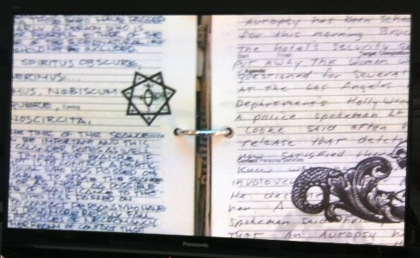 | Griffin  - Project planner page  - Coroner’s office story  - Paired with either old letter (Pratt/Fleming 1246 letter) or séance page
 | African mask  - Project Update Page  - Coroner’s office story  - Unknown placement

TV Series Stories
- Format and spelling issues are as represented in the TV series.

Coroners Office Report/Actor Death
Actor Death – Original / Part 1
A coroner’s office spokes
man said Friday that an
autopsy has been scheduled
for this morning. Bruce Beckler
the hotel’s Security guard and
put away. The woman was
questioned for several hours
at the Los Angeles Police
Department’s Hollywood division.
A police spokesman Lt Dan
Cooke said after her
release that detectives are
now satisfied there was
know was no criminal
involovement on her part.
He declined to identify
her. A coroner office
spokeman said Friday night
that an autopsy has
been scheduled for this
morning. Bruce Beckler
The Hotel security guard
and gardener said the
Actor was lying in Bed.

Extended Version for Multiple pages:
Actor Death – Part 2
The actor was lying in bed
when Beckler entered the room
shortly after noon, according to
investigators. The curtains had
been drawn and several
prescription bottles were found
on a nearby table. Police officers
said there were no signs of forced
entry or struggle inside the hotel
suite. Friends of the actor told
reporters he had appeared tired
and withdrawn during the last
several days but had continued
meeting with studio executives
and visitors at the hotel.

Detectives said they expect to
interview additional witnesses
during the weekend. Results of
the autopsy is expected sometime
next week. Until then, officials
urged the public to avoid speculation
surrounding the circumstances of
the death.

Actor Death – Part 3
Outside the hotel, dozens of
reporters and curious onlookers
gathered through the evening
as news of the death spread
across Hollywood. Hotel guests
were escorted through side
entrances while detectives
continued questioning employees
and reviewing records from the
night before.

Several close friends arrived
at the coroner’s office late
Friday but declined to comment
To waiting reporters.

Authorities said toxicology tests
may take several days to
complete and cautioned that no
official cause of death would be
released until the examination had
been finished. “At this point we
are treating the matter as an
unexplained death,” Lt. Cooke
told reporters. “We have found
no evidence of foul play, but we
intend to complete a full
investigation before reaching
any conclusions.”

Actor Death – Part 4
Studio representatives issued a
brief statement expressing shock
at the actor’s death and extending
condolences to family members. Fans
gathered outside the hotel overnight,
leaving flowers, candles and
handwritten notes near the
entrance. Radio stations interrupted
regular programming to report
developments in the case, while several
television networks prepared special
broadcasts reviewing the actor’s
long career in films and television.

Neighbors and longtime friends
Described the actor as talented
but deeply private. One associate
said he had struggled with exhaustion
in recent months and had been under
considerable pressure while preparing
for a new project. Another friend
insisted the actor had remained
optimistic about the future and had
recently spoken about taking a long
vacation once filming commitments
were completed.

Blood Pact
If first page, add these two lines first:
I went to Missouri and I
learned the truth

In olden times in the West
people used to say “I put my
hand and seal” on a document
when signing it. In the East
this was literal in some cases.
The emperor of Japan in ancient
days “signed” important
documents by dipping his
hand in blood and putting
a full bloody handprint on
the page. In the history
of pacts with the Devil,
people were supposed to sign
their names in blood. I have
seen a couple of alleged pacts
of sort from earlier centuries
and neither, as far as I can
tell, was signed in blood
though they do bear signa
tures of people. Blood
undoubtedly stressed the
seriousness of the signing.
You were giving away your
soul. “The Blood Is the Life.”

