Major Assignment

# Major Functions

|  |  |
| --- | --- |
| **Signature** | **Description** |
| Table loadData(String url) | Load a CSV file from the data URL. This used the [loadTable](https://processing.org/reference/loadTable_.html) processing function. |
| void cleanData(Table data) | Encode the resource columns with 1 for has resource, 0 otherwise. |
| Table getResourceSummary(Table data) | Returns a data table with the following resources separated by zombie and human:  Clothing, Documents, Firstaid, Food, Medication, Sanitation, Tools, Water |
| Table getAgeBins(Table data) | Separated between Zombie and Human, get the age data bins in increments of 20 years between 0 and 100 inclusive. |
| Table getAgeSummary(Table data)  *Mean, Min, Max, Standard Deviation* | Calculate the descriptive statistics for the age column split into zombies and humans. |

# Data Source

* [Kaggle Dataset: Zombies Apocalypse](https://www.kaggle.com/kingabzpro/zombies-apocalypse)
* <https://pastebin.pl/view/raw/34f079e0>

# Mock Up

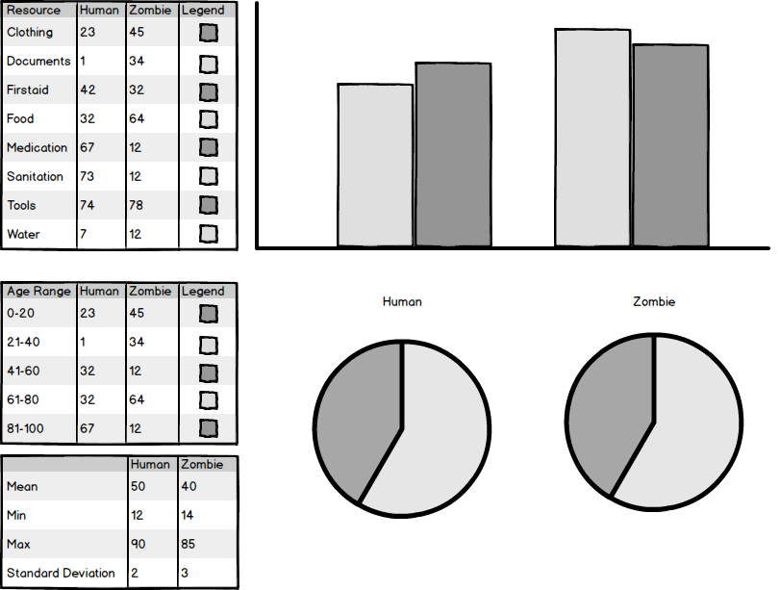

# Colour Scheme & General Design

