# Pseudo Code

Load Data

Sanitise Data

Calculate Average Rainfall

Calculate Median

Calculate the Standard Deviation

Calculate the Mode

Output Results

# Major Functions

|  |  |
| --- | --- |
| **Signature** | **Description** |
| float[] loadData(String input) | Parse the input string and return a float array. |
| JSONArray sanatiseData(JSONArray data) | Remove data points equal to zero and return the new dataset as an ArrayList. |
| float mean(JSONArray data) | Calculate the mean for the datapoints. |
| JSONArray median(JSONArray data) | The median is the value or values that separate the higher half of the values from the lower half. This could be one or two values, and your function should be able to handle both (as this function could be used with different data sets).  <https://processing.org/reference/sort_.html> |
| float standardDeviation(JSONArray data) | The equation for finding the standard deviation of a set is:  The equation for finding the standard deviation  The equation for finding the standard deviation  The equation for calculating standard deviation requires the mean. You should call your mean function and store the result inside this function - you should not calculate the mean again.  It’s easier to do this in parts (and you can separate this into two parts) finding the summation, and then calculating the square root.  To find the sum, you need to iterate through your data, and sum the square of the data value minus the mean. To calculate the square root, use the sqrt function on the sum divided by the number of data values. |
| JSONArray mode(JSONArray data) | The mode is the most frequently occurring number. Like the median, the mode can also be multiple numbers. |

## Mock Up

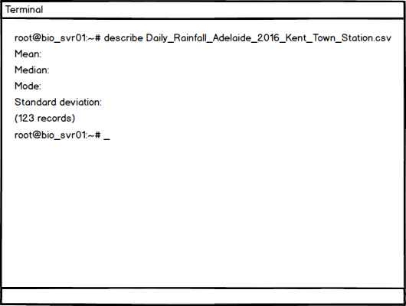

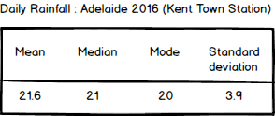

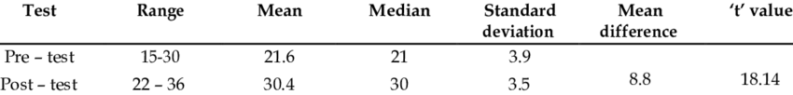

# Colour Scheme

