Worked Problem 03

# Major Functions

|  |  |
| --- | --- |
| **Signature** | **Description** |
|  |  |

# Test Data

|  |
| --- |
| 7.2,7.5,7.6,7.5,7.5,7.4,7.1,7.0,7.0,6.9,6.9,7.1,7.2,7.3,7.1,7.1,7.0,7.2,7.3,7.3  7.4,7.4,7.5,7.3,7.6,7.5,7.5,7.4,7.3,7.3,7.2,7.4,7.5,7.5,7.5,7.4,7.2,7.3,7.5,7.6  7.4,7.5,7.5,7.6,7.6,7.5,7.4,7.5,7.8,7.5,7.5,7.6,7.8,7.8,7.4,7.8,7.9,7.4,7.5,7.5 |

# Colour Scheme

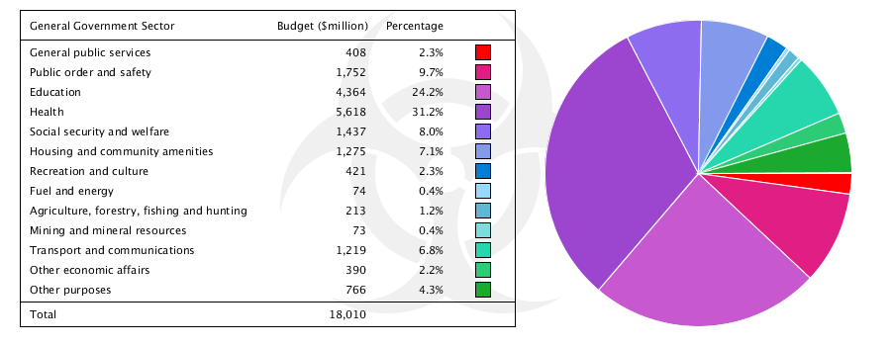

# Mock Up

**Requirement:** Your visualisation can scale with the size of the canvas and with any data values. 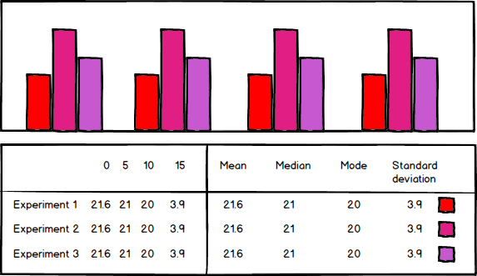

# Other Designs

