# Overview

The scene rendered by the ray tracer shows a room with two boxes and 6 spheres. A piece of artwork showing a house on a hill is displayed on the back wall of the room. One of the spheres shows refractivity, another transparency, a procedurally generated pattern, and a globe texture. The scene is lit by a single spotlight pointing towards the box from above the camera.

The scene out of the box is rendered at a resolution of 900x900 on a window of the same size in pixels with anti-aliasing enabled.

# How to run

Extract the contents of the project and open the extracted folder such that the file “run_csse_lab” is visible.

**Linux mint (Lab computers)**

Running the bash script “run_csse_lab” will build and run the ray tracer.

## Render Time Estimate

The render time of the scene depends on many factors. On the primary development machine running windows 10, a rendering a scene containing 24 distinct objects at 900x900 resolution with anti-aliasing enabled takes 7 minutes. However, the lab computers at UC with the method explained above this process takes closer to 30 seconds.

# Features

## Refraction

The scene objects all can refract light. This is best shown through the sphere in the centre of the scene. The refraction coefficient and index of the object can be modified. It is assumed that the scene is filled with air, a refractive index of 1.

|  |  |  |
| --- | --- | --- |
| Refractive index = 1.3 (Water)  Refraction coefficient = 0.9 | Refractive Index = 1.5 (Glass)  Refraction coefficient = 0.9 | Refractive index = 1.3 (Water)  Refraction coefficient = 0.9 |
|  |  |  |

Each scene object knows about its own refraction index and coefficient (and whether it is enabled or not). The grunt work of the refraction is done in the scenes’ trace method.

## Spotlight

The main scene light is a spotlight. The light properties are properties of the scene; this includes its position, direction and spread angle.

|  |  |  |
| --- | --- | --- |
| Light above camera  Pointing below sphere  Spread angle = 0.3 radians | Light above camera  Pointing at sphere  Spread angle = 0.3 radians | Light above camera  Pointing below sphere  Spread angle = 0.1 radians |
|  |  |  |

## Anti-Aliasing

Anti-aliasing helps minimise the jaggedness of images to create a more convincing image. The ray tracer has anti-aliasing capabilities. It is implemented in the window draw method. When enabled, the window will use 4 rays (from the corners of each pixel) to find an average colour value for the pixel (Super sample anti-aliasing).

|  |  |  |  |
| --- | --- | --- | --- |
| Anti-aliasing disabled  Full scene view | Anti-aliasing enabled  Full Scene view | Anti-aliasing disabled  Close up | Anti-aliasing enabled  Close up |
|  |  |  |  |

## Non-Planar Texture

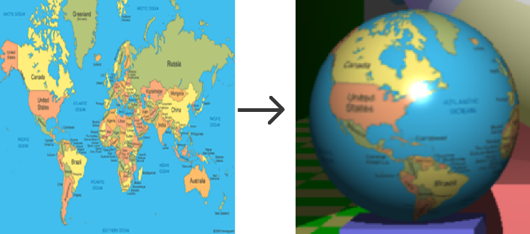On the left of the scene, a sphere is textured to look like a globe. To map a 3D scene coordinate to a 2D texture coordinate, the normal vector at the original 3D coordinate is computed. Using the normal vector, the polar and azimuthal angles can be found (3D sphere coordinates), these coordinates are then normalized to be between 0 and 1. These values are the texture coordinates.

Image source: geology.com

## Procedural Pattern

There are 3 procedural patterns present in the scene. The left and right walls, whose colour components are proportional to the coordinate (red, green, and blue proportional to x, y, and z respectfully). The more complex is the sphere closest to the camera.

The colour RGB values at any point on the sphere can be given by the following. Note: the position is relative to the scene, not the sphere itself.

Red:

Green:

Blue: 1

This results in distorted rings around the sphere, giving it the appearance of a classic bouncy ball.