

Zhixiang Hu

Tech space | 941 progress ave. toronto. centennial college

document of web site tech space by zhixiang hu

Table of Contents

**1.** **Briefing** 2

**2.** **Navigate Bar** 2

**3.** **Colour** 2

**4.** **Typography** 3

**5.** **Wireframes** 4

**6.** **Branding** 5

7. Github Link 6

1. **Briefing**

This a personal web site to demonstrate html, css and javascript technology in web development. Runnable samples are included.

1. **Navigate Bar**

Three status of Navigate Bar:

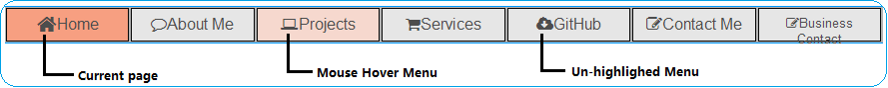

1. **Colour**

List of colors

|  |  |  |  |
| --- | --- | --- | --- |
| Item Name | Color | Css element name | Color code |
| Header back ground |  | #header | # 0099FF |
| Navigate bar back ground color |  | #topnav | #B3B3B3 |
| Unactive menu back ground color |  | .m_normal | #E6E6E6 |
| Hover Menu back ground color |  | #topnav my_menu a:hover | #F6D8CE |
| Current Menu back ground color |  | .m_active | #F79F81 |
| Body back ground color |  | #mainbox | #F6D8CE |
| Look at my works back ground color |  | #next a | #F7BE81 |
| Look at my works for color |  | #next a | #DF3A01 |
| Projects item highlight back ground color |  | .demo_link | #BCF5A9 |
|  |  |  |  |

1. **Typography**

Screen and font size

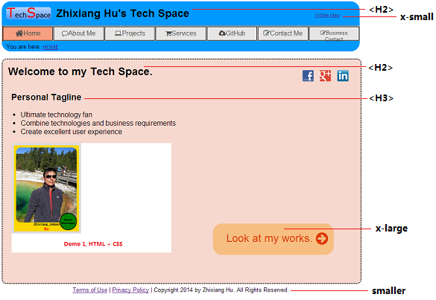

1. **Wireframes**

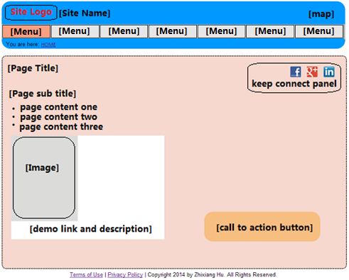

1. **Branding**

Screen of site template

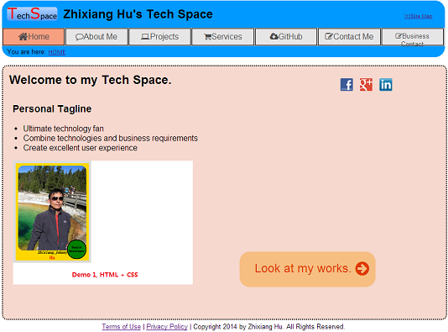

Logo color

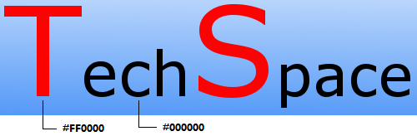

1. **Github Link**

<https://github.com/JohnnyHu9/CC_W14>