**Your Online Database Architecture for Education (YODAE)**

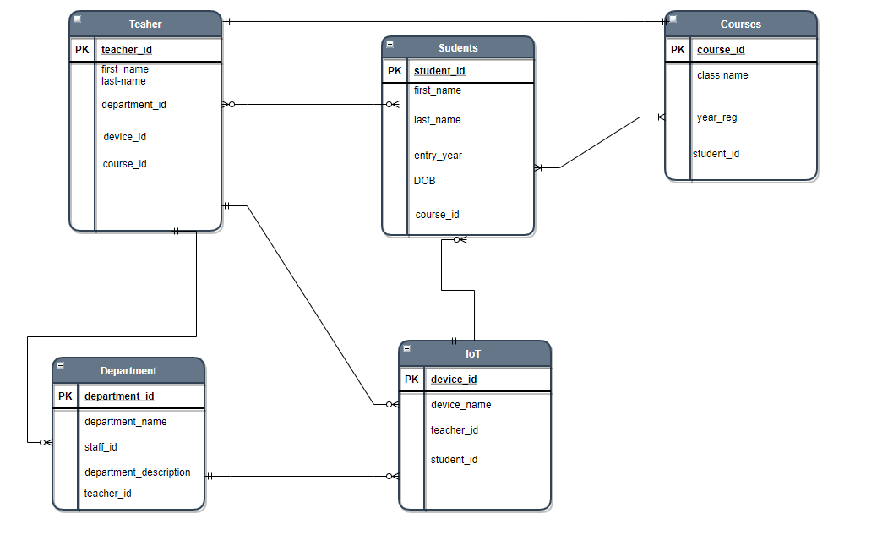

**Set Up Virtual Server: This is to show that I created the EC2 instance on AWS.**

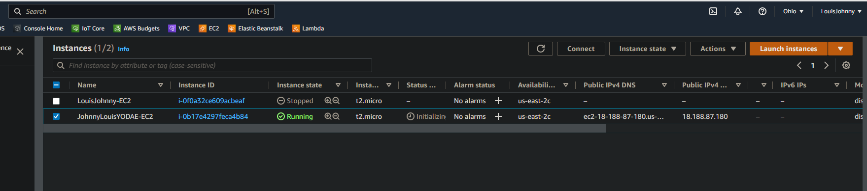

**Php: Showing the PHP – v 7.2 installed on the instance**

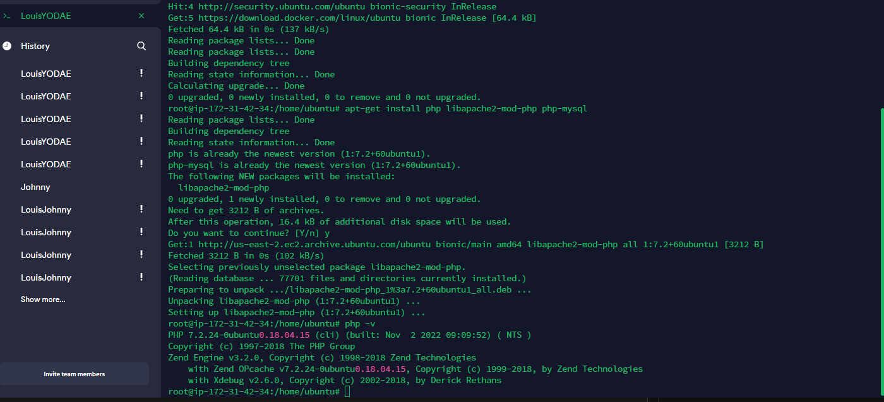

**Showing PHP extensions installed successfully on the EC2 instance.**

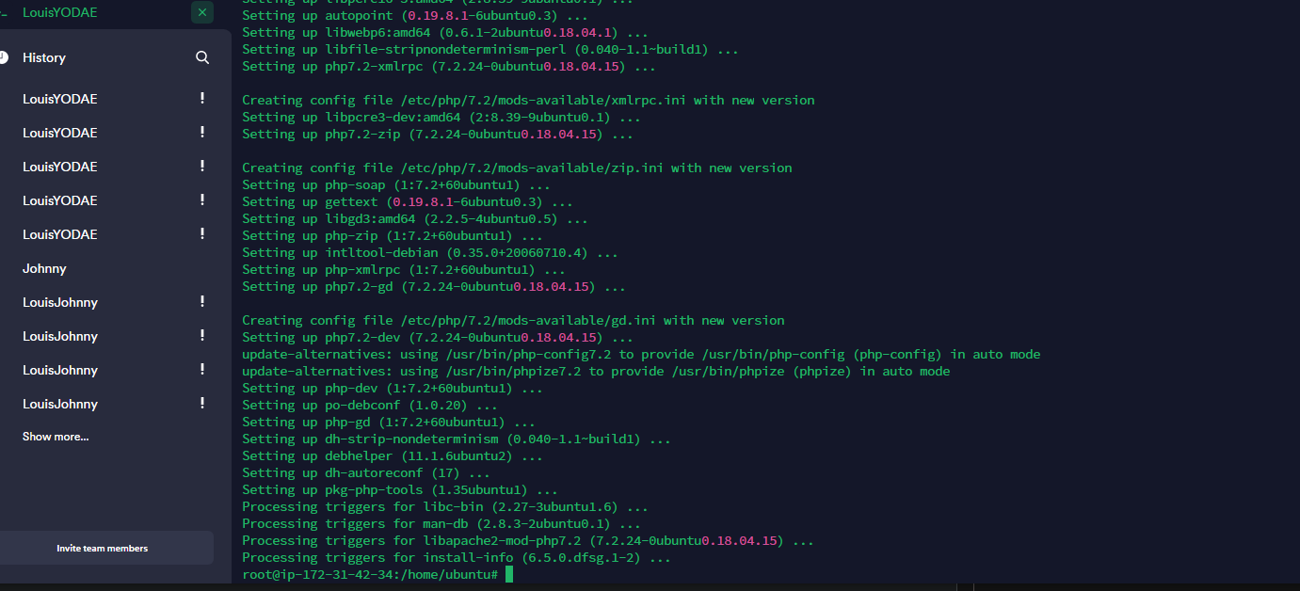

**MySQL: This is to show that MySQL-Server was successfully installed and we’re now at the Database on AWS server.**

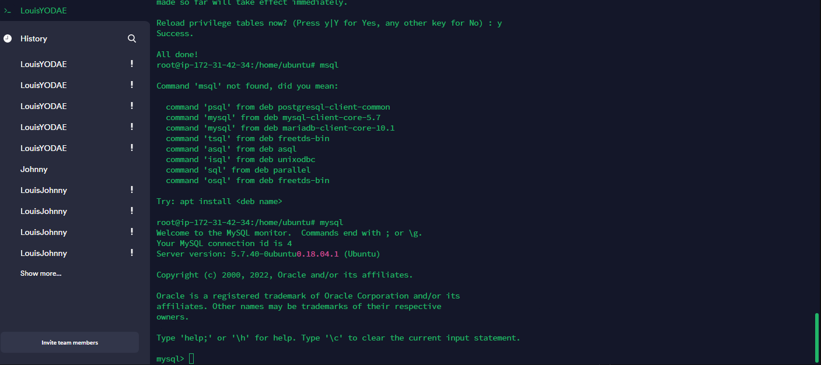

**WordpressDB was successful created**

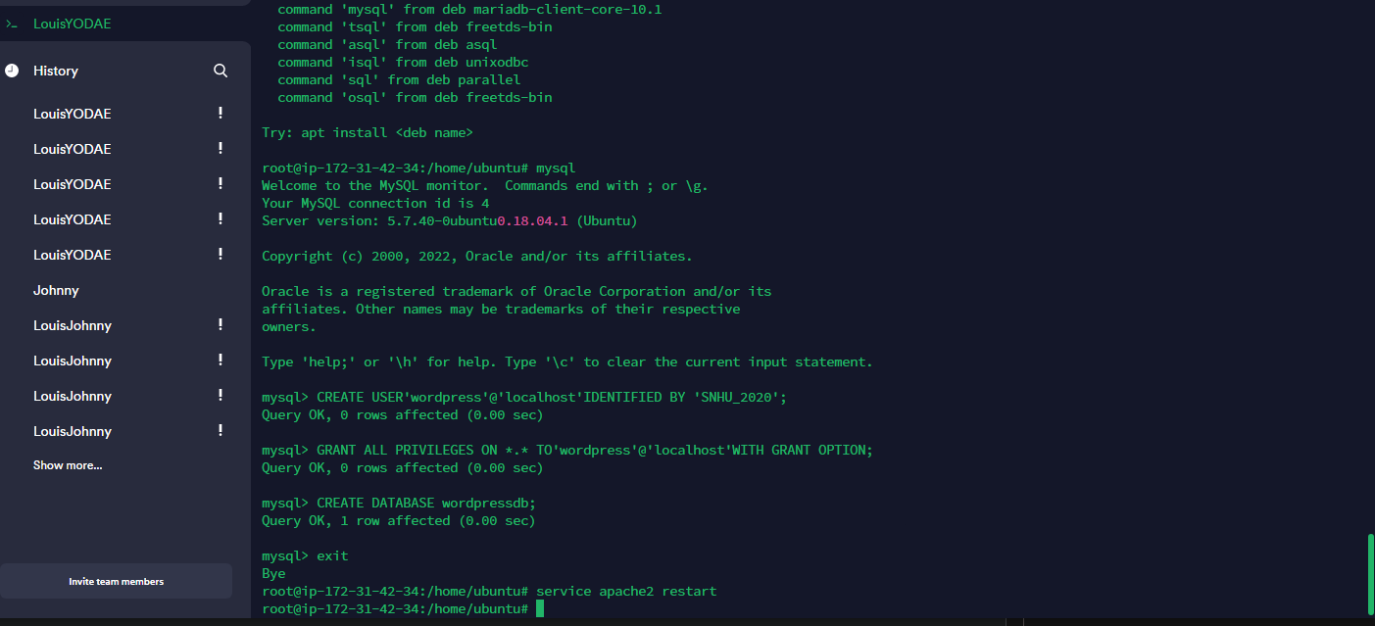

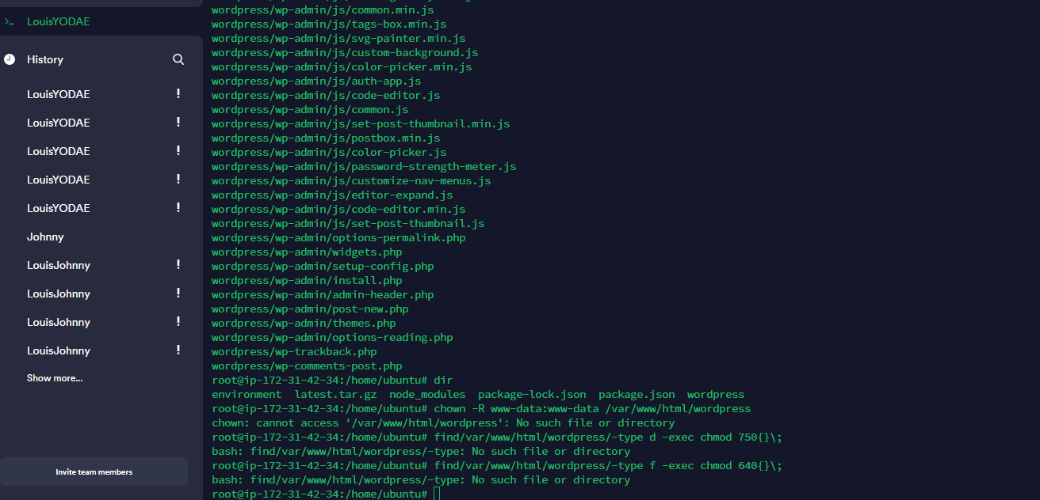

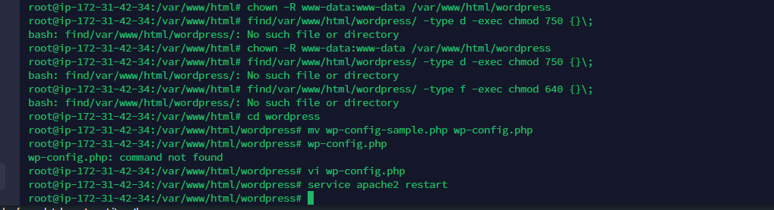

**There it shows the Database was configured.**

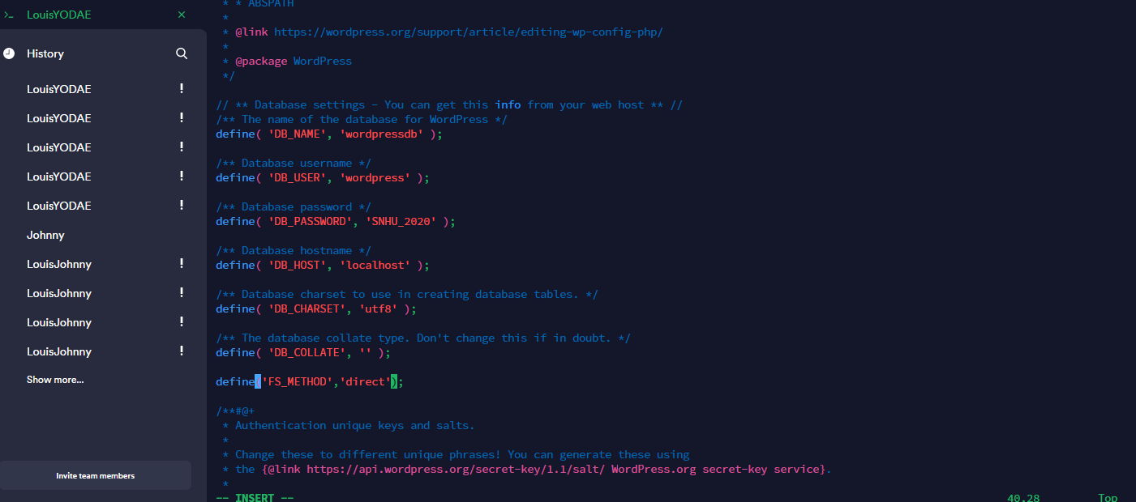

**Error even when port 80 IPv4 and IPv6 configured.**

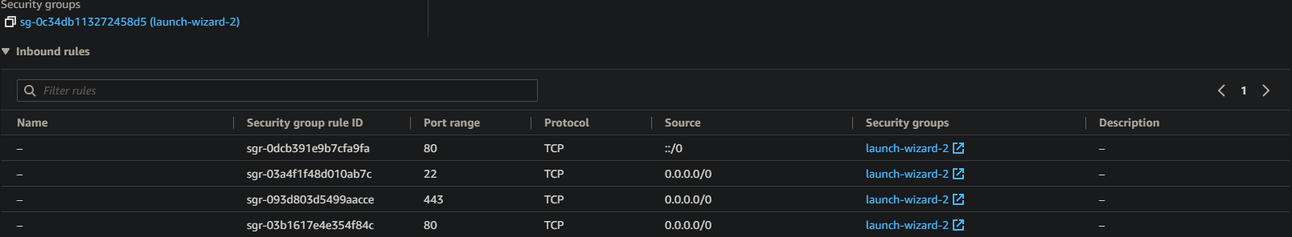

**WordPress: This to show that I was successfully WordPress on my server.**



**Logging to the WordPress site successfully**

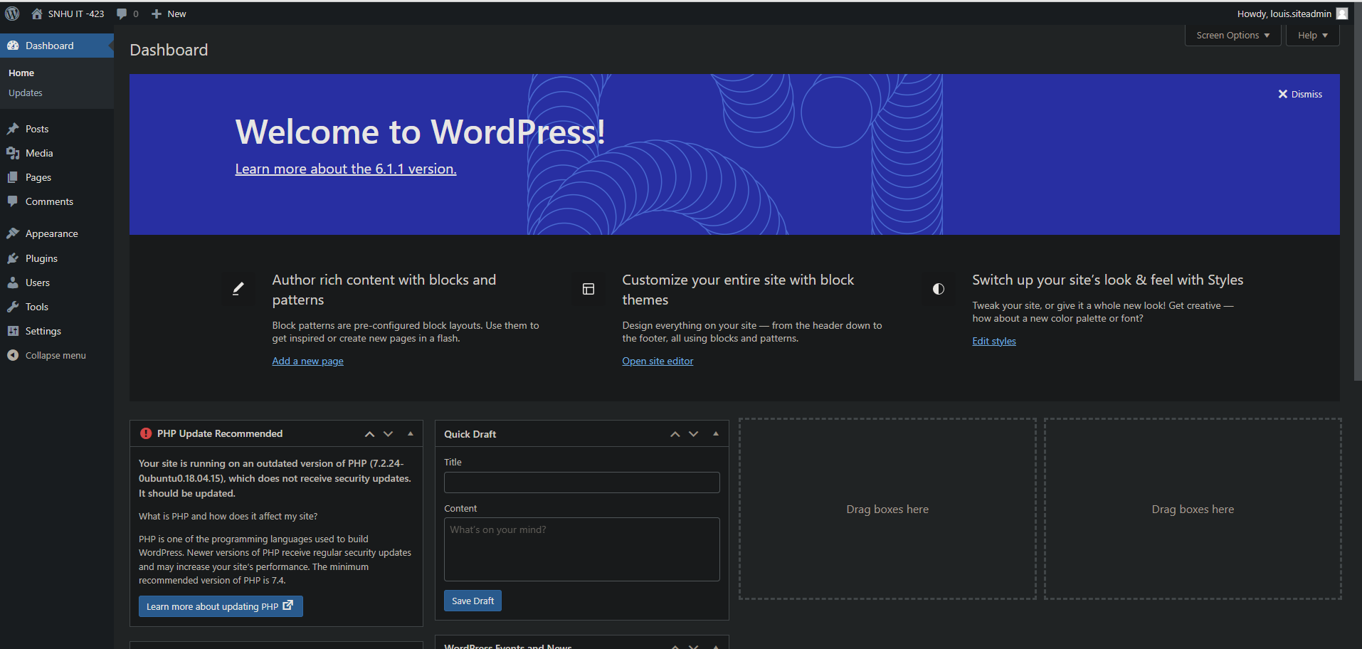

**Entity Relationship Diagram (ERD): This screenshot below is to show that phpMyAdmin has successfully been connected to ERD Database diagram.**

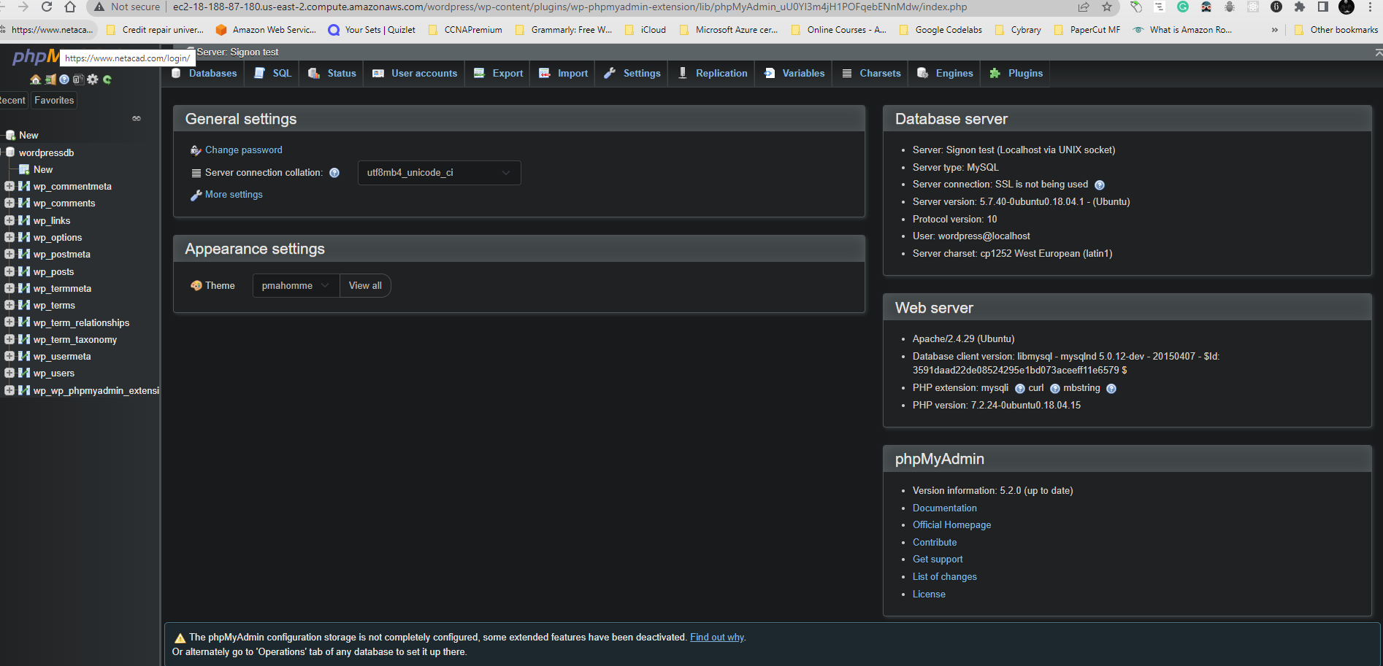

**Tables:**

**The student’s table was successfully created.**

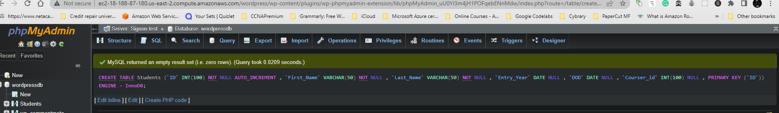

**SELECT * FROM Students;**

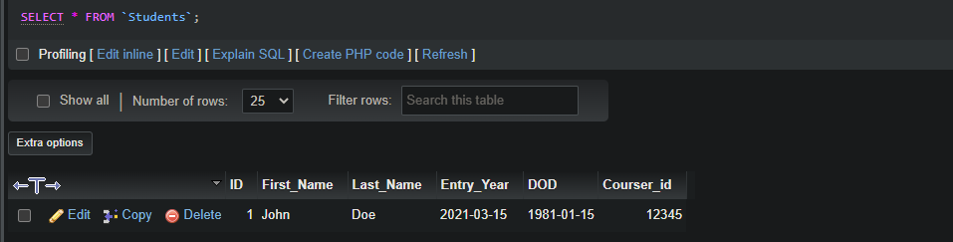

**The table Teacher was successfully created.**

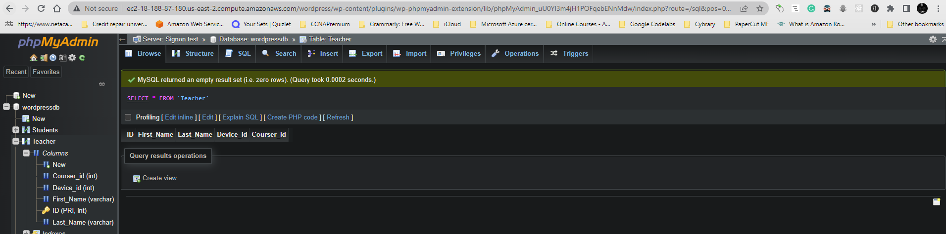

**SELECT * FROM Teacher;**

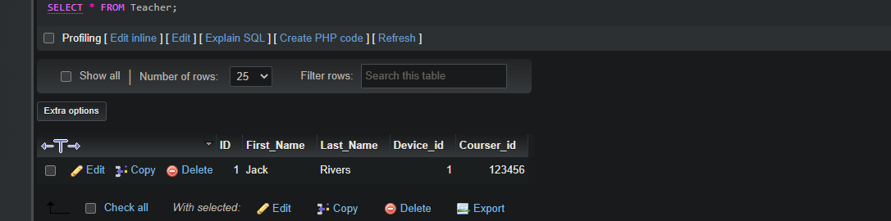

**Department table was successfully created.**

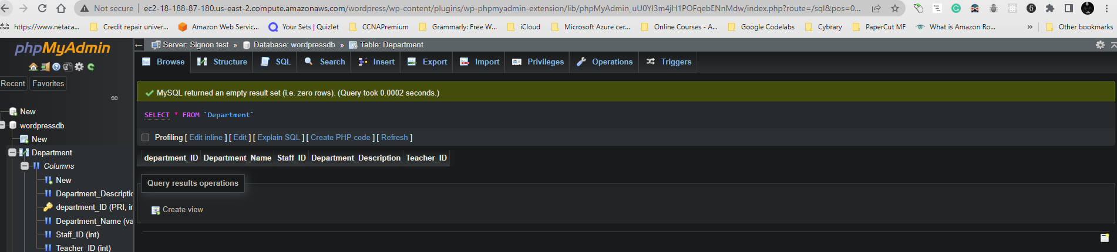

**SELECT * FROM Department;**

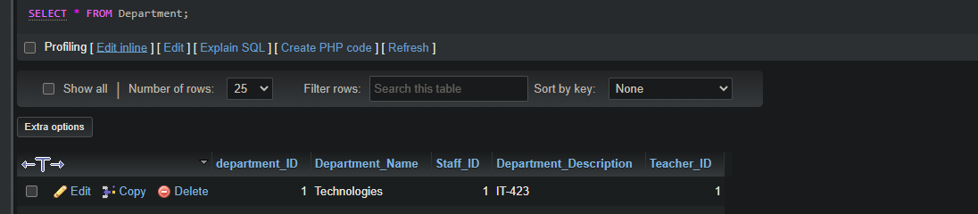

**Courses table was successfully created.**

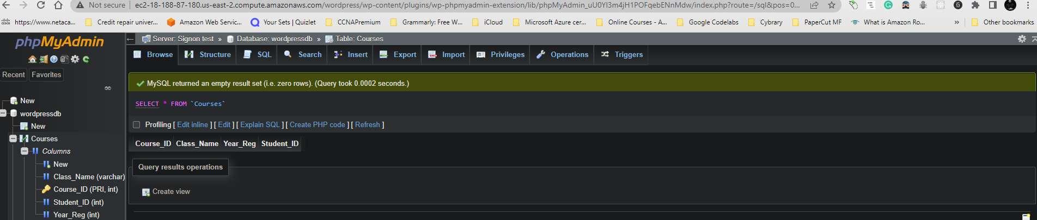

**SELECT * FROM Courses;**

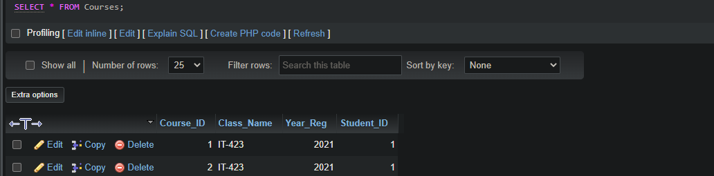

**Table IoT was successfully created.**

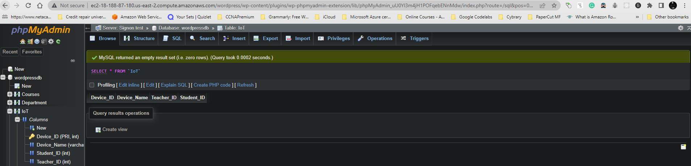

**SELECT * FROM IoT;**

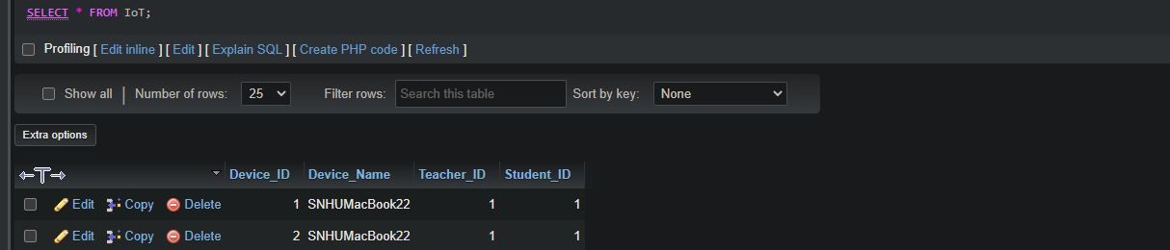

**Add Student Page: This is to show that I was successfully created the student adding page and viewing it on the web after published.**

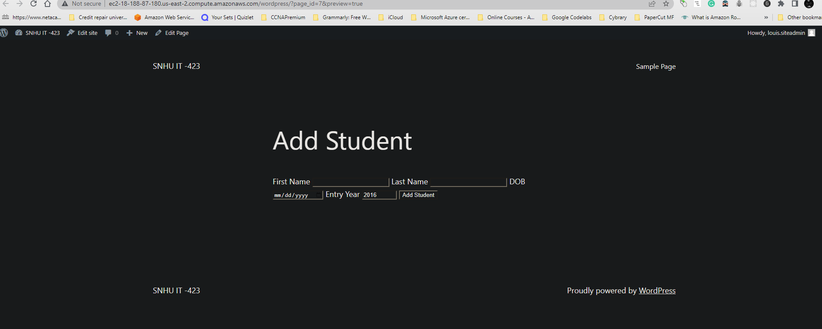

**View Students Page: This is to show that the View Students page was successfully added.**

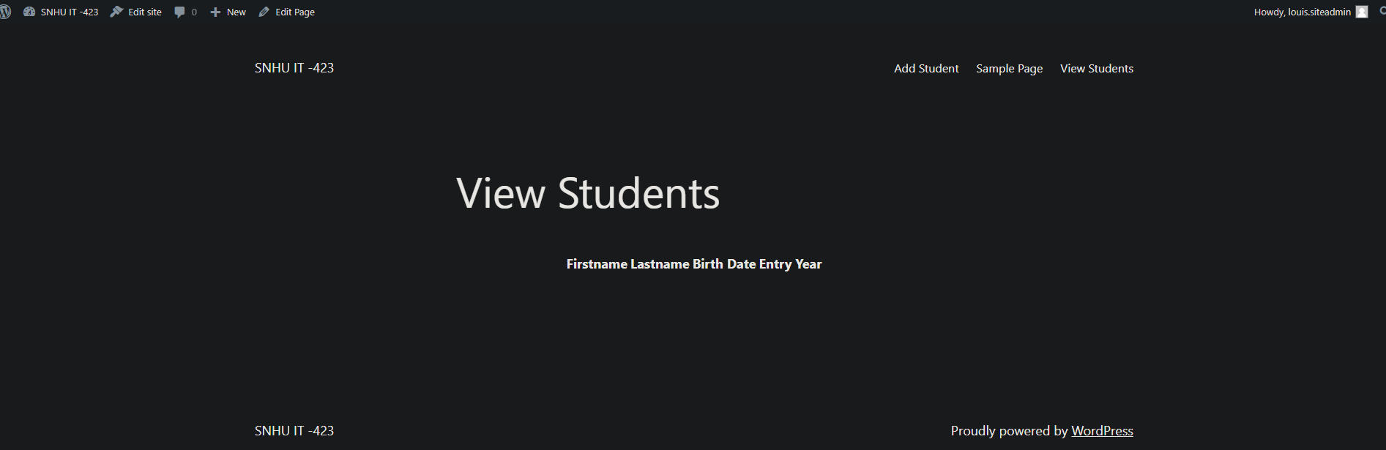

**Error: Received this error when copy and paste the function code.**

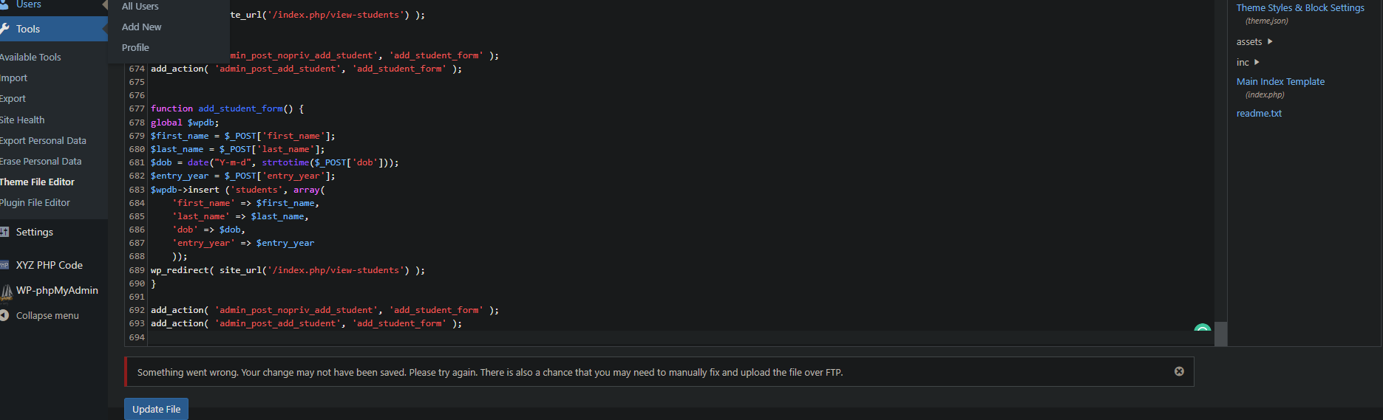

**Site is live and accessible but, the last step has given me an error. The below screenshot is the site. The function are showing above of the screen which was inserted from the previous step.**

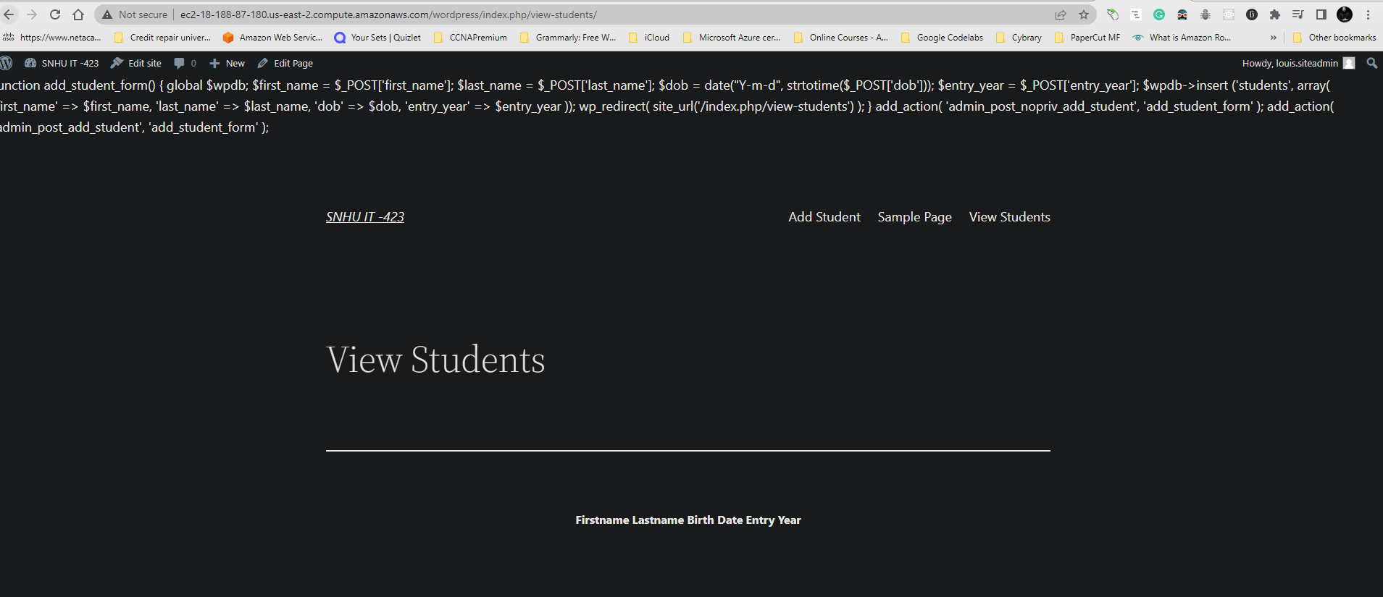

**XYZ PHP Code Plug-in: Error code above is resolved after modified to code to:**

**$students = $wpdb->get_results("SELECT * FROM students;");**

**Add Student:**

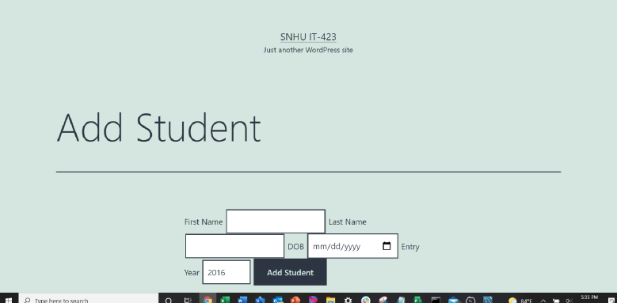

**View Student:**

